Jordan Dardar
CSD380 DevOps
Module 5.2
6/29/2026
Hot Tub Sale and Installation Process

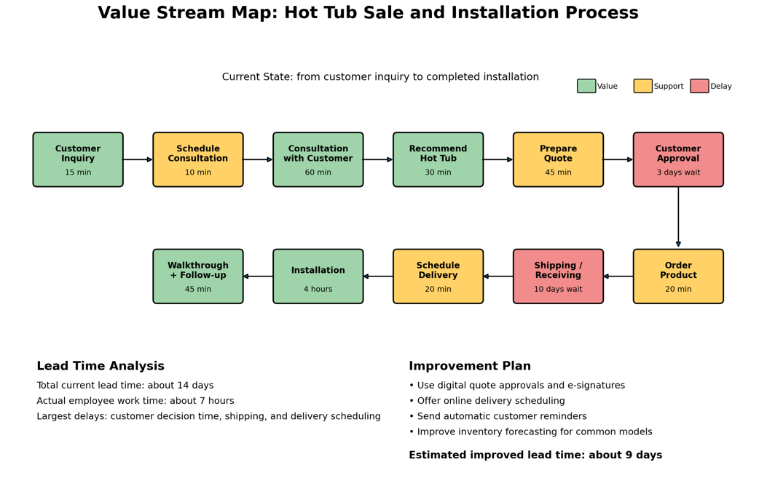
Process Time Metrics:
Step | Estimated Time | Category | Notes
Customer inquiry | 15 minutes | Value-added | Customer begins the process.
Schedule consultation | 10 minutes | Support | Needed to organize the sale.
Consultation | 60 minutes | Value-added | Customer needs are gathered.
Recommend hot tub | 30 minutes | Value-added | Product is matched to customer needs.
Prepare quote | 45 minutes | Support | Could be faster with templates.
Customer approval | 3 days | Waiting/waste | Largest controllable delay.
Order product | 20 minutes | Support | Required administrative step.
Shipping/receiving | 10 days | Waiting/waste | Largest overall delay.
Schedule delivery | 20 minutes | Support | Can be improved with online scheduling.
Installation | 4 hours | Value-added | Main delivery of value to customer.
Walkthrough and follow-up | 45 minutes | Value-added | Confirms customer satisfaction.

Analysis and Improvement Summary:
For this assignment, I created a Value Stream Map based on the process of selling and installing a hot tub. I chose this process because it has several handoffs between the customer, sales staff, ordering, delivery, and installation. That makes it a useful example for identifying where time is being spent and where delays are happening.
According to the Lean Enterprise Institute, a value stream includes the value-creating and non-value-creating actions required to bring a product or service to the customer. Value stream mapping usually starts with a current-state map and is then followed by a future-state map that shows how the process should flow after improvements are made. This matches the purpose of this assignment because the goal is not only to draw the process, but also to analyze the metrics and find ways to optimize it.
In my current-state map, the process starts when a customer contacts the store. The customer inquiry, consultation, product recommendation, installation, walkthrough, and follow-up are the strongest value-added steps because they directly help the customer choose and receive the product. Other steps, such as scheduling, quote preparation, ordering, and delivery scheduling, are necessary support steps, but they do not directly create customer value by themselves.
The biggest issue I found is that the actual work time is much lower than the total lead time. The employee work time is about seven hours, but the full process can take about fourteen days because of customer decision time, shipping, and scheduling delays. This shows that most of the process time is not active work. It is waiting time, which is one of the main forms of waste that Value Stream Mapping is designed to reveal.
To improve this process, I would use digital quote approvals and electronic signatures so customers can approve a quote faster. I would also add online scheduling for delivery, automatic reminders, and better inventory forecasting for popular hot tub models. These changes would not remove the need for sales or installation work, but they would reduce unnecessary waiting and communication delays.
After these improvements, I estimate the total lead time could decrease from about fourteen days to about nine days, while the actual employee work time would remain close to seven hours. This would make the process faster for the customer and easier for the business to manage. Overall, this VSM shows how DevOps and Lean ideas can apply outside of software by focusing on flow, reducing waste, and improving the customer experience.
References:
- Lean Enterprise Institute. (n.d.). Value-stream mapping. https://www.lean.org/lexicon-terms/value-stream-mapping/
- Purdue Lean Six Sigma Online. (2024, November 7). Value stream mapping. https://www.purdue.edu/leansixsigmaonline/blog/value-stream-mapping/

