Jordan Dardar
CSD420 Advanced Java Programming
Module 7.2

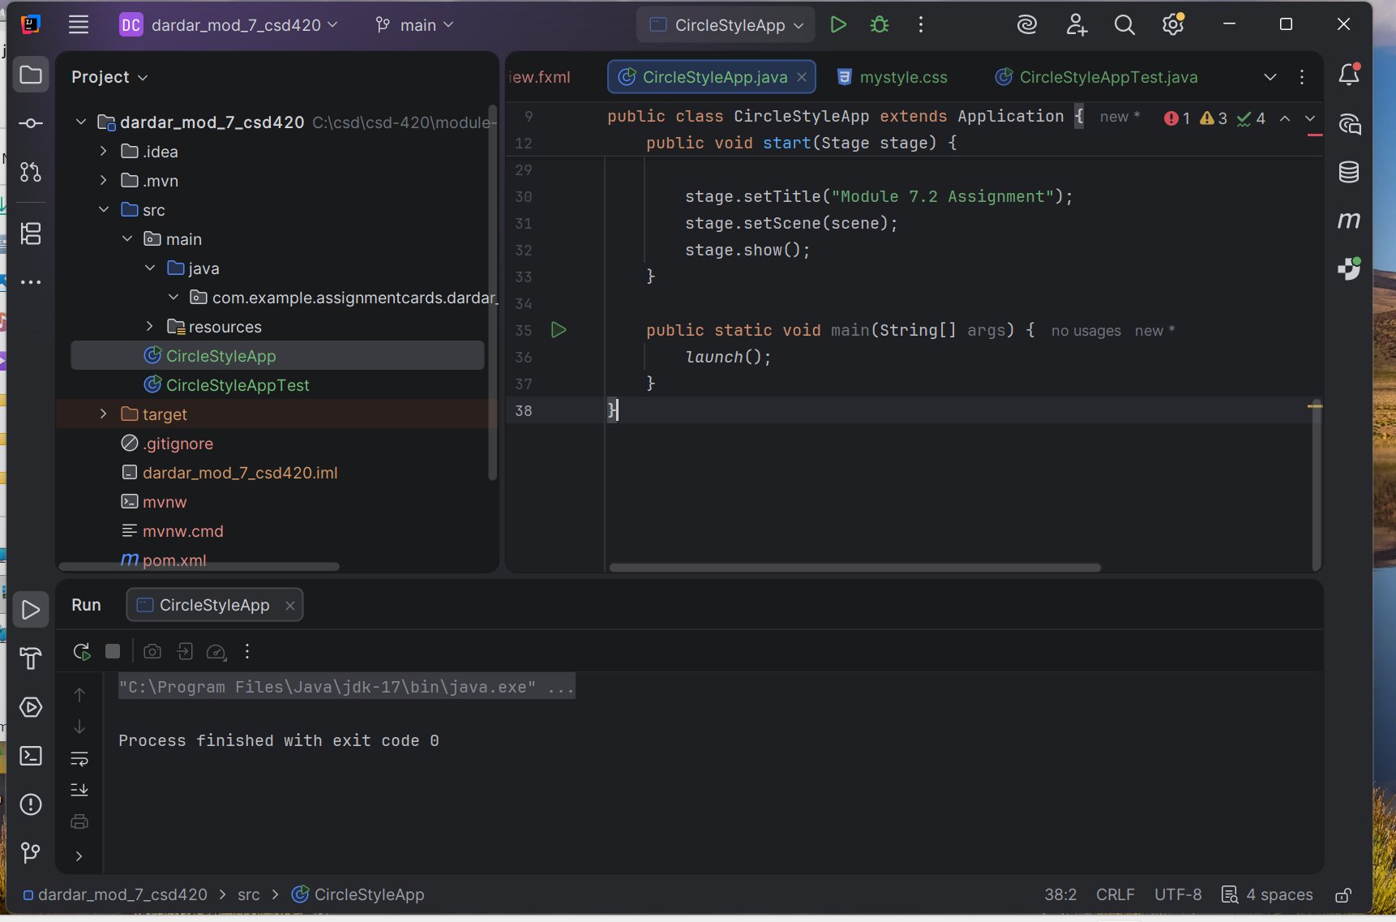 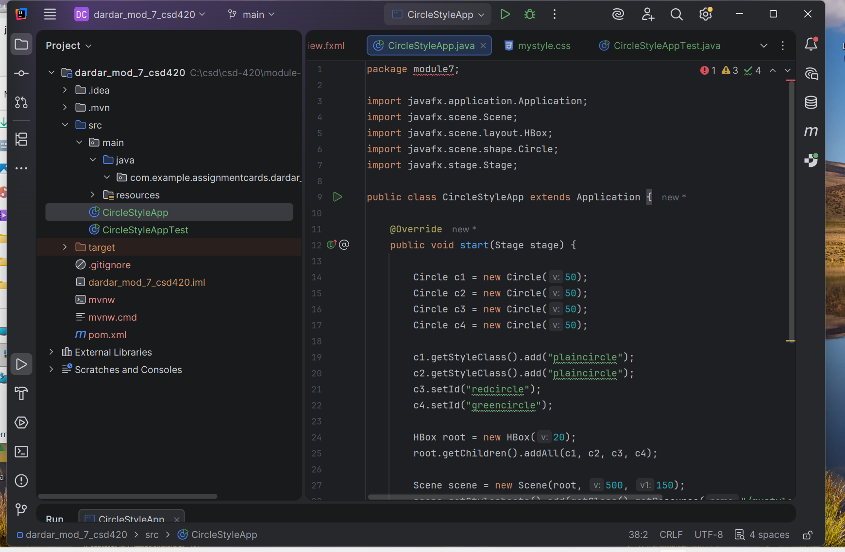 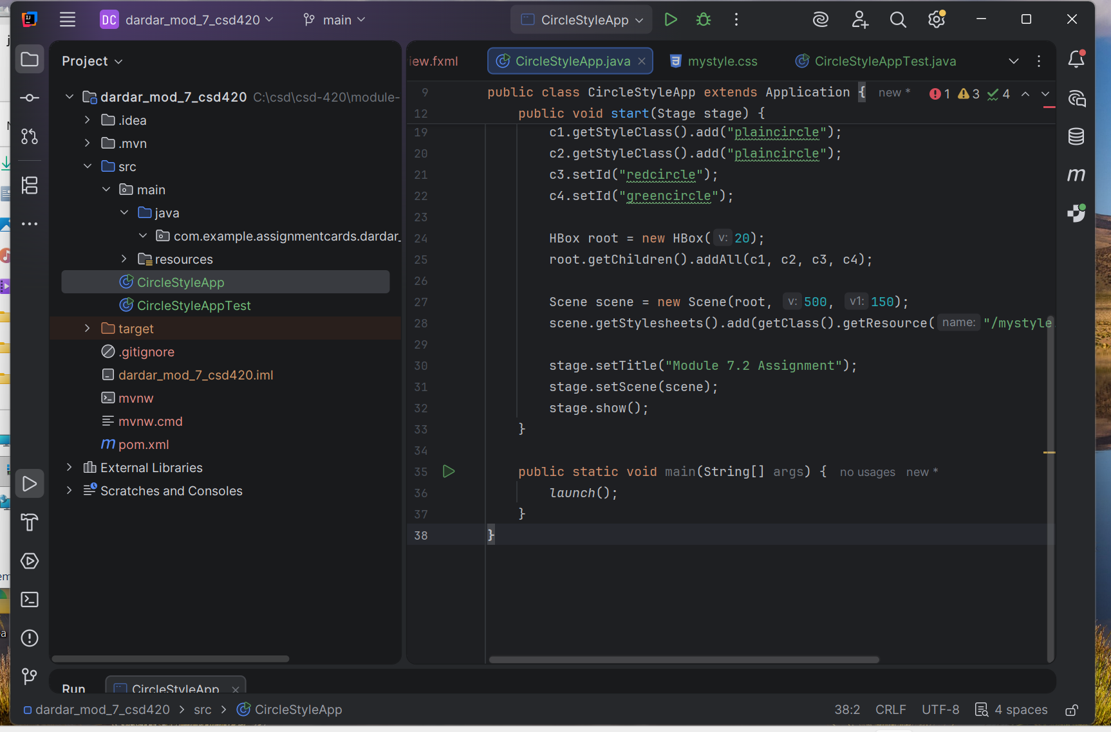 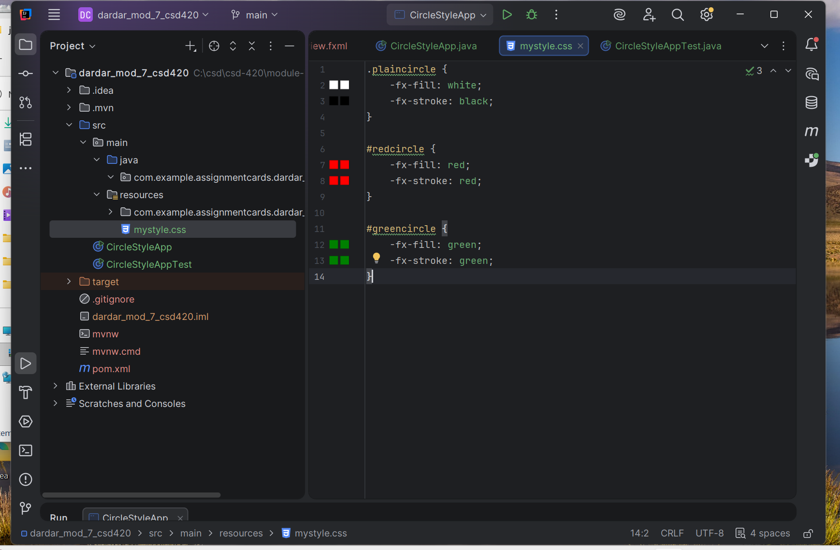 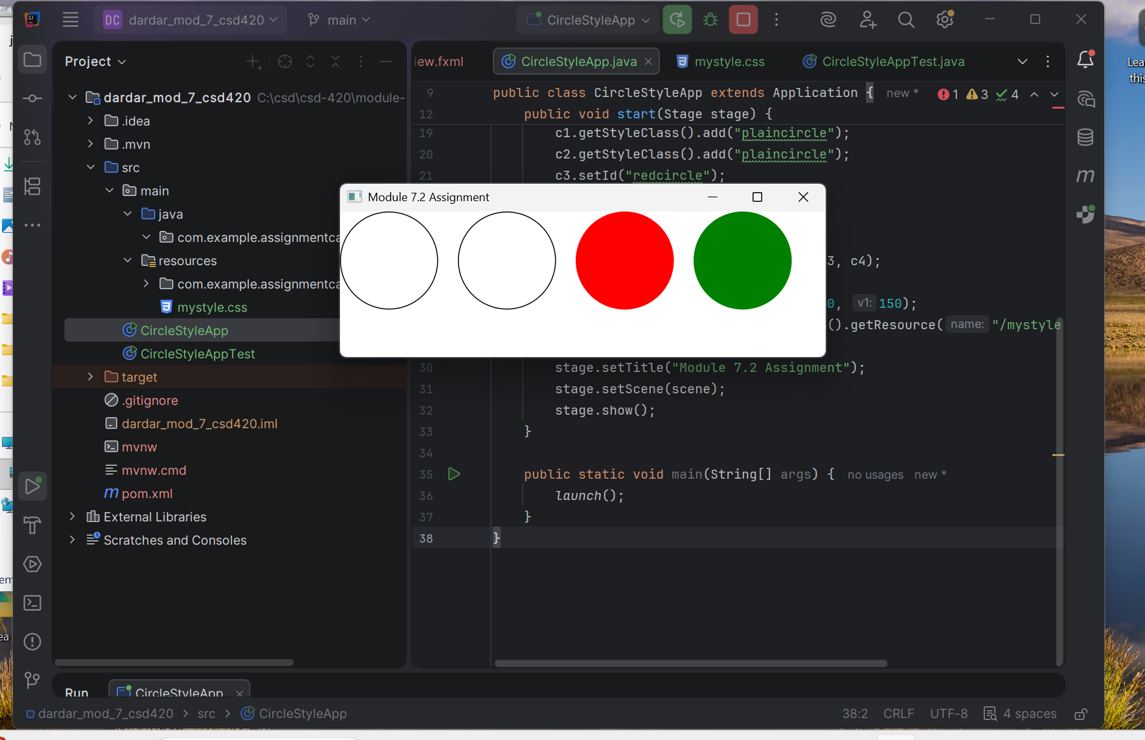 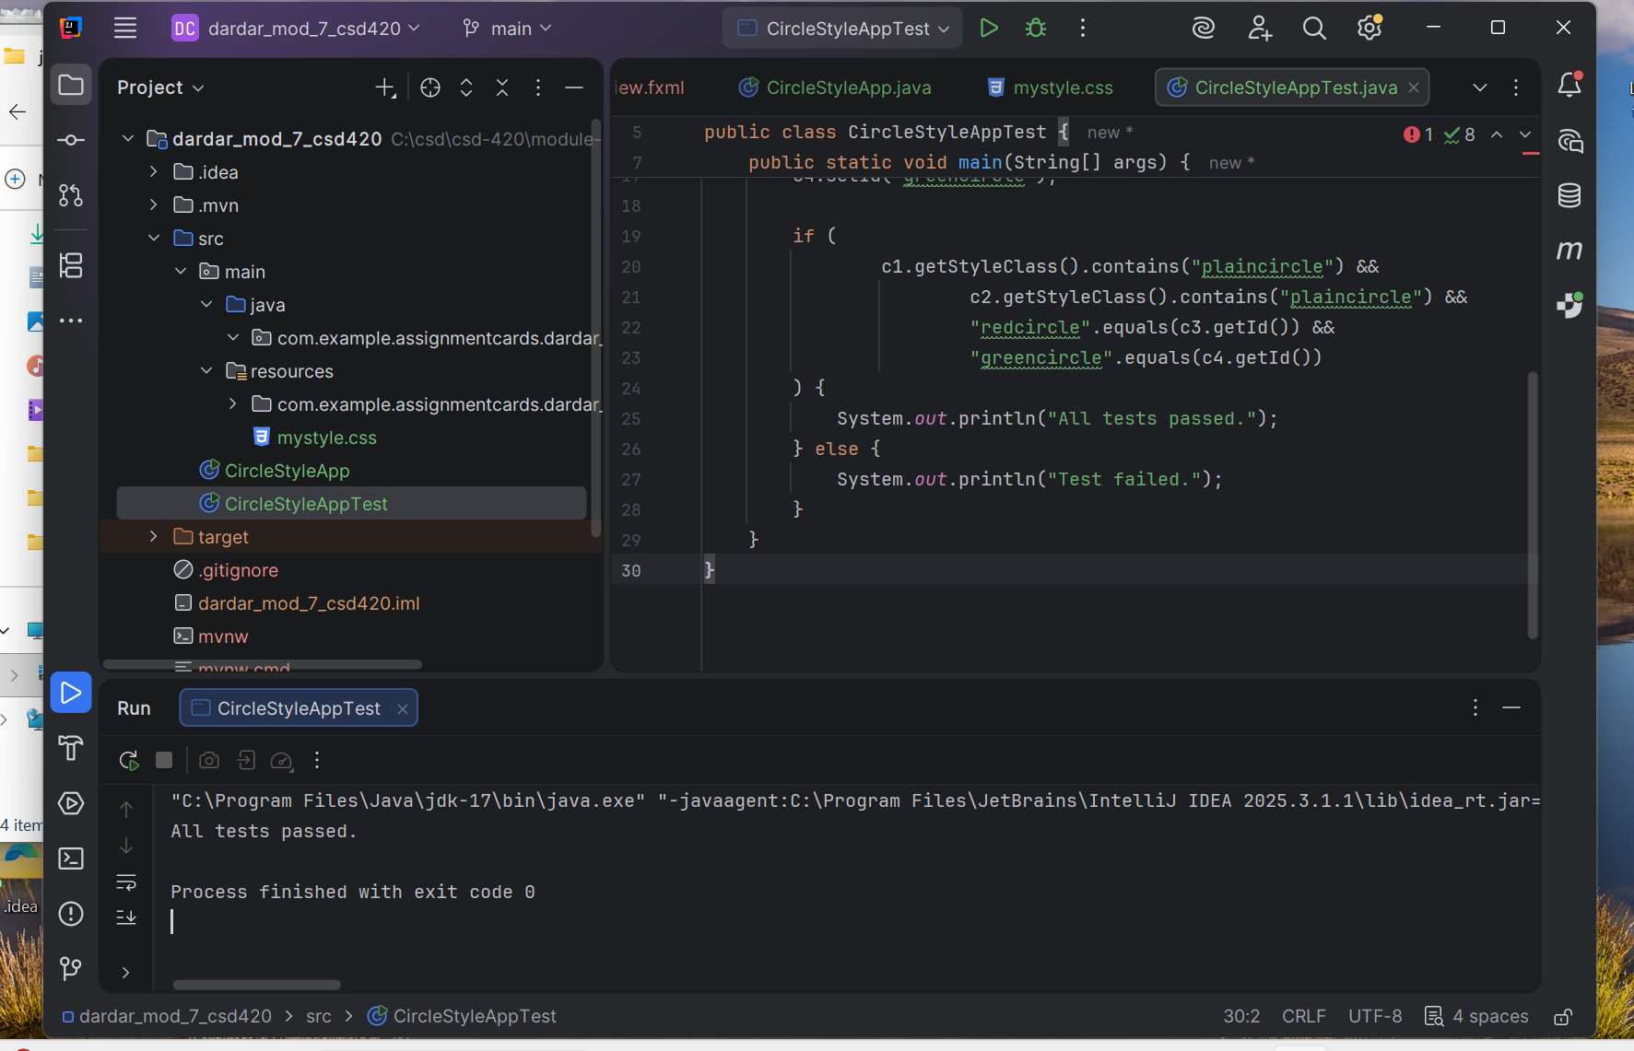 This program demonstrates the use of an external CSS style sheet in a JavaFX application. A style class was created to apply a white fill with a black stroke, and IDs were used to apply red and green colors to specific circles. The application displays four circles and applies the CSS styling correctly using JavaFX.
A test class was also created to verify that the style classes and IDs were properly assigned. The test output confirms that all components function as expected.

