Jordan Dardar
CSD420 Advanced Java Programming
Module 8.2

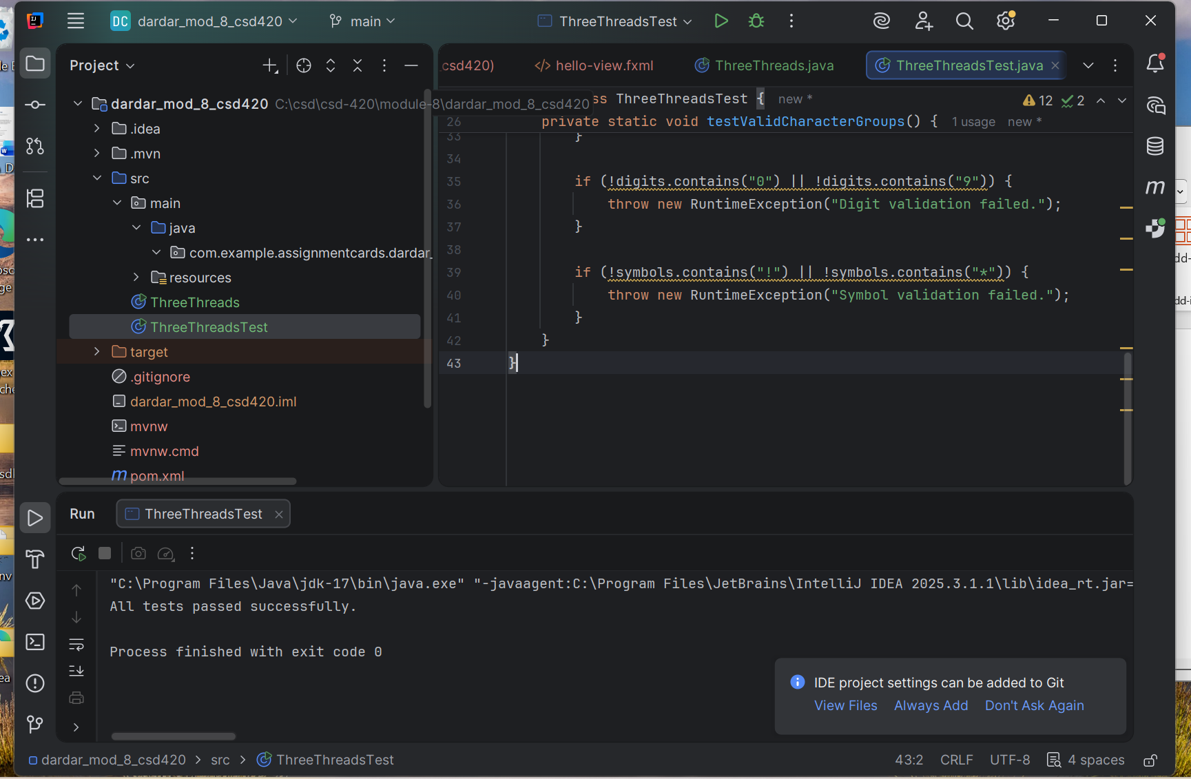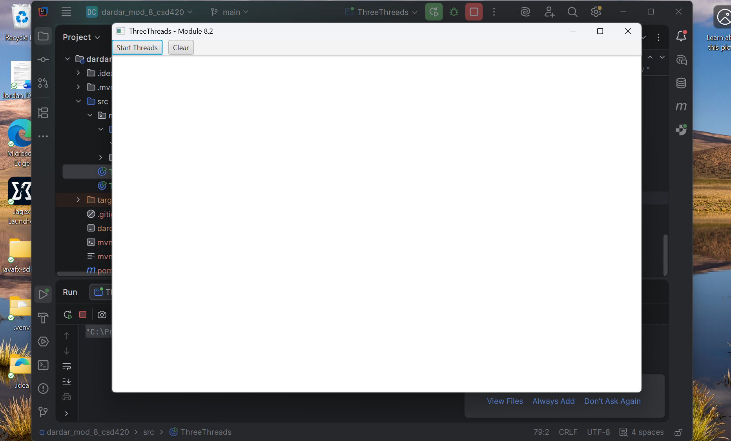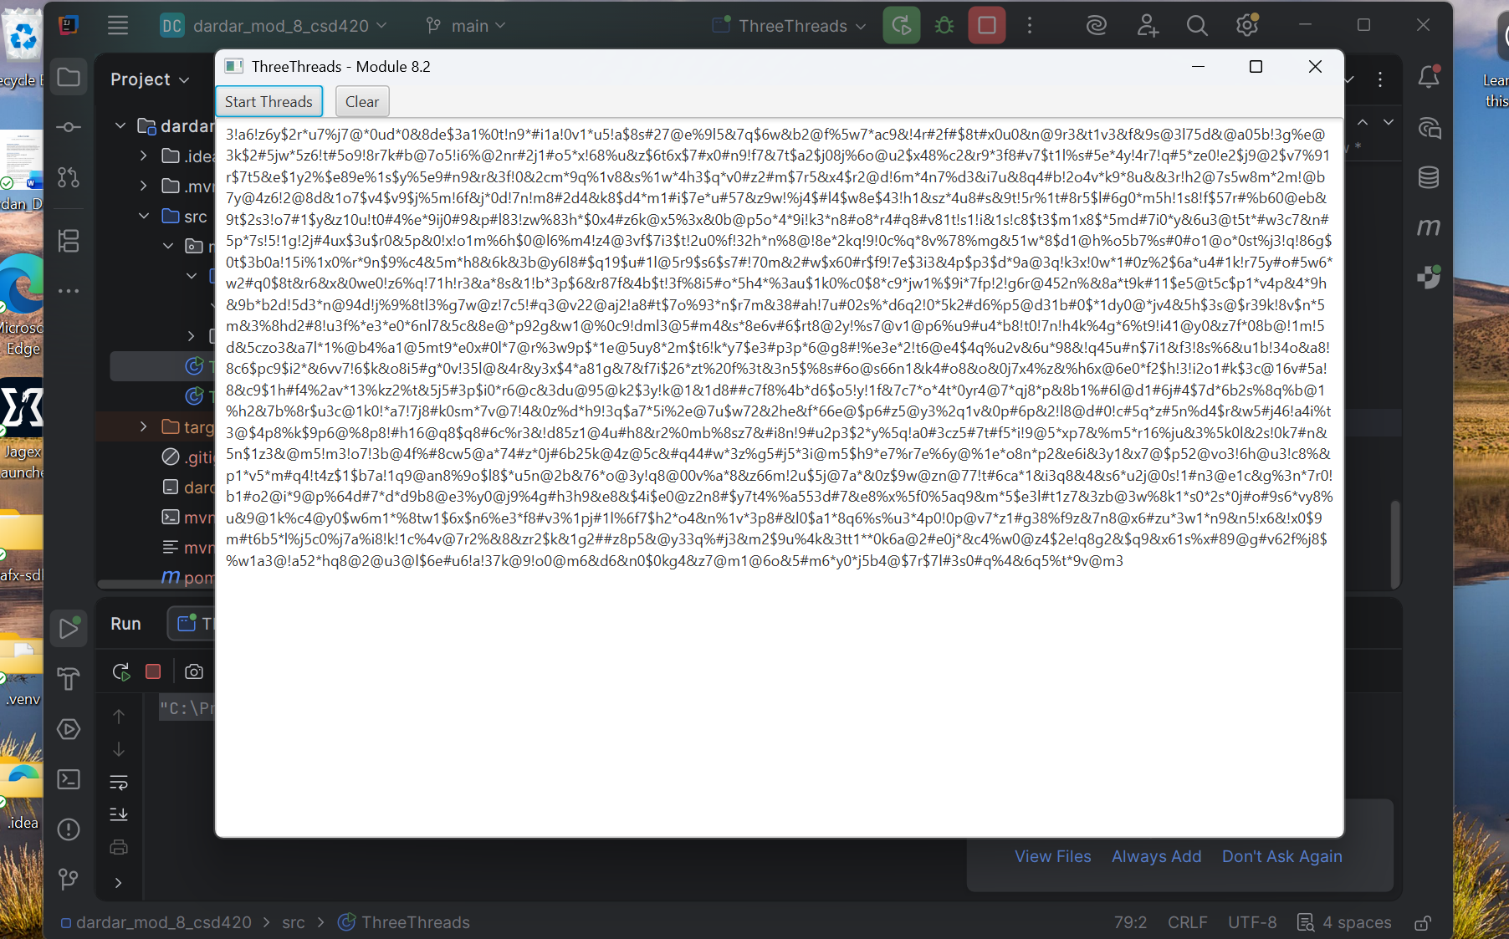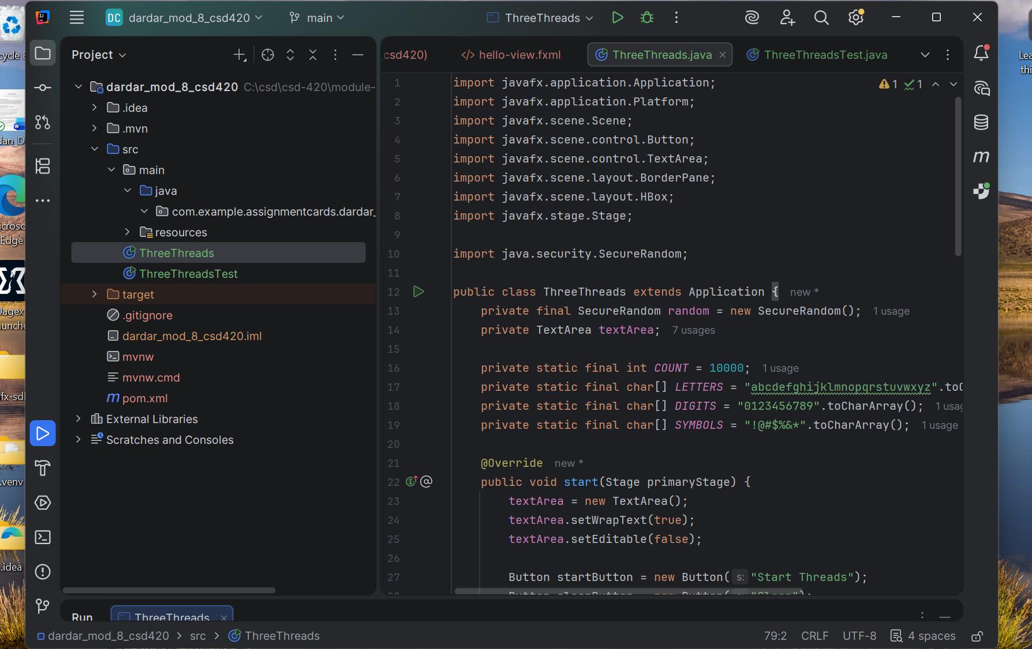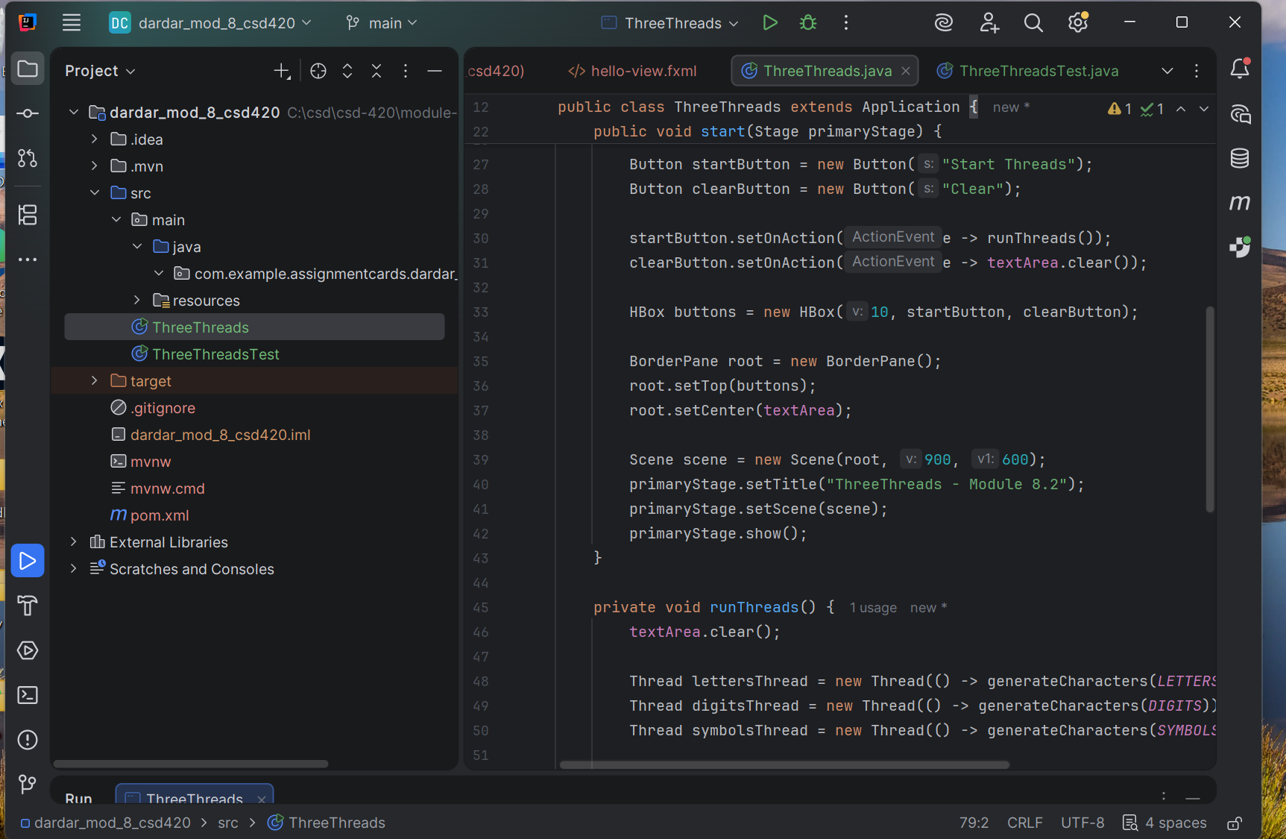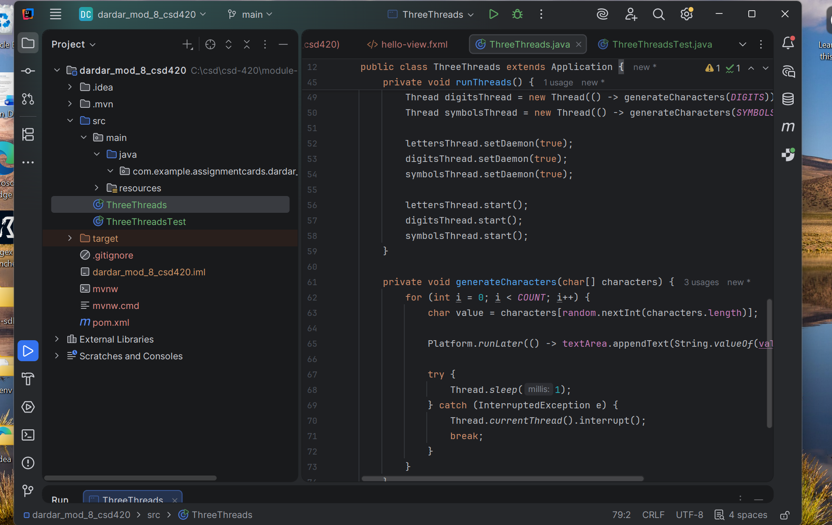Summary
This program demonstrates multithreading in Java by running three separate threads at the same time. Each thread generates a different type of character: letters, numbers, and symbols. Instead of printing all results at once, each character is displayed in real time as it is created, which shows how threads run concurrently.
JavaFX was used to display the output in a text area, and Platform.runLater() ensures that updates to the UI are handled safely from multiple threads. Overall, this assignment helped reinforce how threads work together and how to manage them in a graphical application.

