Jordan Dardar
CSD420 Advanced Java Programming
Module 9.2
5/4/2026

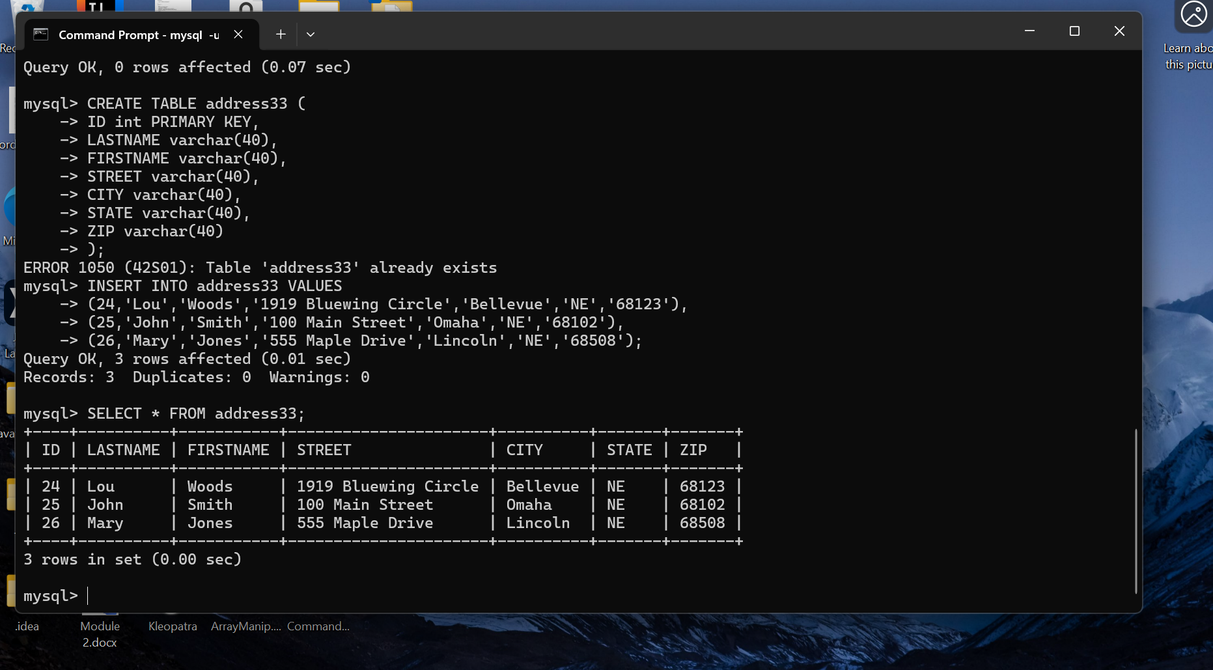 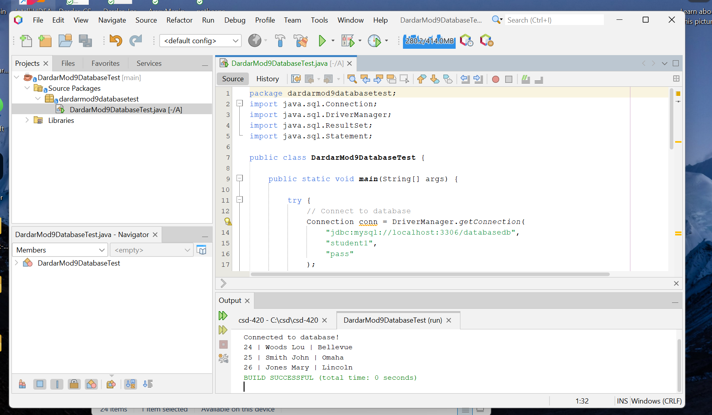 This assignment demonstrates the successful installation and configuration of Java, NetBeans, and MySQL. A database named databasedb was created, along with a table to store address data. Using JDBC, a Java application was developed to establish a connection to the MySQL database.

The program successfully connects using the DriverManager class, executes a SQL query to retrieve data from the address33 table, and displays the results in the NetBeans output window. This confirms that the database connectivity, query execution, and result processing are functioning correctly.

Overall, this assignment verifies that the development environment is properly configured and that Java applications can interact with a MySQL database in a real-world scenario.

