Jordan Dardar
CSD420 Advanced Java Programming
Module 2.2

This program generates an array of five random integers and an array of five random double values, then writes them to a file named jordan_datafile.dat. If the file does not already exist, it is created, and if it does exist, new data is appended to the end of the file. A second program is used to read the data from the file and display all stored values, including any previously appended data. This demonstrates how to use binary file input and output in Java, as well as how to handle appending data and reading multiple records from a file.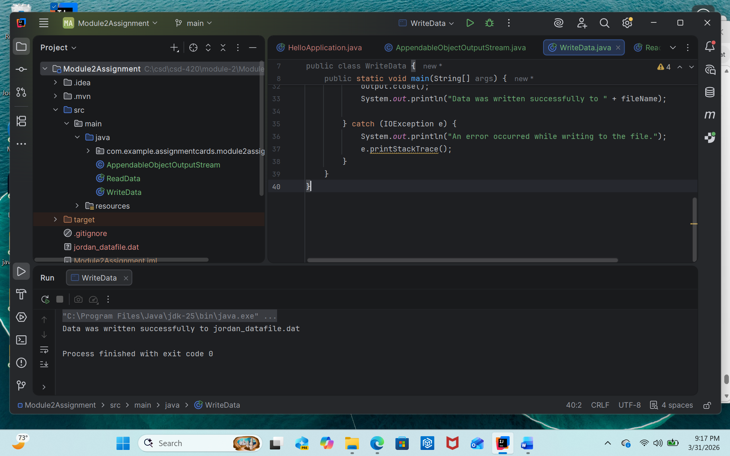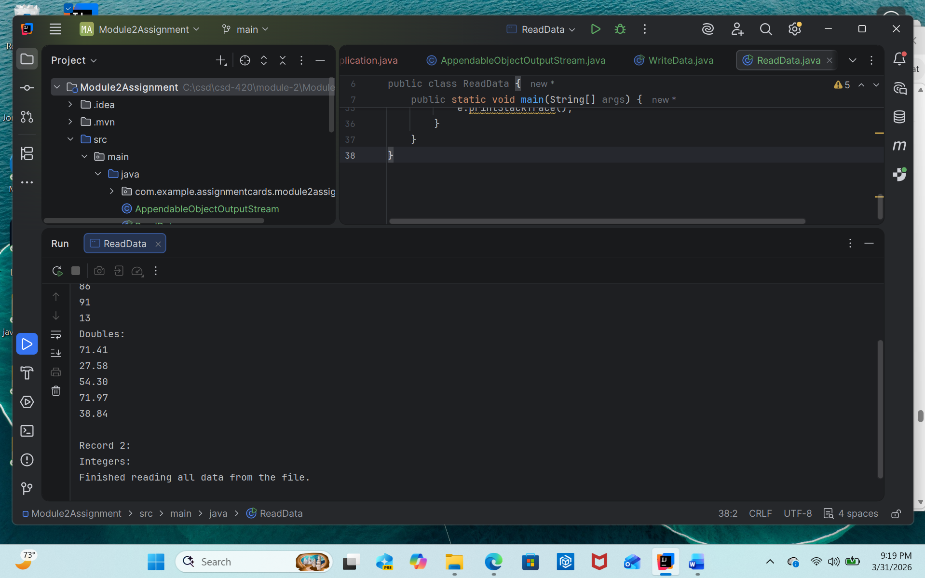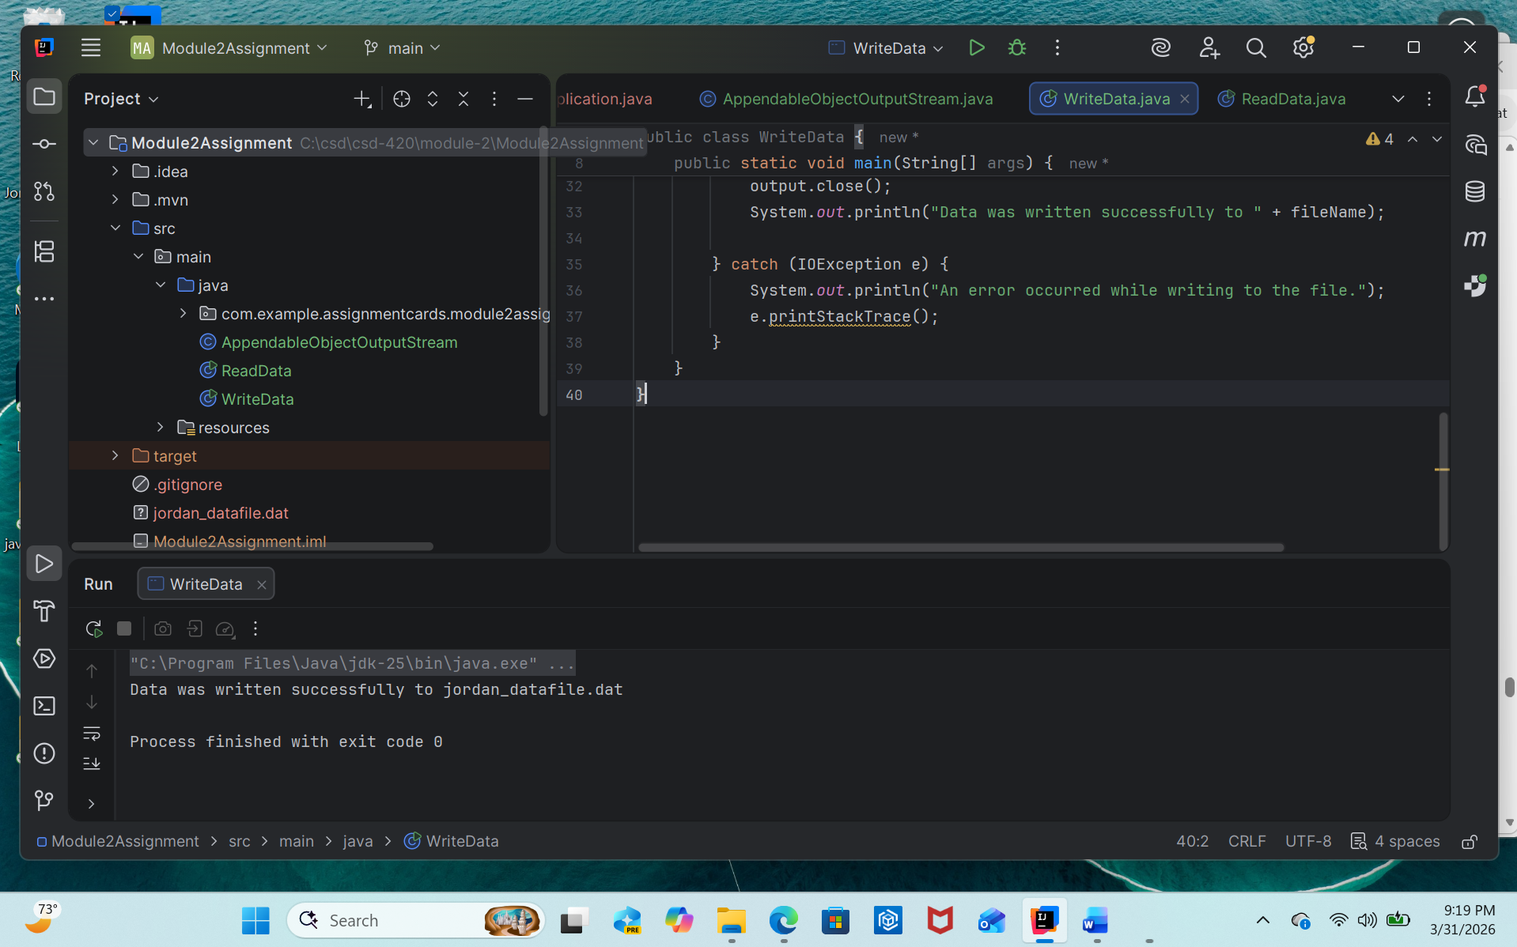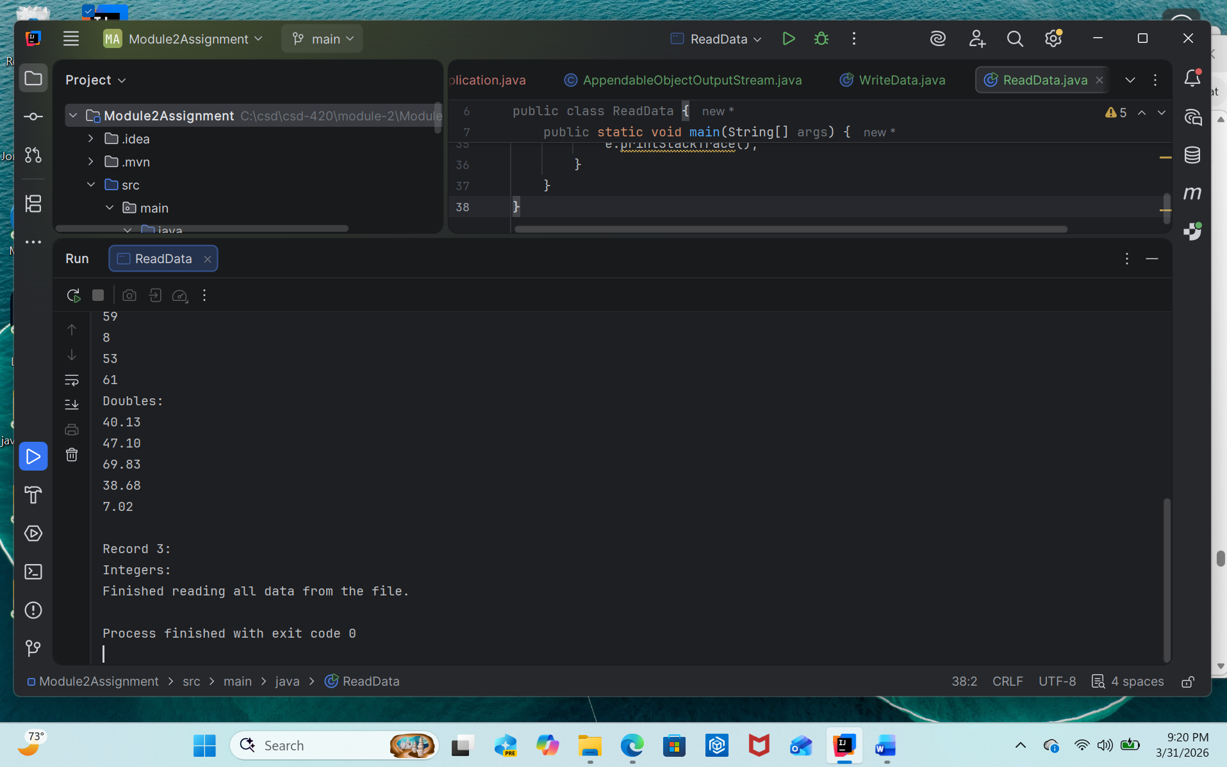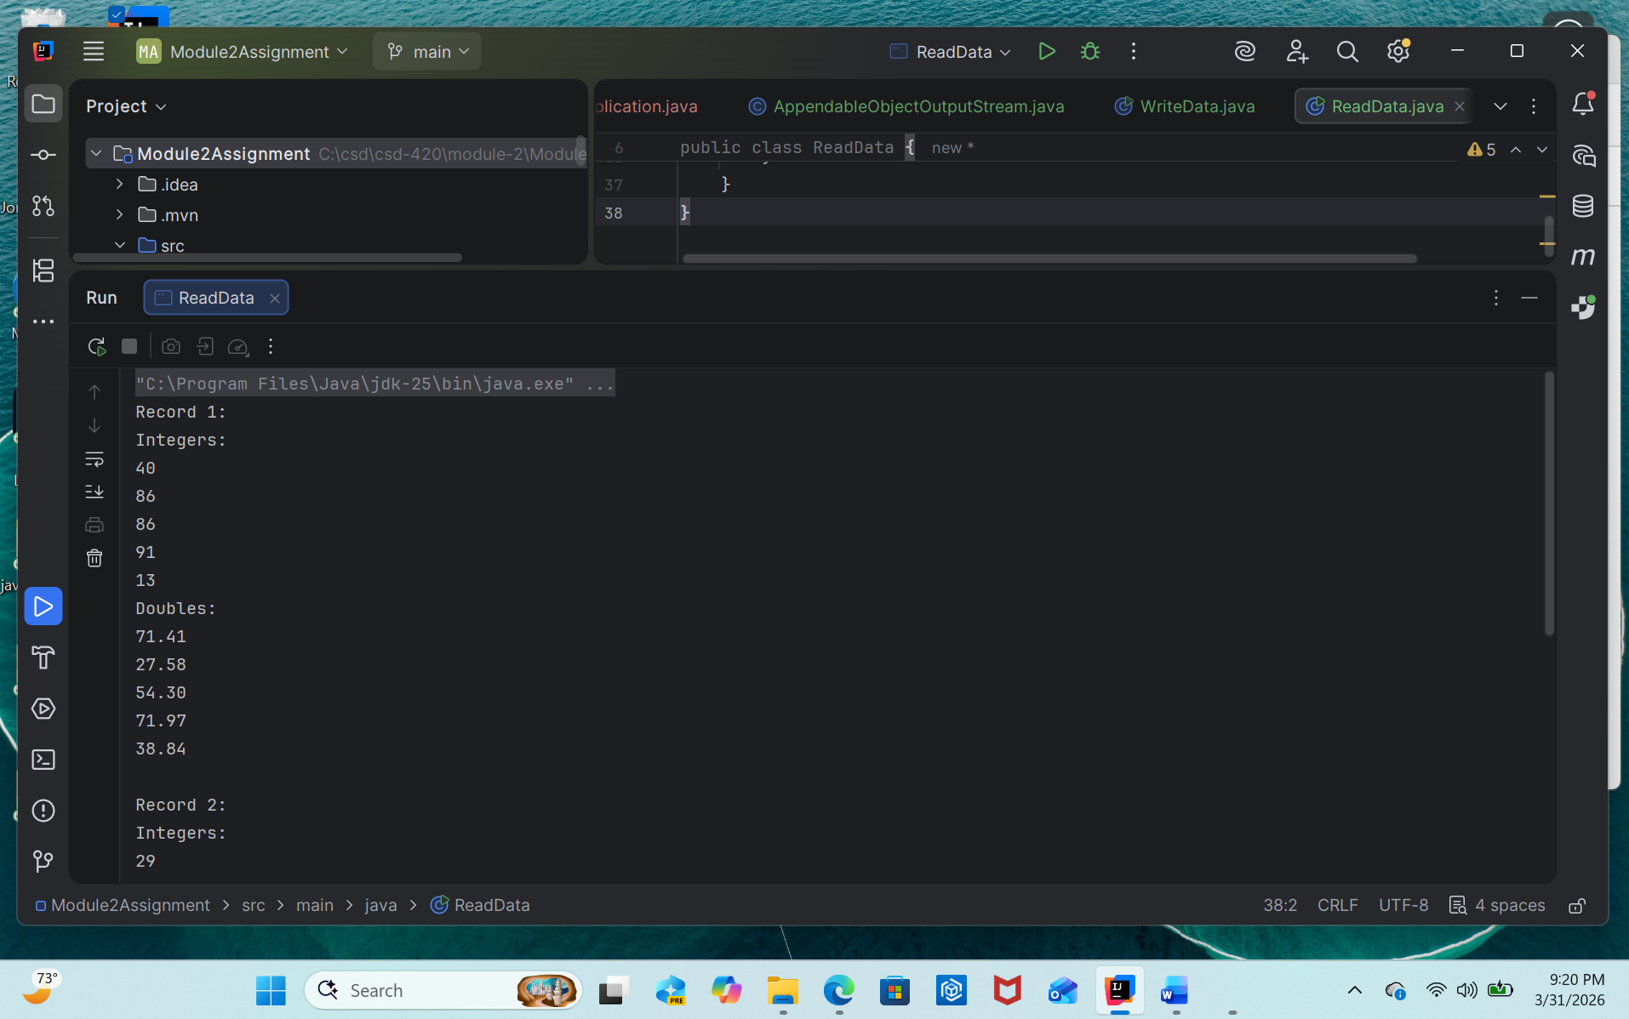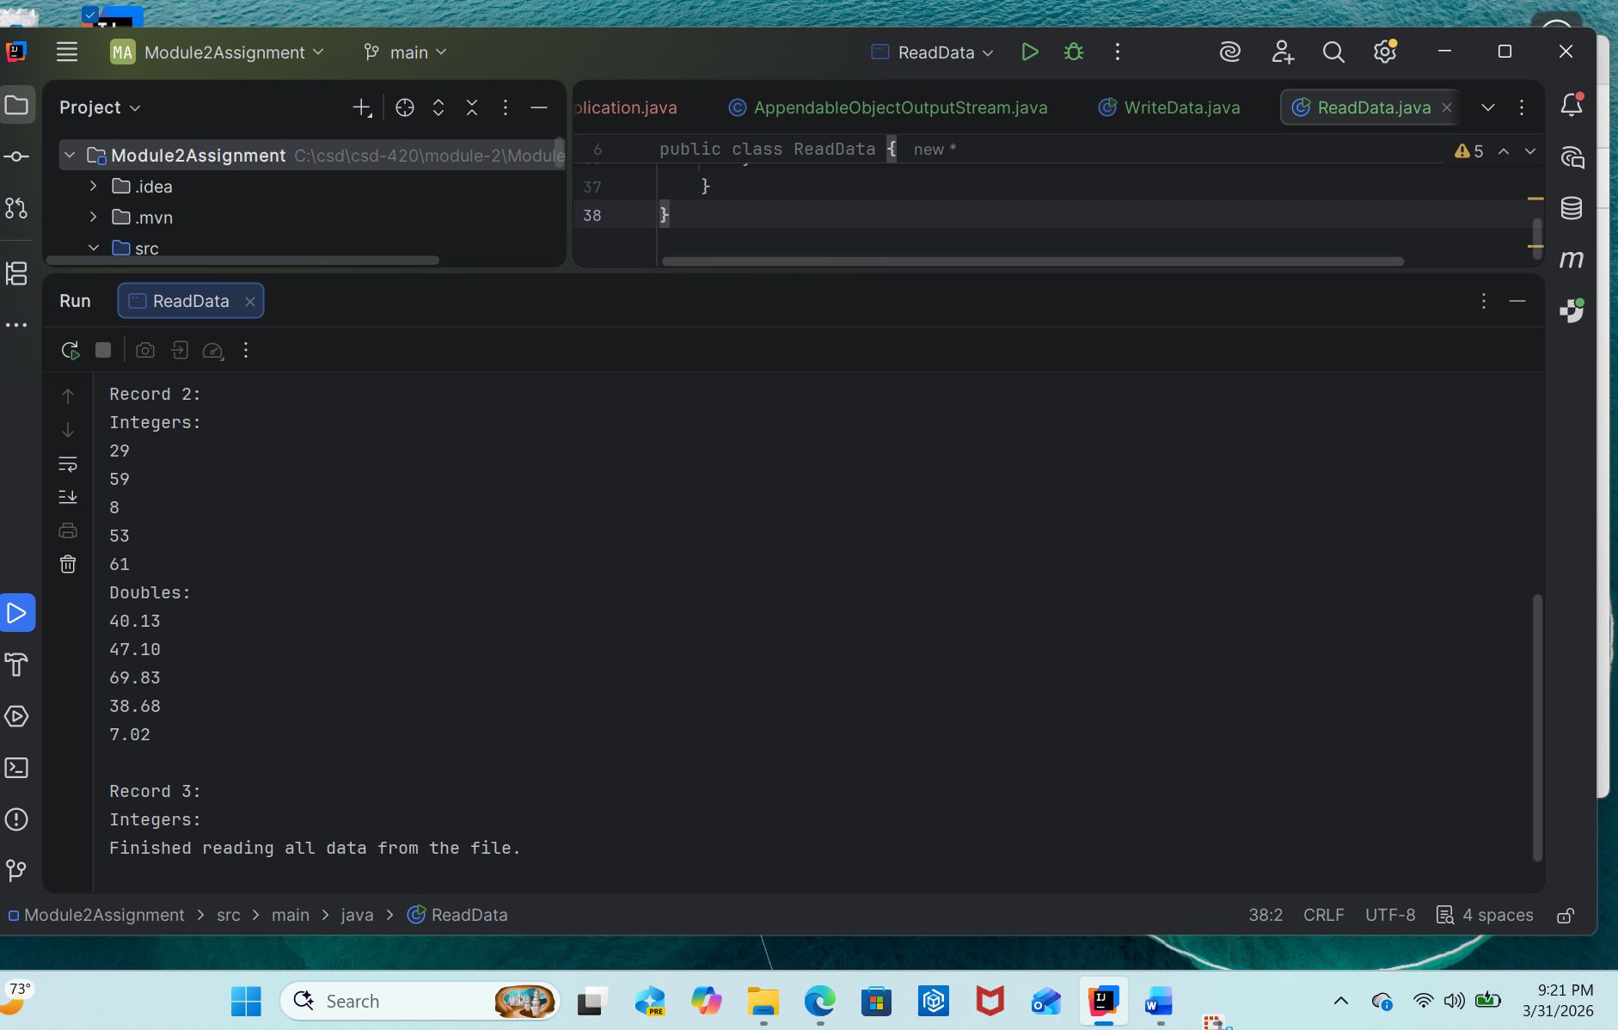 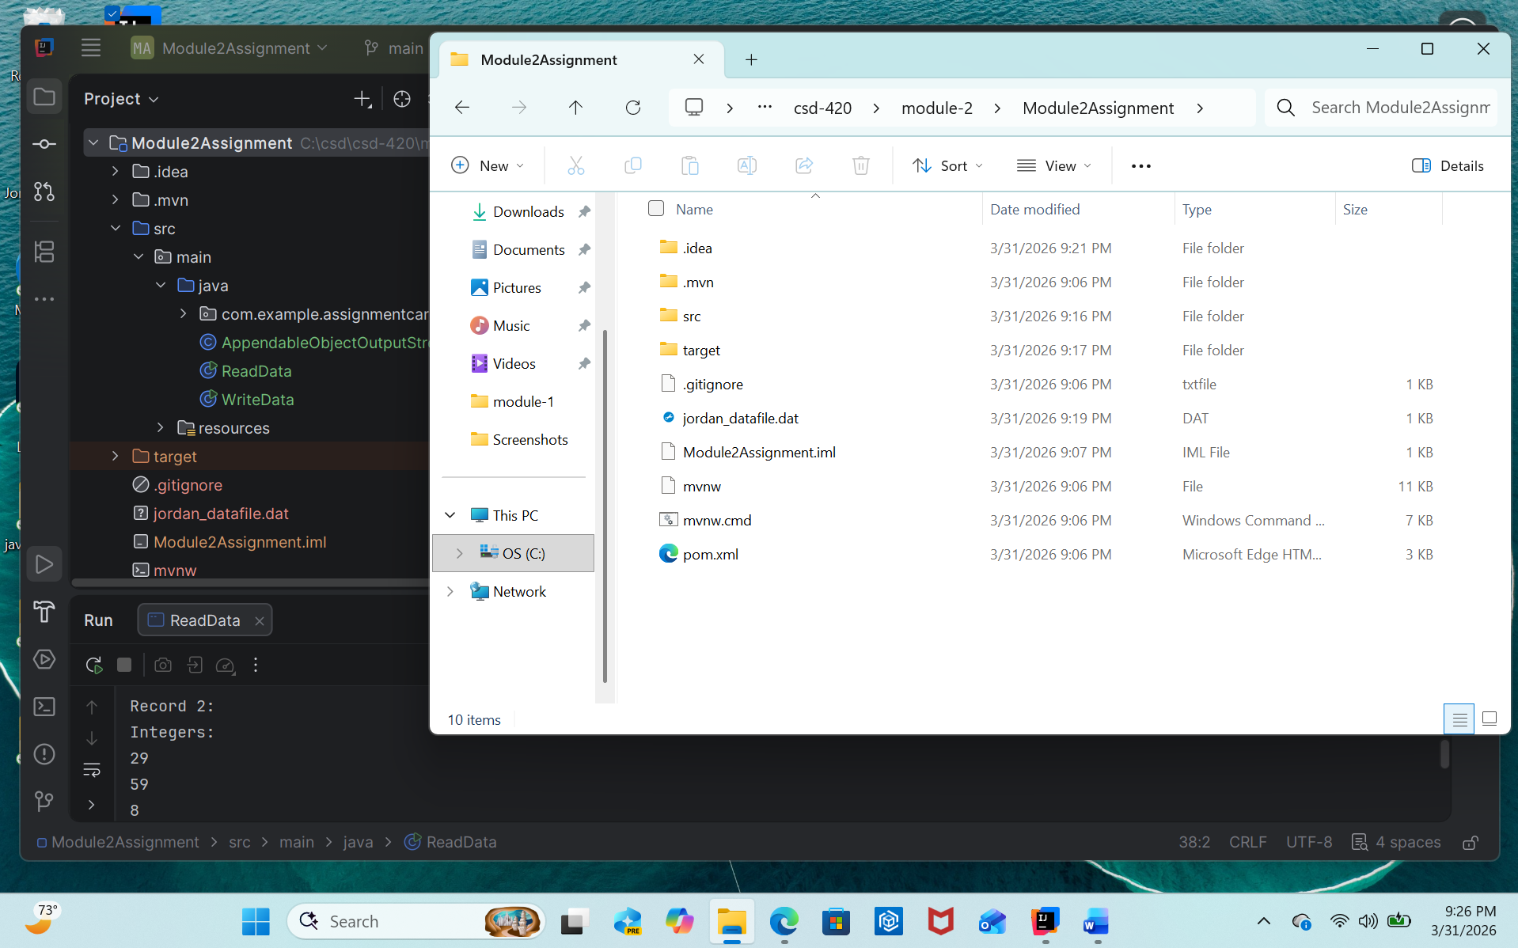This program creates an array of five random integers and an array of five random double values, writes them to a .dat file, appends new data if the file already exists, and uses a second program to read and display all data from the file.

