**Hypothesis tests**

**H1a: Including the factor of player recurrence will lead to a significant increase in the predictive power of the Big Five Inventory (BFI) model along all dimensions.**

Compare independent factor inclusion to baseline model and null model:

Predicting Faction from Extraversion, Agreeableness, and Conscientiousness

Baseline:

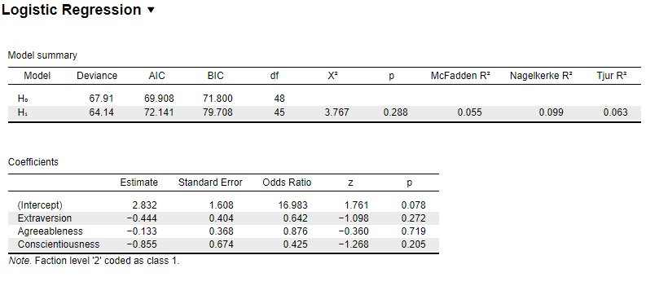

Introducing query focus:

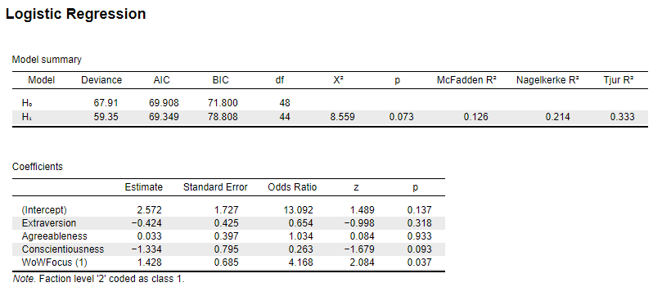

**H2a: A combination of higher Extraversion scores, lower Agreeableness scores, lower Neuroticism scores, and lower Openness scores will predict players’ biological sex such that those scores will correspond with male respondents.**

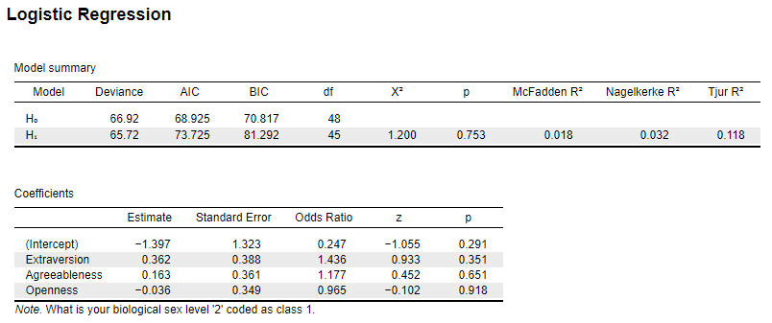

**H3a: A combination of higher Extraversion and lower Neuroticism scores will positively predict player preferences towards PvP play-styles as opposed to RP or PvE.**

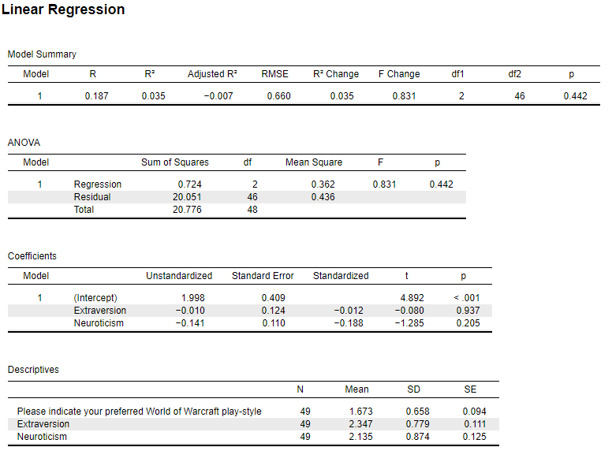

**H4a: Participants’ personality traits will predict their free-responses to queries regarding race and class.**

RACE:

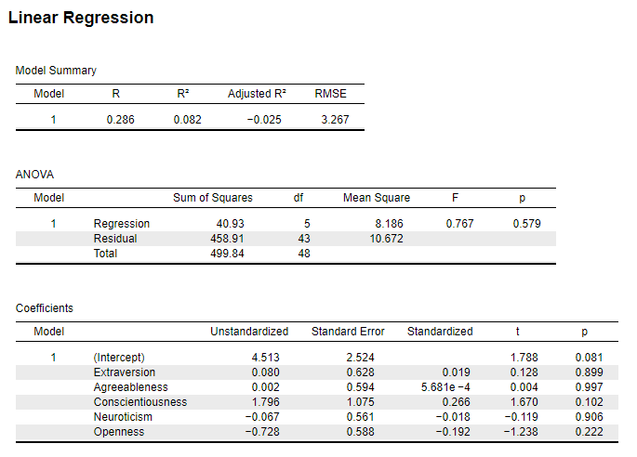

CLASS:

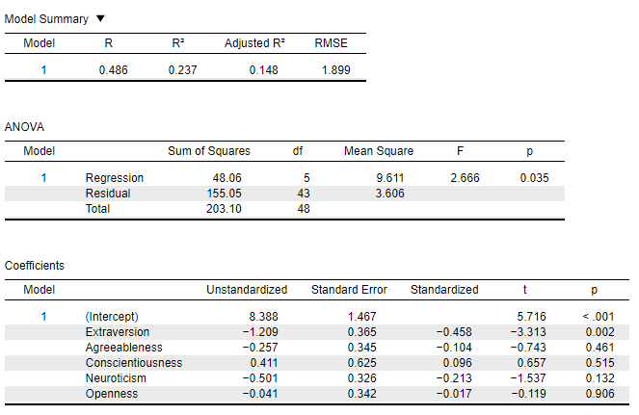

**H5a: Participants’ personality traits will predict their responses to three-choice forced queries regarding race and class.**

RACE (Short):

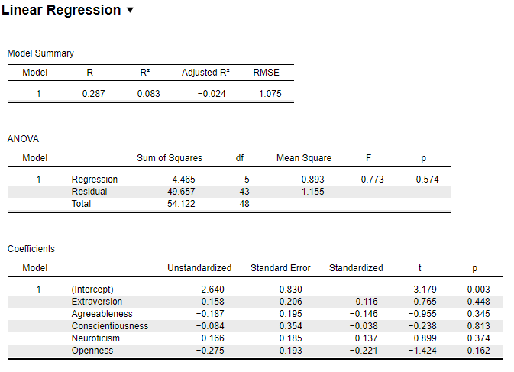

CLASS (Short):

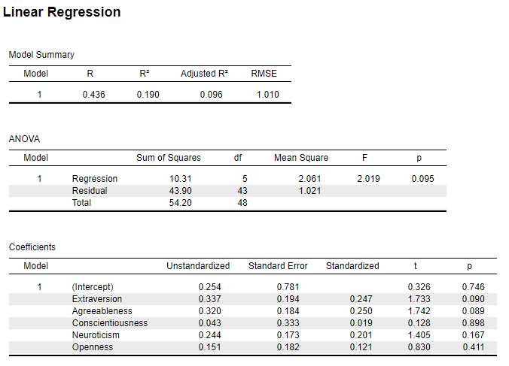

H6a: A combination of increased Conscientiousness scores, increased agreeableness scores, and decreased Extraversion scores will predict players’ alignment such that those exhibiting those traits will be more likely to align with Alliance forces than the Horde.

