**Objective: Financing a National Renewable Energy Grid**

**Nathan Edmunds Professor, MBA, NABCEP Certified**

**Univest Bank Solar Leasing, VP,** [**www.univest.net**](http://www.univest.net)**, West Chester University 302-740-6858 nedmunds1@hotmail.com**

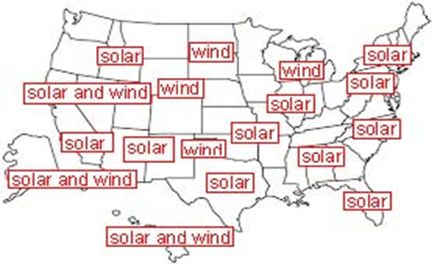 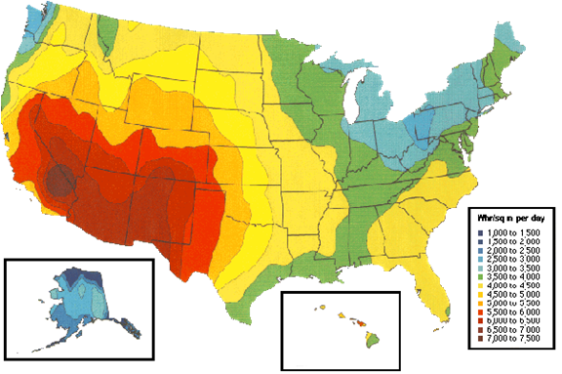

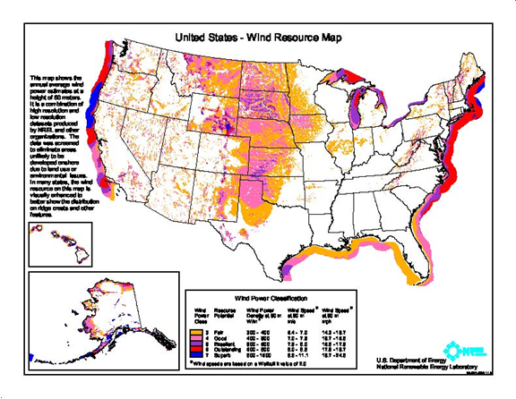 

***Findings and Conclusion***

***-The cost of solar and wind power declined rapidly to 3 cents per kilowatt hour. As the industry grows the cost will continue to decline along with batteries.***

***-Solar and wind power can power 100% of the renewable energy grid with 1% of total land mass. High voltage DC transmission can move power from areas that are over-producing to the regions that need power.***

***-Vacant land in the desert southwest and windy areas in the Midwest are the most suitable locations.***

***-Solar and wind power can be combined with raising sheep, cattle, and crops to maintain the food supply with a nominal reduction in food produced.***

***-An estimated 165,000 Americans die annually from air pollution and there will be a substantial improvement in the health of Americans and reduction in health care costs.***