Dashboard for Center for Employee Health Studies (CEHS)

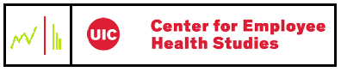

Prepared by:

Jay Dave and Nandhinee Neelakandan

University of Illinois at Chicago

CS522 Fall 2015

Table of contents

Project Introduction

Project Title

Client

Team

Project Overview

Requirements Analysis

Project proposal

Use Cases

Specifications

Disclaimer

Author

Functional specifications

Goals:

Low-ball target

Mid-target

High-target

Full bells and whistles target

Non-Goals

Non-Functional specifications

Prototypes

Prototype-1

Map View

Map View: compare stats

Cost Differential

Prototype-2

Map View

Map View: compare stats

Cost Differential

Prototype-3

CEHS Dashboard frame and Tabular View

Table View

4.3.3. Map View with table view

Compare stats

Cost Differential

Client’s Feedback

# 

# Project Introduction

## Project Title

Dashboard for Center for Employee Health Studies (CEHS)

## Client

1. Jonathan C. Dopkeen

Clinical Assistant Professor and Director

Center for Employee Health Studies

UIC School of Public Health

2. Renee DuBois

Research Specialist at Center for Employee Health Studies

## Team

1. Jay Dave - Project Lead
2. Nandhinee Neelakandan

## 

## Project Overview

This project would create a unique visualization dashboard for the research data at CEHS. This data includes workers’ compensation claims from a Third Party Administrator (TPA) for self-insured companies. Specifically, researchers are looking at the costs of workers’ compensation claims for Illinois and 6 other Midwestern states, and stratifying by whether the workers’ compensation claim was litigated and which body part was injured. This will help them to understand the cost differentials between Illinois and the other states, as well as by injury type within Illinois. Costs being used in this project include lost work time, medical costs, and administrative/legal costs.

# Requirements Analysis

## Project proposal

[Link to Project Proposal document](https://drive.google.com/open?id=0B3UOLiy-DHuleFFWZ1d5a1Frbm8)

*Note: This link will be replaced with the actual use cases once the specifications are approved and no more changes are to be made. Trying to avoid issues caused by redundancy.*

## Use Cases

[Link to Use Case document](https://drive.google.com/open?id=0B3UOLiy-DHulZC1zWm5vRHNscW8)

*Note: This link will be replaced with the actual use cases once the specifications are approved and no more changes are to be made. Trying to avoid issues caused by redundancy.*

# Specifications

## Disclaimer

“This spec is not complete”

## Author

Nandhinee Neelakandan

## Functional specifications

### Goals:

#### Low-ball target

The low level target focuses on the two primary visualization functions that the dashboard should accomplish. They are providing the formatted data in a tabular form and project the computed statistics of the mid-west states on the US map. This includes following use cases completely- *OpenCEHSDashboard, USStateMap, TooltipUSStateMap, AdditionalInformation, ViewData and FilteredTabularData*.

Alice is a researcher in the School of Public Health at UIC. She suddenly gets a task of making a report on the statistics available about the workers’ compensation to her manager. Alice is weak in making computations and is bewildered when she sees the huge amount of data on which she has to make complex computations to derive the facts and statistics. She then seeks the help from the IT staff who suggest her about the dashboard. She gets excited about the dashboard and enters into CEHS dashboard homepage.



‘How do I deal with a csv file? ‘

Alice has no idea of how to open a csv from a spreadsheet application and work on the data. She wants the data from a csv file to appear as a neatly formatted table. Alice also expects the table to appear with the fields and data she is concerned about. Alice clicks the link which says “View data” and when the page is loaded, she selects the appropriate fields and data she is interested to view and clicks submit. A neatly formatted table appears pertaining to her requirements.

After successfully looking the data she is interested in, she wants the statistics of every mid-west state after a complicated computation. She also wants to compare statistics of the mid-west states. So she goes to the dashboard homepage and click “compare state statistics” A US state map pops up with the states shaded in with different colors(the darkest state with the greatest number). Alice hovers over every state and the tooltip shows the appropriate numbers related to the state.



‘How about viewing statistical information as a table? ‘

Additionally, Alice would love to look at the statistics in a tabular layout so that she can see state rankings and corresponding statistical information. So she clicks the button which says “View ranking as a table”. Upon clicking the button, the same statistics which is projected on the state map is displayed in a proper readable format in a specific order with the state with highest numeric value on the top.

*Note: The computations that should be done are yet to be finalized by the client.*

#### Mid-target

The mid target focuses on the functionalities that the dashboard has to accomplish to be complete application. This includes following use cases completely - *CompareVisualization*.

Alice now wants to view how the data for other states are distributed with respect to Illinois. She wants a comparison of data with the mean of Illinois. Also she wants the comparison for every state across six variables for litigated cost or non-litigated cost or both the parameters.



‘I am feeling motivated! ‘

Alice clicks “Compare other states with Illinois” link and is taken to a page which asks her to pick the following:

1. State(s) which should be compared with Illinois

2. Litigated/non-litigated/both cases

3. X-axis (one of the six variables)

4. Y-axis (one of the five remaining variables)

Alice makes choices for all the above mentioned fields and clicks submit. A scatter plot is produced with the data of the state selected for the respective parameters. Also the graph distinguishes the median line of two parameters in the x and y axis for Illinois from the data for other states. In this way Alice makes inference about the data distribution of a state with respect to Illinois.



‘I am in love with this dashboard! ‘

#### High-target

The high target focuses on functionality that can help users to get the visualizations to the real world. Though this functionality is a low priority for user but it would be helpful if users can export the visuals for future reference and research. This includes following use cases completely - *SaveAsPDF*.

Alice is happy that she got all the visualizations needed for her report and is too lazy to make the report for showing the visualizations. So she clicks the “Save” button on top of every page and saves all the visualizations.



‘I swear I am not lazy! ‘

#### Full bells and whistles target

This section specifies the future enhancement for the application.

Alice feels that though the dashboard satisfied all her expectations, she thinks that if the dashboard can project a graph that aggregates the data on a yearly basis for every state, she would be able to analyze the trend.



‘Just one more please! ‘

### Non-Goals

* User would like to have a visual that aggregates the data on a yearly basis for every state.

## Non-Functional specifications

* Performance Requirements:
  + The system shall be responsive all the time.
* Usability and Humanity Requirements:
  + Considering that all users are educated, the system should be intuitive and easy to remember for returning users.
  + A new user who understands the data to be visualized should be able to easily adapt to the dashboard within 15 minutes.
* Look and Feel Requirements:
  + The dashboard should look appealing and grab interest of users.
  + The color coding used should be differentiable.
* Operational and Environmental Requirements:
  + The product shall be operable on a windows desktop/laptop.

# Prototypes

## Prototype-1

* + 1. CEHS Dashboard frame and Tabular View

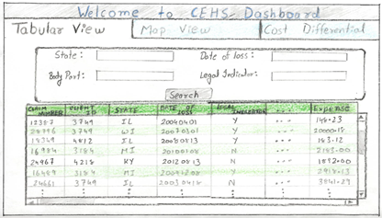

### Map View

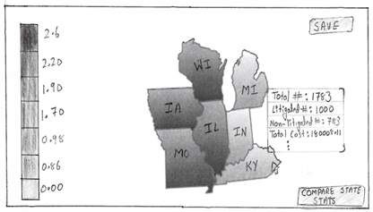

### Map View: compare stats

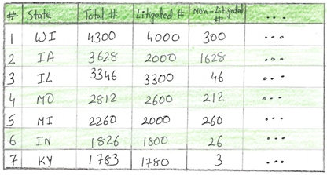

### Cost Differential

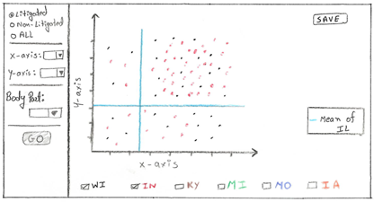

## Prototype-2

* + 1. CEHS Dashboard frame and Tabular View

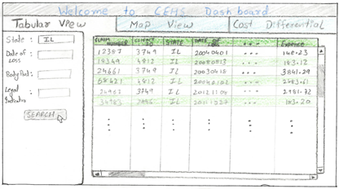

### Map View

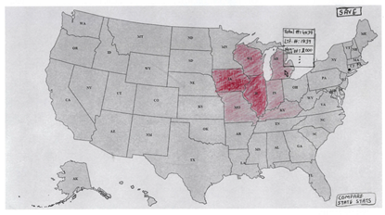

### Map View: compare stats



### Cost Differential

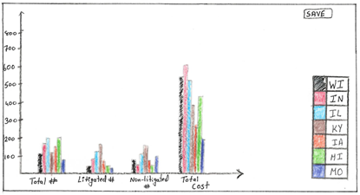

## Prototype-3

### CEHS Dashboard frame and Tabular View

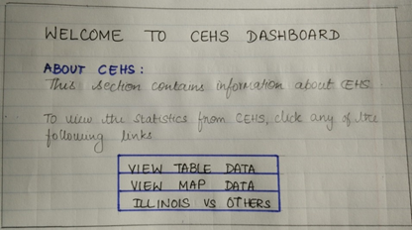

### Table View

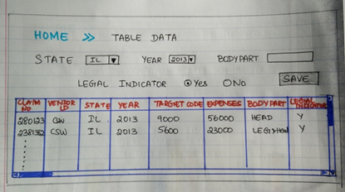

### 4.3.3. Map View with table view

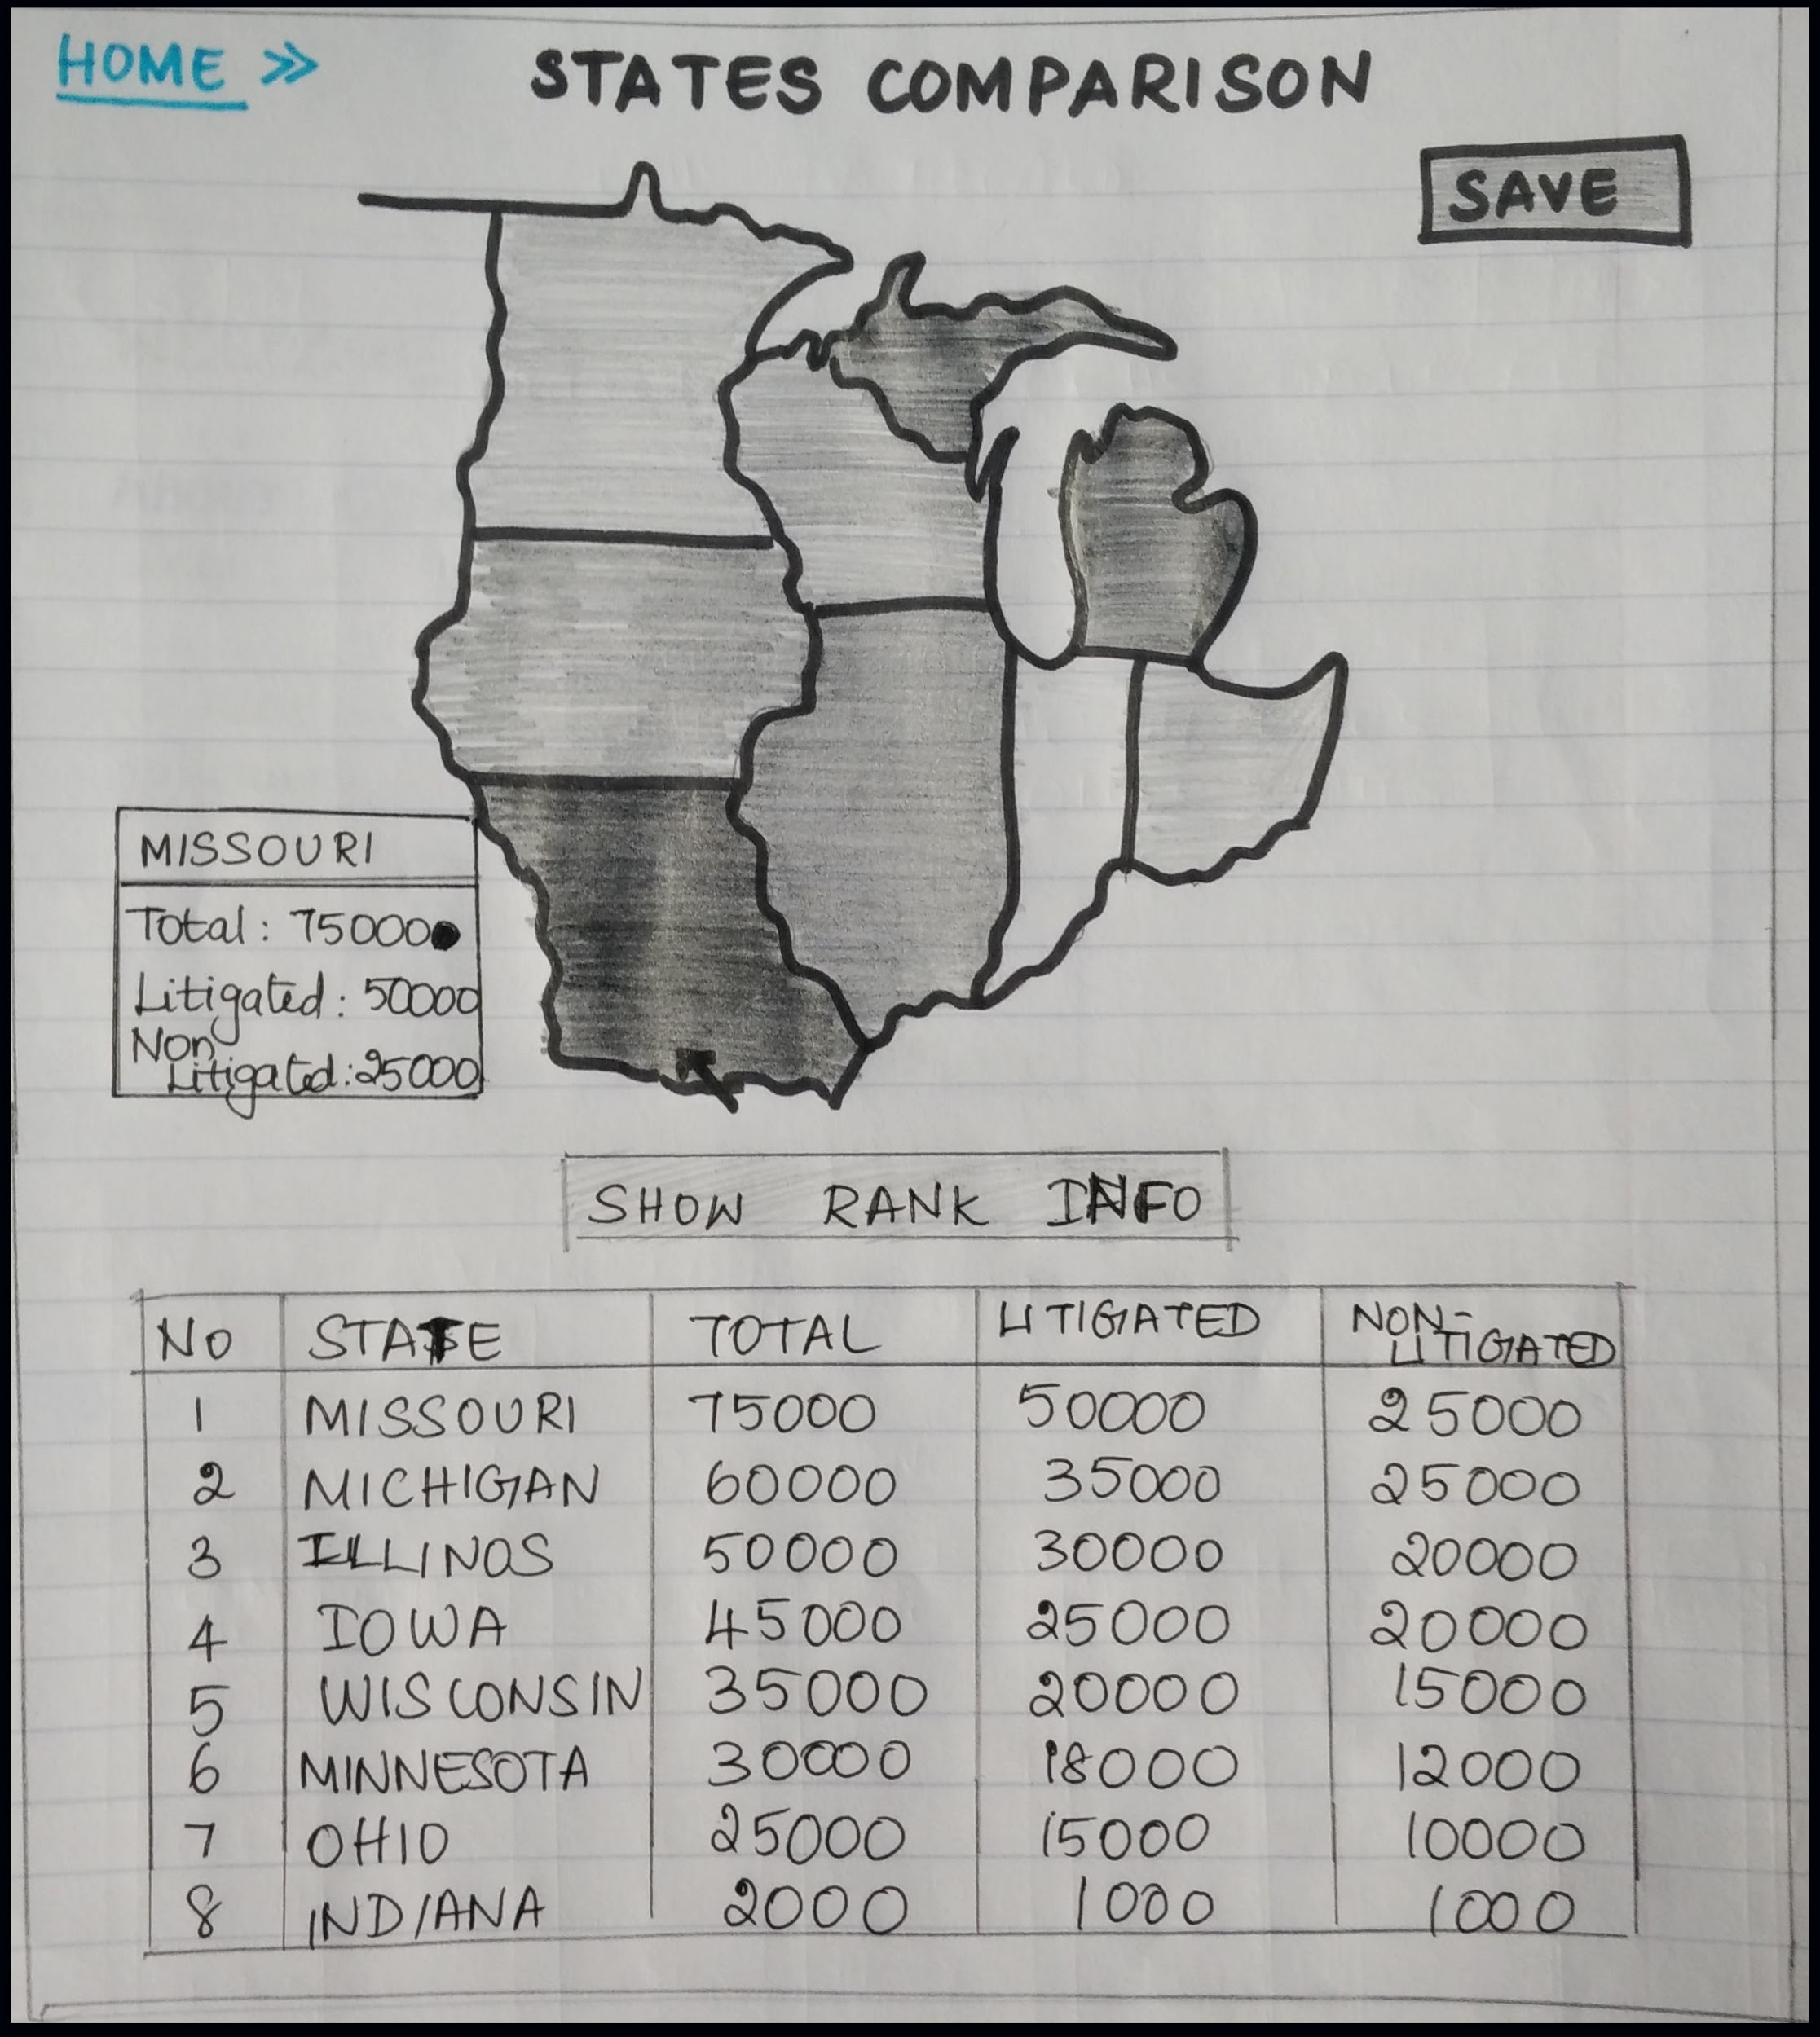

### Compare stats

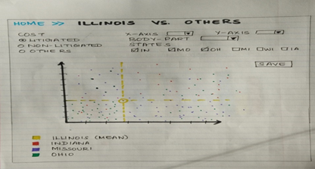

### Cost Differential

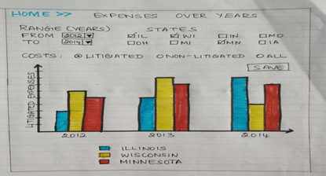

## Client’s Feedback

We met Ms. Renee DuBois on October 16th 2015 and submitted the above prototypes and she was happy with the prototypes. However, she came up with a few suggestions. They are as follows:

1. Dashboard navigation should be as a set of “Tabs” like prototype 1 and 2. This saves the clicks needed to navigate to other pages.
2. For the tabular view of the data a horizontal layout of search option should be incorporated.
3. Instead of text box option for filtering, radio buttons, checkboxes and drop bottoms should be implemented
4. Only mid-west states should be projected instead of the whole US map.
5. The client likes the idea of displaying the map data as a table additionally since it will help the people using screen readers.
6. For comparing the Illinois with other states, a scatter plot graph is preferred to a histogram.
7. The search box layout should be horizontal for the Cost differential graph.
8. For the cost differential graph, there should be filters for the states in the form of checkboxes and those checkboxes should appear below the graph.
9. The option to save the graph should be visible anywhere on top of the page.