Data Analysis for Kayla Nelson’s Doctoral Dissertation

Kayla Nelson

30 April, 2019

Table of Contents

# Data Import and Wrangling

# Overall Descriptive Statistics

|  |  |  |  |  |  |  |  |  |  |
| --- | --- | --- | --- | --- | --- | --- | --- | --- | --- |
| group_type | surface | pre_mean | post_mean | pre_sd | pos_sd | pre_min | pre_max | post_min | post_max |
| Substance Use | surf_1 | -153.394737 | 28.94118 | 759.0863 | 788.8952 | -1680 | 918 | -1074 | 1455 |
| Substance Use | surf_2 | -115.184211 | 372.35294 | 436.4271 | 512.5501 | -861 | 558 | -390 | 1176 |
| Substance Use | surf_3 | 687.947368 | 936.75000 | 688.1497 | 781.9741 | -906 | 1680 | -660 | 1680 |
| Substance Use | surf_4 | 299.526316 | 263.25000 | 513.9983 | 555.9494 | -693 | 1119 | -984 | 1005 |
| Substance Use | surf_5 | 785.684210 | 948.30000 | 526.0541 | 672.9466 | -345 | 1635 | -189 | 1680 |
| Substance Use | surf_6 | 273.789474 | 278.40000 | 606.4617 | 399.2944 | -1140 | 1365 | -414 | 984 |
| Substance Use | surf_7 | 891.600000 | 987.90000 | 707.8860 | 656.7928 | -1053 | 1680 | -222 | 1680 |
| Substance Use | surf_8 | 286.950000 | 367.35000 | 314.0810 | 367.8621 | -378 | 960 | -222 | 1005 |
| Substance Use | surf_9 | 701.250000 | 981.35294 | 579.4059 | 671.2512 | -288 | 1680 | -156 | 1680 |
| Substance Use | surf_10 | 224.400000 | 385.58824 | 562.4884 | 607.8639 | -708 | 984 | -657 | 1287 |
| Non-Substance | surf_1 | 3.272727 | -76.90909 | 841.3505 | 691.3816 | -1008 | 1344 | -1164 | 1008 |
| Non-Substance | surf_2 | -36.000000 | 645.81818 | 387.5461 | 512.7071 | -828 | 570 | -414 | 1365 |
| Non-Substance | surf_3 | 970.800000 | 1010.00000 | 675.3743 | 753.1255 | -90 | 1680 | -651 | 1680 |
| Non-Substance | surf_4 | 247.200000 | 148.66667 | 333.9796 | 548.4733 | -258 | 780 | -780 | 1050 |
| Non-Substance | surf_5 | 973.800000 | 902.10000 | 443.3107 | 775.4483 | 177 | 1635 | -783 | 1680 |
| Non-Substance | surf_6 | 408.000000 | 230.10000 | 400.2449 | 503.7977 | -249 | 1005 | -471 | 825 |
| Non-Substance | surf_7 | 1286.700000 | 1109.70000 | 440.2010 | 514.8659 | 483 | 1680 | 336 | 1680 |
| Non-Substance | surf_8 | 477.600000 | 380.52000 | 350.2136 | 442.5900 | -45 | 1242 | -321 | 1185 |
| Non-Substance | surf_9 | 999.600000 | 893.70000 | 495.3136 | 512.2215 | 369 | 1680 | -180 | 1512 |
| Non-Substance | surf_10 | 164.700000 | 123.30000 | 524.4987 | 600.6221 | -840 | 906 | -1230 | 975 |

Key: surf_1 = INTAFF; surf_2 = INTAUT; surf_3 = SOSTAFF; surf_4 = SOSTAUT; surf_5 = SOSIAFF; surf_6 = SOSIAUT; surf_7 = SSOTAFF; surf_8 = SSOTAUT; surf_9 = SSOIAFF; surf_10 = SSOIAUT.

# Hypothesis 1

H1: Participants seeking treatment for substance abuse will report greater hoped-for affiliation in a reported significant-other relationship following use of their substance of choice compared to participants not seeking treatment for substance abuse.

1. Boxplot for Affiliation Scores by Group at Pre- and Post-Substance Use.
2. Independent T-tests for H1.
3. Assumptions for H1.

## 1. Boxplot for H1

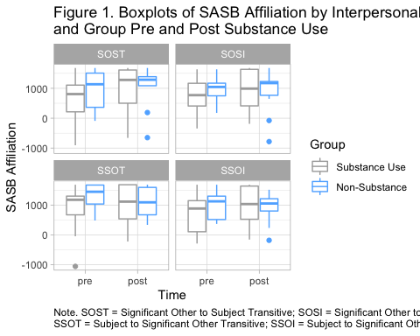

## 2. Independent T-Tests for H1

|  |  |  |  |  |  |  |
| --- | --- | --- | --- | --- | --- | --- |
| surface | statistic | p.value | parameter | conf.low | conf.high | sasb_surface |
| surf_3 | -0.4555534 | 0.6537473 | 19.48384 | -0.9877866 | 0.6341692 | SOST |
| surf_5 | -1.0090096 | 0.3243163 | 21.26083 | -1.1762301 | 0.4073281 | SOSI |
| surf_7 | -0.3787930 | 0.7080509 | 24.91082 | -0.8839190 | 0.6093288 | SSOT |
| surf_9 | -1.1279619 | 0.2702553 | 24.51376 | -1.1823513 | 0.3460971 | SSOI |

## 3. Assumptions for H1

1. Shapiro Test for H1

##   
## Shapiro-Wilk normality test  
##   
## data: sasb_residuals$surf_3  
## W = 0.93993, p-value = 0.1101

##   
## Shapiro-Wilk normality test  
##   
## data: sasb_residuals$surf_5  
## W = 0.9884, p-value = 0.9826

##   
## Shapiro-Wilk normality test  
##   
## data: sasb_residuals$surf_7  
## W = 0.96371, p-value = 0.3839

##   
## Shapiro-Wilk normality test  
##   
## data: sasb_residuals$surf_9  
## W = 0.97543, p-value = 0.748

1. Levene’s Test for H1

## Levene's Test for Homogeneity of Variance (center = median)  
## Df F value Pr(>F)  
## group 1 0.751 0.3941  
## 26

## Levene's Test for Homogeneity of Variance (center = median)  
## Df F value Pr(>F)  
## group 1 0.9303 0.3433  
## 27

## Levene's Test for Homogeneity of Variance (center = median)  
## Df F value Pr(>F)  
## group 1 1.0655 0.3108  
## 28

## Levene's Test for Homogeneity of Variance (center = median)  
## Df F value Pr(>F)  
## group 1 2.7369 0.1106  
## 25

# Hypothesis 2

H2: Adolescents who reported depressantsas their drug of choice will rate their significant others as more sulking and resentful prior to using compared to adolescents who do not report depressants as their drug of choice.

1. Boxplot for SASB Items "Sulk and Scurry by Drug of Choice.
2. Independent T-Test for H2.
3. Means and Standard Deviations for H2.
4. Assumptions for H2.

## 1. Boxplot for H2

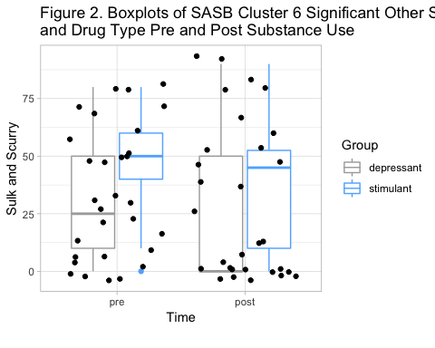

## 2. Independent T-test for H2

##   
## Wilcoxon rank sum test with continuity correction  
##   
## data: h2_data_na$sosicl6p by h2_data_na$doc_fa  
## W = 64, p-value = 0.2657  
## alternative hypothesis: true location shift is not equal to 0

## 3. Means and SD for H2

## # A tibble: 2 x 3  
## doc_fa mean sd  
## <fct> <dbl> <dbl>  
## 1 depressant 30.9 28.1  
## 2 stimulant 45 26.7

## 4. Assumptions for h2

1. Shapiro for H2

##   
## Shapiro-Wilk normality test  
##   
## data: h2_data_na$sosicl6p  
## W = 0.90032, p-value = 0.008551

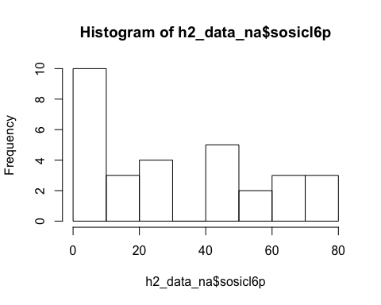

1. Levene’s Test for H2

## Levene's Test for Homogeneity of Variance (center = median)  
## Df F value Pr(>F)  
## group 1 0.5138 0.4794  
## 28

# Hypothesis 3

H3: Participants seeking treatment for substance abuse will report greater hoped-for introject (self-concept) affiliation following use of their substance of choice compared to participants not seeking treatment for substance abuse.

Analyses are almost identical to H1 but with the introject affiliation surface, surface 1. The analyses include the following:

1. Boxplot for introject affiliation differences between treatment groups pre- and post-substance use.
2. Independent t-test examining difference in residual change in introject affiliation between treatment groups.
3. Assumptions for H3.

## 1. Boxplot for H3

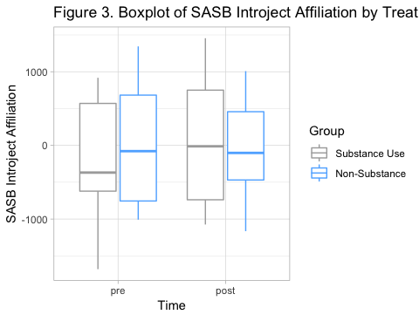

## 2. Independent T-Test for H3

|  |  |  |  |  |  |  |
| --- | --- | --- | --- | --- | --- | --- |
| surface | statistic | p.value | parameter | conf.low | conf.high | sasb_surface |
| surf_1 | -0.6595468 | 0.5160968 | 22.9937 | -1.080495 | 0.558079 | int-aff |

## 3. Assumptions for H3

1. Shapiro for H3

##   
## Shapiro-Wilk normality test  
##   
## data: sasb_residuals$surf_1  
## W = 0.97365, p-value = 0.7

1. Levene’s Test for H3

## Levene's Test for Homogeneity of Variance (center = median)  
## Df F value Pr(>F)  
## group 1 0.2939 0.5925  
## 25

# Hypothesis 4

H4: Participants seeking treatment for substance abuse will report less negative affect following use of their substance of choice compared to participants not seeking treatment for substance abuse.

1. Summary Statistics for H4 and H5 including PANAS Positive and Negative Affect Prior and Post-Substance Use
2. Boxplot for Change in PANAS Negative Affect by Treatment Group
3. Independent t-test for Residual Change in PANAS Negative Affect by Treatment group
4. Three Supplmental Paired t-tests for difference in PANAS Negative Affect
5. Overall Change in PANAS Negative Affect
6. Change in PANAS Negative Affect for Substance-Use Group Only
7. Change in PANAS Negative Affect for Non-Substance-Use Group Only
8. Assumptions for H4

## 1. Summary PANAS Statistics for H4 and H5

1. Mean and Standard Deviations by Group for PANAS Pre and Post

|  |  |  |  |  |  |  |  |  |
| --- | --- | --- | --- | --- | --- | --- | --- | --- |
| group | pos_pre_mean | pos_post_mean | neg_pre_mean | neg_post_mean | pos_pre_sd | pos_pos_sd | neg_pre_sd | neg_post_sd |
| C | 27.36364 | 29.0 | 26.0 | 25.54545 | 11.560906 | 7.389181 | 10.12917 | 8.153081 |
| E | 26.30000 | 29.6 | 29.5 | 23.15000 | 8.541539 | 9.708379 | 10.15926 | 10.204617 |

1. Minimum and Maxiumum by Group for PANAS Pre and Post

|  |  |  |  |  |  |  |  |  |
| --- | --- | --- | --- | --- | --- | --- | --- | --- |
| group | pos_pre_min | pos_pos_min | neg_pre_min | neg_post_min | pos_pre_max | pos_pos_max | neg_pre_max | neg_post_max |
| C | 13 | 11 | 12 | 16 | 49 | 38 | 41 | 42 |
| E | 11 | 10 | 12 | 10 | 39 | 50 | 49 | 40 |

## 2. Boxplot for H4

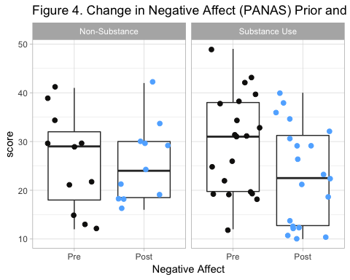

## 3. Independent T-Test for H4

##   
## Welch Two Sample t-test  
##   
## data: panas_processed$panas2_res by panas_processed$group  
## t = 0.79305, df = 24.643, p-value = 0.4353  
## alternative hypothesis: true difference in means is not equal to 0  
## 95 percent confidence interval:  
## -0.4570023 1.0286518  
## sample estimates:  
## mean in group C mean in group E   
## 0.1856569 -0.1001679

## 4. Supplemental Paired T-tests for H4

1. Overall Difference in Negative Affect between Substance Use and Non-Substance Use Participants

##   
## Paired t-test  
##   
## data: panas_data$panas2_2 and panas_data$panas2_1  
## t = -1.7727, df = 30, p-value = 0.08644  
## alternative hypothesis: true difference in means is not equal to 0  
## 95 percent confidence interval:  
## -9.1636961 0.6475671  
## sample estimates:  
## mean of the differences   
## -4.258065

The difference in negative affect change following substance use was non-significant between substance and non-substance use participants (t(30)=-1.77, p=0.09)

1. Paired t-test for change in negative affect using Substance Use Group Only

##   
## Paired t-test  
##   
## data: su$panas2_2 and su$panas2_1  
## t = -2.1612, df = 19, p-value = 0.04366  
## alternative hypothesis: true difference in means is not equal to 0  
## 95 percent confidence interval:  
## -12.4997258 -0.2002742  
## sample estimates:  
## mean of the differences   
## -6.35

Substance use participants showed a significant decrease in negative following substance use (t(19)=-2.16, p=0.04)

1. Paired t-test for change in negative affect using Non-Substance Use Group Only

##   
## Paired t-test  
##   
## data: nsu$panas2_2 and nsu$panas2_1  
## t = -0.11118, df = 10, p-value = 0.9137  
## alternative hypothesis: true difference in means is not equal to 0  
## 95 percent confidence interval:  
## -9.564256 8.655165  
## sample estimates:  
## mean of the differences   
## -0.4545455

Non-substance use participants did not show a significant decrease in negative following substance use (t(10)=-0.11, p=0.91)

## 5. Assumptions for H4

1. Shapiro for H4

##   
## Shapiro-Wilk normality test  
##   
## data: panas_processed$panas2_res  
## W = 0.95646, p-value = 0.2345

1. Levene’s for H4

## Levene's Test for Homogeneity of Variance (center = median)  
## Df F value Pr(>F)  
## group 1 1.2984 0.2638  
## 29

# Hypothesis 5

Hypothesis 5: Participants not seeking treatment for substance abuse will report greater positive affect following substance use compared to participants seeking treatment for substance abuse.

1. Boxplot for Change in Positive Affect by Treatment Group
2. Independent t-test for Residual Change in PANAS Positive Affect by Treatment group
3. Three Supplmental Paired t-tests for difference in PANAS Positive Affect
4. Overall Change in PANAS Positive Affect
5. Change in PANAS Positive Affect for Substance-Use Group Only
6. Change in PANAS Positive Affect for Non-Substance-Use Group Only
7. Assumptions for H5

## 1. Boxplot for H5

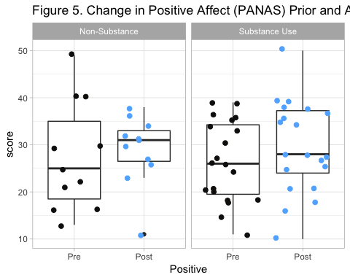

## 2. Independent T-Test for H5

##   
## Welch Two Sample t-test  
##   
## data: panas_processed$panas1_res by panas_processed$group  
## t = -0.10376, df = 27.151, p-value = 0.9181  
## alternative hypothesis: true difference in means is not equal to 0  
## 95 percent confidence interval:  
## -0.7499027 0.6776923  
## sample estimates:  
## mean in group C mean in group E   
## -0.02524439 0.01086080

## 3. Supplemental Paired T-tests for H5

1. Overall Difference in Positive Affect between Substance Use and Non-Substance Use Participants

##   
## Paired t-test  
##   
## data: panas_data$panas1_2 and panas_data$panas1_1  
## t = 1.0162, df = 30, p-value = 0.3177  
## alternative hypothesis: true difference in means is not equal to 0  
## 95 percent confidence interval:  
## -2.735993 8.155348  
## sample estimates:  
## mean of the differences   
## 2.709677

The difference in negative affect change following substance use was non-significant between substance and non-substance use participants (t(30)=-1.02, p=0.32)

1. Paired t-test for change in positive affect using Substance Use Group Only

##   
## Paired t-test  
##   
## data: su$panas1_2 and su$panas1_1  
## t = 1.033, df = 19, p-value = 0.3146  
## alternative hypothesis: true difference in means is not equal to 0  
## 95 percent confidence interval:  
## -3.38648 9.98648  
## sample estimates:  
## mean of the differences   
## 3.3

Substance use participants showed a non-significant change in positive following substance use (t(19)=1.03, p=0.32)

1. Paired t-test for change in positive affect using Non-Substance Use Group Only

##   
## Paired t-test  
##   
## data: nsu$panas1_2 and nsu$panas1_1  
## t = 0.3294, df = 10, p-value = 0.7486  
## alternative hypothesis: true difference in means is not equal to 0  
## 95 percent confidence interval:  
## -9.432282 12.705009  
## sample estimates:  
## mean of the differences   
## 1.636364

Non-substance use participants showed a non-significant change in positive affect following substance use (t(10)=-0.33, p=0.75)

## 4. Assumptions for H5

##   
## Shapiro-Wilk normality test  
##   
## data: panas_processed$panas1_res  
## W = 0.97243, p-value = 0.5881

## Levene's Test for Homogeneity of Variance (center = median)  
## Df F value Pr(>F)  
## group 1 2.3081 0.1395  
## 29

# Hypothesis 6

Three exploratory analyses examined change in relationship and emotions following substance use as they are associated with parental monitoring, peer acceptance, and diagnostic group. Due to no variability in diagnostic group, questions regarding diagnostic group were dropped. Three questions examined were as follows:

1. H6-1: Higher levels of parental monitoring would be associated with a decrease in negative affect following substance use.
2. Scatterplot of Parental Monitoring and Change in PANAS (Negative and Positive Affect) regardless of treatment group
3. H6-1 Pearson Correlation Coefficients
4. H6-1 Assumptions
5. H6-2: Higher levels of peer acceptance would be associated with an increase in positive affect substance use.
6. Scatterplot of Peer Support and Change in PANAS (Negative and Positive Affect) regardless of treatment group
7. H6-2 Pearson Correlation Coefficients
8. H6-2 Assumptions
9. H6-3: Higher levels of peer acceptance would be associated with an increase in perceived affiliation in the actions of a significant other towards the participant following substance use.
10. H6-3 Scatterplot of Peer Support and change in perception of Significant Other acting towards Participant with Affiliation following substance use
11. H6-3 Pearson Correlation Coefficient

## 1. H6-1

1. H6-1 Scatterplot

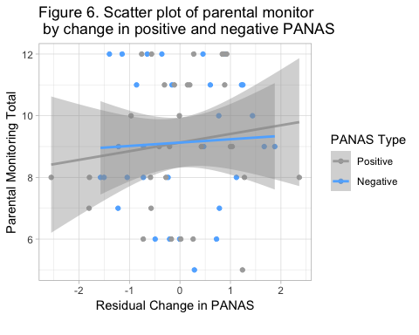

1. H6-1 Pearson Correlation Coefficients

##   
## Pearson's product-moment correlation  
##   
## data: h6_data$panas2_res and h6_data$pmtot  
## t = 0.27347, df = 29, p-value = 0.7864  
## alternative hypothesis: true correlation is not equal to 0  
## 95 percent confidence interval:  
## -0.3091804 0.3979054  
## sample estimates:  
## cor   
## 0.05071587

##   
## Pearson's product-moment correlation  
##   
## data: h6_data$panas1_res and h6_data$pmtot  
## t = 0.70961, df = 29, p-value = 0.4836  
## alternative hypothesis: true correlation is not equal to 0  
## 95 percent confidence interval:  
## -0.2345565 0.4635245  
## sample estimates:  
## cor   
## 0.1306416

1. H6-1 Assumptions

##   
## Shapiro-Wilk normality test  
##   
## data: h6_data$pmtot  
## W = 0.92138, p-value = 0.02569

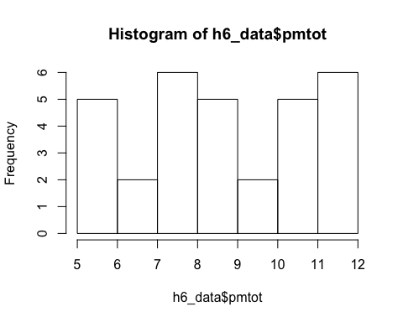

## H6-2

1. H6-2 Scatterplot 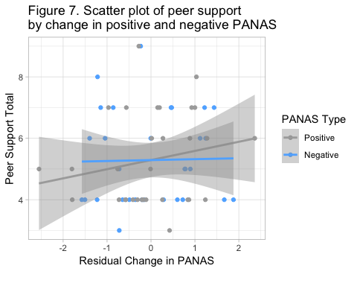
2. H6-2 Pearson Correlation Coefficients

##   
## Pearson's product-moment correlation  
##   
## data: h6_data$panas2_res and h6_data$psmtot  
## t = 0.10843, df = 29, p-value = 0.9144  
## alternative hypothesis: true correlation is not equal to 0  
## 95 percent confidence interval:  
## -0.3366097 0.3718194  
## sample estimates:  
## cor   
## 0.02013164

##   
## Pearson's product-moment correlation  
##   
## data: h6_data$panas1_res and h6_data$psmtot  
## t = 1.0968, df = 29, p-value = 0.2818  
## alternative hypothesis: true correlation is not equal to 0  
## 95 percent confidence interval:  
## -0.1665491 0.5173259  
## sample estimates:  
## cor   
## 0.1995686

1. H6-2 Assumptions

##   
## Shapiro-Wilk normality test  
##   
## data: h6_data$psmtot  
## W = 0.87207, p-value = 0.001553

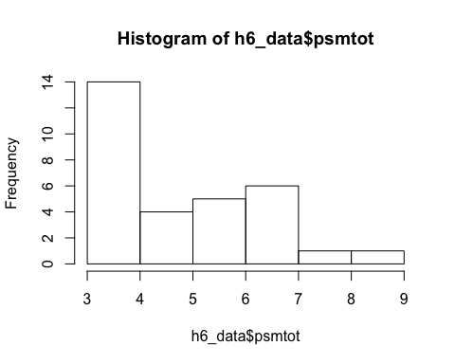

## H6-3

1. H6-3 Scatterplot 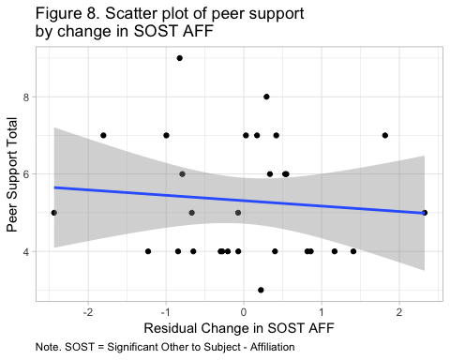
2. H6-3 Pearson Correlation Coefficient

##   
## Pearson's product-moment correlation  
##   
## data: h63_data$surf_5 and h63_data$psmtot  
## t = -0.48507, df = 27, p-value = 0.6315  
## alternative hypothesis: true correlation is not equal to 0  
## 95 percent confidence interval:  
## -0.4443166 0.2832065  
## sample estimates:  
## cor   
## -0.09294678