Wall of Honor Project
Statement of Work
Estimate and bid prepared by Jonathan Bernard for the
United Pentecostal Church International.

Table of Contents
Methodology 2
Requirements Gathering 2
Project Management 2
Scope Of Work 3
User Interface and Design 3
Core Infrastructure 3
Implementation 4
Executive Leadership Display 4
Order of the Faith Display 4
Deceased Ministers Display 4
Administrative Interface 5
Estimate 6
Project and Scope Assumptions 7
Delivery Schedule 7
Payment Schedule 7

Methodology

Requirements Gathering
Jonathan will communicate with project stakeholders to identify the key requirements for each of the displays. Once a consensus is reached on the desired functionality, Jonathan will create documentation detailing the functional requirements, solicit feedback from the UPCI, make necessary updates, and publish the final requirements.

Project Management
During the course of development, Jonathan will break the functional requirements into smaller tasks and features to be completed. These tasks and features will be tracked on a Trello board specific to the project and made available for review by UPCI stakeholders. In addition to real-time access to the Trello board documenting work in progress, Jonathan will provide a weekly summary of work completed, work in progress, and general status updates for the project. In addition, Jonathan and the UPCI may schedule ad-hoc meetings as needed to ensure project success.
As major pieces of functionality are completed (primarily the initial design and later implementation of individual displays), Jonathan may provide short demonstrations of the completed functionality, depending on the UPCI’s schedule and preference. Throughout the project, live versions of the work in progress will be available for review by the UPCI project team. For all deliverables produced, Jonathan will solicit the UPCI stakeholders’ review with a feedback and approval process to ensure the highest possible quality.

Scope Of Work
The scope for this project is to build a web-based application with three pages suitable for use as the primary displays in the upcoming Wall of Honor being built in the UPCI headquarters. These displays will provide access for visitors to view the ministers and administrators who make up the Executive Leadership of the UPCI, the ministers who have been inducted into the Order of the Faith throughout the UPCI’s history, and the list of deceased UPCI ministers. Each of these displays will be interactive, allowing visitors or users to view different groups of ministers depending on the display, as well as see more information about inidividual ministers.
In the remainder of this section we outline the detailed scope of work as we currently understand it, based on conversations between Jonathan and UPCI stakeholders to date.

User Interface and Design
At present there are no designs or mockups related to any of the displays required for this project. There does exist a current site showing the Order of the Faith, but this is not suitable for use in the new Wall of Honor display without significant redesign.
Drawing inspiration from the UPCI branding guidelines Jonathan will create design mockups for each page of the application, detailing not only appearance but also the interactive functionality of each display.

Core Infrastructure
All custom application development requires some amount of technical infrastrucure in order to have a strong foundation. For each project Jonathan ensures the right building blocks are in place to deliver a successful and maintanable application. To meet this goal we will:
- Create a source code repository for storing the Wall of Honor website source code.
- Design a simple architecture for interactive display based on dynamc data.
- Design, setup, and configure the cloud hosting environment necessary to serve the application.
- Setup a continuous integration and delivery environment.
- Perform data migration of existing minister data relevant to each display.

Implementation

Executive Leadership Display
The executive leadership display provides a visitor with a view of the executive leadership of the UPCI (see https://www.upci.org/about/leadership). This will include:
- an overview of names and photographs of ministers who make up the executive leadership of the UPCI,
- a view of the ministers who make up the general board, and
- a view of ministers who comprise the executive board.
Finally, this display wil allow users to select individual ministers and view a larger version of their photograph as well as a biography of the minister.

Order of the Faith Display
The Order of the Faith display will provide a view of all ministers inducted into the Order of the Faith. It will allow visitors to:
- view each year of inductees,
- search for specific inductees by name, and
- select individual inductees to view a larger version of their photograph and their biography.

Deceased Ministers Display
The Deceased Ministers display will provide a view of all ministers affiliated with the UPCI who have preceeded us in death. Similar to the Order of the Faith display, it will allow visitors to:
- view ministers according to the year in which they passed,
- search for specific ministers by name, and
- select individual ministers to view a larger version of their photograph and their biography.

Administrative Interface
The application will provide a simple interface to all UPCI staff to update the information presented on each display:
- update the members of the executive leadership team, general board, and executive board,
- add new ministers to the list of inductees in the Order of the Faith, and
- add information regarding ministers who have passed.
For all ministers this interface will allow UPCI staff to add, remove, or change the photograph, and to add, remove, or alter the biographical entries.

Estimate

Project and Scope Assumptions
The statement of work and estimate presented above are based on a best-effort understanding of the project requirements. If the following assumptions are incorrect it may impact the overall cost of the project, the time it will take to complete, or both.
- The Wall of Honor will not integrate directly with existing UPCI systems. Specifically, the database of ministers will be managed entirely within the WOH system via the provided administrative interface without automated integration into the larger UPCI database of ministers.
- The provided solution will be a web-based application that runs in a modern, standards-compliant web browser.
- Hardware procurement, setup, and configuration is out of scope for this effort.
- User input will be handled via the operating system’s native functionality (for example the default on-screen keyboard provided with Windows 10).

Delivery Schedule
Delivery and payment will be structured with two milestones as follows:
Milestone | Delivery | Responsible Party | Date
1 | Initial designs & mockups | Jonathan Bernard | March 1st
1 | Design approval | UPCI | March 15th
1 | First display (TBD) | Jonathan Bernard | April 15th
1 | First display feedback due | UPCI | May 1st
2 | Second display (TBD) | Jonathan Bernard | May 15th
2 | Second display feedback due | UPCI | June 1st
2 | Final delivery (all displays) | Jonathan Bernard | July 1st
2 | All feedback due | UPCI | July 15th
2 | Go-live deadline | Both | August 1st

Payment Schedule
Invoice | Due Date | Amount
Milestone 1 | May 1st | $3,000.00
Milestone 2 | August 15th | $3,490.00

Next Steps
If I can answer any questions, clarify any issues, or provide assistance of any kind, please to not hesitate to contact me directly:

Jonathan Bernard
Phone: 512-777-1602
Email: jdb@jdb-labs.com

Agreement
This statement of work represents an agreement between Jonathan Bernard and the United Pentecostal Church International.
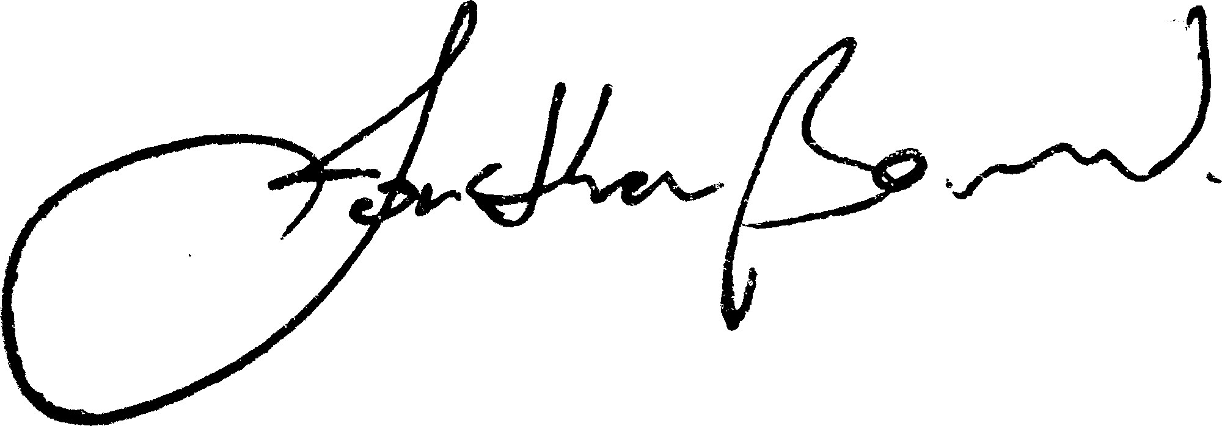
Jonathan Bernard

February 14, 2020

name of UPCI representative, printed

name of UPCI representative, signature

date

