"We'll call you"
David, David, Evan, Guy
ICS 664, Spring 2010

I. Project Goals

With every year, the internet becomes more pervasive in our daily lives. First limited to desktop computers, it now is found on the smallest and most prevalent of devices, including cell phones. With the internet came access to quick and convenient information. Wikipedia, Facebook, Twitter, and many more provide users with the ability to obtain knowledge of everything from ancient Greek mythology to what your friend ate for dinner last night. Despite all of these wondrous advancements, when it comes to sharing contact information, the current available means fall short. For instance, let us consider a situation where a group of friends, Bob, Sally, and John, want to share contact information. This group could use a social networking site such as Facebook to exchange information. However, what if Bob doesn't belong to Facebook? Moreover, what if he moves frequently due to his occupation? Bob could email Sally and John his updated information whenever he changes it, but this would be bothersome to everyone involved. Not only will Bob be forced to constantly write letters, but Sally and John will be forced to read those letters and update their address books. Let us now consider this situation expanded to a larger group of people numbering in the hundreds. Suddenly a minor inconvenience becomes a significant time sink. Therefore, a system is needed that utilizes the ubiquity of the Internet and shares contact information in a convenient and streamline fashion. Enter "We'll Call You".

We'll Call You is an internet based repository of contact information. Users can disseminate as much or as little of their contact information to subscribers/friends via web based technologies. For example, if Bob meets a professional contact, Bob may wish to share his name, phone number and email, yet not his home address. The advantage We'll Call You has over other social networking technologies is the ability to automatically broadcast contact information changes to whomever the user wants without having to write emails or inform the interested parties. If Bob changes his address, everyone on Bob's contact list whom he declares appropriate will be informed of these changes via an email update. Furthermore, if those contacts are also members of We'll Call You, then they will have Bob's updated contact information instantly, without ever manually entering the data. In addition to this advantage, We'll Call You also allows those who do not want to use it themselves to benefit from the system. Members can enter information of other people who are not part of the system on their behalf. This opens the technology to a broader audience, including the technologically challenged. One can imagine a situation where an elderly person cannot use the computer, but her grandson can. With We'll Call You, the grandson can serve as a representative for the elderly person, keeping her information current and alerting her of any changes to other's information.

I.1 Project Requirements
The following is a list of requirements for We'll Call You.

I.1.1 Data Entry Requirements
1) New data can be entered using a computer or smart phone.
2) Changes to data can be undone by those who have proper permission.
3) Users will not be able to enter data without registering.

I.1.2 Data Retrieval Requirements
1) Contact information can be retrieved on both smart phones and computers.
2) Contact information can be filtered and searched
3) All users, including non-registered users, may search the database, but will only acquire a list of identities by name and, for the sake of disambiguation, picture (if any) and state.
3) All other data can be retrieved only by registered users who have been granted access to that data by the user who is managing it.

I.1.3 Automated Features Requirements
1) The system will inform non-registered users when their email is entered into the database, so they may register and assert control over their contact information if they wish. This is accomplished via confirmation link contained within the email.
2) The system will update registered users of changes to contact information they have in their contact list.

I.1.4 Privacy Requirements
1) All data must be encrypted on the server.
2) The user's name, photo, and state are public and will be used to identify the user to other users searching the system.
3) Other than their name, photo, and state, the user can specify what information of theirs are viewable to the public and/or certain other users or groups of users.
4) Contact information of non-registered users is never public and therefore cannot be searched for. However, public entities such as businesses, schools, or other organizations may have public contact information.

I.2 Privacy Issues
Privacy is a concern with any system that enables sharing of personal information. With We'll Call You, this is particularly important, since individuals are capable of sharing information of those who are not registered to the system.

I.2.1 Privacy of Registered User Information
As a rule, We'll Call You only provides a picture, name, and state to anyone searching the system for information. Additional contact information can then be shared if the owner of the requested information approves of the person trying to view it. For example, if Bob is searching for Sally on the database, Bob will only see Sally's picture, name, and city on the search results. Bob must then send a request to Sally for more information. Sally can then decide what of her profile Bob sees, if any. Therefore, any registered user has full control over what information others can see, except for the picture, name, and state.

For identification purposes, the picture, name, and state are mandatory public information. Informal surveys show that many users are reluctant to make any information public when asked. However, the success of Facebook seems to indicate that picture, name, and some geographic information are acceptable forms of identification.

I.2.2 Privacy of non-Registered User Information
Non-registered users are those who have information on the system, but do not own an account to access or edit information. Since these users do not own an account themselves, a picture, name, and state are not mandatory information and therefore they cannot be searched for on the database. Instead, the individuals who entered their data become the data's custodians. The custodians have the privileges and responsibilities of disseminating the data to those whom they trust.

Although there is no perfect method to guarantee a non-registered user's information will enter the database without his/her knowledge, We'll Call You will automatically email the user if their email address is part of the entered data. This email will inform the user that their data has been entered, inform the user of who entered the data, and invite the user to the system. In this manner, it is hoped that not only will some privacy concerns be resolved, but also non-registered users will be encouraged to register and participate in the system.

II. Users and Stakeholders
Users for this product are anyone who has an interest in sharing contact information using cell phones, web browsers, and other internet capable technologies. However, there will be a focus primarily on students and their family and friends.

Stakeholders also include those with contact information being shared, but who do not use the system themselves. For instance, a user might have a grandmother who is not technologically savvy and therefore is unwilling to use the system. However, her grandchildren entered her information to share with their relatives.

II.1 User Personas

Name: High school student
Age: 12-18
Description:
1) Technically adept
2) Has many friends
3) Contact information changes rarely
4) Expects everything to be intuitive (doesn't read manuals)
Goals:
Wants to have friends address/phone numbers quickly accessible to organize group activities.

Name: Undergrad college student
Age: 17-22
Description:
1) Technically adept
2) Has many friends
3) Contact information changes often (dorm rooms may have different numbers)
4) Might be willing to deal with less intuitive systems if they're cool enough
Goals:
Wants to replace writing down new friends' phone numbers on napkins with something more organized and convenient.

Name: Graduate college student
Age: 22-any
Description:
1) Technically adept
2) May have professional contacts
3) Contact information may change often (part time jobs)
4) Most willing to deal with less intuitive systems if it allows for control
Goals:
Wants to keep potential employer contacts available at all times.

Name: Technically inclined professional
Age: 20-50
Description:
1) Technically adept
2) Has many professional contacts
3) Contact information changes rarely (steady job)
Goals:
Wants to keep contact of coworkers, family, and friends on hand, but does not want to have the same settings for these groups. For instance, he/she does not want to mix the family and coworker groups when not applicable.

Name: Technically challenged professional
Age: 40-60
Description:
1) Not technically adept
2) Has many professional contacts
3) Contact information changes extremely rarely
4) May not use the computer often (word processing only)
5) Isn't concerned with coolness
6) Needs intuitive systems
Goals:
Has many groups of colleagues, friends, family that he/she must maintain contact with. Additionally, these groups have very specific needs and therefore cannot be mixed.

Name: Elderly person (retired)
Age: 60-80
Description:
1) Not technically adept
2) Not many contacts outside of family
3) May not use a cell phone or computer often
4) Cell phone might be a "dumb" cell phone (might be a way to transfer numbers to the cell phone chip for hardware transfer?)
5) May have one or more handicaps
Goals:
Wants the system to do everything for them with as little interaction as possible.

Name: David
Age: 28
Description:
1) Enjoys technology
2) Bachelors in Information and Computer Sciences
3) Graduate Assistant
4) Professional Photographer
Goals:
Wants to keep new work contacts from knowing all of his contact information.
Name: Young Female Professional
Age: 23
Description:
1) Works half-time in a professional setting
2) Attends college for a bachelors in her field
3) Single
4) Large geographically diverse family
Goals:
Does not have the time to keep in touch with her large family and therefore wants the system to let the relatives handle their own contact information.
Name: Secret Agent Man
Age: 27
Description:
1) Average guy with a "Top Secret" government job
2) Because of his job, he's must keep his work and personal life very separated
3) Single
4) Constantly moving
Goals:
Wants to maintain his identity as a secret and therefore has strict concerns about privacy. Additionally, he wants the system to help him keep his personal and professional information separate so he does not accidentally divulge secrets to the wrong people.

II.2 User Scenarios

Goal Scenarios

High school student tries to use the system for the first time
John just got a new iPhone and want to use it to store his contacts. He doesn't own an organizer -- all of his contacts are already stored on his old cell phone. Thus, he wants to transfer his old numbers from his old phone to his new phone quickly. Once they are transferred to his iPhone's address book, he wants the system to automatically update the server with his contact information. John's sister has been using the system for a week already and therefore her information, including family contacts, is already on the server. John is unsure who's information is more up-to-date and thus expects the system to advise him on whether to update with his information or to have the server update his contacts.

Undergrad college student meets new friends at a party
Sally goes to a party and meets a few new friends. Two of the friends already have the system, but the last one does not. She wants to easily exchange information with all of them. She certainly doesn't want to share all of her contacts. Therefore, she wants a way to easily select whom she wants to share. She also wants to text message her contact info to her third friend who doesn't have the system.

Graduate student goes to an engineer fair and wants to exchange information with recruiters
Danny is attending an engineering fair and needs to distribute his information to scores of recruiters. He wants the system to automatically send a text message to every one of his professional contacts in a single simple action.

A business professional meets hundreds of potential clientele at a meeting
Joan has hundreds of potential clientele contacts, many of whom do not use their cell phones often. She wants to email her contact information to everyone easily.

Scenario for technically challenged professional is same as old woman scenario more or less.
An old woman wants updates from her grandchildren
Marge has grandchildren who are in college and often change their address (their room number changes). She wants to have her data updated for her without having to press any buttons. She expects the system to notify her when changes occur then automatically alter her addresses.

David exchanges information with a professional off-island
While on a business related trip on Maui, David encounters a new marathon and has a discussion with a newly appointed race director about his services as a freelance photographer. Rather than divulging all his personal contact information such as his Instant Messenger ID, home address, home phone, etc. he wishes to give this new business contact just the professional information.

Middle-aged guy wants to send Xmas cards to a list of relatives and friends
Every year, a few have changed their mailing address, their names (getting married or divorced), or their children (births or deaths). For most of them, this is the only time he mails them anything. He's gotten notices about some of these changes earlier in the year, but not all of them. If he remembers but can't find the notices, or the post office returns cards with bad addresses (for domestic mail), then he contacts them via other means (such as email or Facebook), or asks other relatives or friends, for the updated information. He wants a way for everyone involved to share this information automatically.

Young Female Professional moves to an apartment
Having decided the dorm life is no longer for her, she finds an off campus apartment. After the move, she updates her new address in our system. Within a few days, all of her close friends come over, some unannounced because they received notice of her recent move. At work, she receives a call from her firm's payroll department requesting her to confirm the change in address so that they may officially proceed with the change of address update. Unfortunately for our friend in this scenario, the State of Hawaii's not as with it; when she goes to change her address on her drivers license she can't recall what the new one is - luckily for her, its in the "We'll Call You" app on her iPhone.

Young Female Professional parties hard
Having been single for long enough, and with summer vacation in effect; our friend decides its time to start partying with her free time. With all this partying comes the ballooning of her contacts list. Unfortunately there are a lot of creeps and weirdos out there, but she has to decide how to filter and keep track of these people. Luckily this is a make believe scenario and we make the rules in this world...so everyone she meets is in the "We'll call you" system. Everyone who asks for her contact will get her name and some way to link to her in the WCY system. She always share's her non-professional email address. For those who do not seem stalker-ish, she'll give her phone number via the WCY system.

Young Female Professional organizes a reunion
"Its been 5 years already?" exclaims our character as she's left in charge with organizing the 5 year reunion of her class. Luckily for her, she was a social butterfly and has been in contact with most of the class; also she has the WCY system at her disposal. With ample time ahead, she uses the contact information on WCY to call up as many class members as she can to see if she can track down the rest of the class to get every ones mailing address to send out the invites. A few problems here that we might consider putting into the WCY system is a tagging feature so that she can know which of her contacts are from her HS, and also; the ability to search for her friends and add them would be nice as well.

Secret Agent Man meets Young Female Professional
It was love at first sight, but Secret Agent Man knows better than to lay all his cards on the table right away. So he starts out by giving her his phone and personal email via the WCY system. Also, coming off as not a creep, Young Female Professional does the same. As time goes on and they grow closer, he begins to share more personal information such as his home phone and address. His work phone and address, however, are still classified and remains that way through the obscurity our system provides.

Secret Agent Man gets deployed to Idaho
With terrorist activities threatening the nations supply of potatoes, our friend Secret Agent Man is tasked with going to Idaho for a month and assessing the threat level and reporting back. He is set up with a motel room for the duration of the stay. On the flight over, he updates his temporary secret address. When the plane lands and his phone reconnects, the information is updated in the WCY servers and pushed to all his Top Secret contacts, amazingly David (whom is often contracted by the government to do photo work) is assigned the same duty. When David receives the "change of address" notice from Secret Agent Man, he promptly calls him up to inform him that they'll be neighbors for the next month.

II.3 User/Task Matrix
Scale: 1-10
1 being not very important and 10 being necessary
 | transfer numbers between contacts | share information automatically | mass text messaging | automatic notification | sharing select information
Middle-aged guy | 8 | 7 | 1 | 4 | 8
High school student | 9 | 8 | 1 | 2 | 2
Undergrad college student | 8 | 8 | 8 | 3 | 3
Graduate college student | 5 | 9 | 8 | 5 | 8
Technically inclined professional | 9 | 9 | 5 | 5 | 10
Technically challenged professional | 5 | 10 | 1 | 6 | 5
Elderly person (retired) | 1 | 10 | 1 | 1 | 1
David | 6 | 8 | 9 | 9 | 9
Young Female Professional | 4 | 9 | 7 | 8 | 10
Secret Agent Man | 2 | 8 | 2 | 9 | 10

III Design Prototype
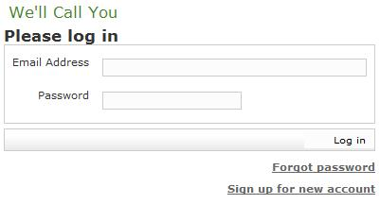
The first page a user typically encounters is the login page. This is an example of clear entry points. The user must either login with a registered email address and password or sign up for a new account. (The Log in button is lacking a push-button affordance only because the visual design of this prototype is not finished. The "We'll Call You" logo also has had no visual design yet.) The basic page layout follows the Right/Left Alignment and Diagonal Balance patterns.

New users normally receive an email notifying them of which user has shared what information about them with which other users, and inviting them to register with the system and take control of their own information. The email includes a link which validates the email address and takes the browser directly to a registration form, which follows the Good Defaults pattern by pre-filling the form fields with the contact information that the other user has already provided about the registering user. This prototype has not implemented this form or email, but it does support new users signing up from scratch, via the Sign up for new account link.

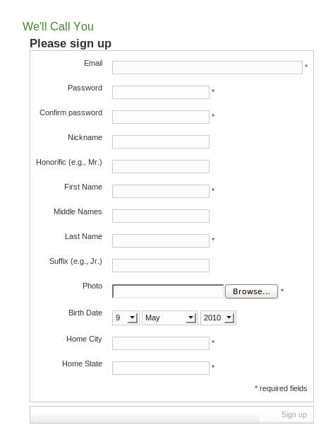
The system will validate the email address in the typical way, by sending an email containing a link that the user must click within some period. A photo is required for identification and disambiguation of users with the same name, although the system cannot tell whether the photo that the user uploads is actually of him- or herself. (The prototype does not even check whether the uploaded file contains a recognized image format.) For the Birth Date field, the system will have a Javascript date picker pop-up and one text field following the Forgiving Format pattern, instead of the three-part select inputs of this prototype.

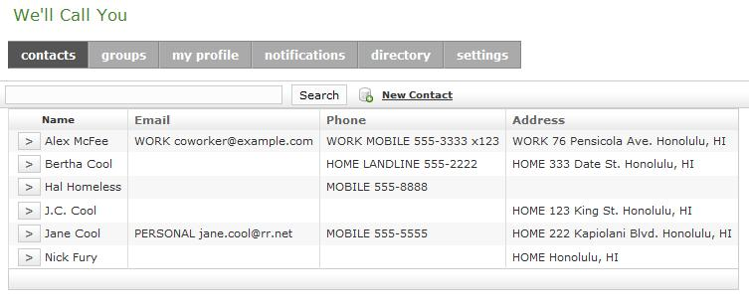
Once the user logs in, she will see the contacts page. The buttons across the top are lacking tab affordances just because the visual design of this prototype is not finished. These tabs follow the Global Navigation pattern, and there are no sub-pages, so no need to use the Breadcrumbs pattern.

The search field is an example of the Forgiving Format pattern. All data fields will be searched, regardless of what the user enters. In an age where Google searching is an everyday occurrence, a search function with forgiving format is not only convenient, but also expected.

Every contact on the list can be expanded to show more details, an example of Extras on Demand. This is also an example of a Tree Table, since all information of the contacts are arranged in a hierarchical format, with Row Striping. Search hits within a contact are automatically expanded for display, and highlighted in a distinct color (not implemented yet in this prototype).

This prototype follows the Sortable Table pattern, although it can sort on only the name on this tab so far. The other columns surface data from different depths within the contact, such as the most closely associated phone number. (This depends on what information the user may access, and the user will be able to indicate what she would prefer to see at the summary level, although that is not implemented in this prototype.) However, displaying different data makes it difficult to sort those columns in the database, where it is done to allow for paging of large result sets. The next version of this prototype may need to limit sorting to search result sets of a size that can be paged and sorted in memory instead of in the database. This is an example of how implementation issues can impact interface design.

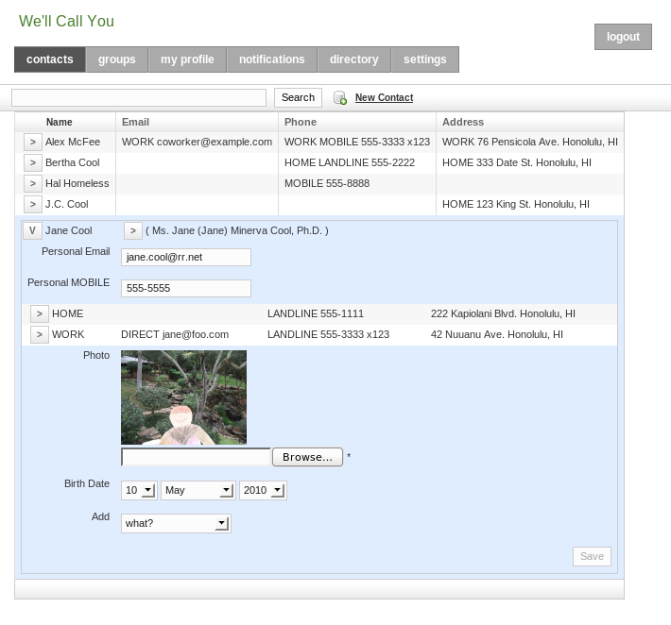
The design follows the Hairlines pattern for borders and rules, and uses preattentive coloring to highlight (in blue) the contact hovered over by the mouse, forming a closure grouping of that contact's information, delineating it from the adjacent details. Other contacts are displayed simultaneously to allow for comparison between search hits and to avoid unnecessary navigation.

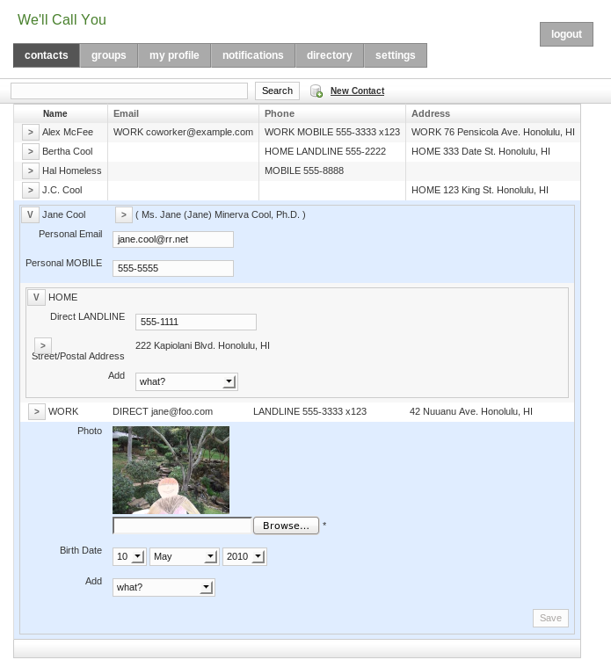

Much of the expanded area is blank because the prototype does not yet show expandable hooks to history and permissions for groupings or individual fields. In interviews, users have expressed a need to sometimes have fine-grained control over who can see what information, such as birth year, street address, or home phone number. However, this prototype has not implemented access permissions yet. Regarding history, see the description of the notifications tab below.

A typical web application has a read-only display of details, with an Edit button that navigates to a form with Save and Cancel buttons, which returns to the read-only details. This prototype is different because it's always in Edit mode, for the fields that the user is allowed to edit (which may vary field-by-field). The color of the expand button indicates whether it contains any editable fields (not implemented in this prototype). Editing has not been implemented on this contacts tab, but see the description of the my profile tab below for more details.

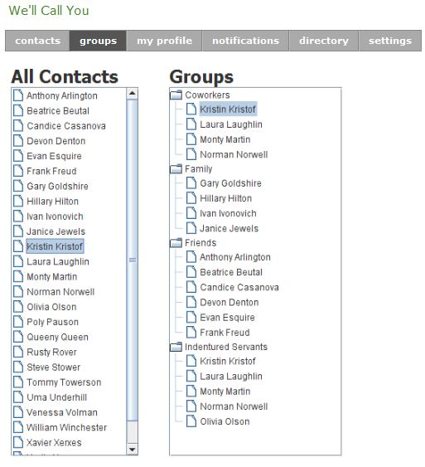
The groups tab allows users to set privileges toward selected groups of individuals. For instance, a user might want to only divulge his phone number to those in his coworker group. He would do this by dragging everyone he wanted to be in the coworker group from the list on the left to the coworker folder on the right. Setting specific privileges for the coworkers is done through a right click.

After demonstrating this feature to the class, it became apparent that the affordances for the drag and drop action need to be improved, as the icons for files and folders are not commonly associated with dragging and dropping. To remedy this, we could change the icons such that they have a shadow behind them, giving the impression that they are floating. This type of visual representation is employed subtly in many applications, including Windows Vista when viewed in icons mode. In addition to changing the icons, tooltips and a short instructional "how to" would both benefit the user. Since there is still much screen space to monopolize on the groups tab, such additions would not significantly affect the minimalist design we strove for.
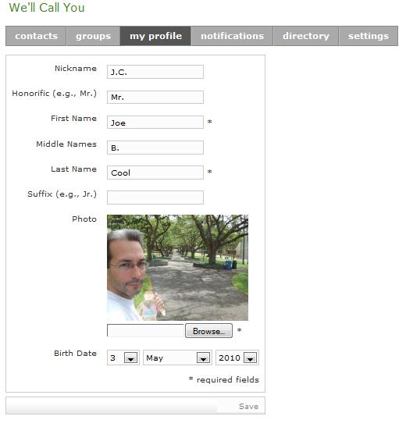
My profile contains all the contact information of the user. Since many of the fields are mandatory when the user registered to the system, we can employ the Good Defaults pattern by automatically filling in the fields we already know. This information is also available on the contacts tab, for comparison and copying, but gets its own tab to highlight its importance to the user. This prototype has not yet implemented the expanding Details on Demand for the associated home or other addresses and communication links. The expanding history or access control hooks are also not implemented yet. The name is split into 6 parts because only two parts are required, and this will allow for sorting by last name (not implemented yet).

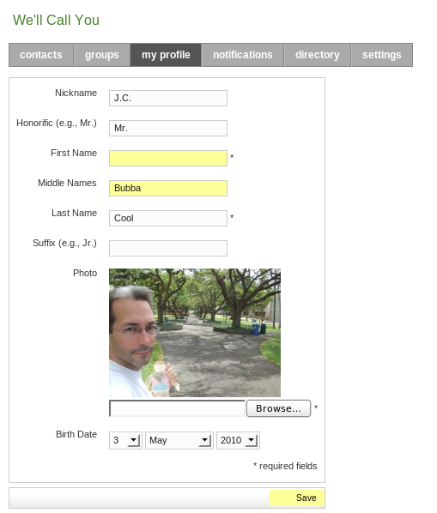

This tab of the prototype illustrates the always editing design, for fields that the user has access to edit. When the user changes the contents of a field, that field is highlighted and the Save button is enabled and highlighted, to provide visibility of the unsaved changes and remind the user that they need to be saved. If the field is changed back to its original contents, it is un-highlighted. If there are no more changed fields, the Save button is un-highlighted and disabled. There is no Reset or Cancel button, following Jakob Nielson's recommendation of allowing the user to accomplish that via navigation. Reset or Cancel buttons are sometimes accidentally pressed, when the user meant to press the Save button, resulting in a frustrating loss of input. Usability testing of this prototype is needed to see if users have difficulty canceling changes in this way, or on the other hand, if they do not expect to lose their unsaved input when changing tabs.

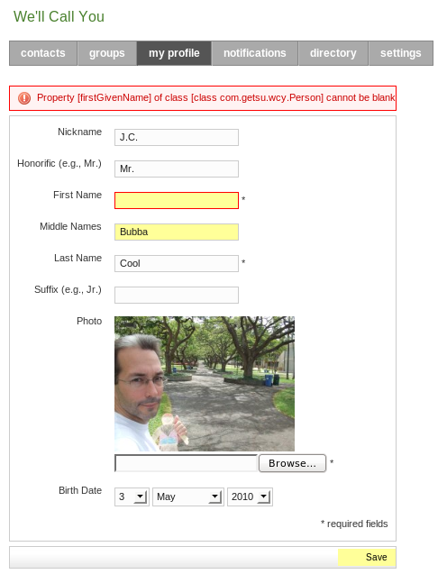

The unsaved change visibility is maintained across form submissions that fail because of input errors. The example above is a submit that is missing a required field. This prototype follows the Same-page Error Messages pattern, although the error message is the default for the implementing web application framework (Grails). The error message will be customized for a better match between the system and real world, suggesting what action the user can take to avoid the error. The following two examples have better error messages.

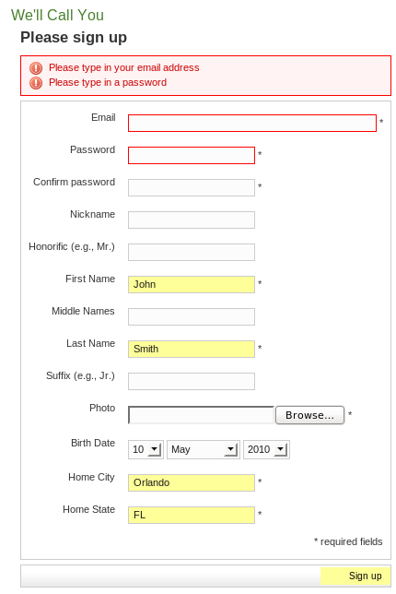

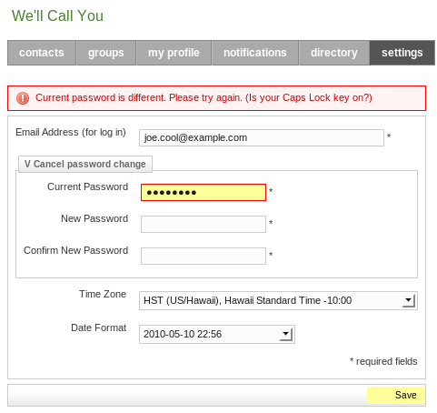

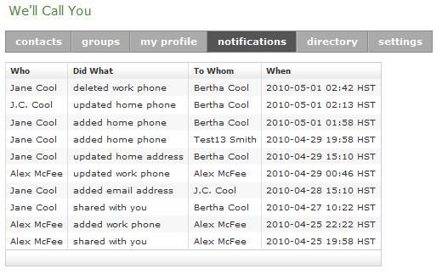
The system sends notifications to the user when changes are made to any data in the user's contact list. Though not shown here, changes made to contact information which the user can alter will have an undo button similar to that found in many wiki sites. This would allow the user to safeguard against malicious or accidental changes in the data.

Whenever contact information is changed, an email is sent out to inform all relevant users. It is conceivable that in a single day, multiple changes may occur to contact data of a single user. Though these changes will appear as multiple notifications on this tab, they will be collated into a single aggregate email at the end of a threshold period (such as a day) to avoid an annoying flurry of email and allow for undo to eliminate the need for any notification. This enables the Safe Exploration pattern, because the sending of an email cannot be undone.

To contrast this system with Facebook's notifications, Facebook strives for more interaction and immediacy, so it sends out emails without delay. But, such notification exposes comments that users later delete for the sake of correction or discretion. The information on We'll Call You does not change so rapidly, so the delay in notification is a good trade-off for safe exploration and less annoyance.

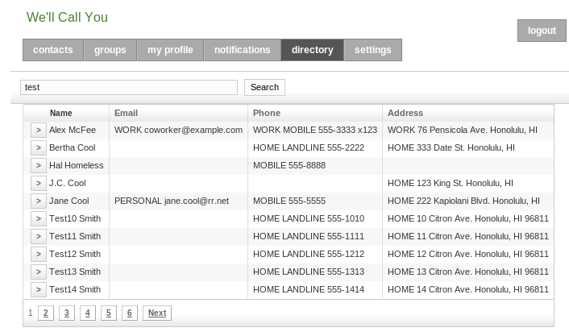
The directory tab contains publicly accessible identity or contact information, in addition to the user's contacts. This is typically businesses and organizations that publish their contact information in the phone book or on the web, as well as other users for whom the user may search and request access to their contact information (adding them to the contacts tab).

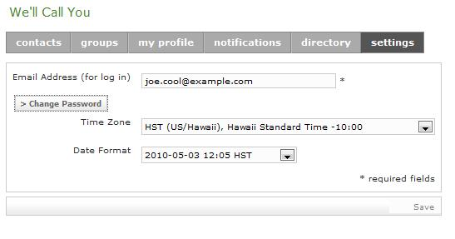
The Settings tab contains all settings pertaining to the application. Currently, the settings are the login email address, date format, time zone, and password, though future iterations may offer more options. Since changing the password requires authentication with the current password, it is different from other form fields, which default to the current value. So, the password fields are hidden until the user clicks the "Change password" button, at which point they're required unless the user clicks the "Cancel password change" toggle button.

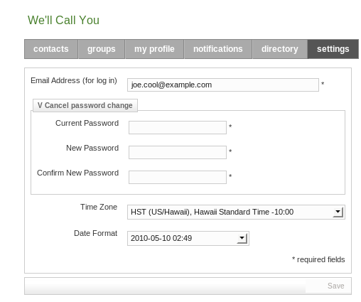

iPhone version:
Account Screen:
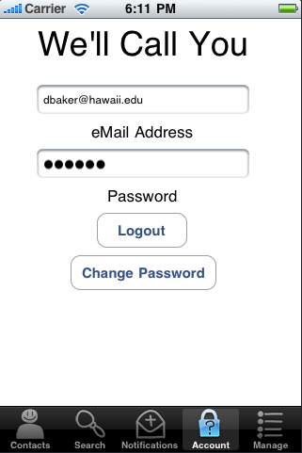
To the left is the login screen for the iPhone side of our product. From this screen, the user is allowed to log in and log out as well as change their password. After loging-in for the first time, the app will remember the login and password to make future use more convenient. Should the user hand the device to another user; they can log in with their account by hitting the "Logout" button, entering their own information, and hitting the same button again (it will change to "Login"). This tab is comparable to the settings tab found in the web-version of our product.

To edit, view, or otherwise interact with the information provided by our system, the user would use the navigation tabs lining the lower border of the screen. Contacts contains all the contacts this user has access to view. Search allows the user to search everyone within the system for people he/she may potentially know. Notifications provides the user with a synopsis of current changes made to and/or by people in his contact network (including himself). Manage is similar to the "contacts" tab but only pertains to the user accounts this user is allowed to modify/edit.

Contacts list:
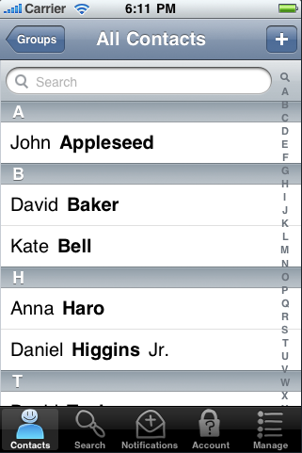
The image to the right is what a user would see upon loading the application after the user initially logs in. It is a list of his/her contacts. The user is allowed to "active search" their contacts list; they can also quickly jump to the starting letter of their contacts last name by scrubbing over the letters lining the right border of the screen. The "+" button in the upper right corner is used to add new contacts. In the case of this particular screen, it would go to the search tab.

This list screen is extremely similar to the "list" screens found also in the "Search" and "Manage" tabs; thusly they will not be presented. The functionality, usage, and capabilities of the other screens are exactly as that found in this list screen. The only difference would be of the contents of the list. The contents of the list found in the "Search" tab is all the users within the system. The contents of the list found in the "Manage" tab would be only the accounts the user is privy to modify (presumably a sub-set of users from his contact list). Of course, the search field is only applied to searchable information. For instance, typing in an unknown (but valid) phone number would not work well within the "Search" tab because the user is only allowed to search information they are privy too; which is name, and general location (state, country, as discussed earlier in the security section). However, searching for say the phone number of a confirmed friend in any of the "listing" tabs (Contacts, Search, Manage) will return the known friend because that data is viewed as "public" to the currently logged in user.

Groups list:
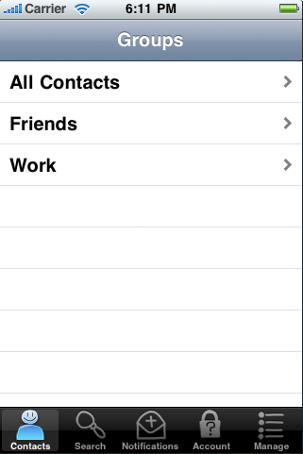
To the left is a sample screen capture of a list of groups a user might have. In this case, Friends and Work. The user can drill down into the different groups to filter out contacts they don't wish to view, or drill down "All Contacts" to see everyone they know. This screen is only found within the "Contacts" and "Manage" tabs.

Active Search:
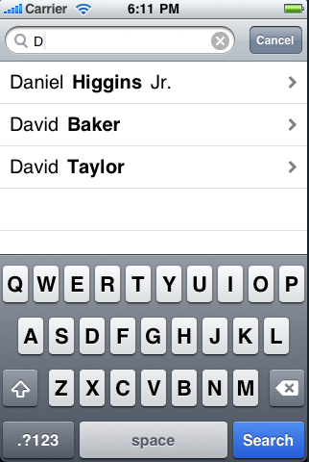
The screen shot to the right displays "Active Search" as well as the search field in use. When the user clicks in the search field within any of the "list view"s, the on-screen keyboard slides up and the user is allowed to start typing in their search information. In the example shown, only the letter "D" was typed and all the names containing a "D" is presented. Typing in "Dav" would shrink this presented list to the two "Davids". To submit the search and present all the found contacts full screen, the user would hit the highlighted "Search" button. Once the "Search" button is hit, the keyboard slides away to provide more screen real estate for the found contacts.

Known Contact - Detail:
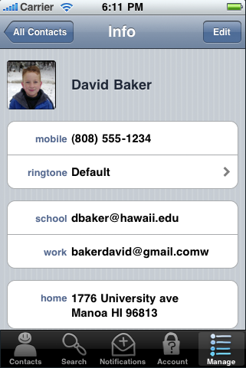
This presented screen shot shows what a user would see when they click on a name of a contact they know. The presented screen shot is from the manage tab which is why the user is able to "edit" this information. To edit this users information, the user would click the "Edit" button located in the upper right. To return back to the contacts (previous screen) the user would use the button in the upper left, "All Contacts" This screen is only presented in the "Contacts" and "Manage" tabs, because the "Search" tab would not have the "Edit" button.

Unknown Contact - Detail:
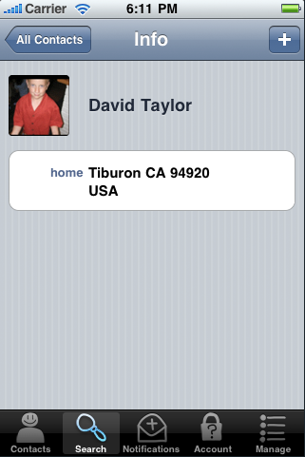
The screen presented to the right is the detail screen (similar to the one above) for a contact that is not confirmed. A user would come to this screen from the search screen (as it searches the whole system, and the other two list screens only display known/linked users). Note the differences between this and the above screen. Most notably is the lack or restricted information that is presented. Another difference is that the "Edit" button is now replaced with a "+" button. This button is used to initiate the add process to linking this person to your contact list.

Edit contact information:
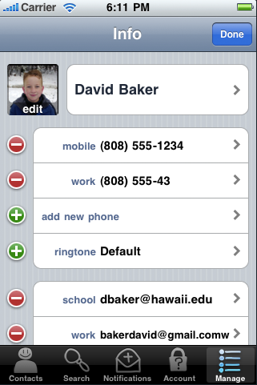
This screen shot shows what the user is presented with when they hit the edit button (as displayed earlier). Note that all fields are editable. This will not be the case for some users and all fields, as they may prohibit you from modifying certain information about them (such as their name). Also note that users are allowed to add more than one phone, email, and address as well as give them customizable labels. They can also remove data. To disable editing mode and return to detailed view mode, use the "Done" button which was the "Edit" button. From this screen, if you click on any of the tabs, the changes (if any) are immediately saved and applied to the account record. At this state, all user information is complete and "Edit" mode is safe to exit.

Information Edit - Phone Number:
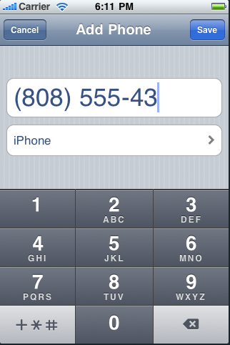
This screen is a drill down of the previous screen. Here we are entering a phone number that we've chosen to label "iPhone" (another selectable drill down level). This screen is similar to all other data entry screens. This is the most simple example as only the keypad is shown. In data fields (such as email, or address) where both alpha and numeric data can be entered, a keyboard is displayed rather than the keypad. In order to keep this document to a manageable length, only the phone number edit screen will be presented and discussed as the other fields are similar with marginal differences. The biggest feature of the "Information Edit" screen that is discussion worthy is that there is no tab bar displayed along the bottom of the screen. This is intentional to prevent data entry errors. For example, the phone number currently entered is incomplete in length. If the bottom tab bar were displayed, the user could change tabs mid-entry causing this data to either be lost, thrown away, or saved in this erroneous state. So in order to avoid all these problems, the user is not afforded the opportunity to switch tabs and is only presented the two options of "Cancel" or "Save". Cancel does the obvious action, while saving would perform a check on entered data. In this case, it would warn the user that the phone number entered is incomplete. Other examples of data checking would be checking for incomplete email address or format similar to that found in the web portal version.

Notifications:
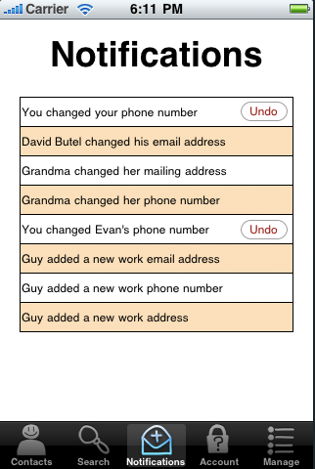
This screen is the Notifications screen. It's similar in function and display to the web-portal version except down-sized for the iPhones' screen. Note the "Undo" buttons are offered to changes that "you" the user has made. This screen makes it convenient to correct recently made mistakes as well as view changes to your contacts that have been recently made.

IV Evaluation Criteria

The primary benefit of using this system is convenience. Therefore, this system must be very easy to use and require minimal learning. To measure ease of use and learnability, the following evaluation criteria can be used:

1) How quickly a user is able to accomplish his/her task.
A group of users will be given a set of tasks to perform without human supervision or help. The application software must be designed such that it can detect when a task is completed and alert the user when to stop. During the experiment, the users start and end times will be recorded. Due to the possibility of a large amount of variance in user performance, the user group must be large enough to reduce the uncertainty of the measurements.

In addition to a controlled experiment such as the one above, data can also be gathered in an informal manner. When users are working with the application in the real world, the software can detect when they begin and end certain tasks. For instance, when they want to enter data for a new entry in the contact list, the software can log the time when the user accessed the new data entry function and when the user has finished filling out all of the required fields. Naturally, some of the tasks will need to be omitted if the user decides to quit without finishing the task. Furthermore, environmental factors may contribute to the user's performance and thus times that lie in the statistical extremes of user performance should also be factored out of the evaluation. Using this technique, one can track the increase or decrease of average user performance caused by a change in the software.

2) How often does the user make mistakes.
Similar to our first criteria, testing for mistakes will consist of giving a group of users tasks to perform. Unlike the first criteria, we aren't looking for a statistically significant measurement; we're looking for areas of the interface that cause the most errors. In light of this, a very large group of users is not necessary. Instead, a small group of users could be tested frequently for incremental improvements to the interface. Small and frequent tests could be done in-house to reduce time and monetary costs, though third party testers will likely be required for major milestones.

3) How long does it take a users to overcome difficulties.
Ideally, our system should not only be easy to learn, but easy to master. Testing user performances on provided tasks over several days should give us an impression of how easily the system is mastered. If users continue to make errors on certain parts of the system, then we would know that those components need revision immediately. If, however, users learn to use the component after only a couple errors, then we know that the component's revision priority can be lowered. This knowledge would allow us to streamline the development process by allowing us to avoid spending time on less critical issues.

4) How often does the user access certain areas of the application.
Memorability is an important aspect for all applications, but is especially crucial for those that are seldom used. After all, one can scarcely expect the users to be satisfied if they are expected to relearn all that they have forgotten whenever they use the application. In this project, we predict that certain parts of the We'll Call You may be utilized less frequently than others. We also predict that different users will have different habits. Users such as the high school student may be constantly changing their contact data, while an elderly person may entirely rely on others to update their contacts. By monitoring a diverse set of users, we will be able to discover where our system needs to be most memorable.

