Storefront Shopping Cart

James Hartley
CSC-17B-44085
April 22, 2019

1. Introduction
Create a storefront / shopping cart using model-view-controller. HTML/PHP on the frontend and C++ / MySQL connectivity on the backend.

2. Description
Create a product class, front page should allow user to select products and add them to the ‘shopping’ cart, Cart will be a class that holds an array of product classes. Checkout should total out prices for the various items that were added to the cart.

Classes
Class | Purpose
User | Stores user information and Cart
Cart | Holds an array of products
Product | Holds product properties

Product Variables:
Item Name, Price, Weight, Array of Images.
Cart Variables:
Price Total, Array of Products.
User Variables:
User Name, Password, Email, Cart.
Screenshots:
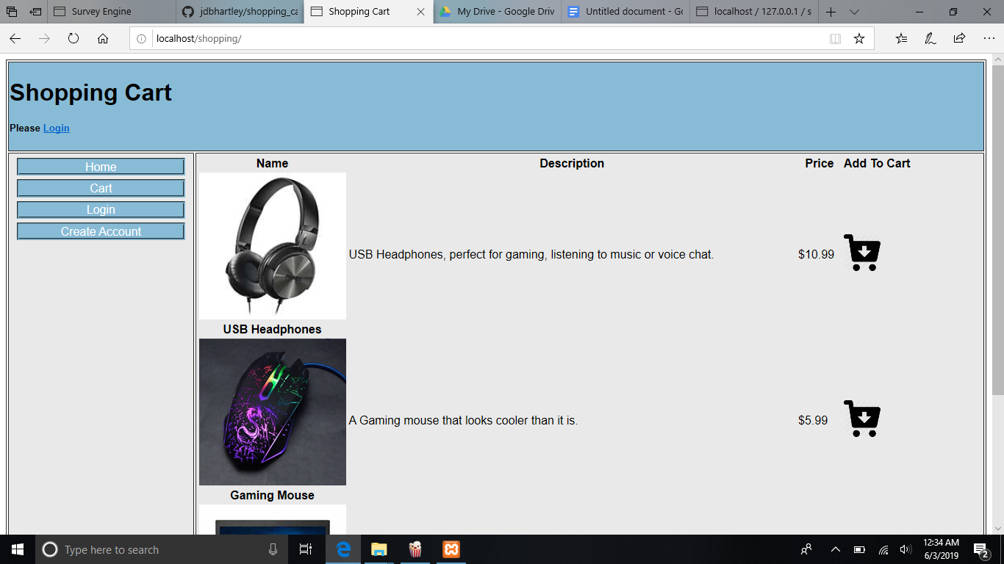
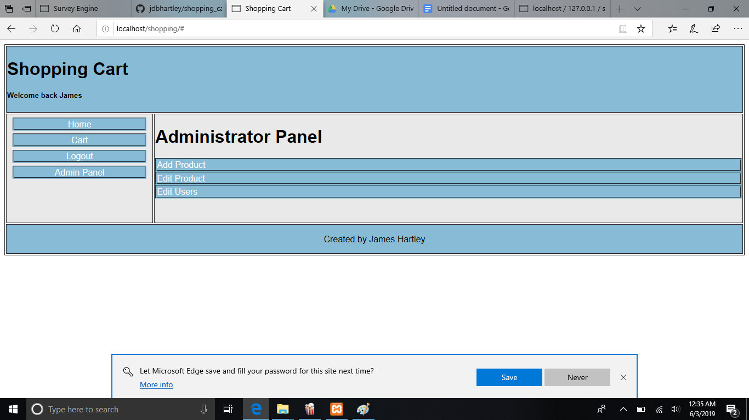
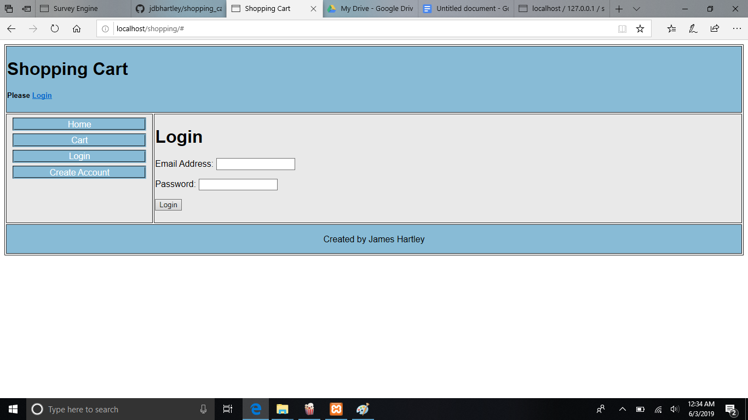
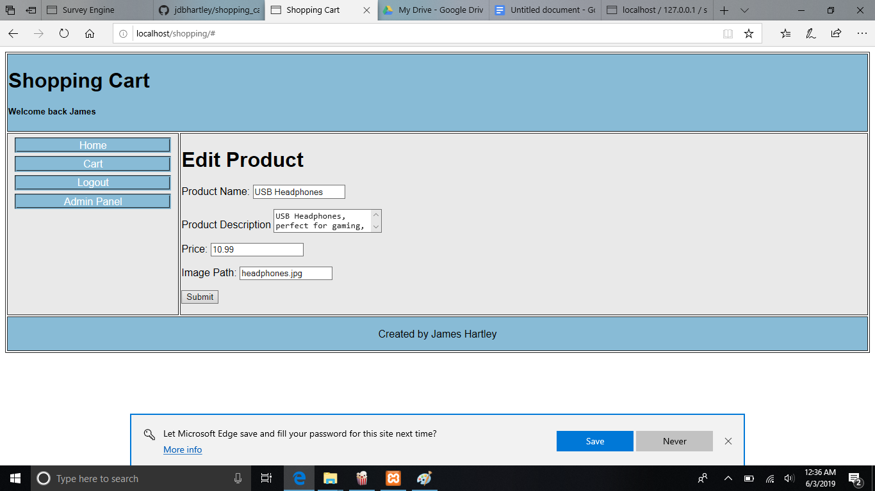

4. Overview
Cart information is stored via cookies as a JSON file, products are stored in the MySQL Database, User account creation is done with RegEx, any account is an admin for testing purposes. Editing products uploads changes to MySQL Database, adding products is similar.

5. Testing Instructions

Please import shopping_create_schema.sql into local database and extract the shopping folder to htdocs.

