Survey Engine

James Hartley
CSC-17B-44085
April 22, 2019

1. Introduction
Create a survey engine using HTML, JavaScript, PHP and C++ using the Model-View-Controller method.

2. Description
Survey Engine should allow users to create surveys, display them and store them in a MySQL database.

Classes
Class | Purpose
Survey | An Array of Questions
Question | A question with title, and array of answers to select.
Survey Variables:
Survey Name, Array of Questions
Question Variables:
Title, Array of strings used as Answers.

Instructions to test:
Import survey.sql to local database in a table named survey, extract survey folder into htdocs and run local server.

3. Screenshots
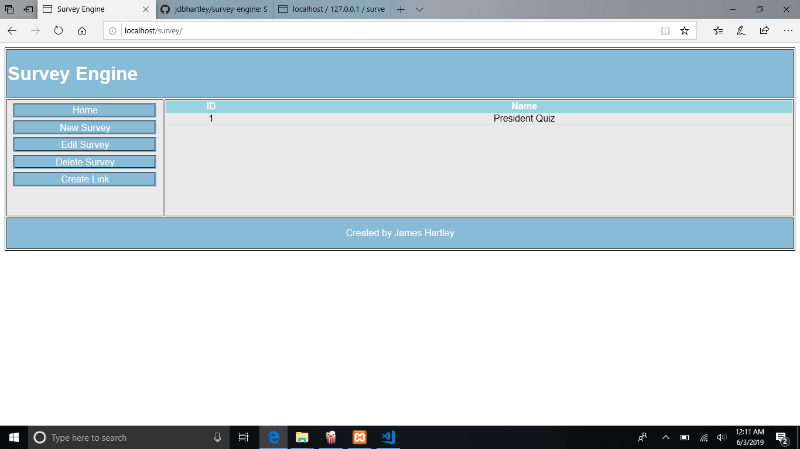
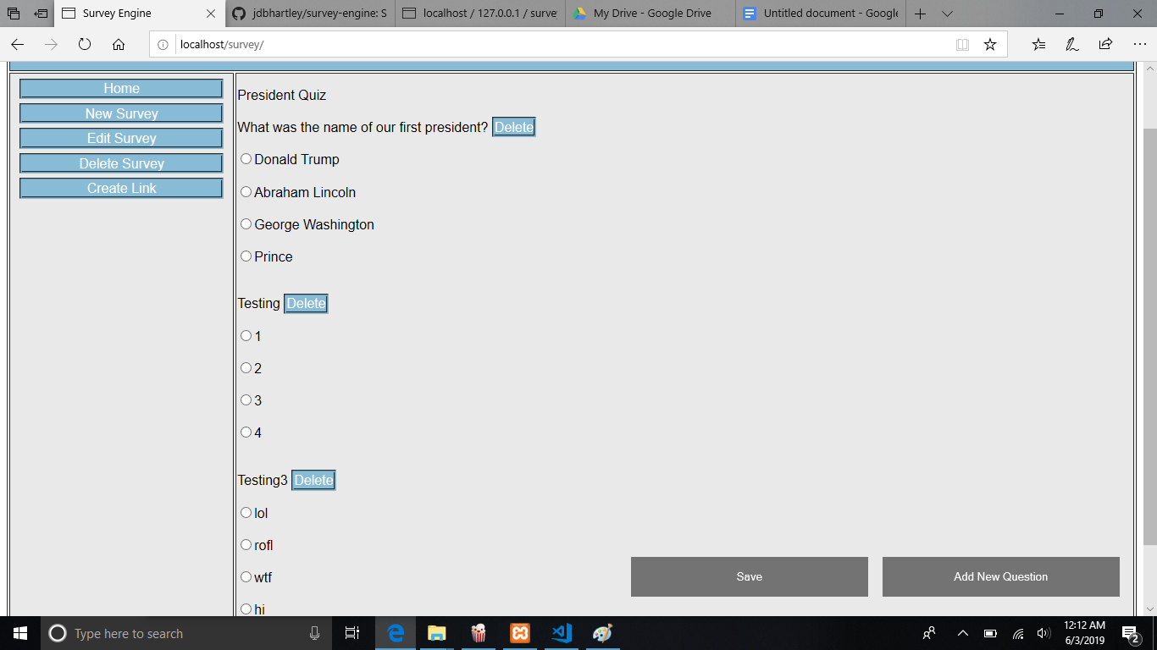
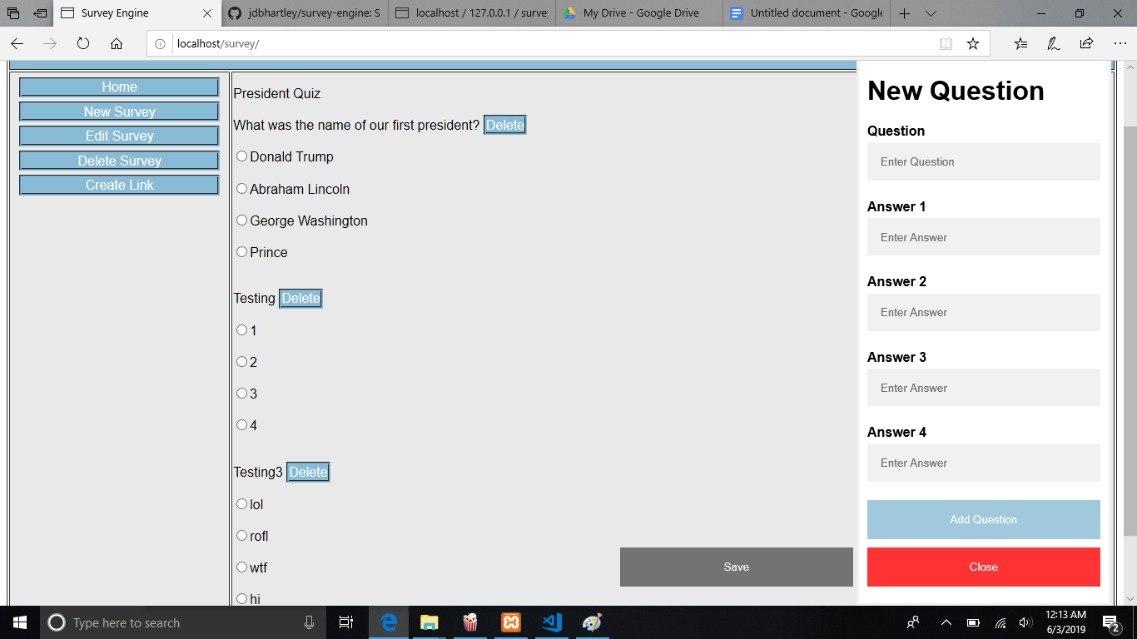
Code Description:
JavaScript, Jquery, PHP and MySQL
Website does all processing from one main page, which starts as a table with selectable indexes, admin options on the side let you alter the surveys which are then uploaded to the database through an AJAX call to a PHP script. The AJAX call sends the survey in JSON format which is then stored on the database.
When a survey is requested it is downloaded from the database, converted from JSON back into the JavaScript object and displayed.

