

**Execute IG Batches**

Version 1.3

Dated 2020-03-02

# Revision History

| Version | Date | Revision Description | Author |
| --- | --- | --- | --- |
| 0.1 | 2020-02-17 | Draft Version | Chandan |
| 1.1 | 2020-02-20 | AIX working command example added | Chandan |
| 1.2 | 2020-02-26 | New Solution With Socket Server | Chandan |
| 1.3 | 2020-03-02 | Improved the performance of BatchSubmit.jar | Chandan |
|  |  |  |  |
|  |  |  |  |
|  |  |  |  |
|  |  |  |  |
|  |  |  |  |

# Table of Contents

1 Required Files And Information 4

1.1 Jars: igsocketservice_1.0.3.jar 4

1.2 Jars: submitigbatch_2.3.0.jar 4

1.3 Know the path of following files on Server 4

1.3.1 Config Files: Get path of QuipozConfig.xml 4

1.3.2 Properties Files: Get path of database.properties 4

2 Preparation Step 4

2.1 Put the Jars on the server 4

2.1.1 igsocketservice_1.0.3.jar 4

2.1.2 submitigbatch_2.3.0.jar 4

3 Execution 5

3.1 Additional Information 5

4 Appendix 6

# Required Files And Information

## Jars: igsocketservice_1.0.3.jar

## Jars: submitigbatch_2.3.0.jar

## Know the path of following files on Server

### Config Files: Get path of QuipozConfig.xml

### Properties Files: Get path of database.properties

# Preparation Step

## Put the Jars on the server

Place following two jars on the IG Batch Server:

### igsocketservice_1.0.3.jar

### submitigbatch_2.3.0.jar

Let us say the folder is /home/jpacpr/igsocketservice.

# Execution

Go to the folder where you have saved the two jars say /home/jpacpr/igsocketservice. Then run the below command line:

java -Doracle.jdbc.autoCommitSpecCompliant=false -DQuipoz.CSCGroupAsiaWeb.XMLPath=H:/ckp/tools/allJars/ig/Config/QuipozCfg.xml -Ddbconfig=H:/ckp/tools/allJars/ig/Config/database.properties -cp H:/ckp/tools/allJars/ig/csc-smart400-batch-1.0-SNAPSHOT.jar;H:/ckp/tools/myexport/SubmitIgBatch/submitigbatch_2.3.0.jar;H:/ckp/tools/myexport/IGSocketService/igsocketservice_1.0.3.jar core.Server 2020

Substitute the value of <PathOfConfig.xml> And <PathOfdatabase.properties>. It may look like below

Example on AIX: /usr/IBM/WebSphere/AppServer/java/8.0/bin/java -Doracle.jdbc.autoCommitSpecCompliant=false -DQuipoz.CSCGroupAsiaWeb.XMLPath=/opt/ig/conf/PTX22/QuipozCfg_PTX22.xml -Ddbconfig=/opt/ig/conf/PTX22/database.properties -cp /opt/ig/batchjob/PTX21/csc-smart400-batch/csc-smart400-batch-1.0-SNAPSHOT.jar:/home/jpacpr/javawork/IGSocketService/submitigbatch_2.3.0.jar:/home/jpacpr/javawork/IGSocketService/igsocketservice_1.0.3.jar core.Server 2020

The client command line to test:

/usr/IBM/WebSphere/AppServer/java/8.0/bin/java -cp /home/jpacpr/javawork/IGSocketService/igsocketservice_1.0.2.jar core.Client 127.0.0.1 2020 action=status bn=G1AUTOALOC bd=20250901 uid=BATCHUSER tout=1

## Additional Information

The first time execution of any action will take some time but its subsequent execution takes less than 5 secs:

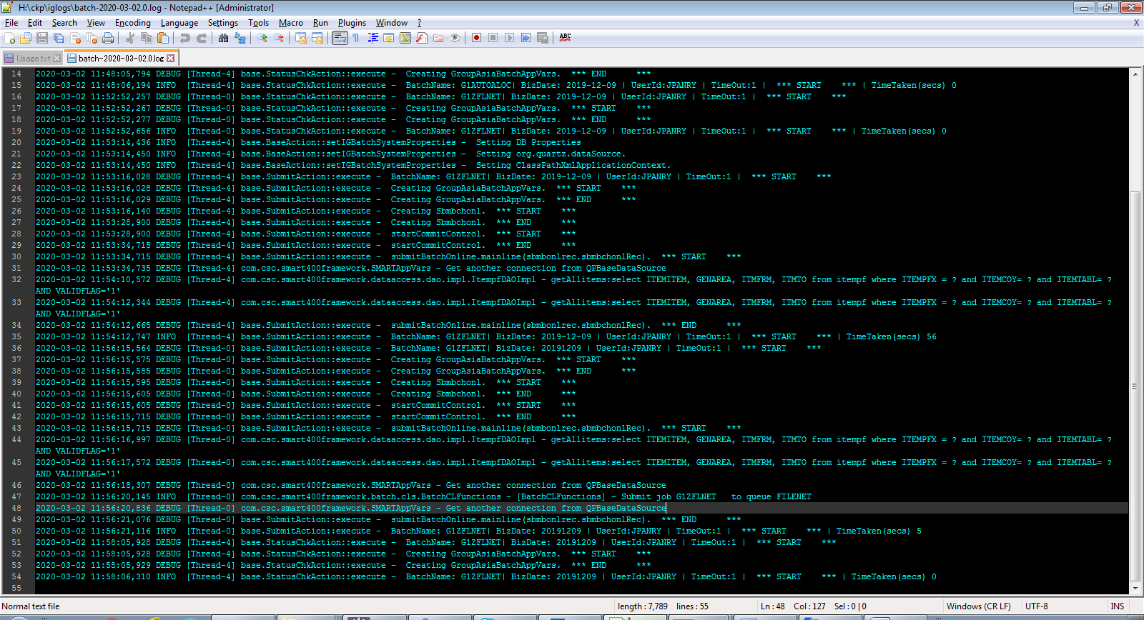

# Appendix



Source Codes:

