Java7_Notes:

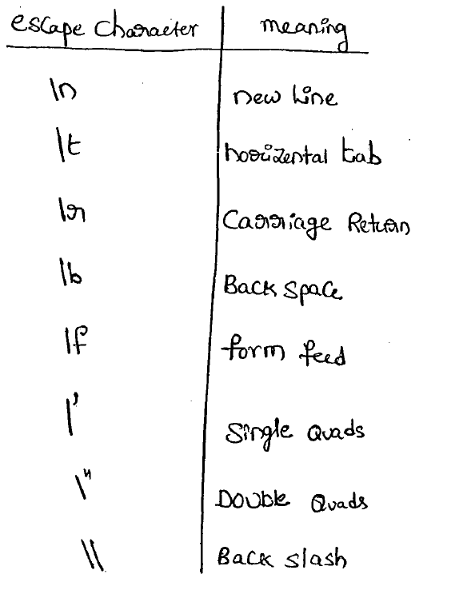

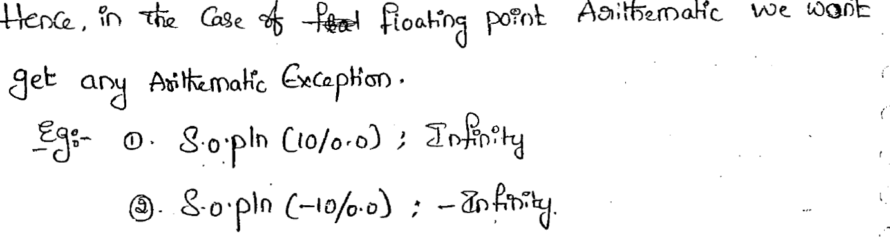

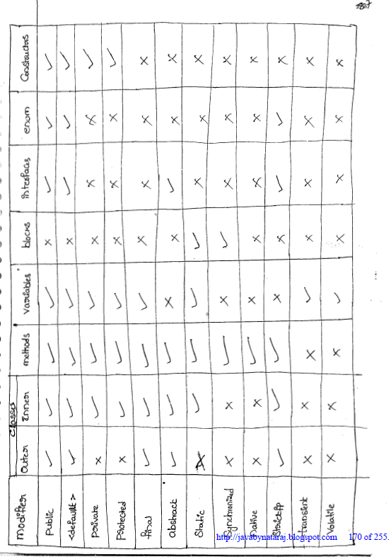

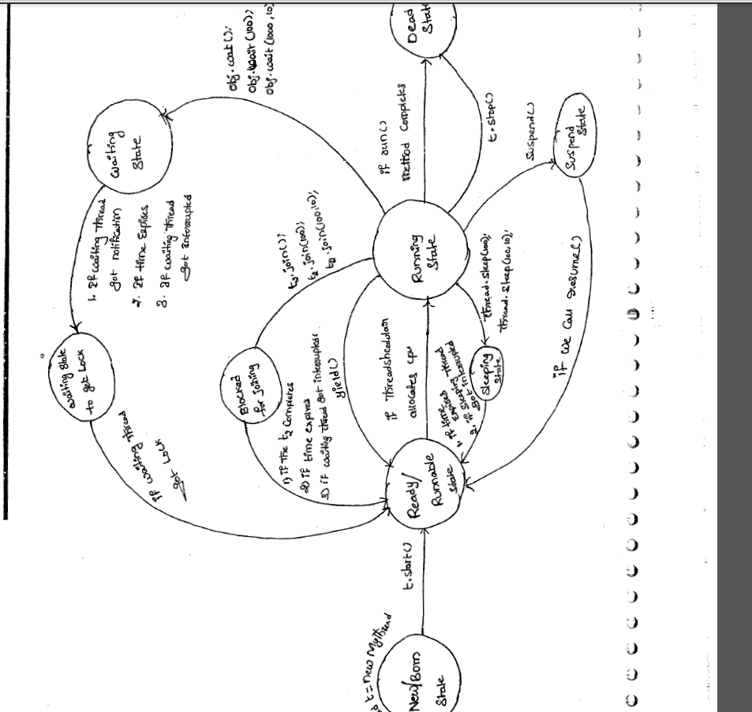

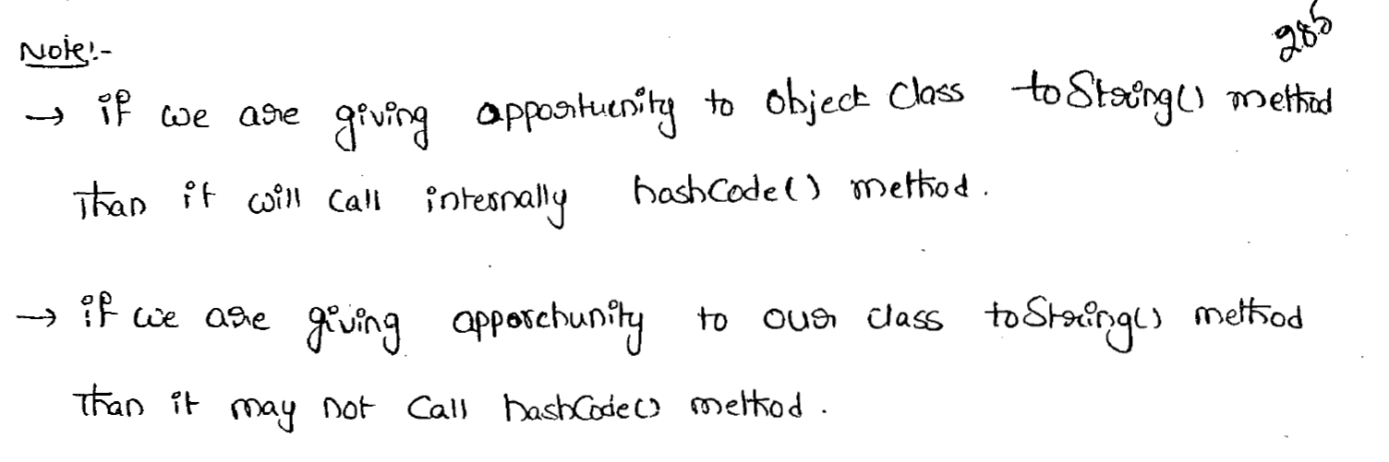

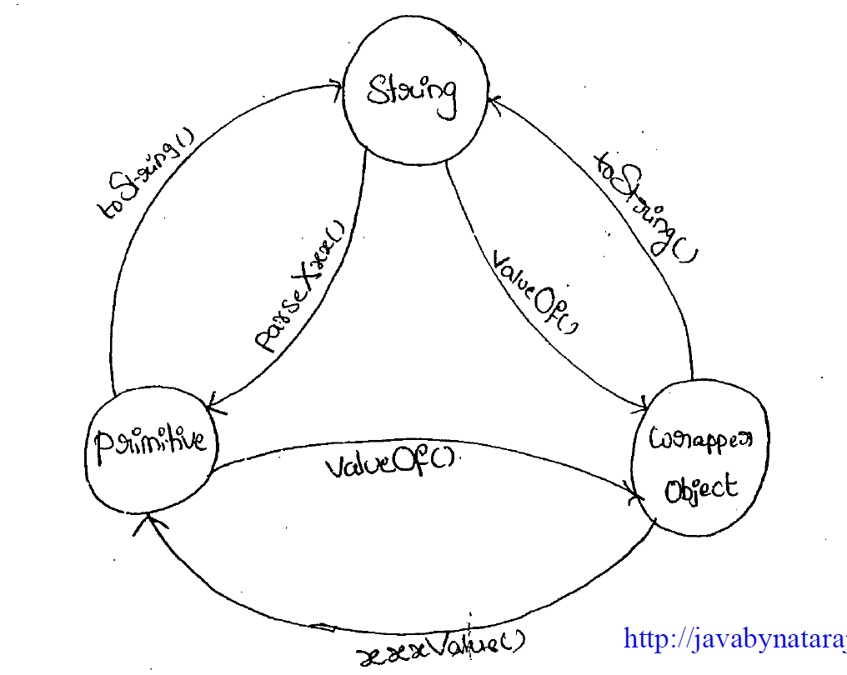

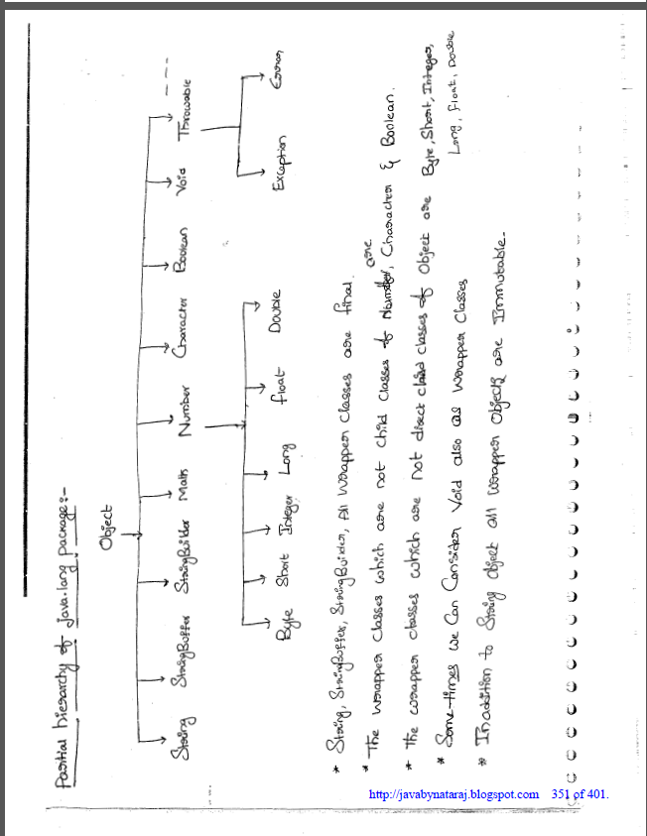Inheritance ex.

1. When parent and child have different name methods (No Overriding)

|  |
| --- |
| class Vehicle{  void run(){  System.out.println("Vehicle is running");  }  }    class Bike1 extends Vehicle{  void run1(){  System.out.println("Bike is running safely");  }  }  class Bike2 {  public static void main(String args[]){  Vehicle obj = new Bike1(); //Cases  obj.run(); //Cases  }  } |

Case 1:

Vehicle obj = new Bike1();

obj.run();

Output: Vehicle is running

Case2 :

Vehicle obj = new Bike1();

obj.run1();

Output: **Compile by: javac Bike2.java**

122.93/Bike2.java:16: error: **cannot find symbol**  
 **obj.run1();**  
 ^  
 symbol: method run1()  
 location: variable obj of type Vehicle  
1 error

1. When parent and child have same name methods (Overriding)

|  |
| --- |
| class Vehicle{  void run(){  System.out.println("Vehicle is running");  }  }    class Bike1 extends Vehicle{  void run(){  System.out.println("Bike is running safely");  }  }    class Bike2 {  public static void main(String args[]){  Vehicle obj = new Vehicle(); //Cases  obj.run(); //cases  }  } |

Case1:

Vehicle obj = new Vehicle();

obj.run();

Output: Vehicle is running

Case2:

Vehicle obj = new Bike1();

obj.run();

Output: Bike is running safely