[Java Source Code Analysis using SonarQube | Java Techie](https://www.youtube.com/watch?v=hyBznKcoKEg)

[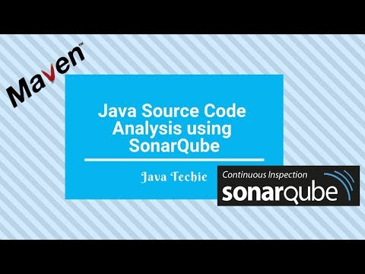](https://www.youtube.com/watch?v=hyBznKcoKEg)

-------------------

1.

Setup SonarQube in a Docker Container and Bootstrap the Quality Configurations - [Setup SonarQube in a Docker Container and Bootstrap the Quality Configurations](https://www.youtube.com/watch?v=PPWeiHz7X00&t=0s)

[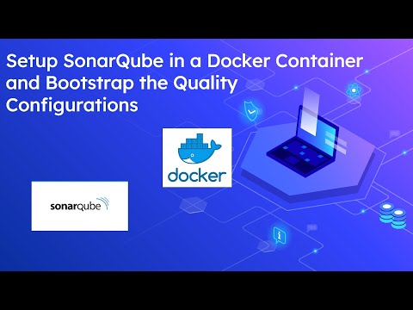](https://www.youtube.com/watch?v=PPWeiHz7X00&t=0s)

2.

[Sonarlint Connected Mode with Eclipse and SonarQube(Docker)](https://www.youtube.com/watch?v=cvMCfmZ2XZ0)

[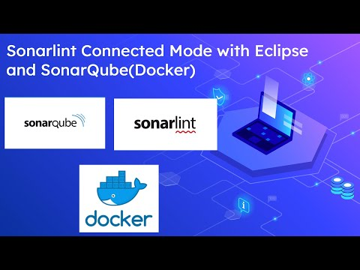](https://www.youtube.com/watch?v=cvMCfmZ2XZ0)