**Unsafe conditions**

Feeling depressed or unsafe? Get help now!

Call our emergency hotline at 1800-999-9999

Need depression counselor?

Call/text from anywhere in the USA at any time

about anything that is bothering you.

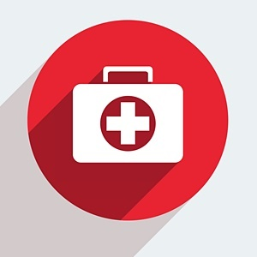

Our webpage designed to help you get an easy access to your therapist in case of a mental breakdown, or severe depression.

Your therapist is available 24/7