I am doing a VEEJ trajectory to Jupiter, launch targeted in 2020. Porkchop plots are shown below.
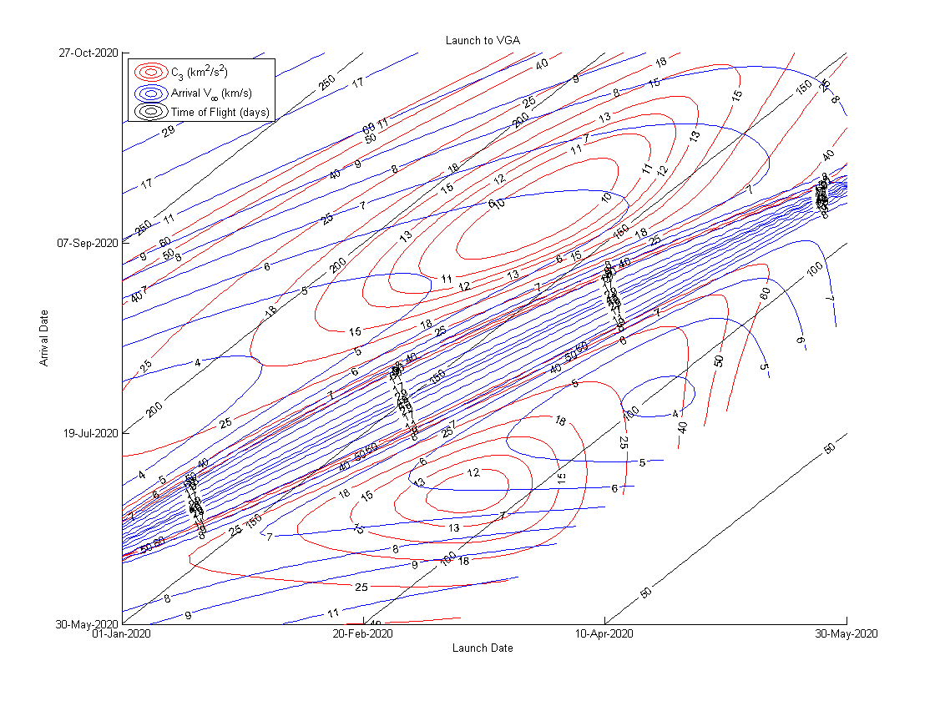
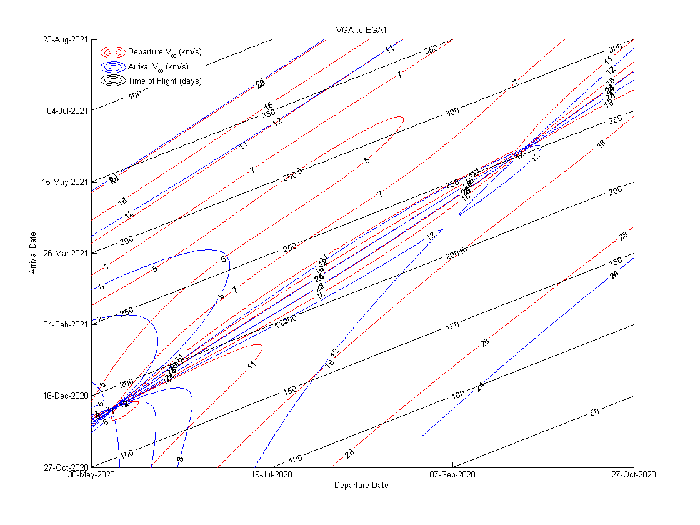

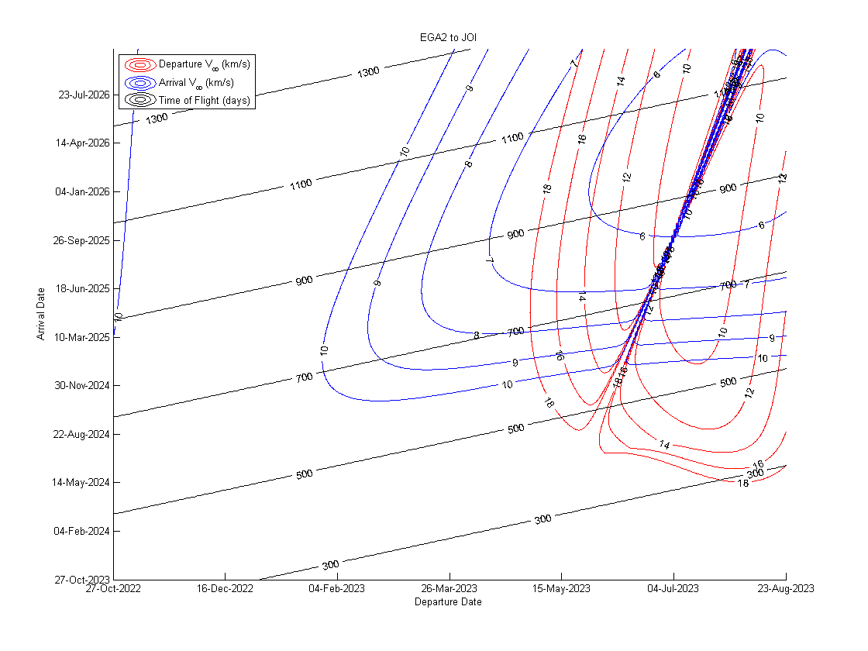
The windows were searched to find trajectories that met the requirements. I have chosen the trajectory with the least V_inf error.
Launch: 26-Feb-2020 12:00:00
VGA: 15-Sep-2020 12:00:00
EGA1: 12-Jul-2021 12:00:00
EGA2: 12-Jul-2023 12:00:00
JOI: 14-Feb-2026 12:00:00

B-plane targeting:
VGA r_p = 2.3224e+04 km
VGA turning angle = 29.6257 deg
VGA BT = 2.9790e+04 km
VGA BR = 4.7357e+03 km

EGA1 r_p = 6.7452e+03 km
EGA1 turning angle = 46.9996 deg
EGA1 BT = -7.0692e+03 km
EGA1 BR = -7.4747e+03 km

EGA2 r_p = 6.8203e+03 km
EGA2 turning angle = 45.5613 deg
EGA2 BT = -1.0163e+04 km
EGA2 BR = 1.4181e+03 km

C3: 16.7213 km^2/s^2
V_inf JOI: 5.5868 km/s
Total V_inf error: 2.65e-4 km/s
E-E resonant phi = 130.0614 degrees
