1.
b.
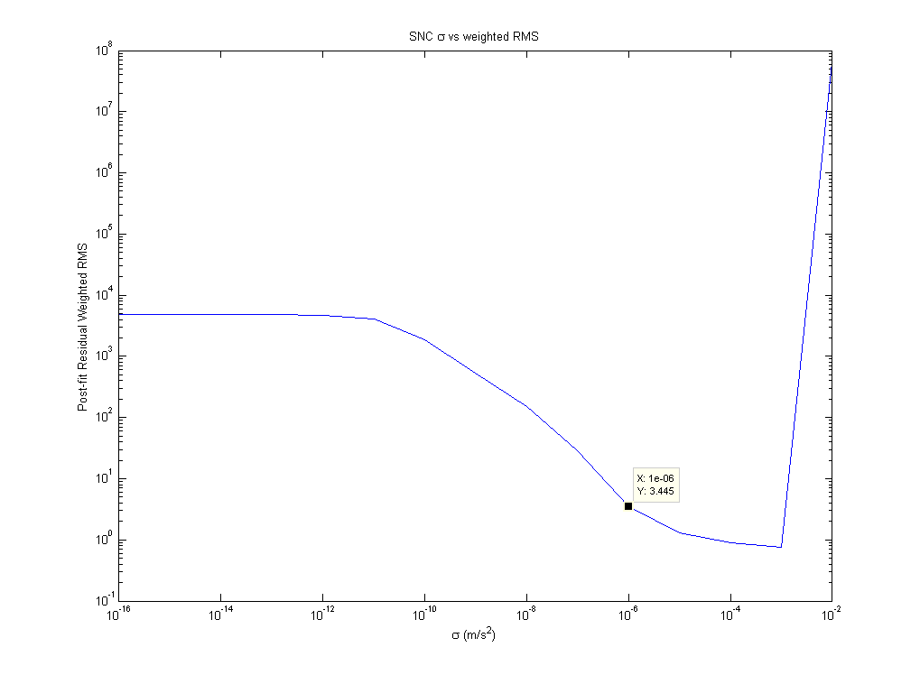
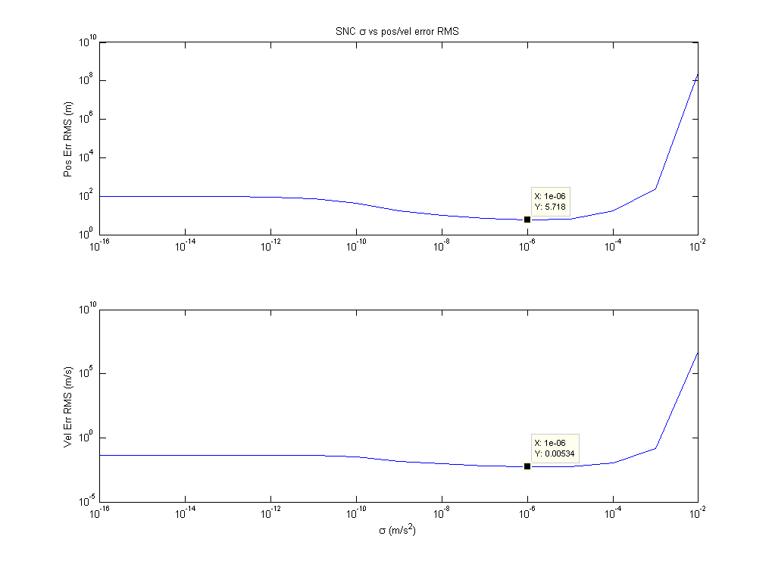
The optimal value for σ is 1e-6. The state errors were the lowest and the weighted RMS was relatively low compared to other values of σ. Performance for this value is shown below.

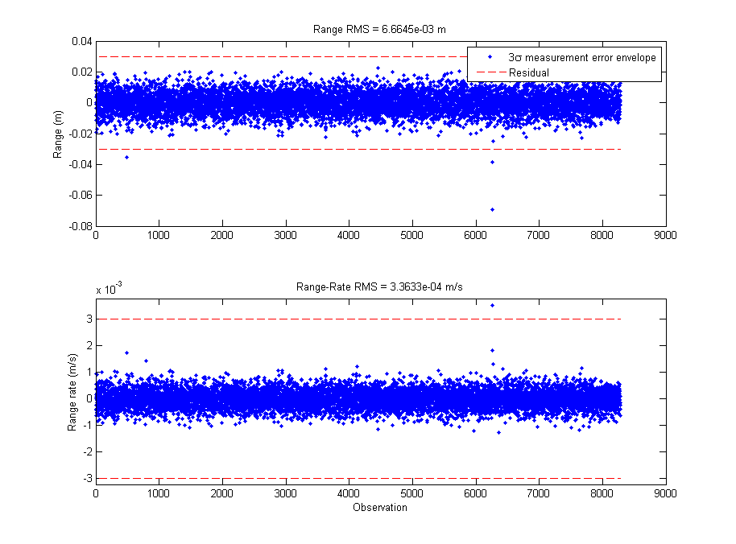

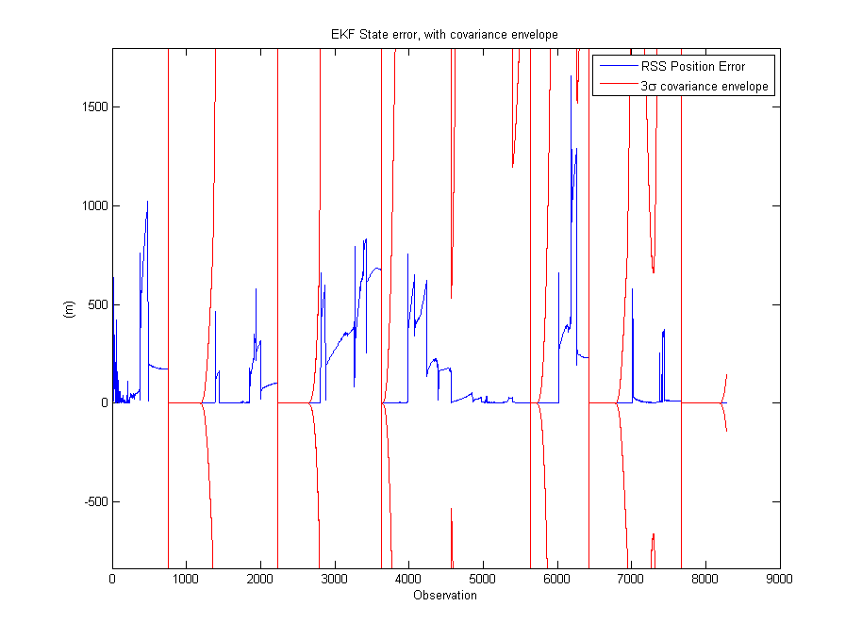

c. The performance is exactly the same in this case. Since there are only diagonal terms and they are all the same, the transformation does nothing.

2.
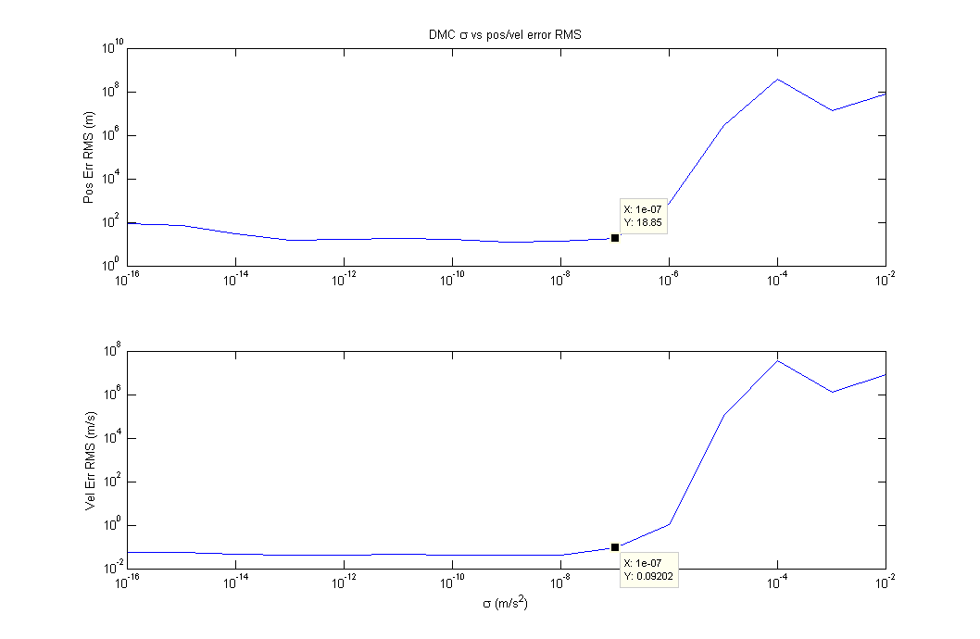

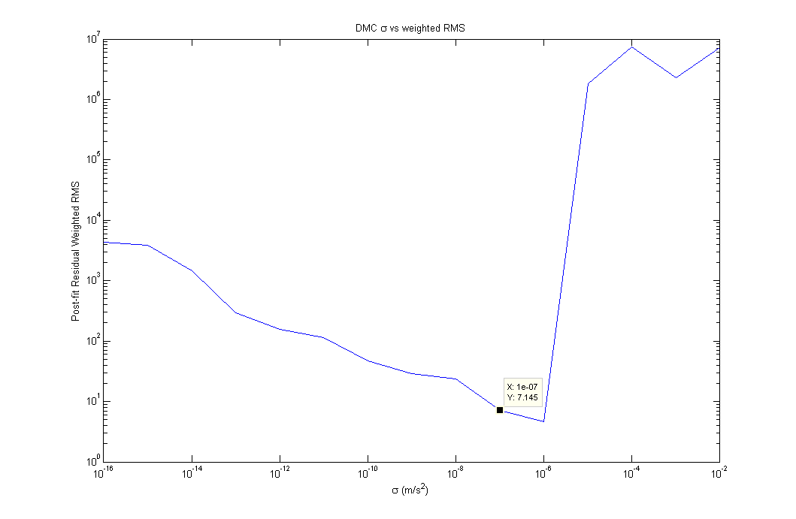

At this point I realized I was not propagating w as I should've been, but the hour was late. I found a decent value of σ to be 1e-8 for the given tuning parameters. Ideally, as with the SNC, the state errors would be the lowest and the weighted RMS was relatively low compared to other values of σ. Performance for this value is shown below. Unfortunately the state error was outside the covariance envelope sometimes.

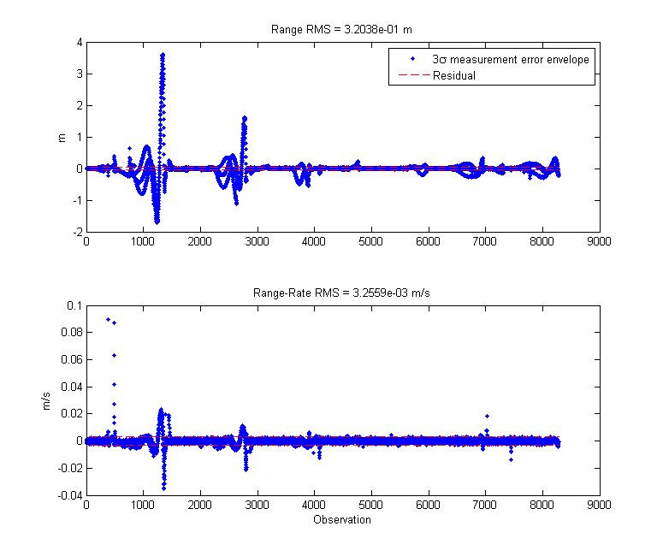

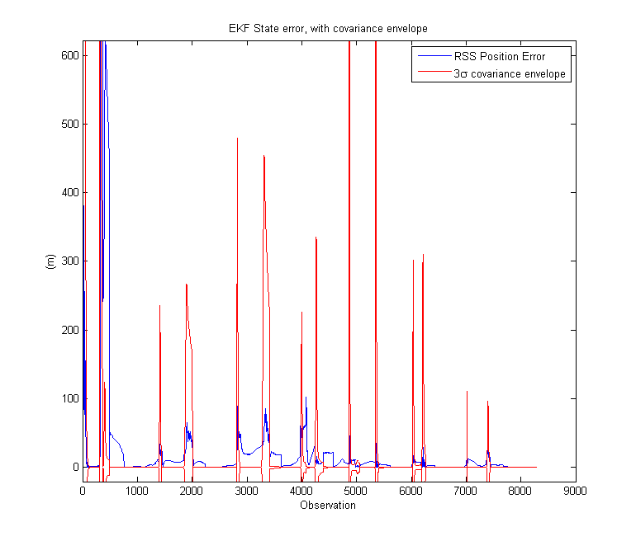

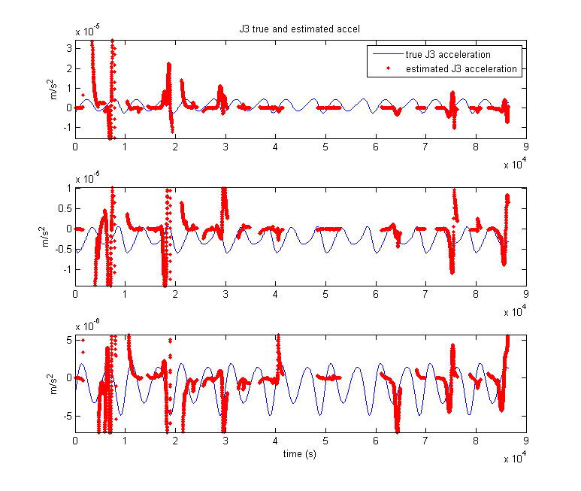
The J3 was not well estimated. I'm guessing the DMC's primary contribution was just keeping the covariance unsaturated.

I tried changing τ to p/3. Results are shown below.

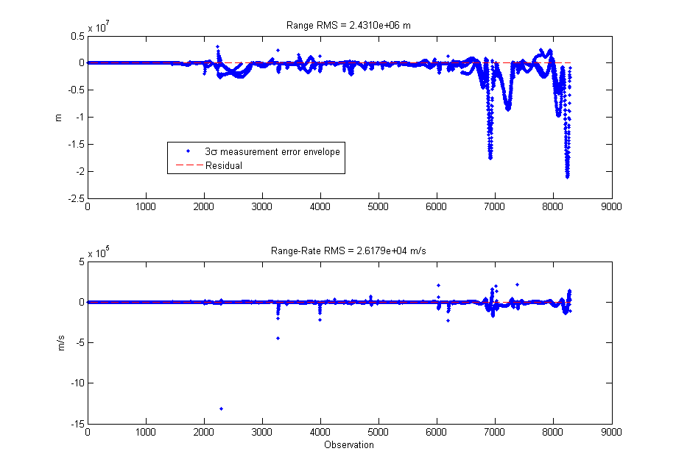

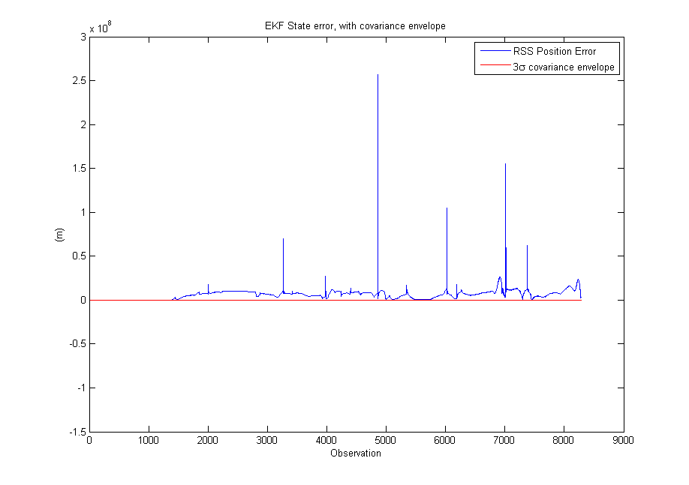

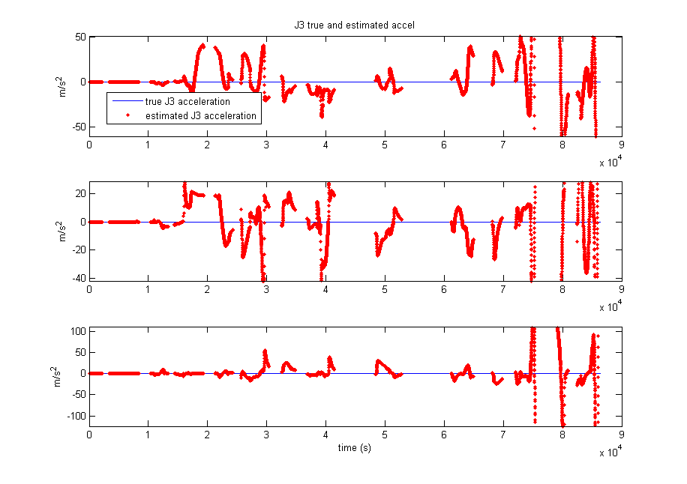
I thought that making tau smaller would better model the acceleration. Either I'm mistaken, or I have a bug in my code.

For a maneuver, one could tune for a higher variance and lower time constant (higher beta), assuming that the filter dynamics are pretty accurate to start with. This would allow a higher acceleration to be found, but the unknown acceleration would drop off quickly in the absence of a maneuver.

