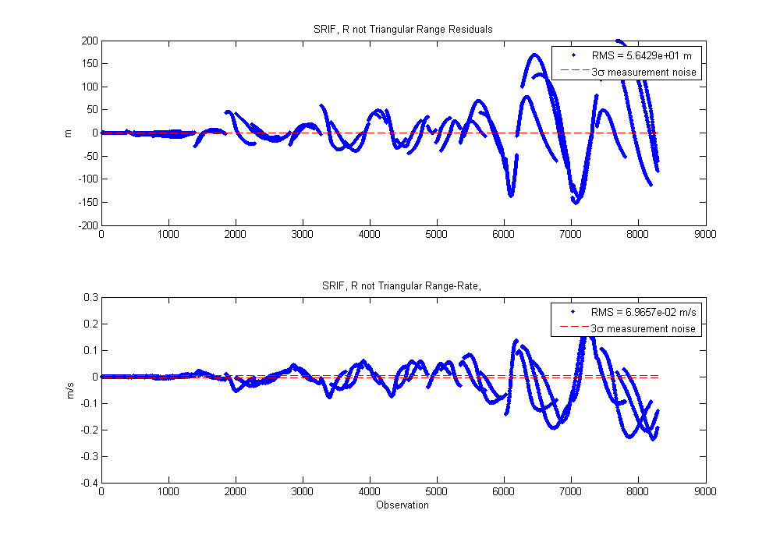
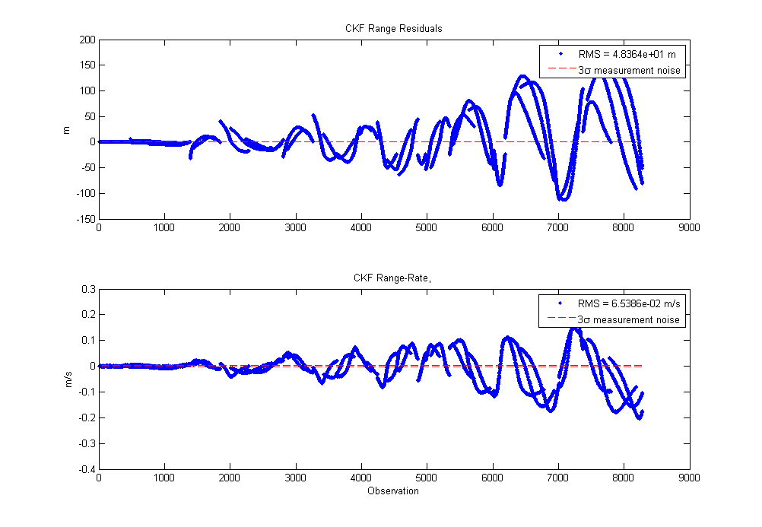
1. The postfit residuals and RSS state error for the SRIF can be seen below.

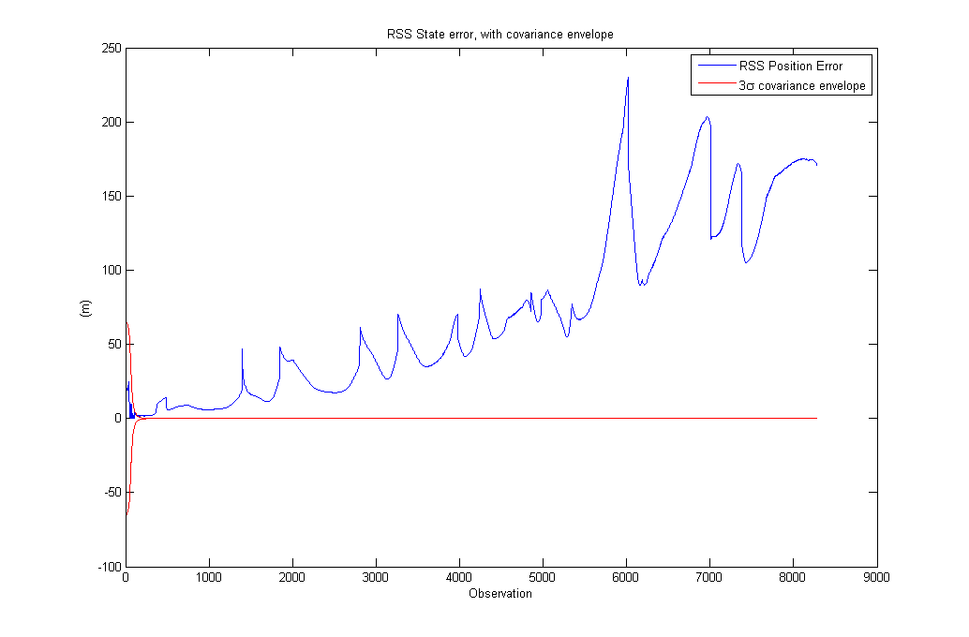
The residuals look close to the CKF. The RSS position error also has a similar profile to the CKF's. Unfortunately I wasn't able to get the forced-upper-triangular R working for some reason (fixing a bug ended up breaking it when I thought it was working), despite using the same Householder algorithm. See below:
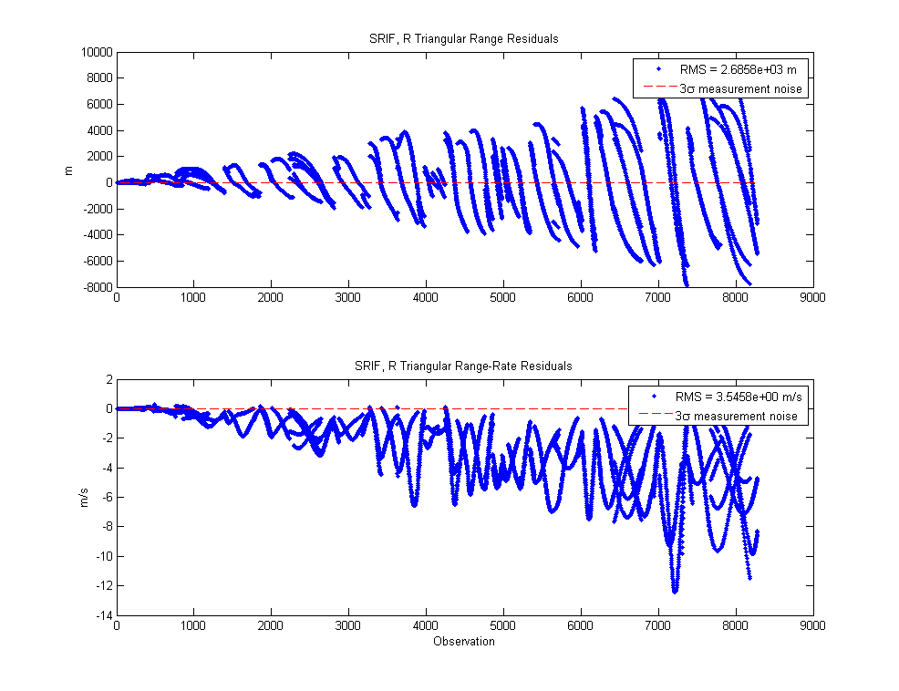
I know the results are supposed to be similar. I believe this would be due in part to the STM not “de-triangularizing” R very much with the dense observations. Unfortunately I wasn't able to verify that. I think if R stayed triangular, I would probably see a closer result to the CKF. Possibly better, with the square-root formulation allowing for less error. I ended up accumulating error as a result of R_bar not being triangular, so not much of a surprise that it performed a little worse.
2. Results for the interplanetary spacecraft are shown below:
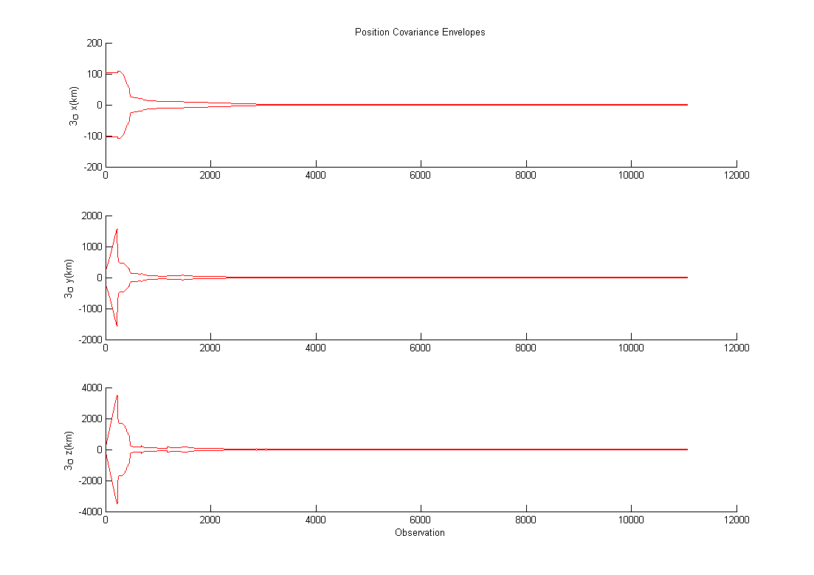
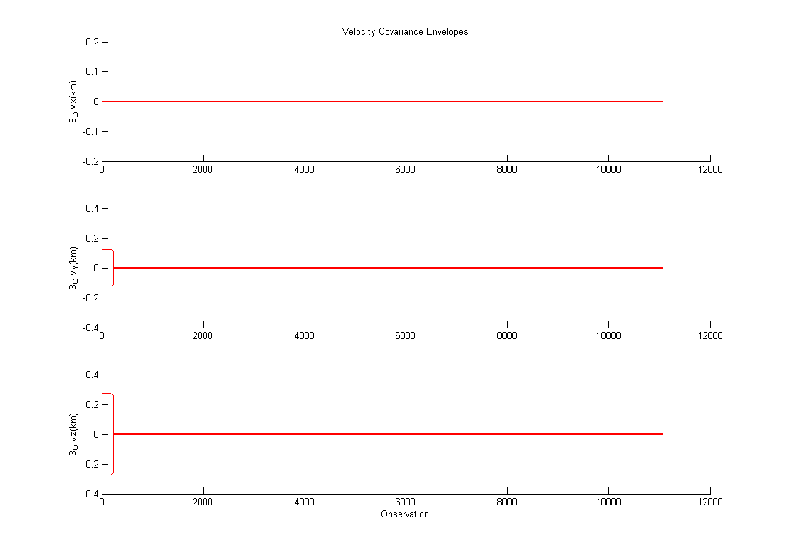

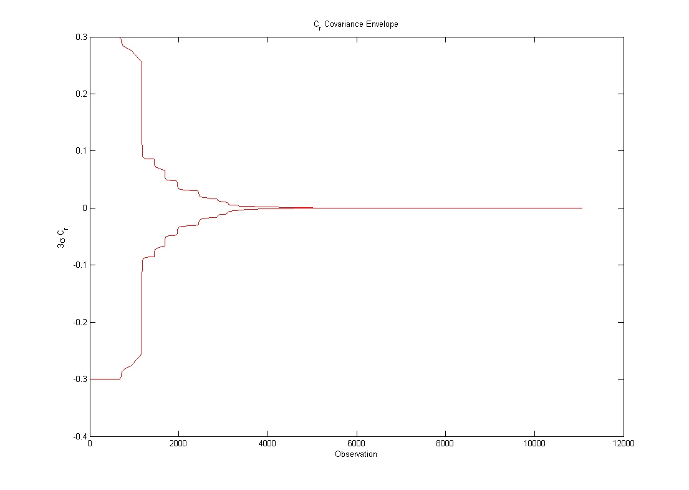
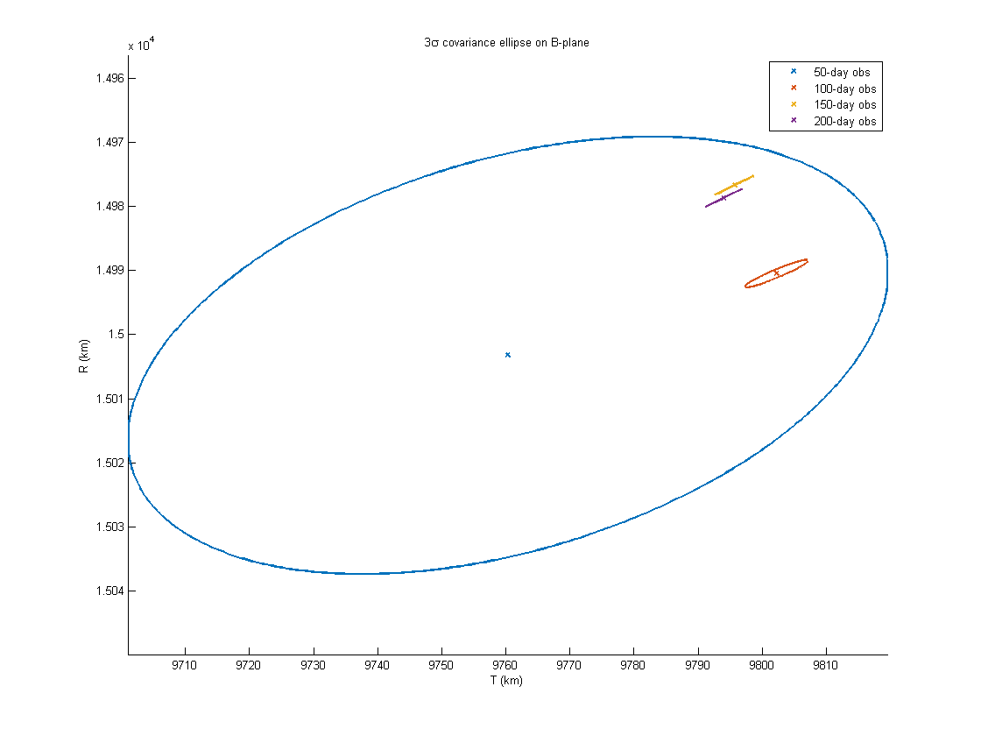
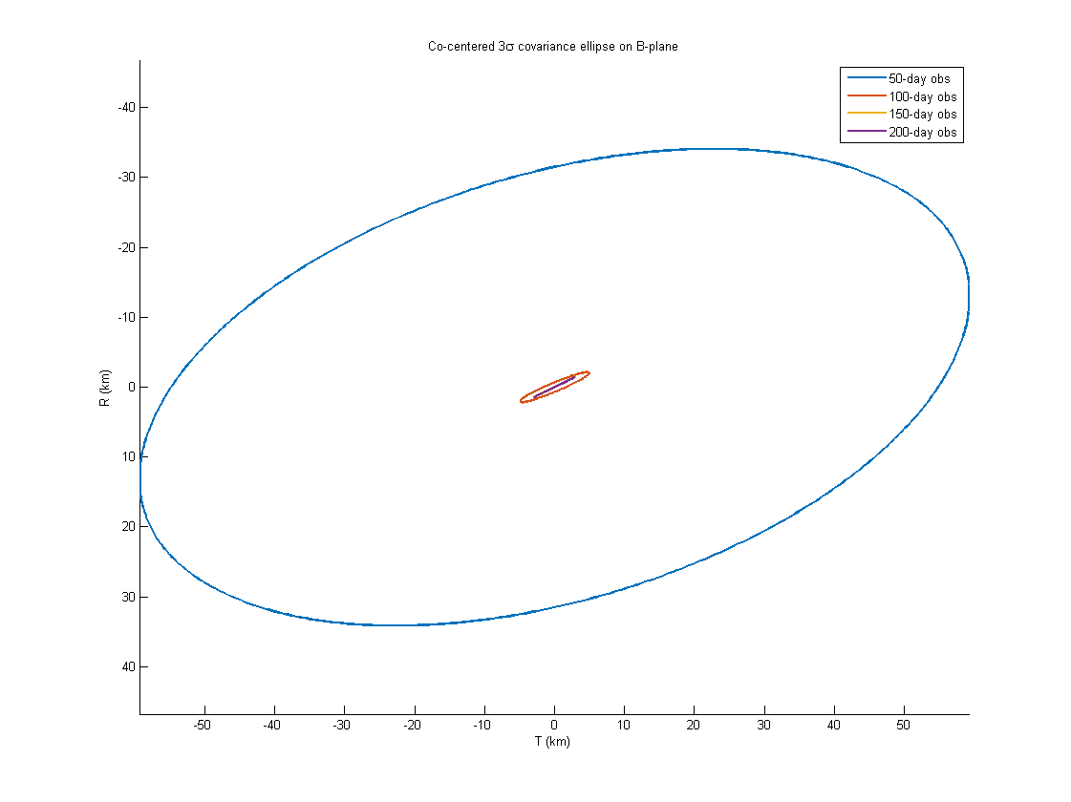
Final state at DCO:
X -7.049310509872721e+07 km
Y -1.464186722468296e+07 km
Z -6.381549379627151e+06 km
VX 7.031845410474670e+00 km/s
VY -3.845128856840645e+00 km/s
VZ -1.669872344142978e+00 km/s
Cr 1.000044090063793e+00

Without process noise, the covariance ended up collapsing as the observations were processed. However, the predicted target wasn't very far off (in the sense that space is a big place...). The covariance ellipses on the B-plane got smaller, as expected. This is due to both the covariance shrinking during filtering and subsequent iterations having to propagate the uncertainty for less time. My method was as follows:
- Propagate state from DCO to SOI
- Calculate LTOF
- Compute B-plane
- Propagate STM from DCO to SOI+LTOF
- STM_DCO_intercept = reshape(X_to_BPlane(end,8:end)',7,7); %The STM
P_intercept = STM_DCO_intercept*final_P*STM_DCO_intercept';%propagate the uncertainty
P_int_Bplane = B_plane*P_intercept(1:3,1:3)*B_plane'; %Rotate to B-plane
[U,D] = eig(P_int_Bplane(2:3,2:3)); %Principle axes
ellip_tilt = atan2(U(2,1),-U(1,1)); %the tilt

I ended up iterating the solution around 3k observations, and then around 6k observations. There was not much improvement beyond that. Below you can see the residuals:
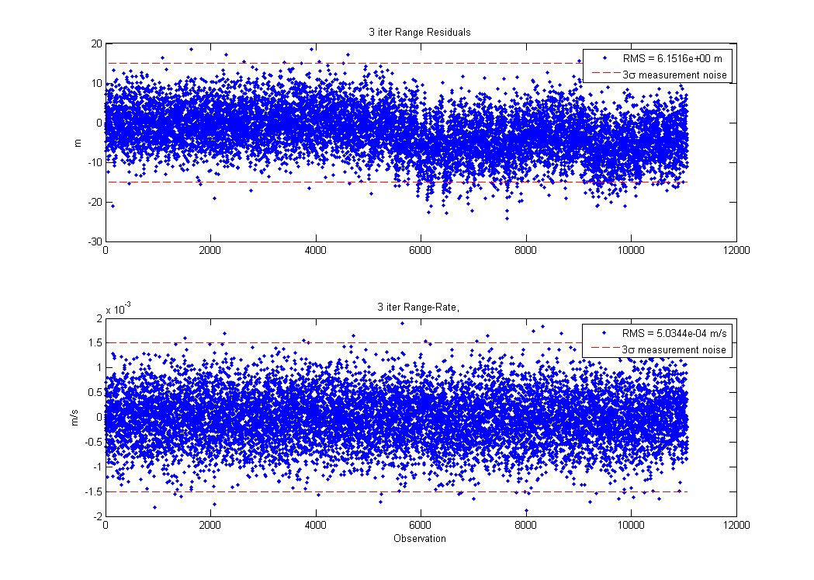
As you can see, the range residuals aren't matching the noise at the end. I ended up trying another method: fit each 50-day interval by iterating a few times on each. That is, iterate 3 times on the first 50 days, use the estimate as the a priori for the next 50 days, and repeat the process. The covariance was also propagated by Phi*P*Phi', where Phi is the STM between the last obs of the last set to the first obs of the new set. Results are below:
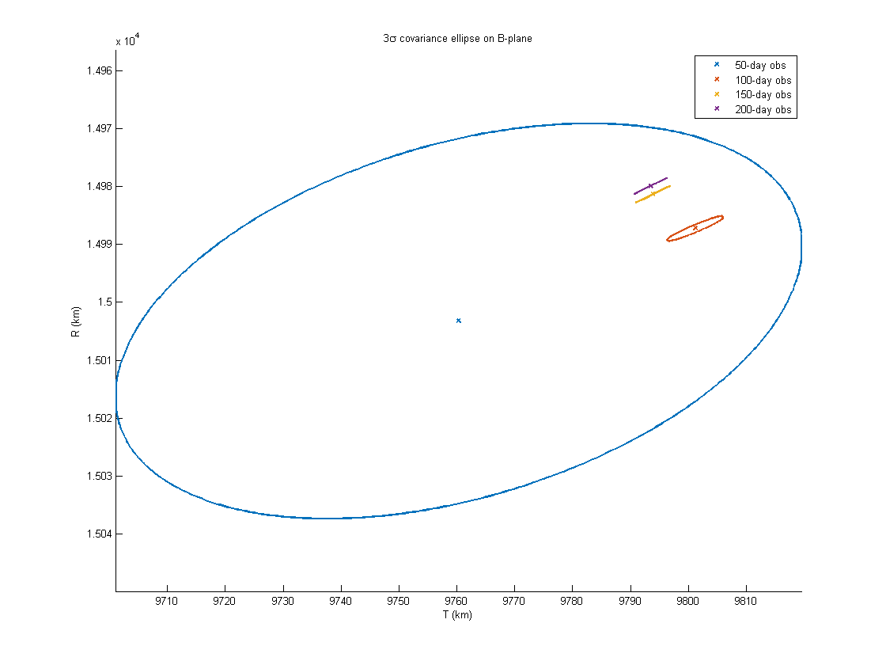
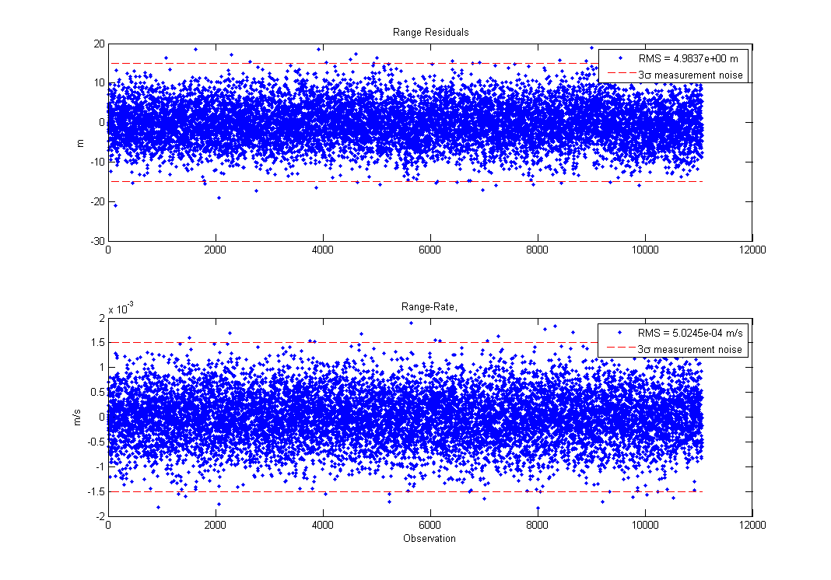

As you can see, the residuals fit the noise much better. It's not totally surprising for this EKF-like implementation, since I reset the reference state 3 times. The target does not change much, but considering the residuals from the first try weren't too biased, and that the bias only happened toward the end, only the final two ellipses would be affected. Those ellipses are quite small due to the collapsed covariance at the end.

PS This was a really fun homework!

