1) Simulate Orbit Data:
Orbit params:
a = 10000; %km
e = 0.05;
i = 25*pi/180; %rad
RAAN = 210*pi/180; %rad
w = 35*pi/180; %rad
f = 0;

Ground station locations:
- Boulder, CO: latitude 40 degrees, longitude -105 degrees
- Perth, Australia: latitude -32 degrees, longitude 116 degrees
- Diego Garcia: latitude -7 degrees, longitude 72.5 degrees
- KSC: latitude 28.5 degrees, longitude-80.5 degrees
- Singapore: latitude 1 degrees, longitude 103 degrees
- Johannesburg, South Africa: latitude -26 degrees, longitude 28 degrees

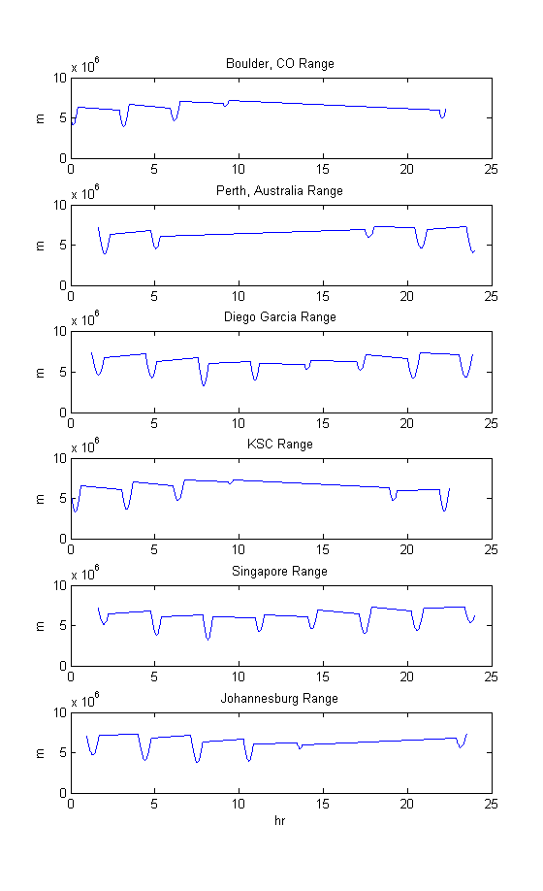
Ground station ranges:
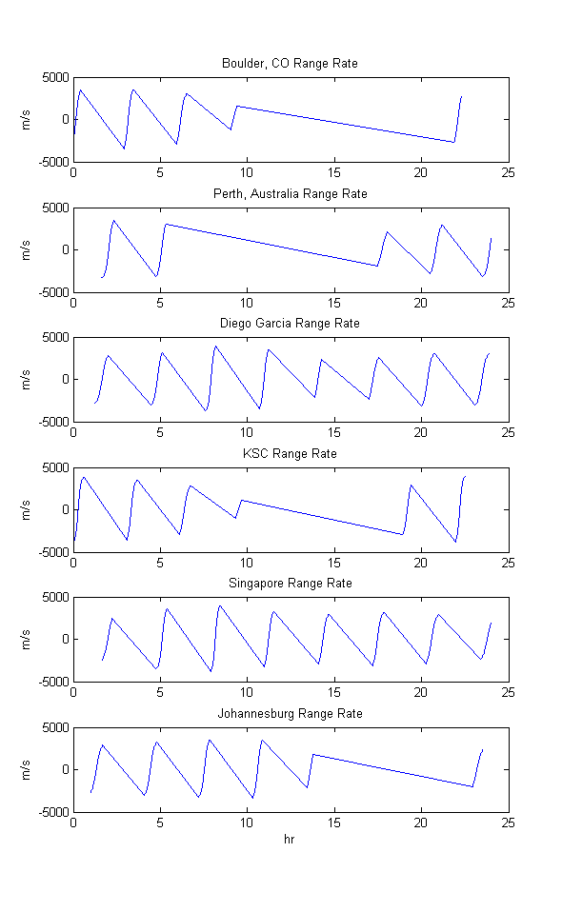
Ground station range-rates:

J3 Acceleration:
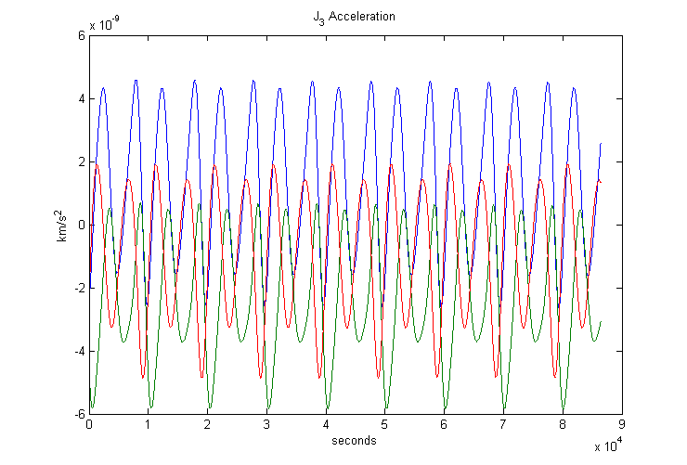

2) Filters – a priori state added 50 meters to all axes, subtracted 0.01 from velocities. I tried all sorts of values here to no avail, even perfect.

CKF State diff from truth with covariance envelope:
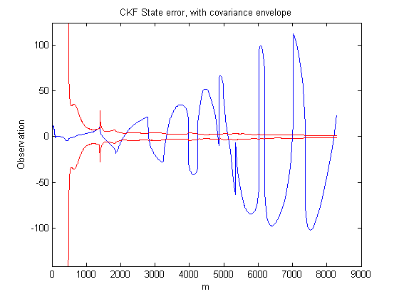

CKF residuals with error envelope
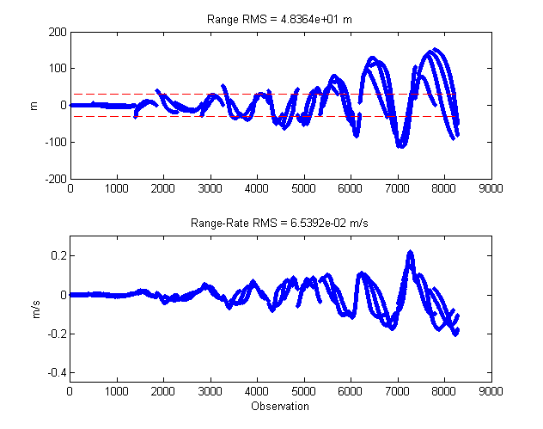
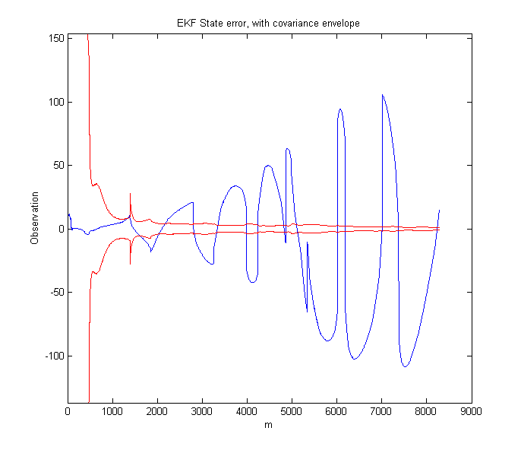
EKF State diff from truth with covariance envelope:

EKF residuals with error envelope (started processing after 200 CKF iterations) (definitely does not match noise)
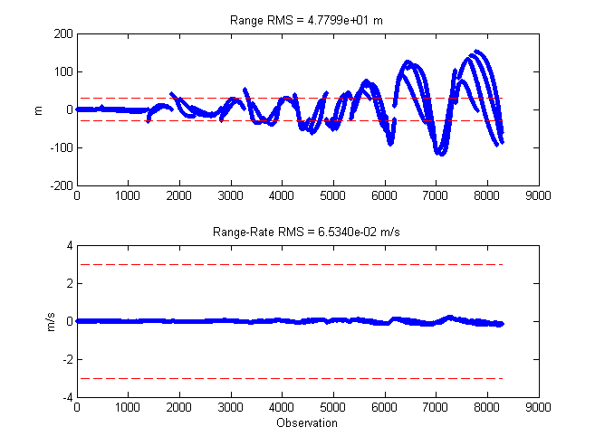
Diff between EKF and CKF positions, since their plots are so close:
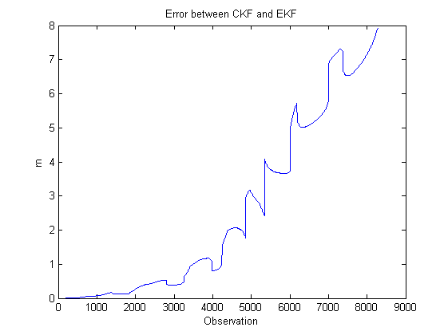

Comparison
Unfortunately, my filters did not work well. For some reason, I was unable to stop the covariance from collapsing, leading to my measurements getting ignored. However, I can speak to how it should work.

The CKF propagates a single reference trajectory, and the estimated deviation is applied to it to get the true state. The EKF would constantly update the reference state, helping remove issues caused by the propagation model and the linearity involved in the STM. Thus, the EKF should perform better if implemented correctly. It should also be able to handle larger a priori errors just by merit of being a little more robust.

