I decided to see how far I could take the SRIF. First, I tried a pseudo-extended method in which I iterated 50 days of observations, then another 50, etc. The residuals are shown below.
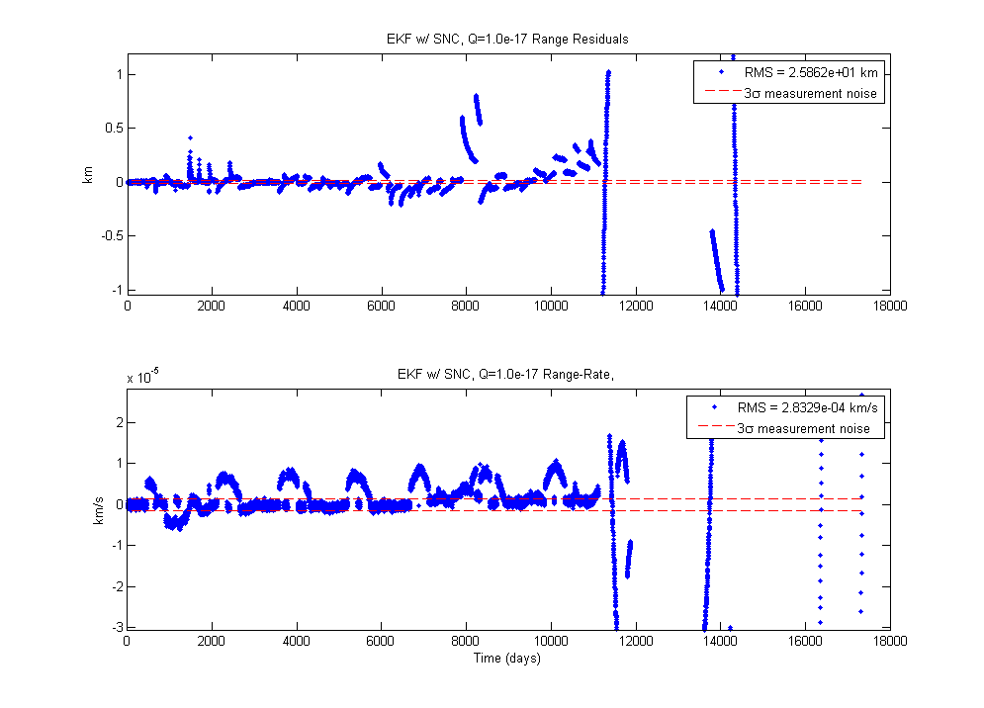

As you can see, they did not fit the noise.

Next, I added process noise to the SRIF. The implementation was pretty easy, just do the orthogonal transformation on the augmented cost-function matrix. I found that large noise variance resulted in good fits for the range values, but the range-rate data saw an over-fit. This was not good, because the measurements would be trusted too much, compared to the dynamic model of the filter. These residuals can be seen below.
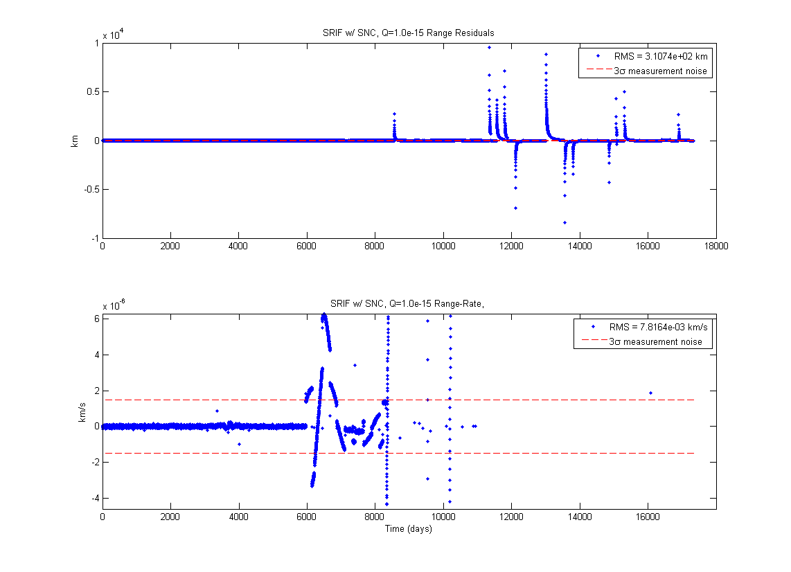

Eventually I settled on Q_SNC = I*1e-17, and reiterated the first 12k observations. The residuals can be seen below, wrt observation number and time.
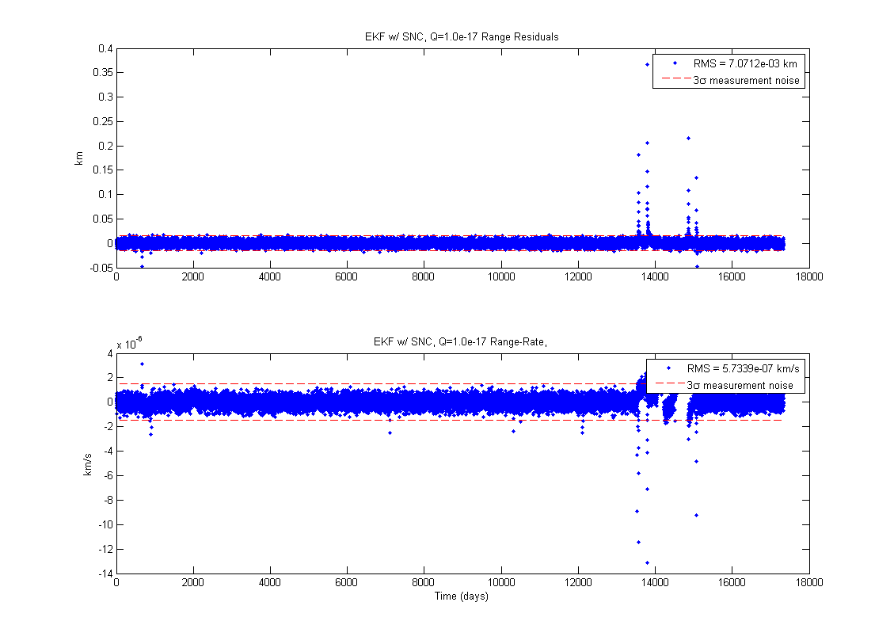

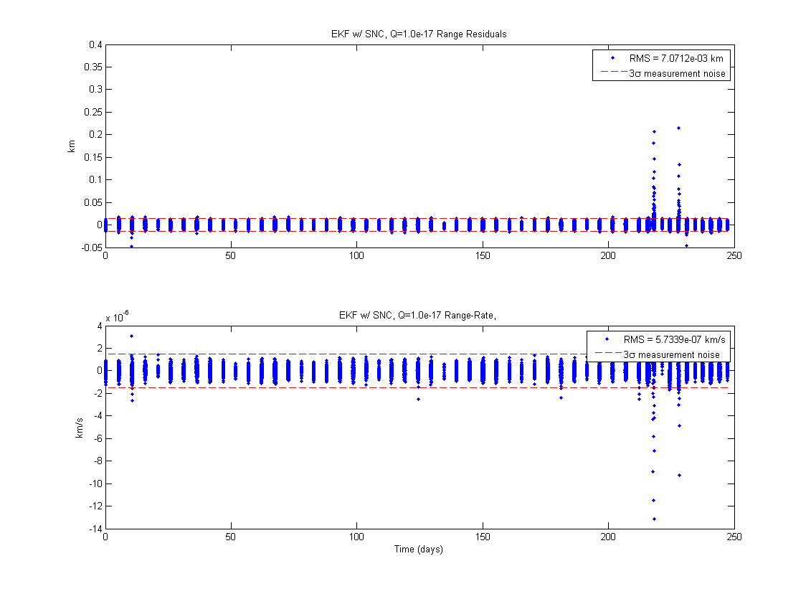
Around 13k observations, the residuals see a significant hiccup. My guess is that the spacecraft has a time-varying component to the SRP acceleration, more specifically the A-to-m ratio. However, this cannot be separately determined from Cr because they only appear multiplied together where they appear in the dynamic model. However, I could see the estimate of Cr change between the first 12k observations and the rest, which tells me that the change is being captured in the estimate of Cr. Seeing the first ~12k observations being spaced about 5 days apart, and that those observations are mostly within the 3-sigma noise boundary, I guess that the period is roughly 5 days for the A-to-m variability. The A-to-m discrepancies could also point to some discrete maneuvers.

An interesting effect I saw in running the SRIF in an iterated fashion, was that the propagated covariance (like I had done in HW 5) would become immediately non-PD when I plugged it back in for the next set of observations to be processed. I solved this by having Rj as an output and propagating that. I thought it was interesting to see that the error from inverting Rj, propagating P, and inverting/chol'ing just once was enough to kill the filter. The condition number of the resulting covariance was ~12, explaining the problem with the inversions.

The estimated initial state was found by the SRIF to be:
-2.740917877722248e+08
-9.286975337897727e+07
-4.016906097822943e+07
32.670145948361892
-8.937573859839247
-3.878981505223423
0.956858514892039

This is within the a priori covariance. The covariance and B-plane intercept from the SRIF are shown below:
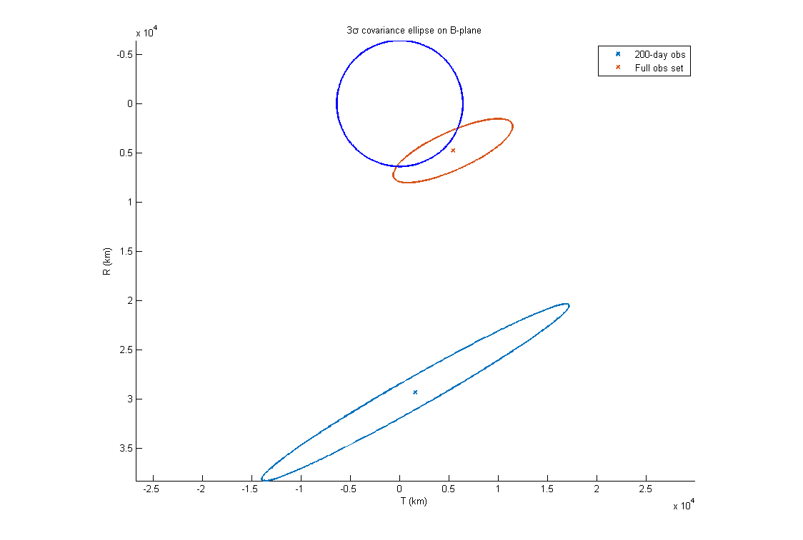
The un-fit data at the end of the observations drove the intercept point very close to the Earth. In fact, the spacecraft will almost certainly impact since the true intercept is between the center of the earth and the B-plane target.

I also did a short experiment with the EKF. I found the optimum process noise variance to be 1e-17, but the EKF did not perform nearly as well as the SRIF. The error induced by the high condition of the covariance would explain why this happened.

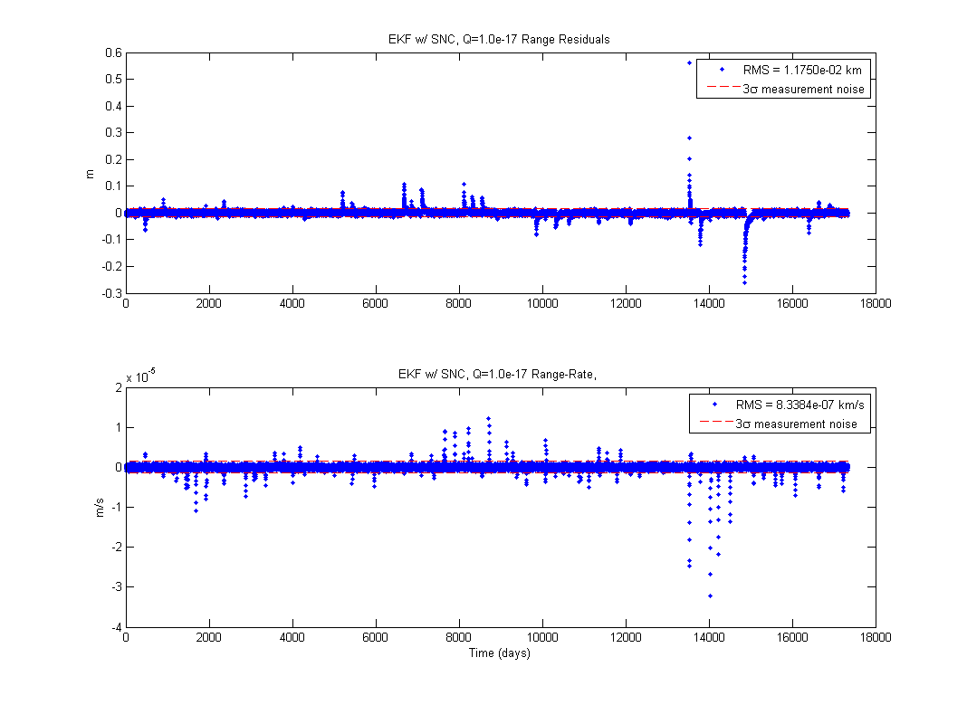
There are large residuals in the same places as the SRIF, as well as the observations leading up to them. Any more process noise would over-fit the range-rate data, and thus would not provide a better solution. A better way might be to try DMC or Gauss-Markov.

The smoothed initial state from the EKF was:
-5.481939277580566e8
-1.857163612096067e8
-0.804014173269862e8
65.341099651990419
-17.875922196441294
-7.757348752245751
2.989416137479457

The initial velocity is double the a priori! The results are definitely suspect. I believe the large errors from the a priori are due to the smoothing of the estimate taking into account the latest data along with the insufficient dynamic model in the filter. It's just fitting some trajectory, and due to the large timescale the error is large. This filter/smoother worked well before, so I don't think it's my implementation. Below is the B-plane target:

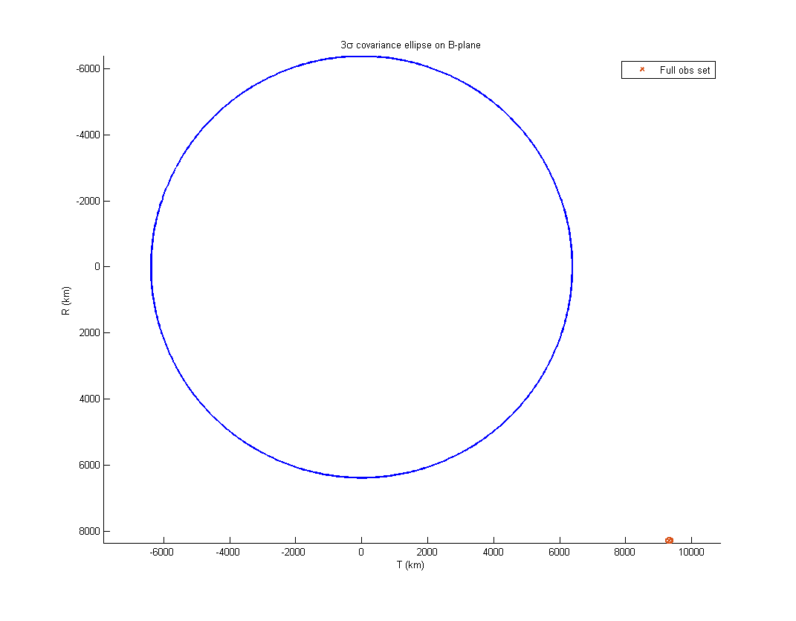

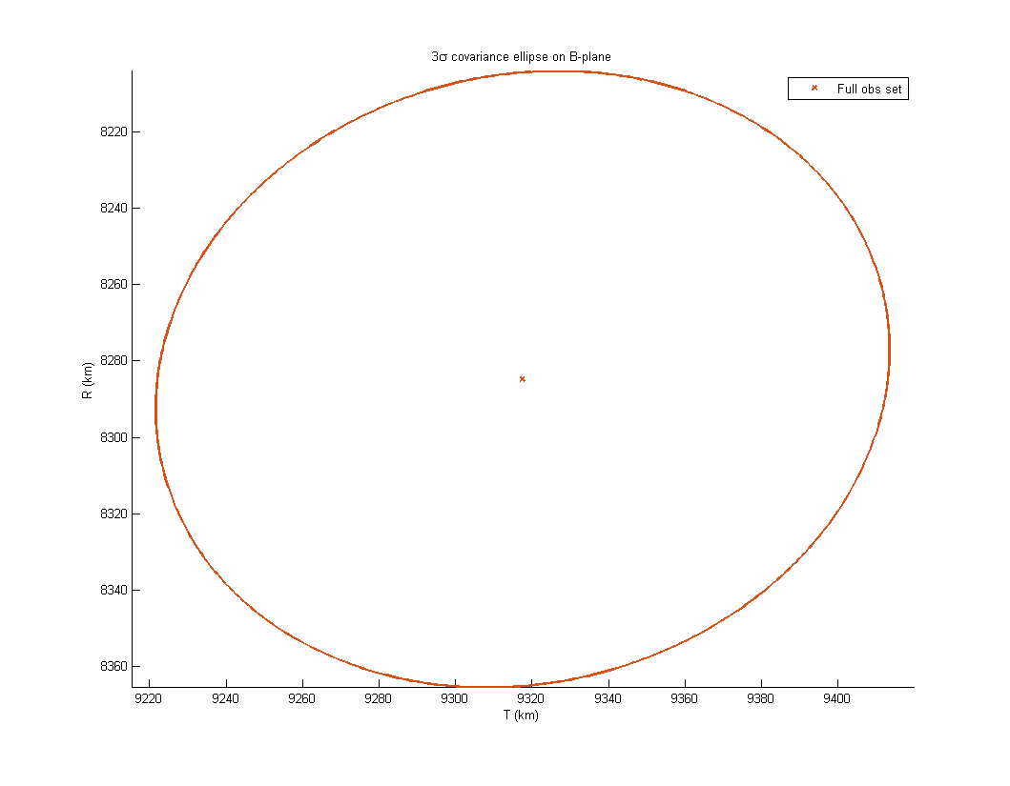

The final EKF covariance is much smaller than the SRIF's. However, I trust the SRIF's covariance more due to the filter using the square root, resulting in no inversions or squaring throughout the processing. The target, however, is more desirable.

