Part 1
Problem 6.5

Sxc =
-0.1469 0.0002
-0.0123 4.2299e-05

Perturbation Matrix Gamma =
-0.1469 0.0002
-0.0123 4.2299e-05

Data noise covariance Px =
0.5178 -0.0214
-0.0214 0.9953

Consider covariance Pc =
0.5394 -0.0196 -0.1469 0.0002
-0.0196 0.9954 -0.0123 0.0000
-0.1469 -0.0123 1.0000 0
0.0002 0.0000 0 1.0000

From the sensitivity and perturbation matricies, one can see that the biggest contributor to filter error in these consider parameters is x0 on the pendulum angle, theta. This makes sense because it has a noticeable effect on the range measurement that incorporates x0 and theta. The gravity constant has a smaller effect on both estimated states for this standard deviation. This is due in part to it not being in the measurement model, as well as the small angles assumed to be involved. The sensitivity and pertubation matrices are the same due to the Pcc being identity.

The data noise covariance shows that the filter reduces the uncertainty from the a priori covariance.

The consider covariance again demonstrates the sizable impact on the estimated parameters by the consider parameters through the cross terms. The cross terms are just Sxc due to Pcc being identity.

Problem 6.8
With C = [h] = [6.4] and Pcc = [1], I get
X_est =
2.8718 ± 0.1439 m
0.0022 ± 0.0205 m/s

This is closer to the true value than the example in the book, because there were no dynamic modeling errors assumed. The measurement model error was only had an effect in Hc.

Perturbation Matrix Gamma =
-0.1439
-0.0205

one standard deviation of the affects position the most, up to .14 meters in this case.

Pc =

0.1635 0.0146 -0.1439
0.0146 0.4538 -0.0205
-0.1439 -0.0205 1.0000

Px =

0.1428 0.0117
0.0117 0.4534

As expected, the considered parameter increases the uncertainty in the state. These uncertainties are smaller than the example at 10 seconds due to there only being one parameter considered.
Part 2
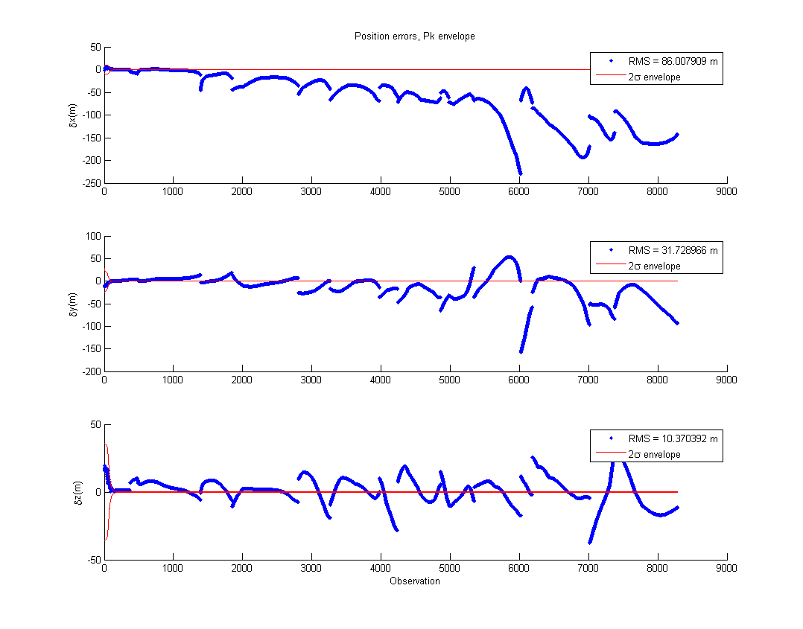
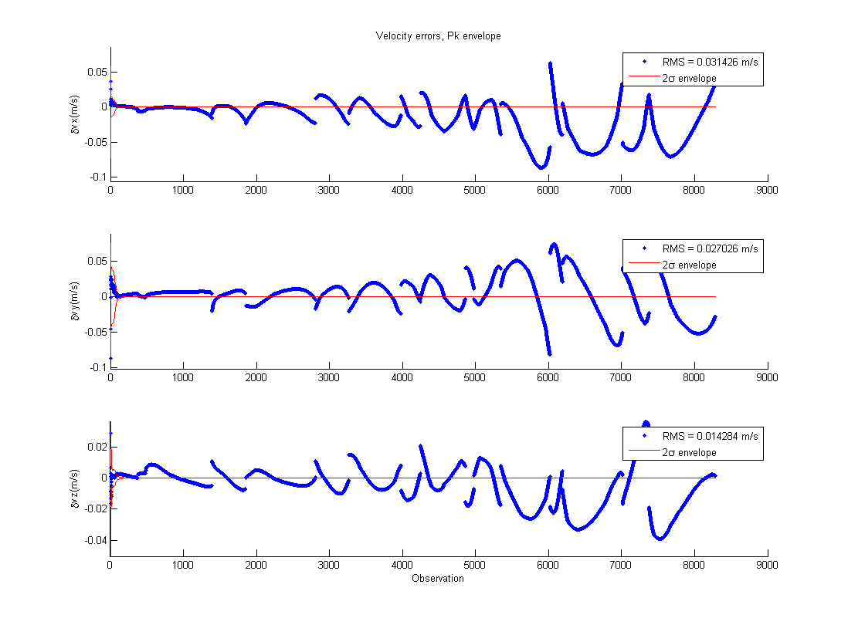

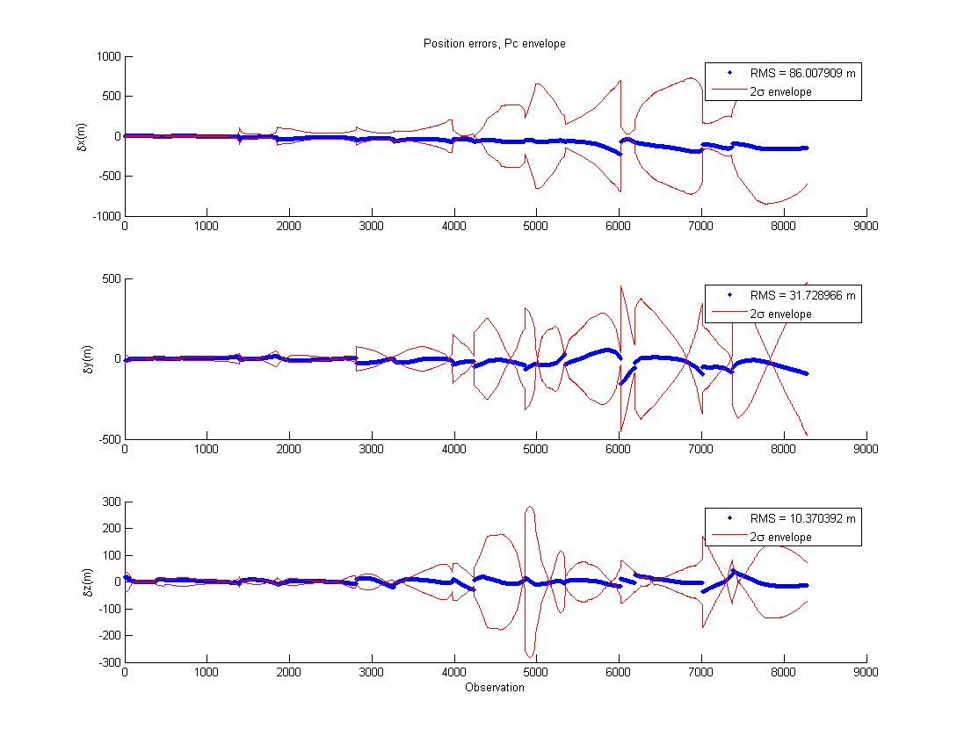
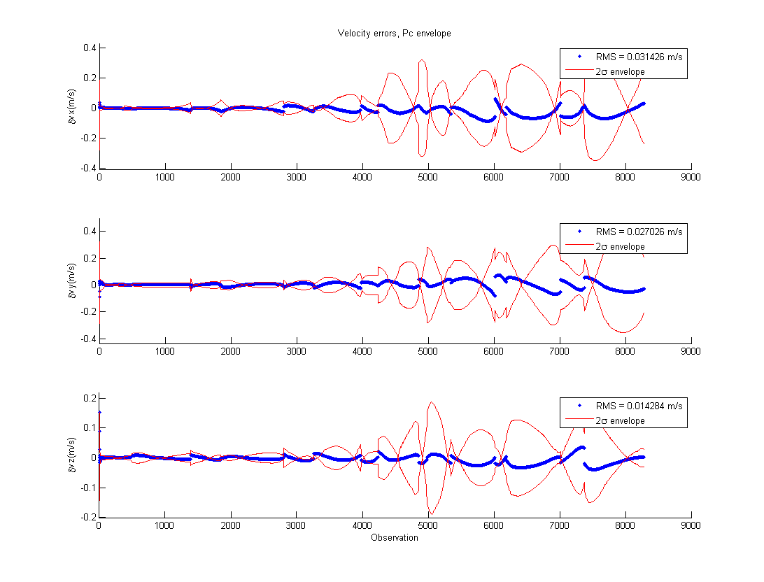
Percentage of x_est points outside of 2-sigma Pc envelope:

Component | Percent outside envelope
x | 6.98
y | 4.23
z | 11.99
vx | 6.52
vy | 5.43
vz | 11.06

I find the Pc envelope to be more realistic. When J3 is not modeled, the filter becomes smug because the covariance, the filter's measure of uncertainty, shrinks. Saturation can be seen when the errors are outside of the Pk envelope. With the Pc envelope, you can see that, while the errors are the same, the errors are within the envelope. The higher uncertainty is accurate in this case, since the errors are so large. 2-sigma distance from the mean should contain ~95% of the points, and the Pc case comes pretty close for most components.

Mapping the estimated state back to t0, and propagating it and the Pc:
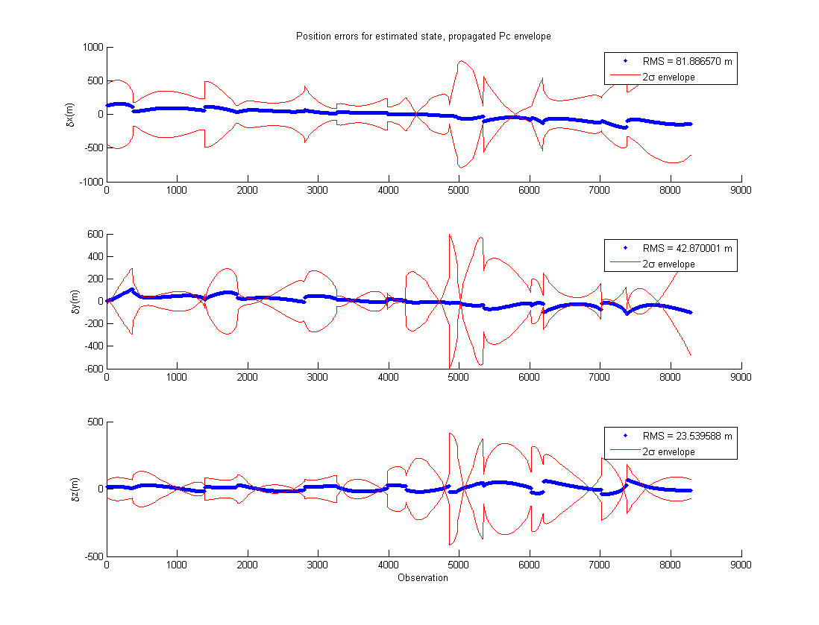
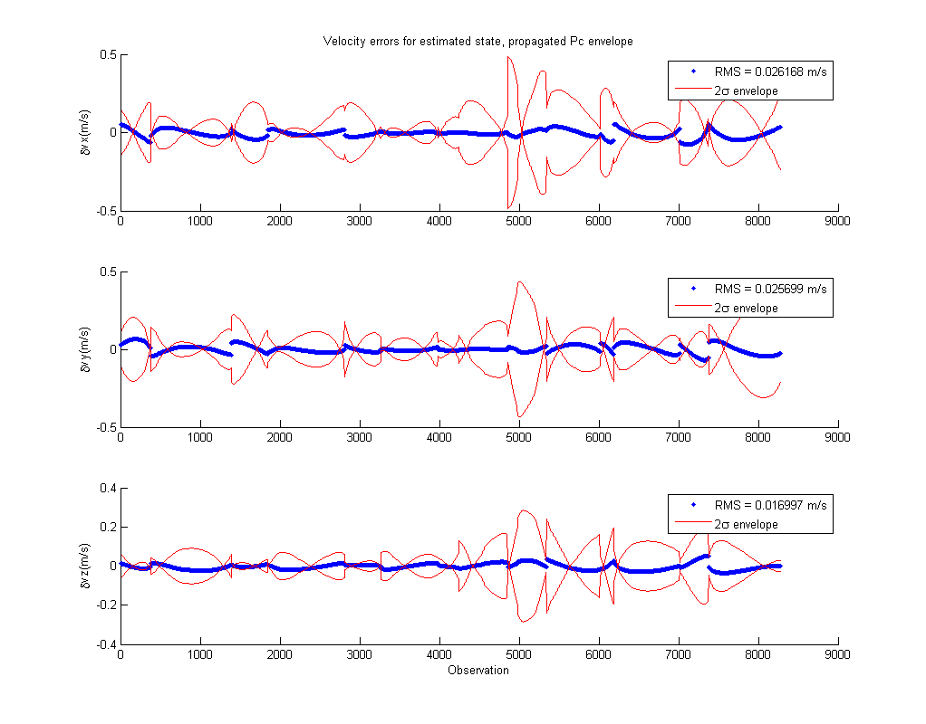
Percentage of component post-fit points outside of the 2-sigma envelope

Component | Percent outside envelope
x | 1.63
y | 11.29
z | 3.97
vx | 6.8
vy | 4.4
vz | 5.86

The state errors are generally close to the 95% mark that should be characterized by 2-sigma. The y component being so much larger surprised me. The covariance for it is generally tighter than the x component, which I would think should be roughly the same. The z component being different does not surprise me, since that's what the J3 perturbation is based on.

For a linear filter, the affect of J3 is too large to ignore over a long timespan. The uncertainty become unrealistically small, when the true uncertainty was comparatively much larger at the end of the observation period. In my opinion, J3 should be modeled, or process noise should be added to reflect the true uncertainty in the filter. In addition, prediction becomes hard because the error grows with time (as seen in Born's book). Including J3 would not only reduce the uncertainty realistically in the filter (making its output more accurate), but would give the prediction of future states more certainty.

