1.a) Plot the P trace errors
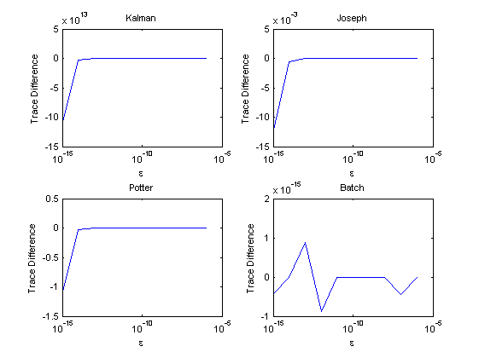Illustration 1: semilogx() Plots of P2 Trace Error
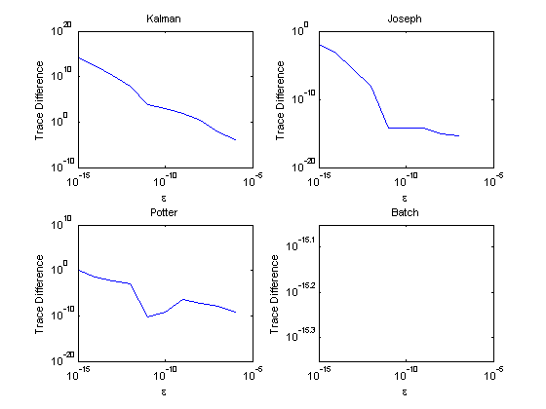Illustration 2: loglog() Plots of P2 Trace Error
b) Compare the behavior of the filters
As epsilon gets smaller:
- Kalman gets less accurate (it's the least accurate of the four). The covariance matrix isn't guaranteed to be positive definite (or symmetric) due to the iterative solution to obtain it.
- Joseph is the most accurate of the sequential processors, for longer. It ensures that the covariance matrix is positive definite and symmetric.
- Potter is still better than Kalman because it's a square-root algorithm; it computes and carries the better conditioned W instead of P. It does not force P to be positive definite or symmetric, so it is generally less accurate, although more machine precision might see this algorithm fairing better than Joseph, according to the trend.
- Batch is pretty much exact, given the precision of my computer. At least every-other one has an error of zero, leading me to believe that any deviation is due to rounding. This P is calculated in one step, so there aren't in-between calculations that accumulate errors. The zero-error causes the lines not to be plotted in the loglog() for Batch.

2.a) Derive the true covariance of the given system and measurement model in terms of epsilon.
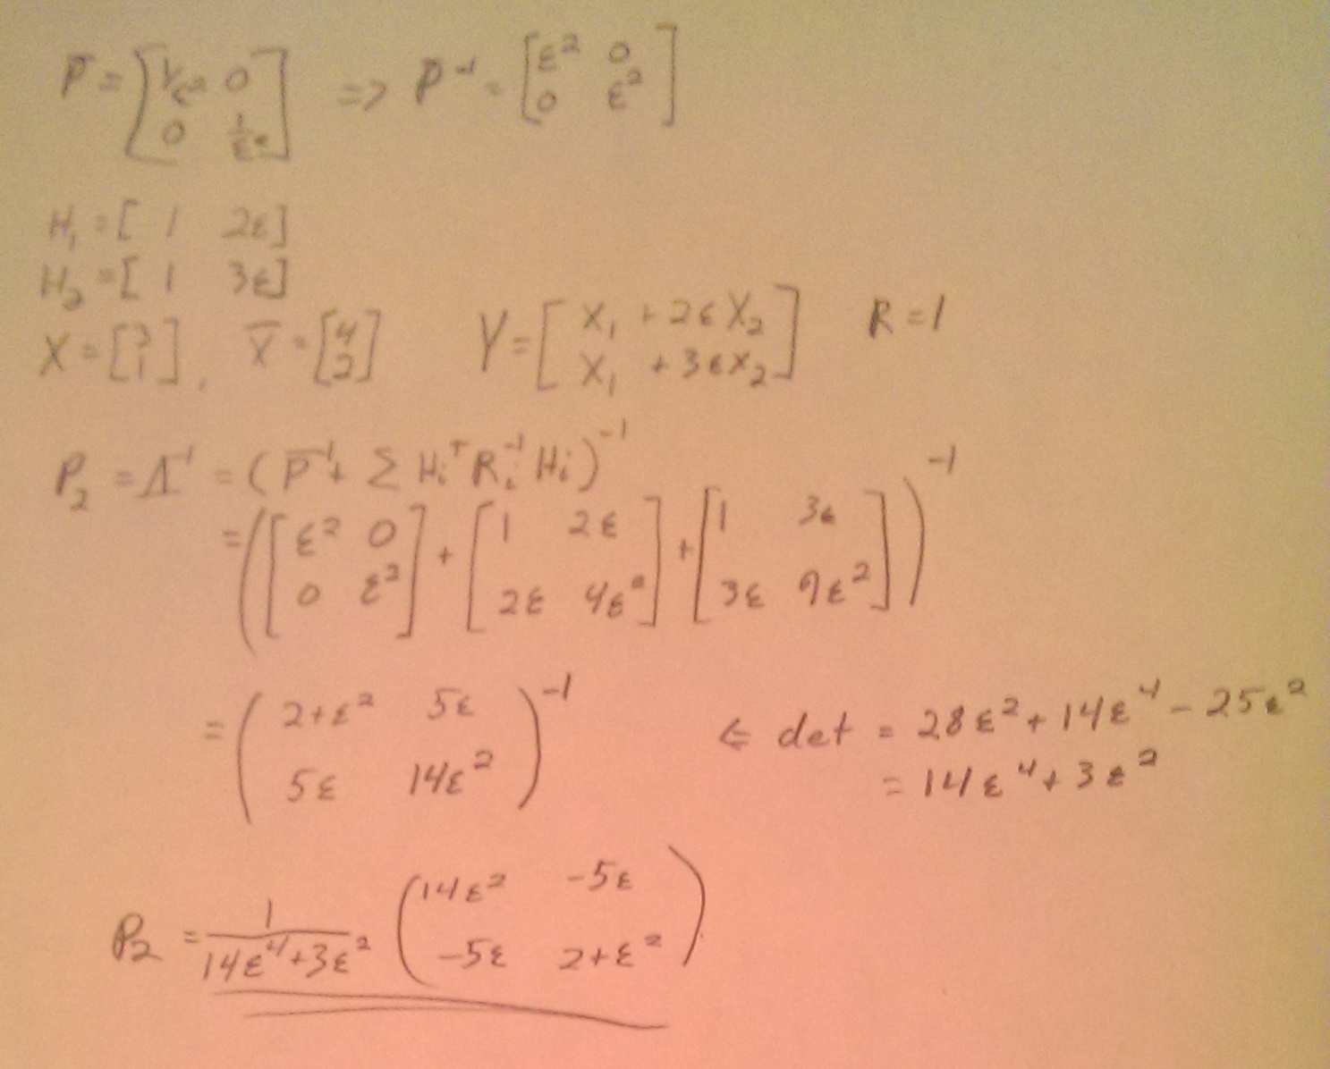Illustration 3: Derivation of True P
b) Plots of the state errors (computed - exact):
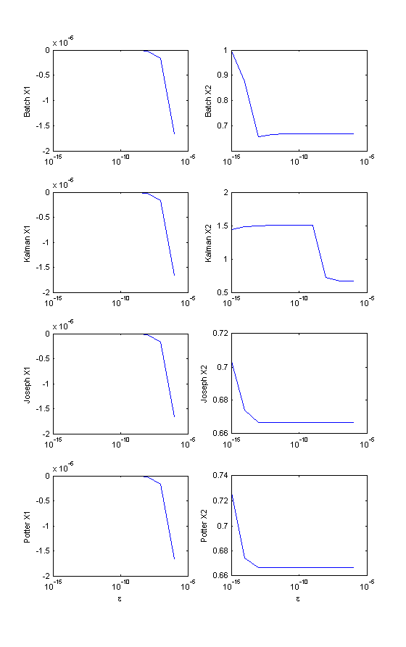Illustration 4: semilogx() of State Variables Error
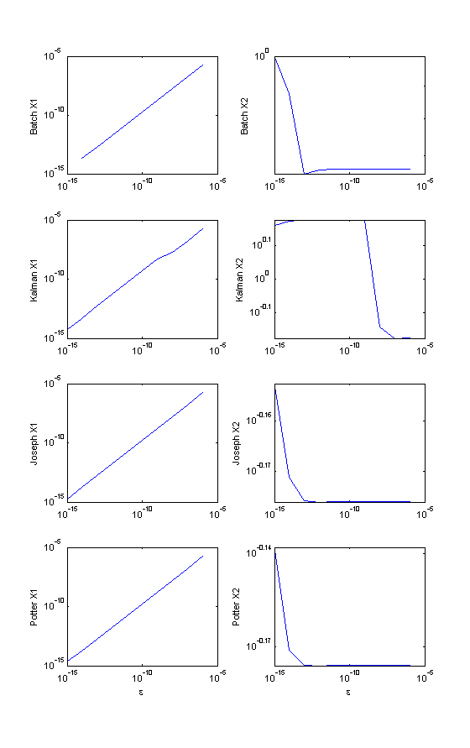Illustration 5: loglog() of State Variables Error

c) Compare and contrast the performance of the filters
For X1, all the filters performed very closely. As epsilon got smaller, the solution became more accurate. This is because X1's variance is very small (much more so than X2's, which is why the errors are so much smaller). However, all of the X2s increased in error with smaller epsilon, due to the measurement model being less and less able to “utilize” the X2 term with finite machine precision. For X2, Potter and Joseph methods had the least error overall, due to their well-calculated P. Kalman continued to hold the same magnitude of error for all values of epsilon. Batch held a similar value to Joseph and Potter until epsilon=10-13, where its error drastically increased. This would be due to a very small information matrix causing numerical errors when taking the inverse.

