Smoothed CKF
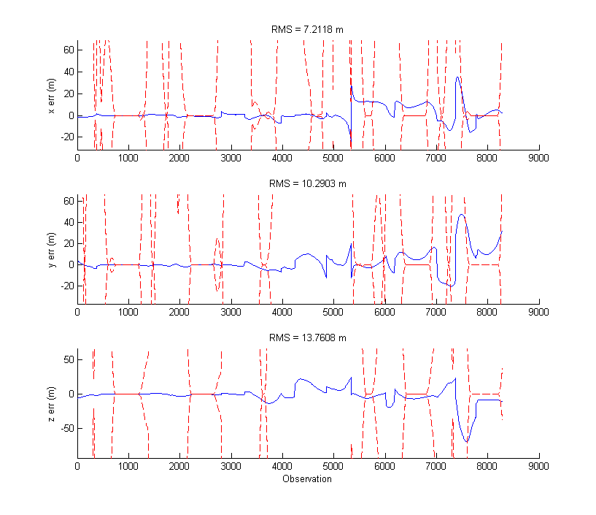

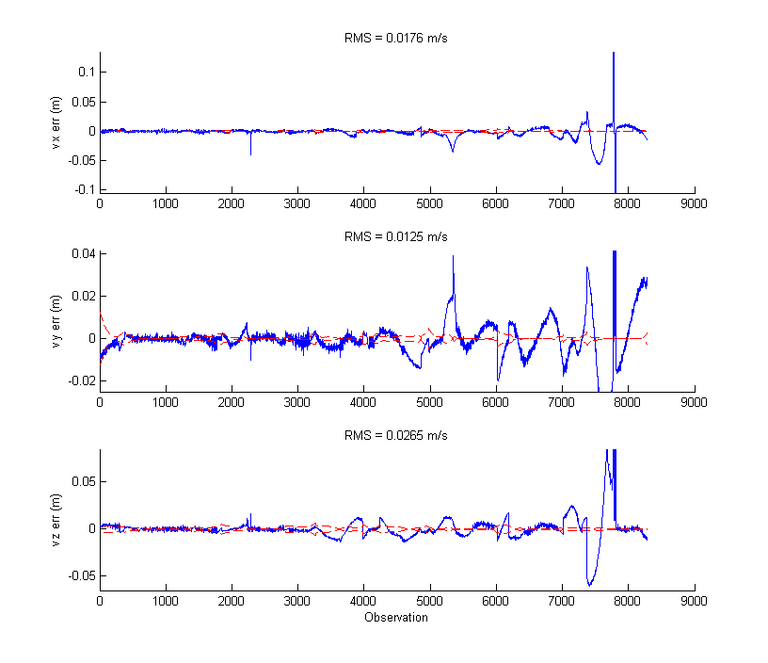
Compared to the unsmoothed EKF with SNC, the errors from truth are much smaller. However, the CKF still diverges toward the end of the observations. However, much of the time the errors are outside of the very small covariance envelope.

EKF Smoother
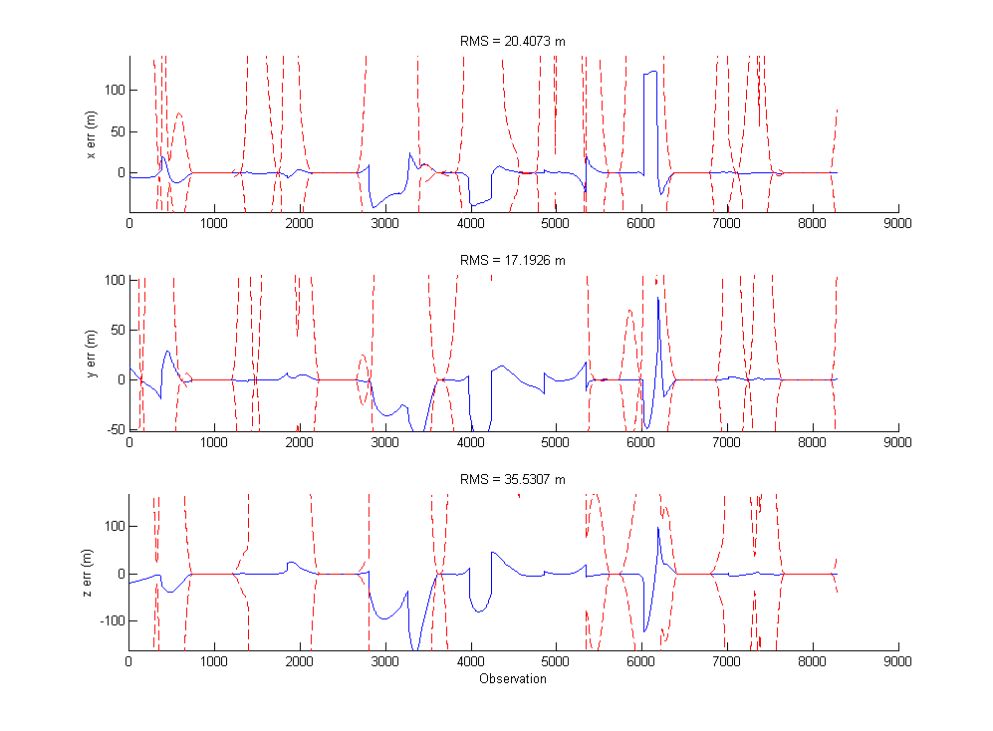

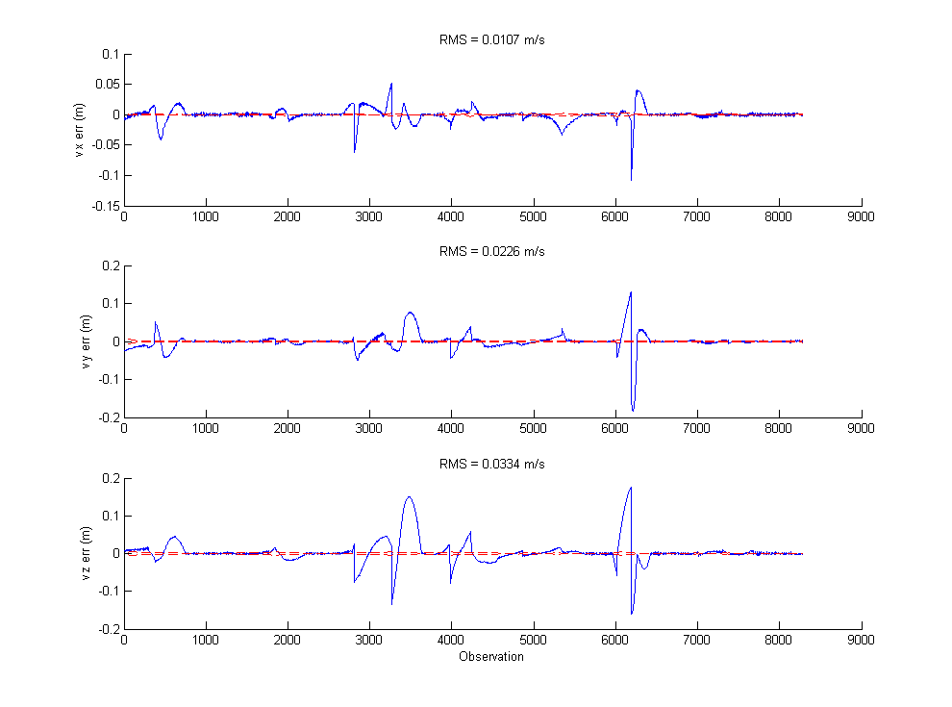
The RMS were bigger on the EKF, which I did not expect. However, the position errors stay within the covariance envelope better.

