**Awanish Mishra 9919103170**

**F-6**  
**VLAB EXPERIMENT-1**

**AIM: -** To study and verify Maximum Power Transfer Theorem **THEORY:**

This theorem states that -  
"In an active network of impedances maximum power is transferred to the load when the load impedance equals the complex conjugate of an equivalent source impedance of the network as viewed from the terminals of the load."

Consider the network shown in the fig.a.

Let Zeq is the equivalent impedance of the network as viewed from the terminals AB replacing all the independent sources by their internal impedances as shown in fig.b.

Let this Zeq = Z1 || Z2 = R+jX  
Then the maximum power is transferred to the load, if ZL is complex conjugate of Zeq.

 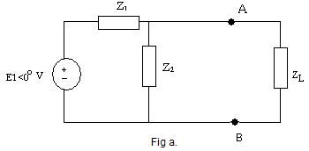 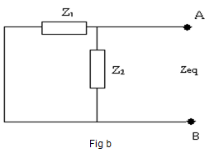

Mathematically ZL = Zeq*

So ZL = R-jX

Thus for maximum power transfer to the load, the resistance of load and resistance part of Zeq must be same while the reactance of load and and Zeq must same in magnitude but of opposite in sign. So if Zeq reactance is inductive, ZL must be capacitive and vice versa.

**Formula used**

RL = Rth ....... For maximum power transfer.

IL = Vth / (Rth + RL) = Vth / (Rth + Rth)

Where,

Pmax = IL2 RL = Vth2 / 4Rth

**Circuit Diagram:**

= Vth / 2 Rth

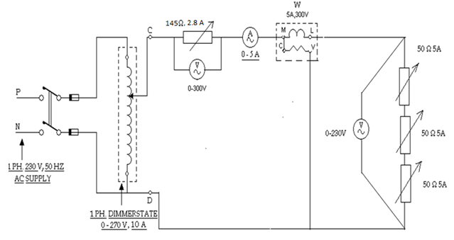

**PROCEDURE:**

1. Connect the circuit as shown in circuit diagram.
2. Apply the source voltage and observe the value of current and load voltage.

3. Remove the connections and measure the value of source resistance and load resistance.

**OBSERVATION TABLE:**

|  |  |  |  |
| --- | --- | --- | --- |
| Source Voltage Vs Volts | Power W | Load Voltage VL Volts | Load Current I Amp |

10 20 10

1.09

4.35 0 .71

5.9459+j4.3243 11.8919+j8.648 4.0541+j4.3243

0.2391+j0.17391 0.4783+j0.347 0.1630+j0.1739

           

How to perform simulation

1. Enter the values of V1, Z1& Z2.  
2. Click on solve button.  
3. It will give the values of ZL, VTH, ZTH, IAB& PMAX.  
4. It is verified from ZL& ZTH that RL = RS for maximum power transfer.

**Output**

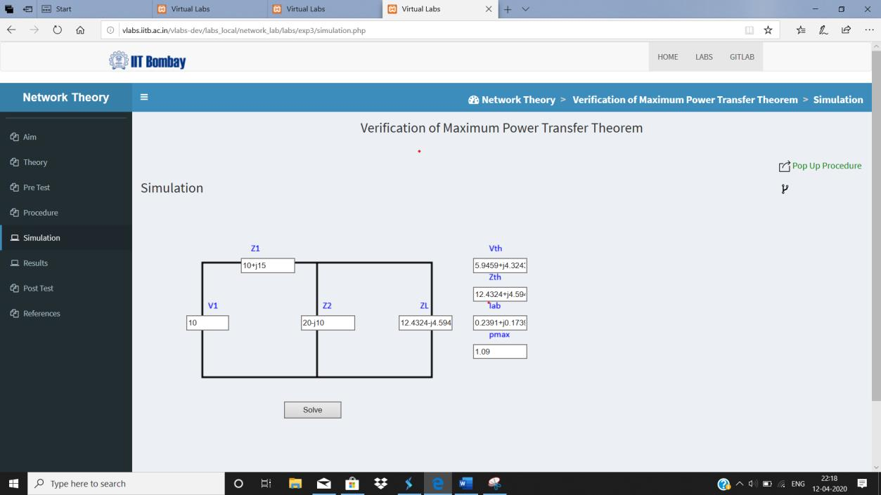 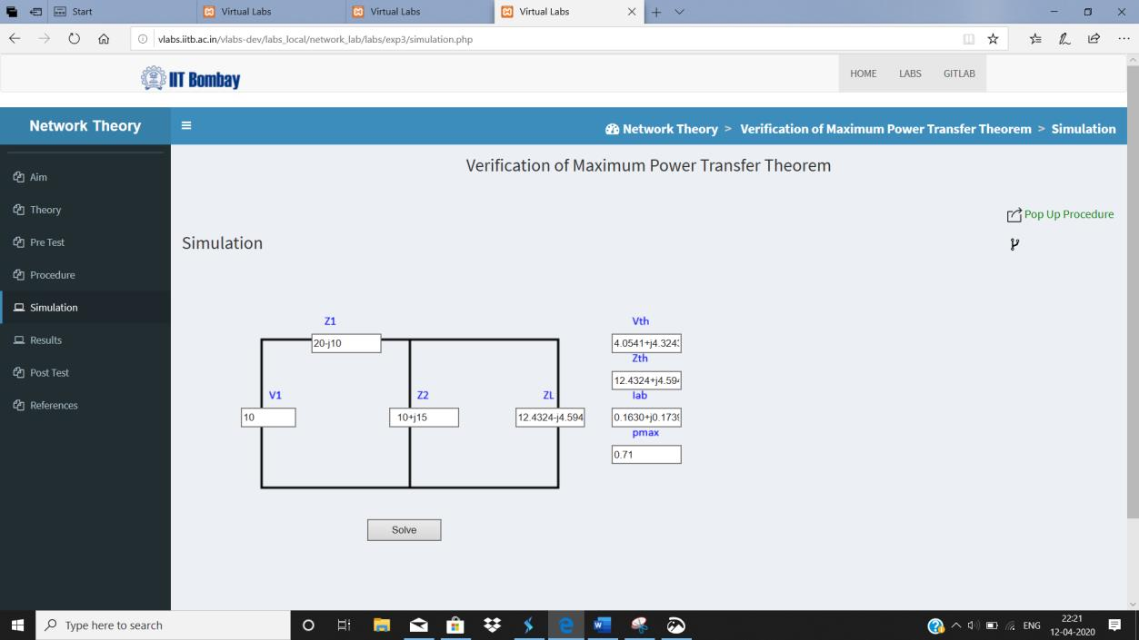

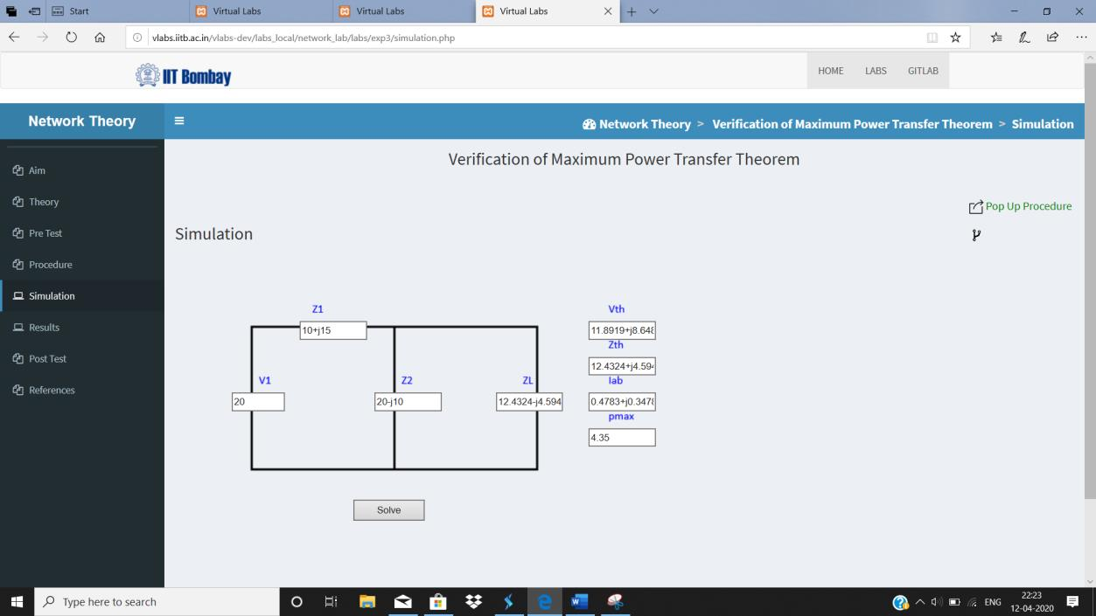

**RESULT TABLE:-**

  

Observed Calculated

|  |  |  |
| --- | --- | --- |
| Power Transfer | 1.09 4.35 0.71 | 1.08 4.35 0.70 |

**CONCLUSION:**

1. How power transfer is done using maximum power transfer theorem?
2. Is there any method to have maximum transfer of power, explain?