PHYSICS VLAB EXPERIMENT-1

CHARACTERISTICS OF THERMISTOR

# AIM

To plot the characteristics of thermistor and hence find the temperature coefficient of resistance.

# COMPONENTS

Thermistor

Rheostat

Voltmeter

Multimeter

Oil bath arrangement

# FORMULA USED

The dependence of the resistance on temperature can be approximated by following equation,

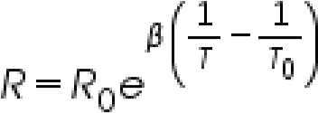

---------------------------------- (1)

R is the resistance of thermistor at the temperature T (in K)

Ro is the resistance at given temperature To (in K) β is the material specific-constant

The material specific-constant of a NTC thermistor is calculated by the formula shown below and is expressed in degrees Kelvin (°K).

Differentiating (1) w.r.t. T, we get

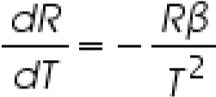

and  is the temp coefficient of resistance.

Taking log of (1) and simplifying we get,

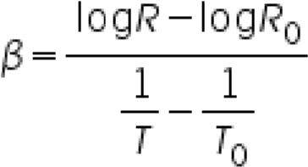---------------------------------- (2)

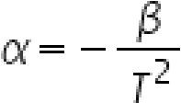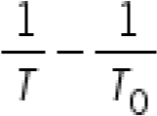

and so -------------------------------------- (3)

A graph plotted with  in Y axis and in X axis for NTC and PTC is shown below. The slope of graph gives value of β.

FIG:CIRCUIT DIAGRAM

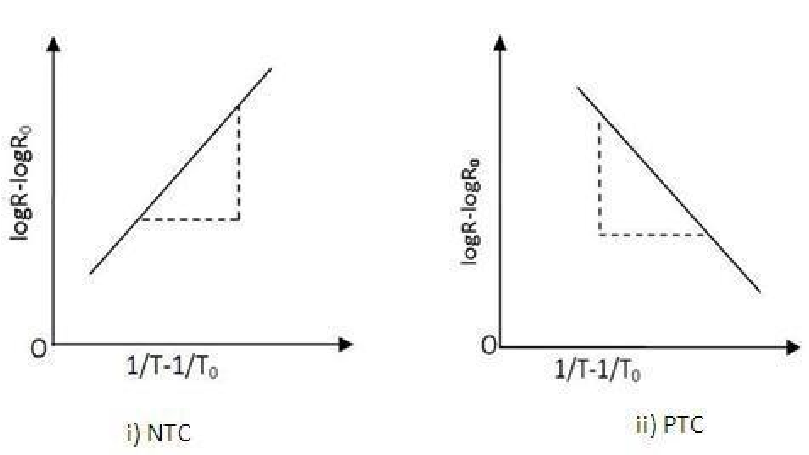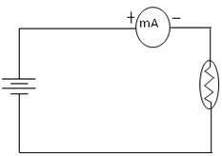

# OBSERVATIONS

The least count of Voltmeter is = 0.1 V The least count of Ammeter is=0.01mA

The room temperature is = 25°C

To=25 (degree Celsius)

Ro=100 ohms

|  |  |  |  |  |  |  |  |  |
| --- | --- | --- | --- | --- | --- | --- | --- | --- |
| **Voltag e**  **V** | **Temperatu**  **re**  **C** | **Temperatu**  **re**  **K** | **Curren**  **t**  **I(mA)** | **Resistanc e** | **1/T-**  **1/To** | **LogR**  **-**  **LogR o** | **beta** | **alpha=beta/T ^2** |
| 0.2 | 30 | 303 | 2.7420 | 84.56 | -  0.0000 5 | -  0.168 | 3340 | -0.03637 |
| 0.2 | 40 | 313 | 4.1634 | 59.47 | -  0.0001 6 | -  0.518 | 3225 | -0.03291 |
| 0.2 | 50 | 323 | 4.9900 | 40.89 | -  0.0002 5 | -  0.894 | 3576 | -0.03427 |
| 0.2 | 60 | 333 | 6.9696 | 27.53 | -  0.0003 5 | -1.29 | 3685.7 1 | -0.03323 |
| 0.2 | 70 | 343 | 12.496 | 17.534 | -  0.0004 4 | -  1.709 | 3884.0 9 | -0.03301 |
| 0.2 | 80 | 353 | 17.902 | 11.653 | -  0.0005 2 | -  2.149 | 4132.6 9 | -0.03316 |
| 0.2 | 90 | 363 | 28.853 | 7.335 | -  0.0006 0 | -  2.612 | 4353.3 3 | -0.03303 |
| 0.2 | 100 | 373 | 43.570 | 4.517 | -  0.0006 7 | -  3.097 | 4622.3 8 | -0.03322 |
|  |  |  |  |  |  |  |  |  |

**1/T-1/To**

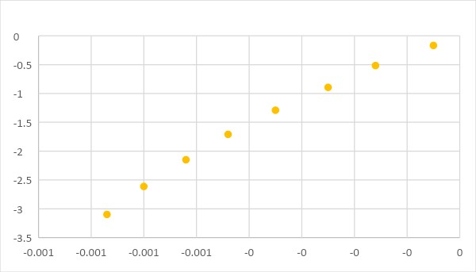

# 1/T-1/To vs logR-logRo

# RESULTS

The material constant of thermistor, β= 3851.2

The temperature coefficient of thermistor , α= 0.0335500(K-1)

# PRECAUTIONS

1. Temperature may not be taken at regular intervals.
2. Check the connections properly.
3. Note down the readings properly with correct units etc.

# SOURCES OF ERROR

1. Units may not be taken properly.
2. Calculations and readings may be incorrect.
3. Use calculator for doing calculations etc.