Malware Types & Behavior Analysis

1. Objective
The objective of this task is to understand different types of malwares and analyze their behavior using an online malware analysis tool (VirusTotal).
- Different Malware types
Virus: Malicious code that attaches to legitimate files and spreads when the infected program is executed.
Worm: Self-replicating malware that spreads automatically through networks without user interaction.
Trojan: Malicious software disguised as legitimate applications to steal data or provide unauthorized access.
Ransomware: Malware that encrypts or locks files and demands payment for restoration.
Spyware: Malware that secretly monitors user activity and collects sensitive information.
Adware: Software that displays unwanted advertisements and may track user behavior.

2. Tool Used
- VirusTotal (online malware scanning and analysis platform)

3. Malware Sample Analyzed
Sample Hash (EICAR test malware):
44d88612fea8a8f36de82e1278abb02f
This hash represents a test malware sample used for security research and antivirus testing.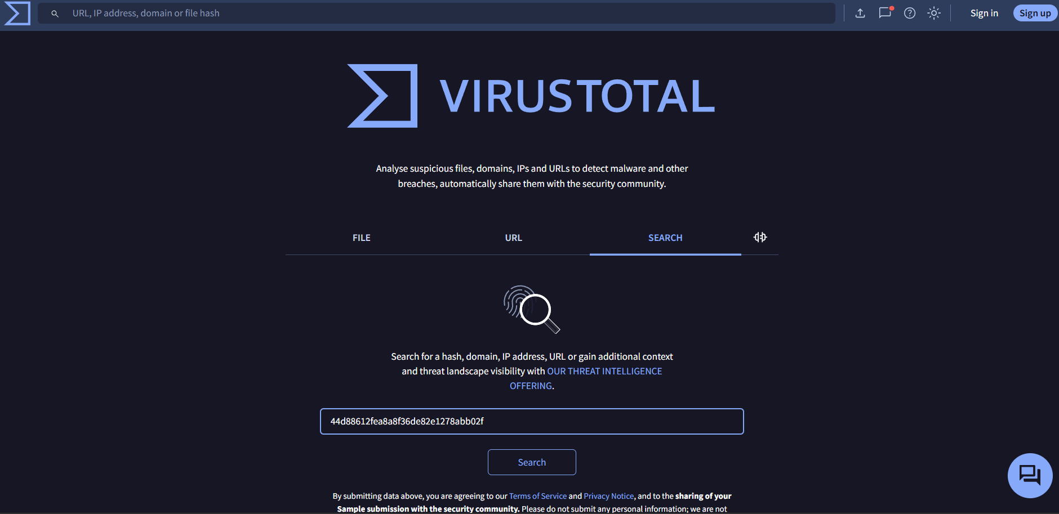

4. Malware Classification
Based on VirusTotal analysis, the sample is classified as:
- Malware Type: Trojan
- Category: Test malware sample
- Detection Ratio: Detected as malicious by multiple antivirus engines
Trojans are malicious programs that appear legitimate but perform harmful activities in the background.
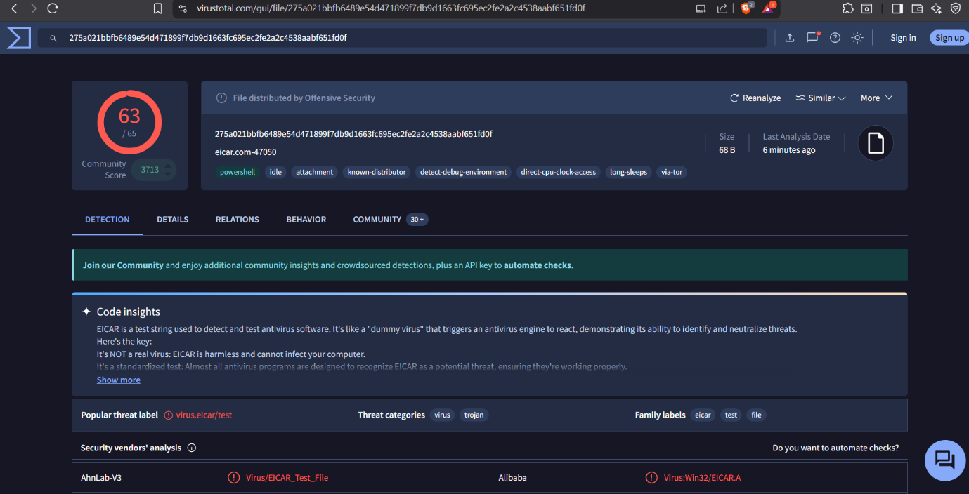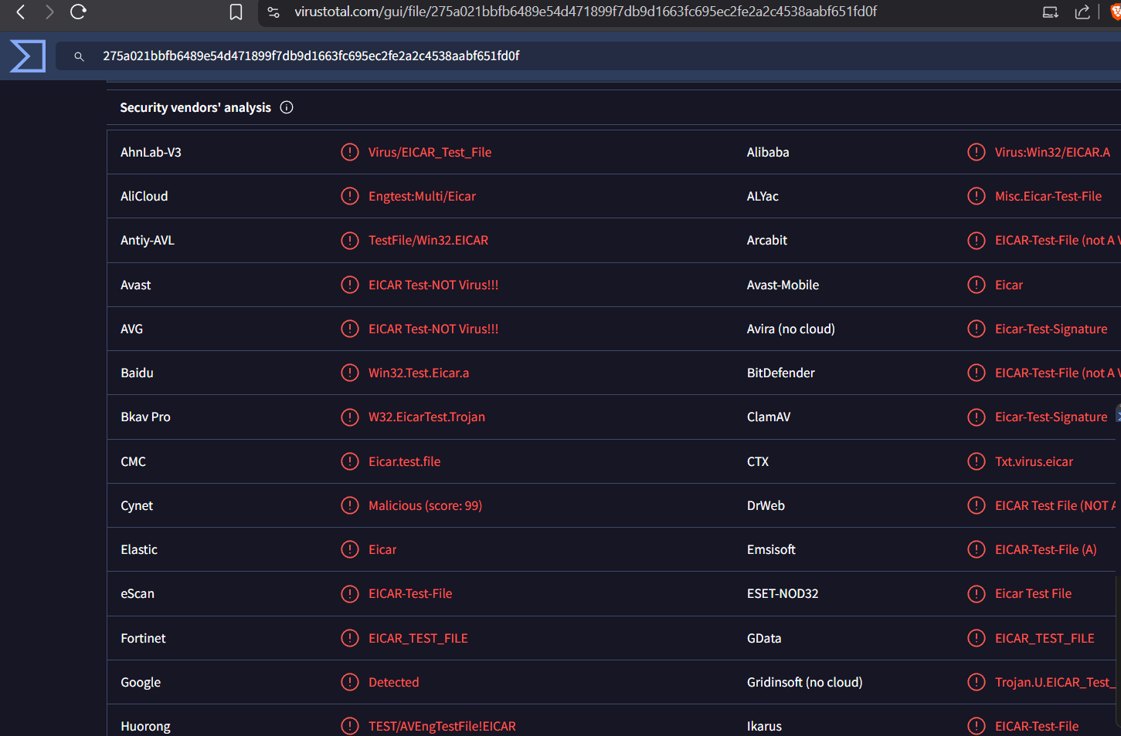

5. Behavior Analysis
The following suspicious behaviors were observed:
- Identified as malicious by security vendors
- Potential execution of harmful code
- Possible file modification and system interaction
- Ability to spread through files or downloads
These behaviors indicate that the file exhibits characteristics of malware.

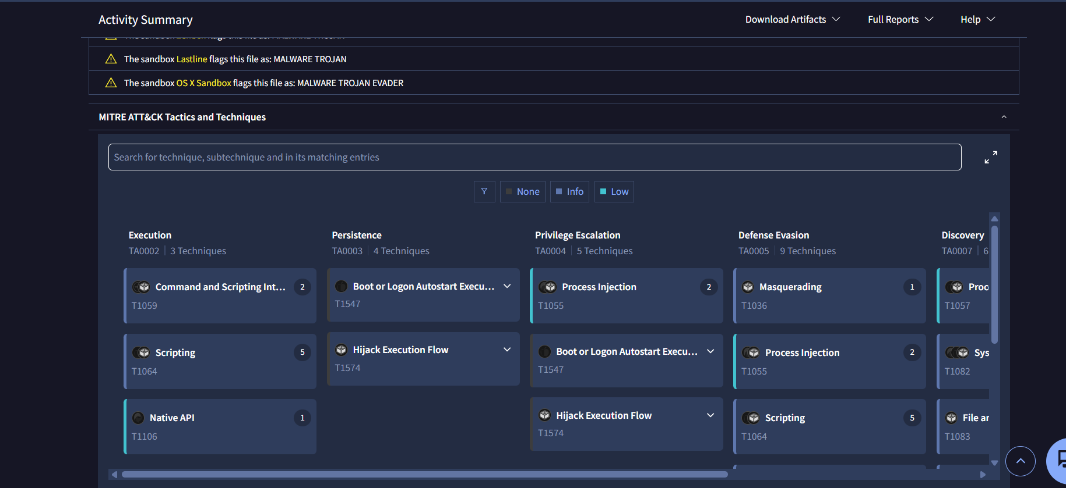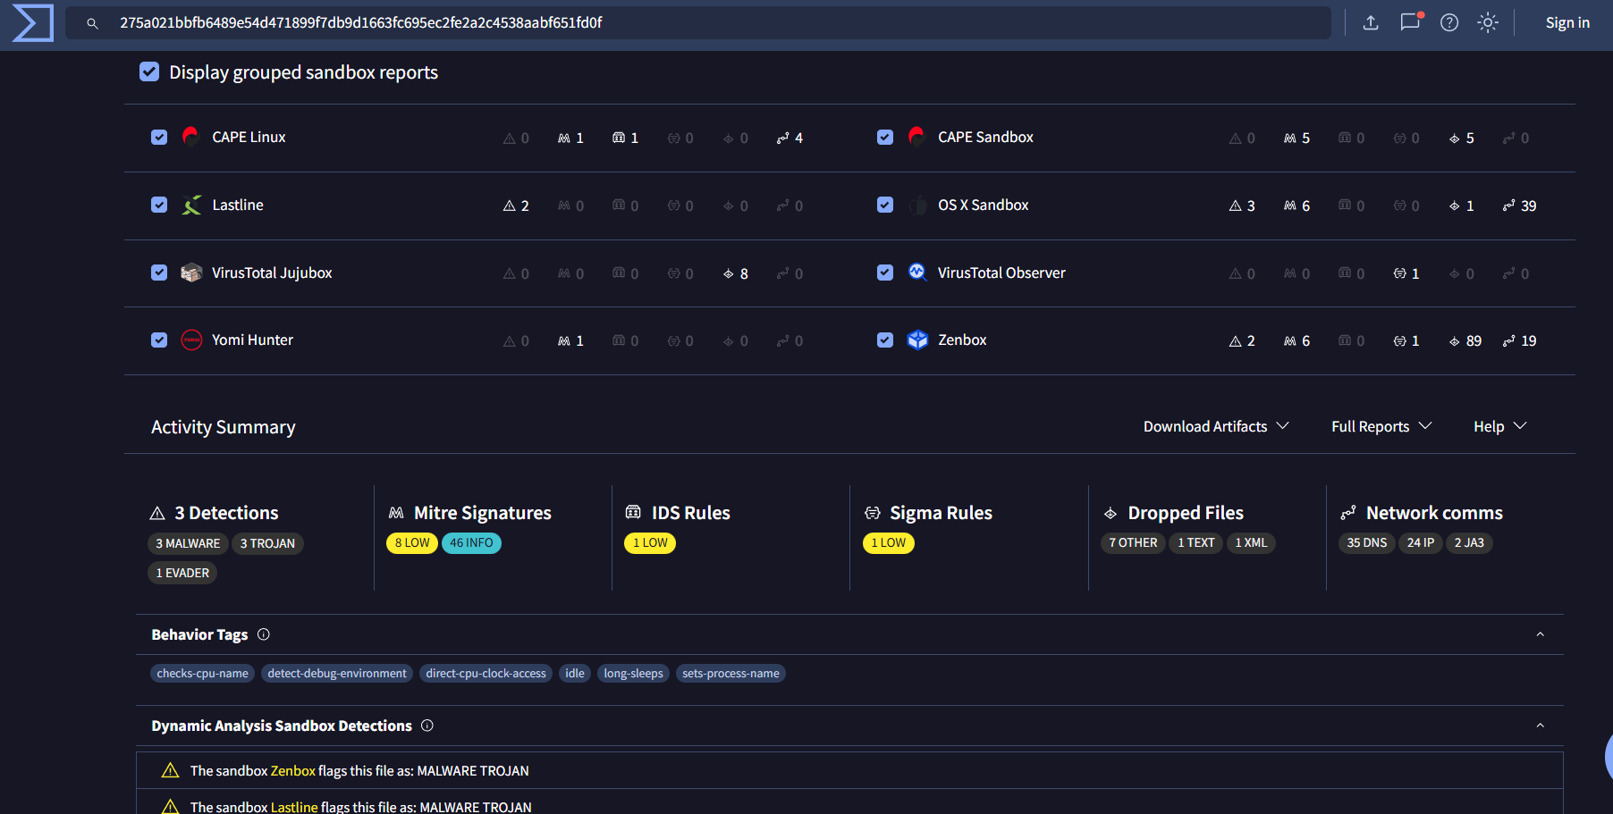
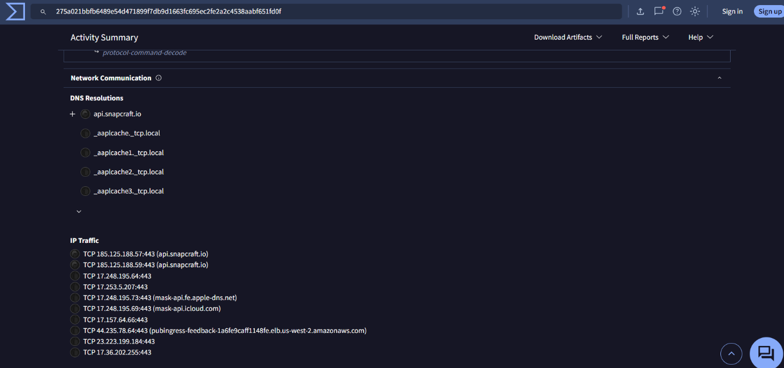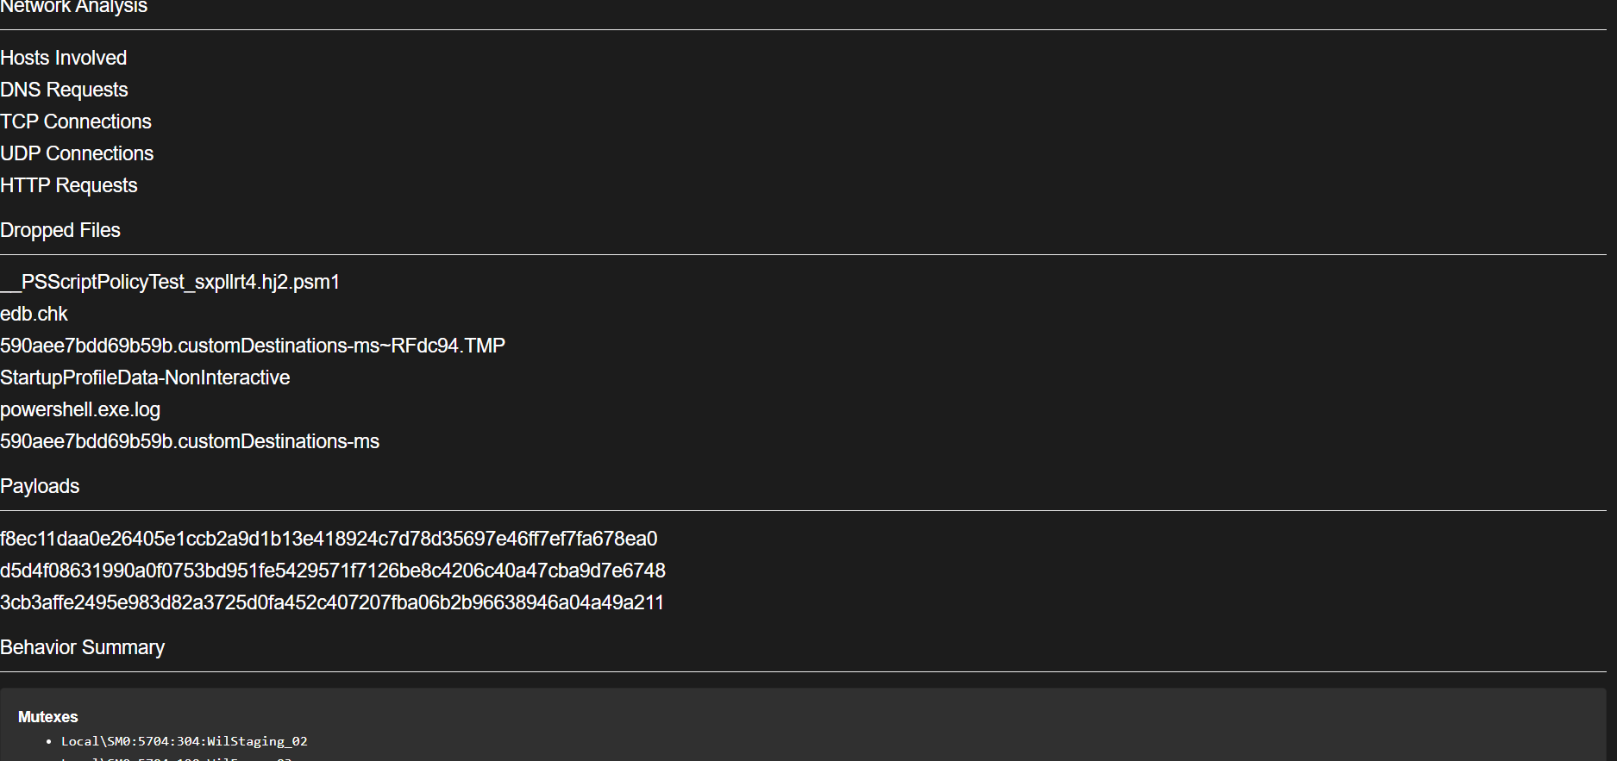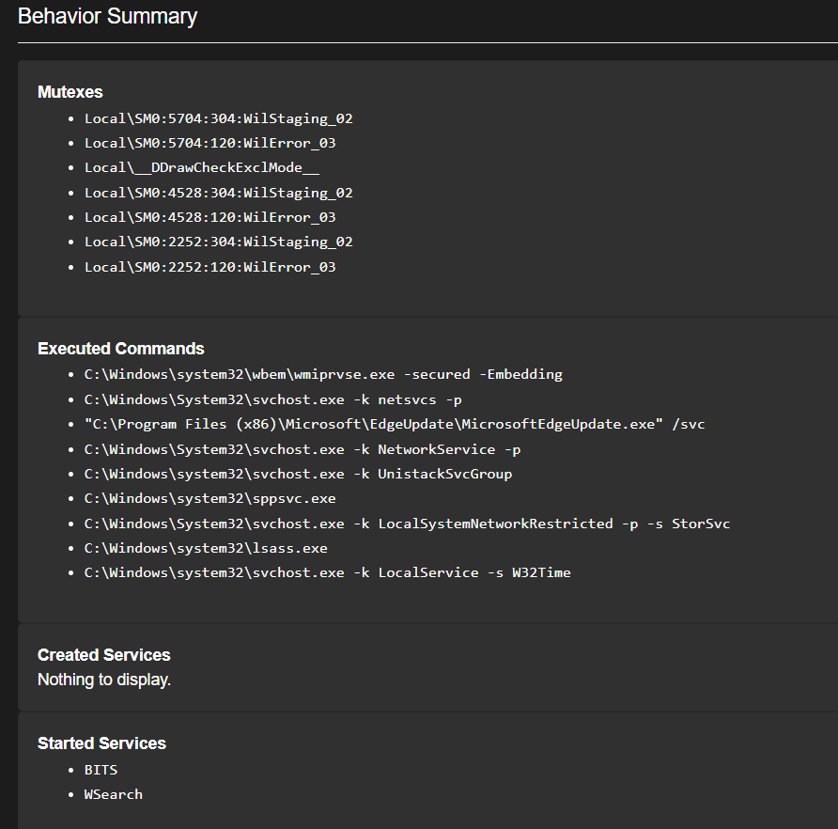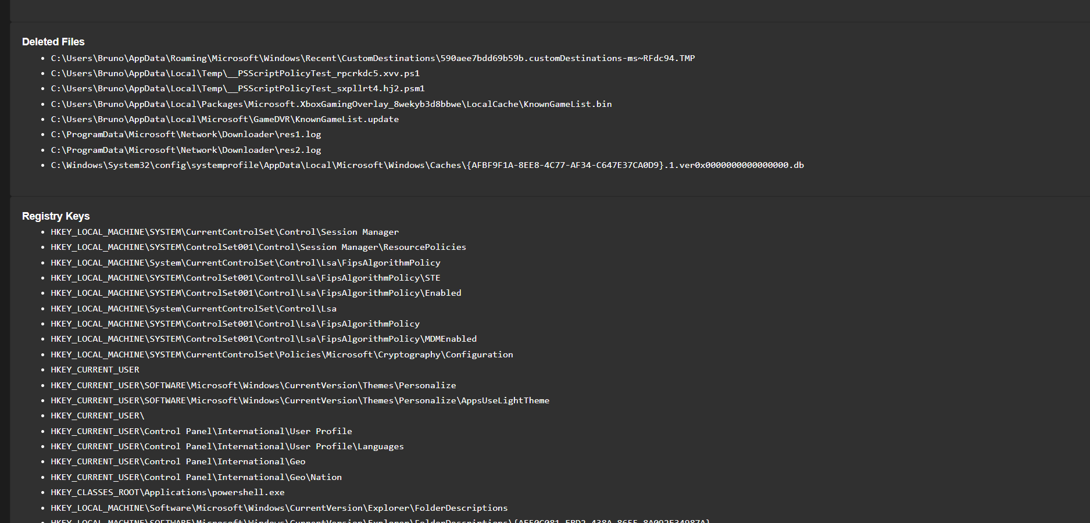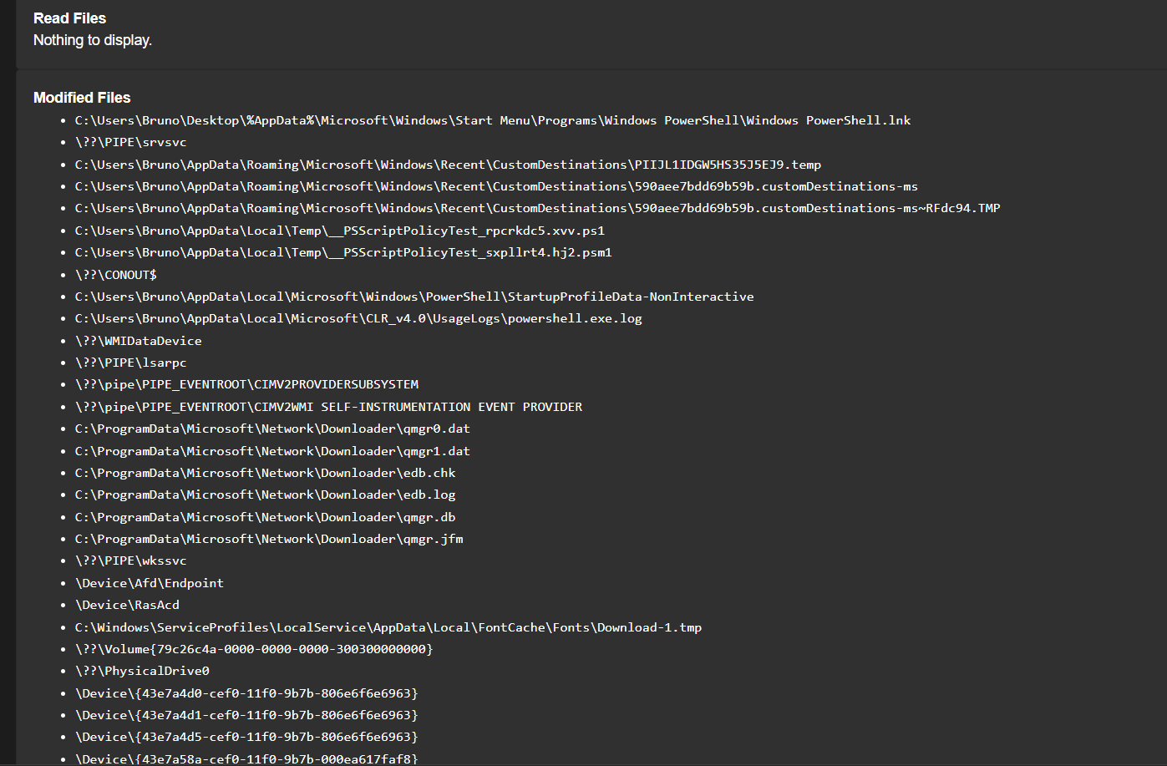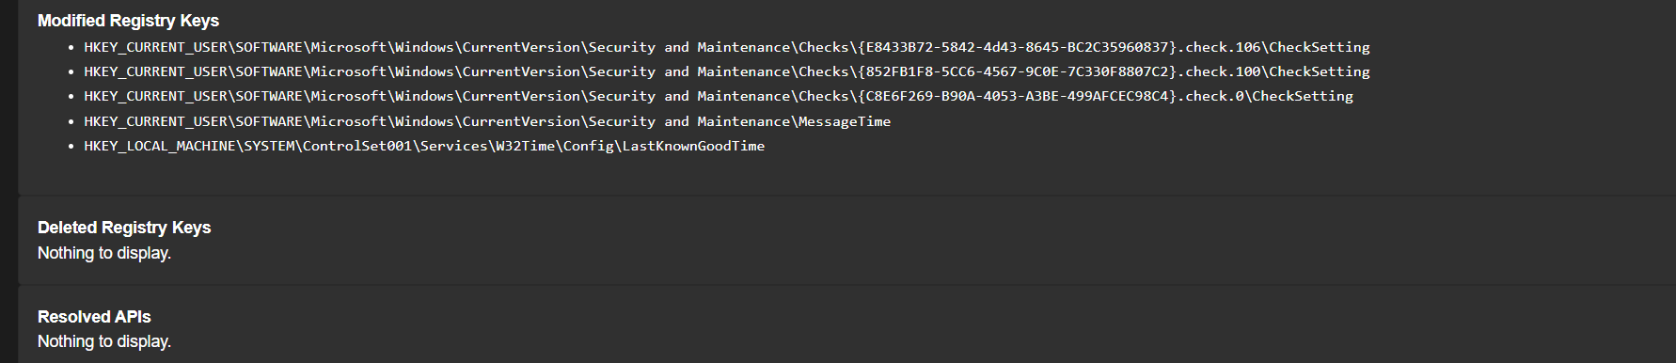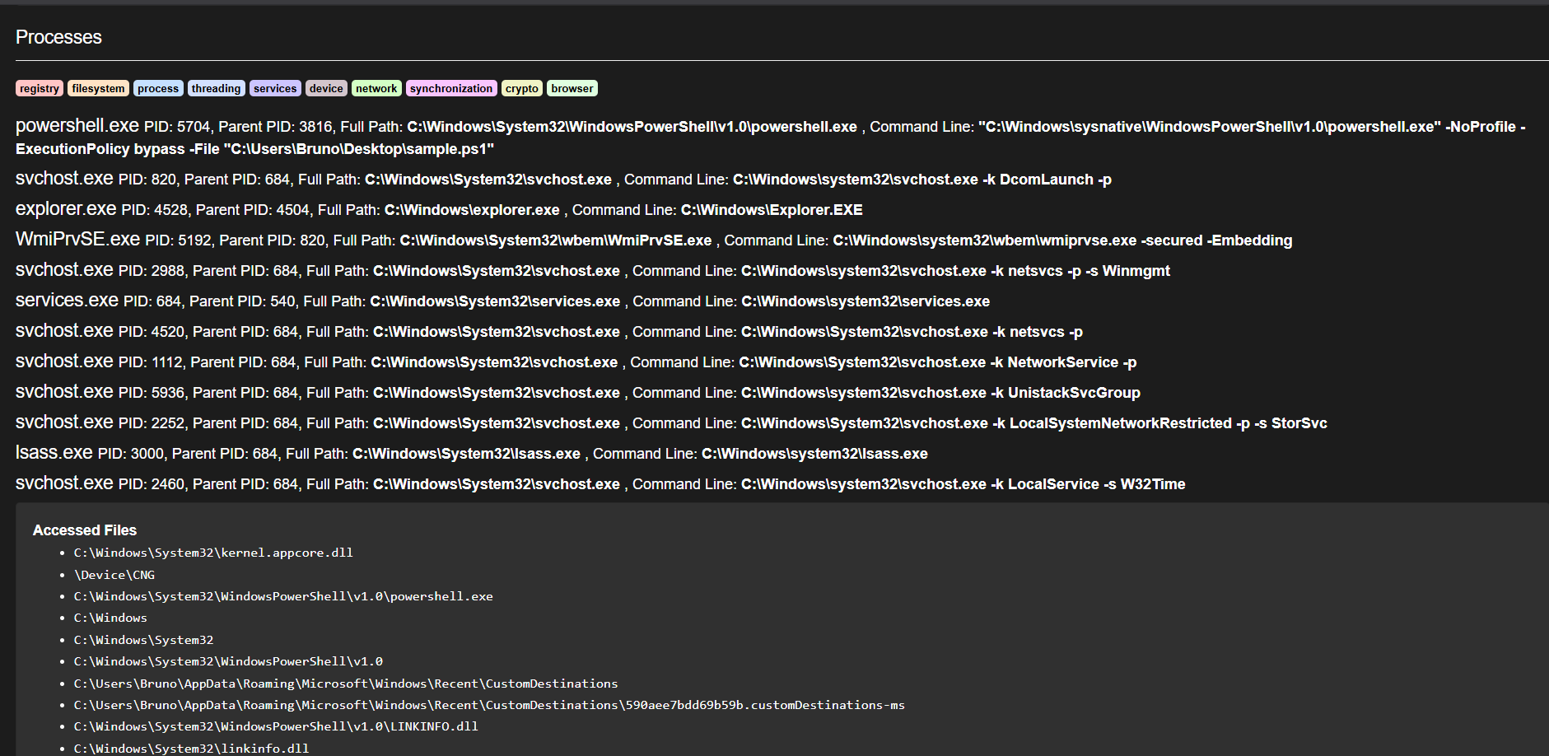

6. Malware Lifecycle
The malware follows a typical lifecycle:
- Creation – Malware is developed by attackers
- Delivery – Malware is distributed through email, downloads, or websites
- Execution – Malware runs on the victim’s system
- Persistence – Malware stays active in the system
- Propagation – Malware spreads to other systems
- Impact – Data theft, system damage, or ransom demand

7. Malware Spread Methods
Common methods of malware spread include:
- Email attachments
- Malicious websites
- Fake software downloads
- USB devices
- Network vulnerabilities

8. Prevention Methods
To protect systems from malware:
- Use updated antivirus software
- Avoid downloading unknown files
- Keep operating systems and software updated
- Use firewalls
- Enable email filtering
- Use strong passwords and Multi-Factor Authentication (MFA)
- Educate users about phishing and malware

9. Observations
- Malware can be detected using online tools like VirusTotal
- Trojans often disguise themselves as legitimate software
- Malware behaviour can be analyzed through detection reports
- Security awareness is crucial to prevent infections

10. Conclusion
This task demonstrates that malware can be classified and analyzed safely using VirusTotal. Understanding malware types and behavior helps in improving cybersecurity awareness and implementing effective defence mechanisms.

