Restaurant Review

Software Engineering
ITSC-3155
Final Project Report

<11/26/2019>

<Group 7>

Table of Contents
1. Introduction 1
1.1 Purpose 1
1.2 Scope 1
1.3 References 1
2. General Description 1 1
3. Effort 1
4. Programs Developed 1
5. Conclusion 2

1. Introduction
This is a JavaFX project in which a user can add a restaurant and review it as well. The user can also view the top 10 restaurants based on the ratings. The GUI guides the user with buttons and descriptions. A total of 4 screen have been designed for this project.

1.1 Purpose
The purpose of this project is to learn JavaFX application development along with effective GUI design. The project helps to add restaurants and review them. A restaurant can be reviewed multiple times and it is rated on the basis of average user rating. The top 10 restaurants list is updated as the user gives reviews.

1.2 Scope
The project scope is as follows:
- Add or create a restaurant name and description
- Search a restaurant
- Select a restaurant from list
- Review and rate a restaurant
- View Top ten restaurants

1.3 References
https://docs.oracle.com/javase/8/javafx/api/toc.htm

2. General Description

This is a JavaFX project in which a user can add a restaurant and review it as well. The user can also view the top 10 restaurants based on the ratings. A user can search a restaurant and can also select it from a list to review.

3. Effort
Task | Estimated Time of Research | Actual Time of Research | Estimated Coding Effort | Actual Coding Effort
GUI design | 4 hours | 5 hours | 5 hours | 7 hours
GUI padding | 2 hours | 2 hours | 2 hours | 2 hours
Code | 3 hours | 6 hours | 2 hours | 4 hours

4. Programs Developed
4.1 User Interfaces:

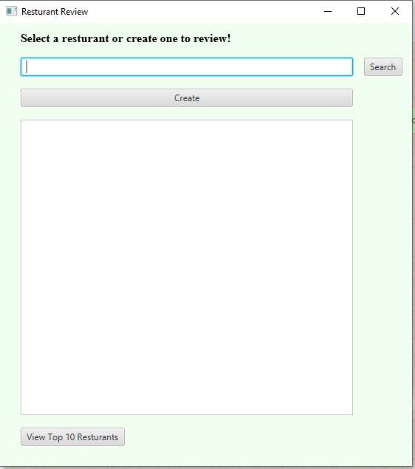

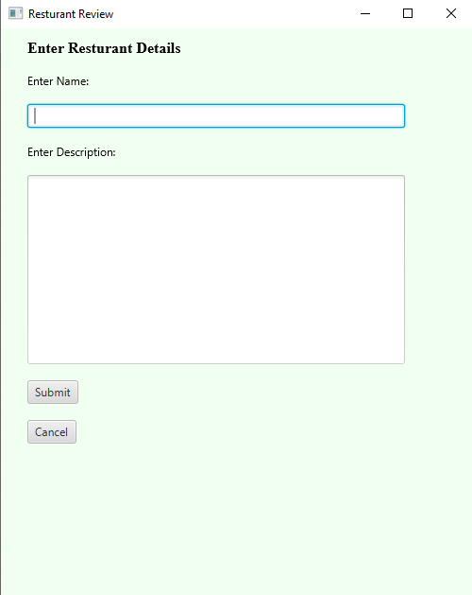

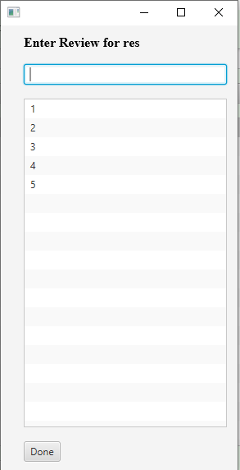

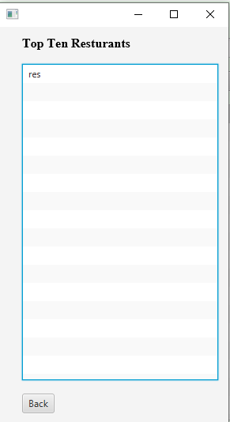

5. Conclusion
This project is helpful in understanding and practicing the JavaFX application along with the GUI. This application can be helpful for adding different restaurants and reviewing them. This can help in finding the top ten restaurants based on user feedback and ratings. This project is scalable and is extendable for more features to be added and can also serve as a real life application.

