AI Job Search System
System Architecture & Pipeline Flowchart
James T. Debruhl | C:\ai-agents | Generated: April 30, 2026

System Overview
A fully autonomous multi-agent job search pipeline running locally on an NVIDIA RTX 4070 Super at zero API cost. The system wakes the PC from sleep daily at 7:00 AM, scouts multiple job boards, scores every posting against your specific profile using a local LLM, generates tailored resumes and cover letters for high-scoring jobs, and delivers a morning digest — all without manual intervention.

Tech stack:
- Language model: Ollama / qwen3:14b running locally at localhost:11434
- Agent orchestration: CrewAI framework
- Automation: Windows Task Scheduler + Python subprocess
- Dashboard: Flask web app at localhost:5000
- Hardware: NVIDIA RTX 4070 Super (full GPU utilization)

System Flowchart
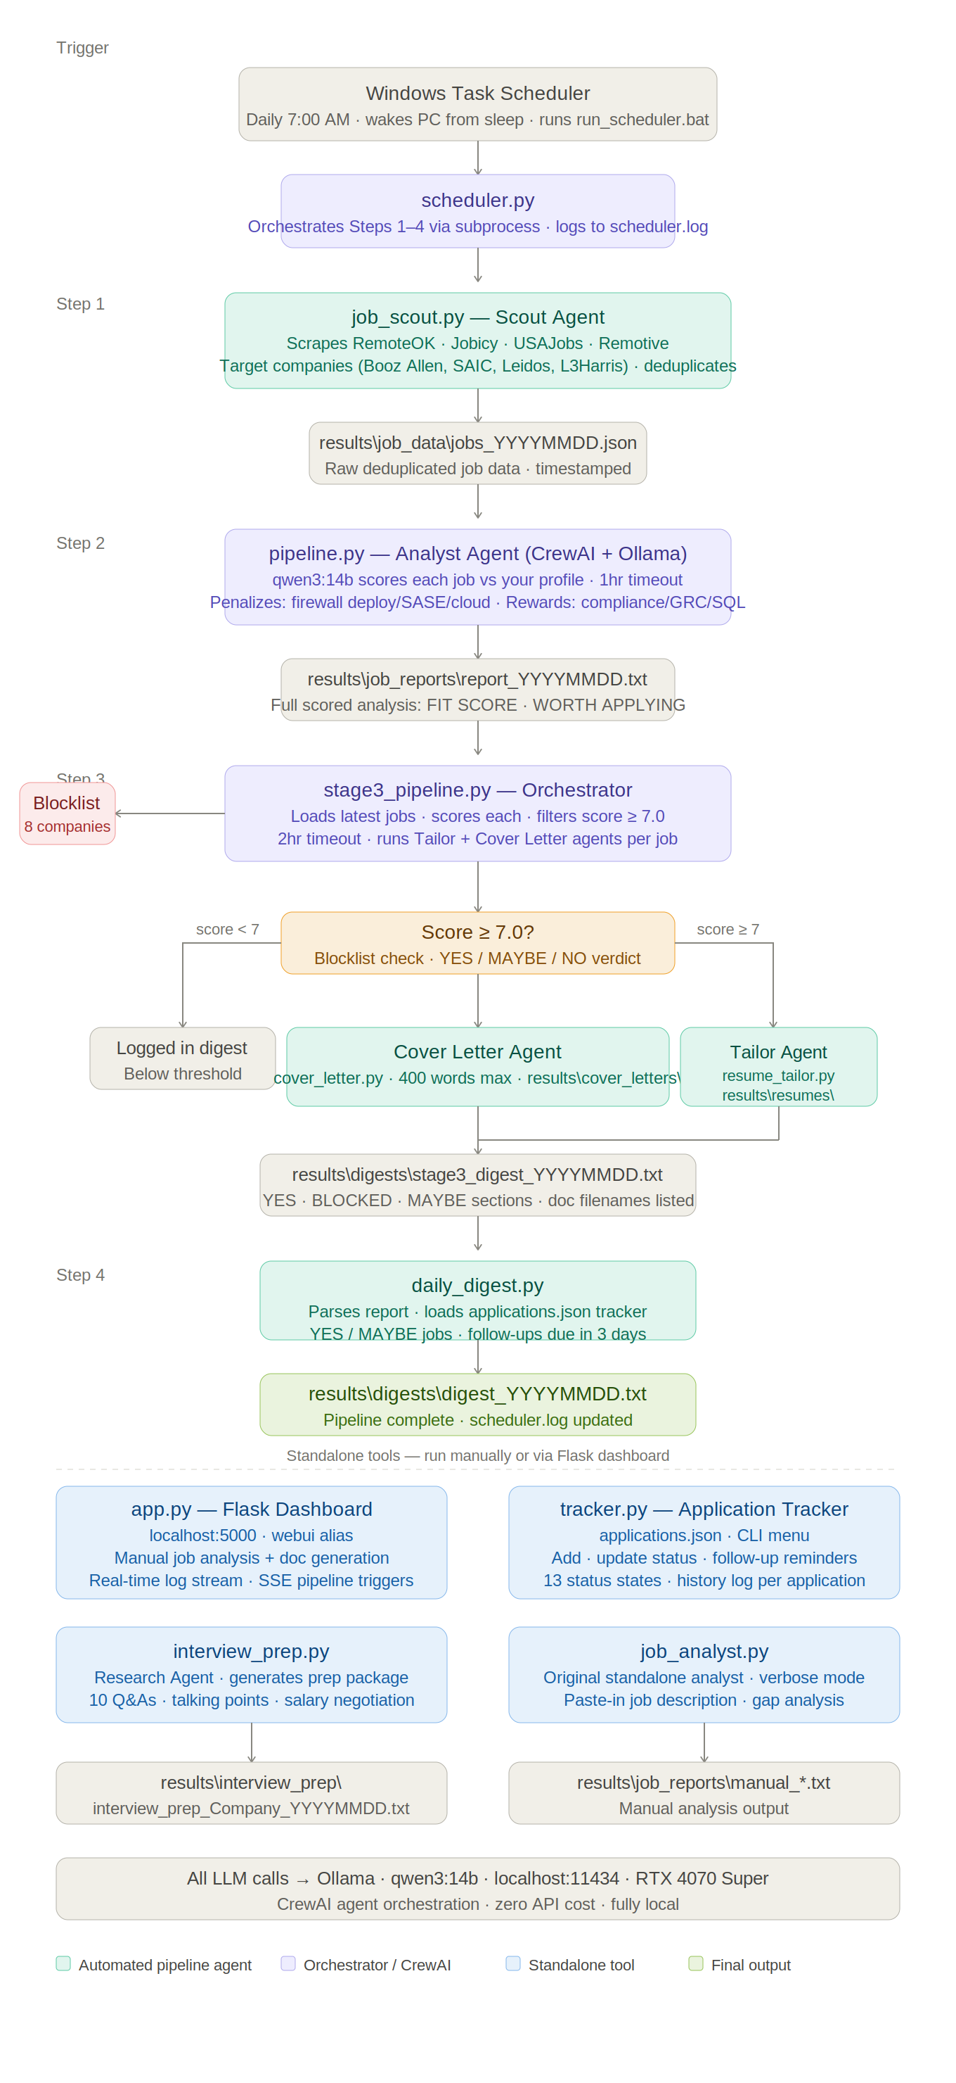

Automated Pipeline — Step by Step
Step | Script | What It Does
Trigger | run_scheduler.bat | Windows Task Scheduler wakes PC from sleep daily at 7:00 AM and launches the bat file, which activates the venv and runs scheduler.py
Orchestrate | scheduler.py | Runs Steps 1-4 in sequence via subprocess. Logs every action with timestamps to scheduler.log. Handles timeouts and errors per step.
Step 1 | job_scout.py | Scrapes RemoteOK, Jobicy, USAJobs, and Remotive. Also targets Booz Allen, SAIC, Leidos, and L3Harris specifically. Filters by title/tags, removes excluded roles, deduplicates. Saves to results\job_data\jobs_YYYYMMDD.json.
Step 2 | pipeline.py | CrewAI Analyst Agent (qwen3:14b) scores each job 1-10 against your profile. Penalizes firewall deployment/SASE/cloud roles. Rewards compliance/GRC/SQL/reporting roles. 1hr timeout. Saves full analysis to results\job_reports\report_YYYYMMDD.txt.
Step 3 | stage3_pipeline.py | Orchestrator loads jobs, re-scores, filters to score >= 7.0. Checks blocklist (8 companies currently blocked). For each passing job: Tailor Agent writes custom resume, Cover Letter Agent writes 400-word letter. Saves to results\resumes\ and results\cover_letters\. Writes stage3_digest file.
Step 4 | daily_digest.py | Parses latest report, loads applications.json tracker, summarizes YES/MAYBE jobs, flags follow-ups due in 3 days. Saves results\digests\digest_YYYYMMDD.txt.

Standalone Tools
These tools run independently — either manually from the command line or triggered through the Flask dashboard.

Tool | Purpose
app.py (Flask Dashboard) | Web UI at localhost:5000. View jobs/scores, manage applications, read documents, stream live logs, manually trigger any pipeline stage, and run one-off job analyses with automatic document generation.
tracker.py | CLI application tracker. Add applications, update through 13 status states (Applied through Offer Accepted/Rejected), set follow-up dates, view history per application. Feeds into daily digest.
interview_prep.py | Research Agent generates a full interview prep package: company brief, 10 role-specific Q&As with tailored answers drawn from your actual background, technical topics to review, strongest talking points, questions to ask, and salary negotiation guidance.
job_analyst.py | Original standalone analyst. Paste any job description directly into the script for immediate verbose analysis — required skills, gap analysis, and application strategy. Useful for one-off jobs found outside the pipeline.

Flowchart Color Legend
Teal | Automated pipeline agents — Scout Agent, Cover Letter Agent, daily_digest.py
Purple | CrewAI orchestrators and analyst agents — scheduler.py, pipeline.py, stage3_pipeline.py
Blue | Standalone tools — Flask dashboard, tracker, interview prep, job analyst
Green | Final outputs — completed digest files, pipeline success
Amber | Decision gates — score threshold filter, blocklist check
Red | Blocklist — companies filtered from document generation
Gray | Triggers, file artifacts, and intermediate data outputs

Output Directory Structure
C:\ai-agents\
├── scheduler.py (orchestrator)
├── job_scout.py (scout agent)
├── pipeline.py (analyst agent)
├── stage3_pipeline.py (tailor + cover letter orchestrator)
├── daily_digest.py (digest generator)
├── app.py (Flask dashboard)
├── tracker.py (application tracker CLI)
├── interview_prep.py (interview prep agent)
├── job_analyst.py (standalone analyst)
├── scheduler.log (live pipeline log)
├── run_scheduler.bat (Task Scheduler entry point)
├── launch_dashboard.bat (double-click: opens PS + Chrome)
└── results\
├── job_data\ (raw scout JSON files)
├── job_reports\ (full analysis reports)
├── resumes\ (tailored resumes per job)
├── cover_letters\ (cover letters per job)
├── digests\ (daily digest + stage3 digest)
├── interview_prep\ (prep packages)
└── applications.json (tracker data)

Built by James T. Debruhl · Jacksonville, FL · 2026 · Local AI · Zero API Cost

