The RESOLVE Swiss trial for people with chronic non-specific low back pain:
statistical analysis plan for a cluster randomised controlled trial
Jürgen Degenfellner$​^{1}$, Fabian Pfeiffer$​^{1}$, Andrea Stehrenberger$​^{1}$,
Silvia Careddu$​^{1}$, Bettina Sommer$​^{1}$, Thomas Benz$​^{1}$
$​^{1}$ Institute of Physiotherapy, ZHAW Zurich University of Applied Sciences, Katharina-Sulzer-Platz 9, 8400 Winterthur, Switzerland
Correspondence: Jürgen Degenfellner, Institute of Physiotherapy, ZHAW Zurich University of Applied Sciences, Katharina-Sulzer-Platz 9, 8400 Winterthur, Switzerland. E-mail: degn@zhaw.ch

Abstract
Background. Statistical analysis plans describe the planned data management and analysis of a clinical trial before the data are seen, and so protect the eventual results from data-driven analytical choices. This paper reports the statistical analysis plan for the RESOLVE Swiss trial, which evaluates graded sensorimotor retraining combined with pain science education against usual physiotherapy for people with chronic non-specific low back pain.
Design and analysis. RESOLVE Swiss is a two-arm parallel-group cluster randomised controlled trial in Swiss physiotherapy practices. The practice is the unit of randomisation and the participant is the unit of analysis. The primary outcome is back-specific disability, measured with the Roland–Morris Disability Questionnaire at 18 weeks after the baseline measurement. The primary analysis is a linear mixed model over the baseline and 18-week measurements. It carries fixed effects for time and the treatment-by-time interaction, no main effect of treatment, random intercepts for practice, and random intercepts for participant. The model constrains the two arms to a common baseline mean, and the treatment effect is estimated with Kenward–Roger degrees of freedom, the small-sample correction that guards against anti-conservative mixed-model inference when the number of practices is small. A complementary Bayesian analysis with prespecified priors, informed by the individual participant data of the Australian RESOLVE trial, accompanies the frequentist results. We report the intra-cluster correlation with its uncertainty, the analyses of secondary outcomes, the handling of missing data, non-adherence and contamination, and the planned reporting.
Conclusion. Prespecifying the analysis reduces the scope for bias in the results of RESOLVE Swiss.
Trial registration. German Clinical Trials Register DRKS00039237, registered 4 February 2026. Swiss BASEC number 2025-00784, Human Research Switzerland HumRes67737.
Keywords: Low back pain; Cluster randomised trial; Statistical analysis plan; Mixed models; Physical therapy.

1 Introduction

1.1 Background and rationale
Chronic non-specific low back pain is a leading contributor to years lived with disability worldwide, while commonly used treatments typically provide only modest effects (Wand and O’Connell 2008). Given these limitations, interventions targeting mechanisms proposed to contribute to persistent pain have been developed. The Australian RESOLVE trial evaluated one such intervention, combining pain science education with graded sensorimotor precision training. Compared with a sham intervention, RESOLVE produced a modest reduction in pain at 18 weeks and improvements in disability persisting through 52 weeks (Bagg et al. 2022). A smaller Swiss pilot study compared a related intervention with usual physiotherapy and reported similar findings (Wälti et al. 2015). That is the basis for evaluating it in Switzerland on a larger scale.
Despite these findings, evidence remains limited in two respects. First, because the Australian RESOLVE trial used a sham comparator, its comparative effectiveness against usual physiotherapy has not been established. Second, the intervention has so far been evaluated at a research institute, in participants recruited partly through community advertising. Its effectiveness under routine conditions of care therefore remains unknown. RESOLVE Swiss addresses these limitations by comparing the intervention with usual physiotherapy under routine conditions of care.
This statistical analysis plan (SAP) prespecifies the main analyses for RESOLVE Swiss. It was developed before outcome data were analysed and follows recommendations for statistical analysis plans in clinical trials (Gamble et al. 2017). It also follows the CONSORT extension for cluster randomised trials (Campbell et al. 2012). It specifies the planned frequentist analyses of the primary and secondary outcomes, a complementary Bayesian analysis of the primary outcome. It also summarises the planned Bayesian interim analysis. It should be read alongside the trial protocol (Wirz et al. 2026).

2 Methods

2.1 Trial design
RESOLVE Swiss is a two-arm, parallel-group, cluster randomised, investigator blinded, multicentre trial with intended 1:1 allocation at the cluster level. Participating physiotherapy practices and institutions constitute the clusters, while participants within each cluster are the units of observation and analysis. All outcomes are assessed at baseline and at 18 weeks. Self-reported questionnaires, including the primary outcome, are additionally assessed at 26 and 52 weeks after baseline (section 2.9).
If participants within practices were individually randomised, contamination would be a risk. Therapists within the same practice may exchange knowledge, clinical strategies, and treatment approaches, potentially exposing control participants to intervention components. Practice-level randomisation was therefore chosen to minimise contamination between treatment groups (Campbell et al. 2012).
The trial initially randomised 20 physiotherapy institutions across Switzerland in a 1:1 ratio (section 2.4). Following withdrawals, 6 clusters remain in the intervention arm and 9 in the control arm at the time of writing. The implications of this imbalance for statistical power are quantified in section 2.6. The potential impact of cluster withdrawals on between-arm comparability is addressed in section 2.5. Cluster flow and reasons for withdrawal will be reported in accordance with the CONSORT cluster extension (Campbell et al. 2012).
The trial is a Category A study under the Swiss Ordinance on Clinical Trials (ClinO Art. 61). Ethical approval was granted by the Cantonal Ethics Committee of Zurich as lead committee (BASEC 2025-00784). The trial is registered in the German Clinical Trials Register (DRKS00039237) and with Human Research Switzerland (HumRes67737).

2.2 Eligibility
Eligibility is assessed at two levels: the cluster and the participant (Campbell et al. 2012).
Practices. Swiss outpatient physiotherapy practices and institutions are eligible if they are willing to be allocated to either trial arm. Therapists in clusters allocated to the intervention arm must complete 50 hours of RESOLVE training before delivering the intervention. Their skills must also be assessed before treatment delivery. They must also successfully complete a three-part competency assessment, comprising a multiple-choice examination, an on-site supervision assessment, and a critical reflection on a video recording of their treatment conducted within their institution.
Participants. Eligible participants are adults aged 18 to 75 years referred for physiotherapy because of non-specific low back pain lasting at least three months. They must have a baseline RMDQ score of at least 7 points and sufficient German to follow the study procedures and complete the questionnaires. Participants must also have internet access, be willing to use a personal device, and have a person available to assist with home training.
Participants are excluded if they have evidence of specific spinal pathology, including malignancy, fracture, infection, or inflammatory joint or bone disease. Further exclusion criteria are radiculopathy; pregnancy or less than six months postpartum; and major medical disease contraindicating general exercise. Spinal surgery within the preceding 12 months and lumbar intra-articular or perineural steroid injection within the preceding three months are also exclusionary. Participants are also excluded if they cannot follow study procedures or have an open legal dispute with an insurer related to back pain.
An fMRI substudy will include 40 of the 220 participants. Its exploratory analyses are outside the scope of this SAP.

2.3 Interventions
Participants in both arms receive 12 individual sessions with a qualified physiotherapist over 16 weeks. The first two sessions may last up to 60 minutes, with the remaining ten lasting approximately 30 minutes. Sessions are initially delivered weekly and subsequently every two weeks. The intervention is the RESOLVE programme, comprising pain science education, graded sensory retraining, and graded motor relearning and loading. It is delivered by therapists who have successfully completed the 50-hour RESOLVE training. The comparator is usual physiotherapy, delivered by therapists who have not completed this training.
Usual physiotherapy is expected to vary across practices. Treatment delivered in the control arm will be documented and described.

2.4 Randomisation and allocation
Practices were allocated 1:1 by the central trial coordinator at ZHAW, before the intervention therapists were trained and before any patient was treated. The allocation took place live on 15 May 2025, by drawing balls of two colours from a bag, one colour per arm, which fixed the complete allocation at once. Concealment of an ongoing allocation sequence therefore does not arise. The corresponding selection risk lies at patient recruitment (section 2.5).
Two implications arise for the analysis. First, the allocation of the 20 practices was performed without stratification or covariate constraints, so it brings no design variables into the model (Kahan and Morris 2012; Hemming and Taljaard 2023). Second, no further practices are being recruited, for the reasons set out in section 2.6. Should any be added later, allocating them non-randomly would confound wave with treatment arm. They would therefore be randomised as a batch (Ivers et al. 2012; Moulton 2004), which makes the wave a stratum of the randomisation, and variables that structure the randomisation belong in the analysis (Kahan and Morris 2012). The recruitment wave would then be recorded for every practice and would enter the model as a covariate.
Participants cannot be blinded, since the intervention includes a substantial home training component. The three physical assessments (two-point discrimination, the point-to-point test and lumbar movement control) are video-recorded and rated by a blinded assessor. The remaining outcomes are self-reported and completed at home through REDCap, which removes interviewer influence. The trial statistician is not blinded, because the analysis requires access to the full dataset, including which practice belongs to which arm.

2.5 Recruitment of participants after cluster allocation
Because practices are randomised before their patients are recruited, and because the recruiting therapists know which arm their practice is in, patient selection can differ between arms. This identification or recruitment bias is a threat characteristic of cluster randomised trials (Campbell et al. 2012; Eldridge et al. 2009). We will therefore report, by arm and by practice, the number of patients screened, found eligible, approached, and consenting. Visible baseline imbalance is not by itself evidence of bias. The expected difference between arms is zero under randomisation, but with 15 practices the chance variation around zero is wide and some imbalance is to be anticipated. Imbalance is, however, also the main signal that recruitment differed between arms, and it will be read alongside the screening counts but not tested for “significance” (Campbell et al. 2012; Senn 1994).
Selection can also operate at the practice level. The 20 practices were randomised 10 to 10, and the withdrawals since then have been unbalanced, falling mostly on the intervention arm, plausibly because the intervention asks more of a practice than usual care does. The practices that remain in the intervention arm are therefore a self-selected subset. We will report the withdrawals with their timing and stated reasons in the flow diagram, describe the remaining practices at both levels of the baseline table, and read the arm comparison with this asymmetry in mind.

2.6 Sample size
The target difference is a 2-point between-group difference on the Roland–Morris Disability Questionnaire (RMDQ, range 0–24), which is the difference the investigators consider worth detecting. It was chosen conservatively against what comparable trials of usual care have reported. RESTORE found 4.6 points for cognitive functional therapy against usual care in 492 participants (Kent et al. 2023), and a nonrandomised trial of an enhanced transtheoretical model intervention found 2.7 points against usual physiotherapy in 220 participants (Ben-Ami et al. 2017). Two points lie 57% and 26% below those estimates. The between participant standard deviation of the RMDQ at 18 weeks is taken from the Australian RESOLVE trial (intervention 3.6, SD 4.6; control 6.4, SD 5.8 (Bagg et al. 2022)), giving a pooled SD of 5.2 points.
The sample size and power calculations largely follow Teerenstra et al. (2012). Their model splits the practice effect and the participant effect each into a part that is the same at baseline and at 18 weeks and a part that is not, which leaves three correlations to name. The intra-cluster correlation $ρ$ is the correlation between two participants in the same practice at one occasion. The cluster autocorrelation $ρ_{c}$ is the correlation between a practice’s own mean at the two occasions. The subject autocorrelation $ρ_{s}$ is the correlation between a participant’s two measurements within a practice, which is the 0.6 taken from the Australian trial.
Adjusting the 18-week score for the baseline draws on both kinds of correlation. The coefficient the adjustment uses is the correlation between a practice’s mean at baseline and at 18 weeks,
$$r=\frac{\overset{‾}{m}ρ}{1+(\overset{‾}{m}−1)ρ} ρ_{c}+\frac{1−ρ}{1+(\overset{‾}{m}−1)ρ} ρ_{s},$$
where $\overset{‾}{m}$ is the mean number of analysed participants per practice (Teerenstra et al. 2012, eq. 5). This $r$ always lies between $ρ_{c}$ and $ρ_{s}$, close to $ρ_{s}$ when practices are small or $ρ$ is small and close to $ρ_{c}$ otherwise.
From there the requirement follows in two multiplications from the sample size of a $t$ test on the 18-week scores alone, which is 109 participants per arm (Teerenstra et al. 2012, sec. 2.3). The design effect accounts for the clustering and the factor $1−r^{2}$ for the baseline adjustment. The requirement per arm is $109×DE×(1−r^{2})$ with $r$ from equation (1). Unequal practice sizes are the one ingredient the framework leaves out, since it assumes a common practice size. We follow Eldridge et al. (2006) and inflate $\overset{‾}{m}$ inside the design effect,
$$DE=1+\left[\left({cv}^{2} \frac{k−1}{k}+1\right)\overset{‾}{m}−1\right]ρ,$$
with $k=k_{1}+k_{2}$ the number of practices, $k_{1}$ and $k_{2}$ the number in the intervention and the control arm, and $cv$ the coefficient of variation of practice size, the standard deviation of the sizes divided by their mean.
For the intra-cluster correlation, the values reported for primary care outcomes are usually small, with a median near 0.01 (Adams et al. 2004). For patient-reported pain and disability outcomes the observed values sit at the low end of that distribution. The one published clinic-level estimate of $ρ$ for the RMDQ comes from the SOLAS feasibility trial, which ran in seven physiotherapy clinics per arm against usual physiotherapy, and it is 0 (95% CI 0 to 0.10) (Hurley et al. 2020; King et al. 2023). The UK BEAM trial ran in 181 general practices with the RMDQ as its primary outcome. It allowed for an intra-cluster correlation of 0.04 at the level of the treating therapist, the largest of the three clusterings it faced (UK BEAM Trial Team 2003), and reported the correlations it observed as smaller than that (UK BEAM Trial Team 2004). Measures of the care process show systematically larger intra-cluster correlations than clinical outcomes (Campbell et al. 2005), and the RMDQ is a clinical outcome. We therefore read 0.01 as a plausible value and the larger values as caution. For the size variation, unequal practice sizes can be ignored when $cv<0.23$, but for trials randomising United Kingdom general practices $cv$ is typically around 0.65 (Eldridge et al. 2006). We found no published figure for physiotherapy practices, so we take the general practice value as an approximation and plan on $cv=0.65$. With $\overset{‾}{m}=13.3$, $k=15$ and $cv=0.65$, the design effect is 1.18 at $ρ=0.01$, 1.35 at $ρ=0.02$ and 1.53 at $ρ=0.03$, so the requirement is 83, 95 and 107 participants per arm respectively. With the more optimistic $cv=0.4$ those three fall to 80, 90 and 100.
Two sources estimate the cluster autocorrelation from data. Martin et al. (2016) report a median of 0.65 (interquartile range 0.61 to 0.69) for United Kingdom general practices over twelve-month periods, and Korevaar et al. (2021) a median of 0.73 (interquartile range 0.19 to 0.91) across 44 continuous outcomes in the CLustered OUtcome Dataset bank. Both medians sit above the 0.6 we plan on. Planning on $ρ_{c}=0.6$ is therefore the cautious reading of that evidence, and Table 2 shows what other values would require. The trial therefore aims for 100 analysed participants per arm, where analysed means that both the baseline and the 18-week RMDQ are recorded. Since attrition is expected, 220 participants will be recruited at baseline, 110 per arm, as registered. The buffer of about 10% matches the loss to follow-up assumed in Table 1, and 100 analysed participants per arm meet the requirement for intra-cluster correlations up to about 0.024.
Sample size per arm required to detect a 2-point difference in RMDQ at 18 weeks with 80% power and two-sided $α=0.05$, by intra-cluster correlation. Based on a pooled SD of 5.2 points, adjustment for the baseline score (subject autocorrelation 0.6), an average of 13.3 analysed participants per practice and a coefficient of variation of practice size of 0.65, and a cluster autocorrelation of 0.6.
 | Intra-cluster correlation
 | 0 | 0.01 | 0.02 | 0.03
Design effect (eq. 2) | 1.00 | 1.18 | 1.35 | 1.53
Analysed participants per arm | 70 | 83 | 95 | 107
Recruited per arm (10% attrition, rounded up) | 78 | 93 | 106 | 119
Analysed participants per arm required at 80% power, by the assumed cluster autocorrelation $ρ_{c}$. All other inputs are as in Table 1. The column $ρ_{c}=0.6$ is the one used there. Empirical medians reported for the cluster autocorrelation are 0.65 (Martin et al. 2016) and 0.73 (Korevaar et al. 2021).
 | Cluster autocorrelation $ρ_{c}$
Intra-cluster correlation | 0.4 | 0.5 | 0.6 | 0.65 | 0.8 | 0.9
0.01 | 86 | 84 | 83 | 82 | 79 | 77
0.02 | 102 | 99 | 95 | 93 | 87 | 83
0.03 | 118 | 113 | 107 | 104 | 95 | 88
Because the intra-cluster correlation has to be assumed, the requirement is reported across a range of plausible values (Hemming and Taljaard 2023).
The inputs of the sample size calculation do not weigh equally. Across the intra-cluster correlations considered the requirement runs from 70 to 107 per arm, a subject autocorrelation of 0.5 instead of 0.6 turns the 83 at $ρ=0.01$ into 95, and ignoring the size variation between practices altogether ($cv=0$) would lower the 83 to 79. The between-practice variance is estimated from the practices themselves, so the test statistic for the treatment effect follows a $t$ distribution with $k−2=13$ degrees of freedom (Hayes and Moulton 2017, sec. 10.3.1). Power follows from that reference distribution (Teerenstra et al. 2012, sec. 2.4),
$$power=Φ_{t, k−2}​\left(\frac{δ}{\sqrt{var(\hat{δ})}}−t_{α/2, k−2}\right), var(\hat{δ})=σ^{2}(1−r^{2}) DE\left(\frac{1}{\overset{‾}{m}k_{1}}+\frac{1}{\overset{‾}{m}k_{2}}\right),$$
where $δ$ is the target difference, $σ$, $r$ and $DE$ are as above, and $Φ_{t, k−2}$ is the distribution function of the $t$ with $k−2$ degrees of freedom. Figure 1 shows the calculation for the current allocation at $ρ=0.01$.
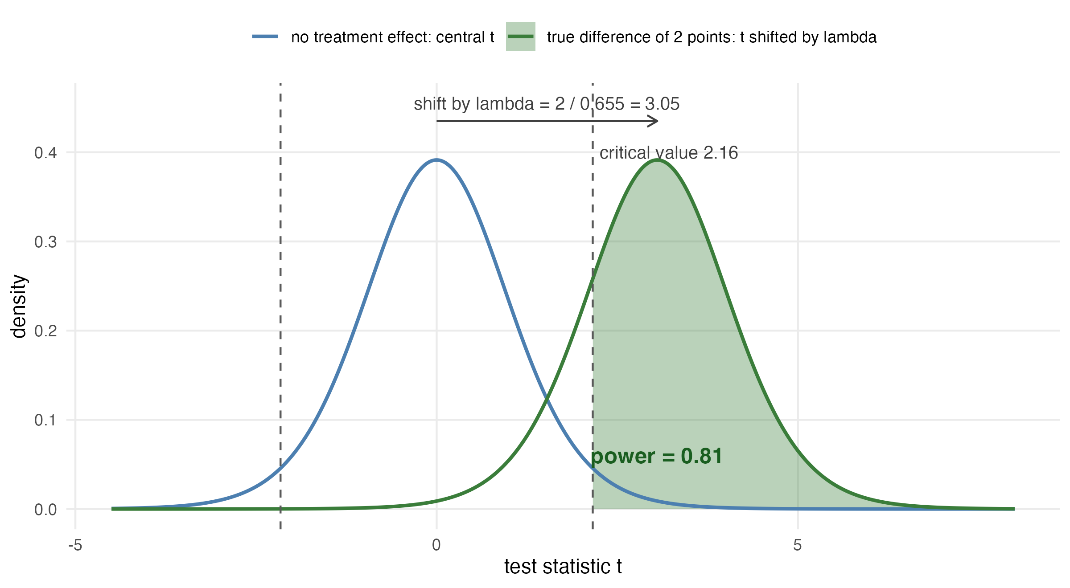
Power of the current 6 versus 9 allocation at an intra-cluster correlation of 0.01, from equation (3). The blue curve is the distribution of the test statistic when there is no treatment effect, a central $t$ with 13 degrees of freedom, with the two-sided 5% bounds as dashed lines. The green curve is the same statistic when the true difference is 2 points, the same $t$ shifted by $2/0.655=3.05$ standard-error units. The shaded area beyond the bound is the power of 0.81, the first entry of Table 3.
The variance under the root is the ANCOVA variance of Teerenstra et al. (2012, eq. 7). With 15 practices, power reaches the planned 80% at $ρ=0.01$ and declines as the intra-cluster correlation rises (Table 3, whose first row is the current 6 versus 9 split). The analysis itself needs no modification for unequal arms. More practices would raise the power. Adding participants to the practices already enrolled has strongly diminishing returns (Hemming et al. 2017), about ten practices per arm has been recommended as a general minimum for valid inference (Breukelen and Candel 2018), and spreading 200 analysed participants over 7 practices per arm reaches the planned power at $ρ=0.01$ (Table 3). The last block of that table shows the limit of recruiting on the control side alone. With the intervention arm held at 6 practices, three further control practices raise power by at most two percentage points, because the arm with fewer practices dominates the variance of the comparison. Practices for the intervention arm are therefore worth more than practices for the control arm.
The trial nevertheless keeps its 15 practices, and Table 3 records what recruitment would buy. The reason is a trade-off the power calculation cannot see. Spreading a fixed number of participants over more practices raises power whenever the intra-cluster correlation exceeds zero, but it also leaves each therapist with fewer participants. The RESOLVE programme is demanding to deliver and therapists get better at it with repetition. Thinning the caseload works against the effect the trial is trying to detect. We cannot quantify that loss from the information available. It enters neither the model nor the table, and it is why the team is cautious about adding practices. If practices are added after all, they will be randomised as a batch with both arms represented and the split chosen to move the overall allocation towards balance (Copas and Hooper 2021), and the recruitment wave will enter the model as described in section 2.4.
Power to detect a 2-point difference in RMDQ at 18 weeks, two-sided $α=0.05$, with a $t$ reference distribution on $k_{1}+k_{2}−2$ degrees of freedom. Every row holds the analysed sample at 200 participants. The average practice size falls as practices are added. The first block shows the current allocation and two hypothetical extensions that balance the arms at 10 or 11 practices each, the middle block is balanced, and the last block holds the intervention arm at 6 practices while control practices are added. Bold marks power at or above 0.80: in the first block all values that reach it, in the other blocks the smallest design that does so at each intra-cluster correlation.
 |  | Intra-cluster correlation
Practices (int./ctrl.) | Mean practice size | 0.01 | 0.02 | 0.03
6 / 9 | 13.3 | 0.81 | 0.75 | 0.69
6+4 / 9+1 | 10.0 | 0.85 | 0.81 | 0.77
6+5 / 9+2 | 9.1 | 0.86 | 0.82 | 0.79
5 / 5 | 20.0 | 0.75 | 0.66 | 0.58
6 / 6 | 16.7 | 0.79 | 0.71 | 0.65
7 / 7 | 14.3 | 0.81 | 0.75 | 0.69
8 / 8 | 12.5 | 0.83 | 0.78 | 0.73
9 / 9 | 11.1 | 0.84 | 0.80 | 0.75
10 / 10 | 10.0 | 0.85 | 0.81 | 0.77
6 / 10 | 12.5 | 0.80 | 0.75 | 0.70
6 / 11 | 11.8 | 0.80 | 0.75 | 0.70
6 / 12 | 11.1 | 0.80 | 0.75 | 0.70
All sample size and power computations are reproducible from the script R/sample_size.R that accompanies this paper.

2.7 Data integrity and missing data
Patient-reported outcomes are captured electronically in REDCap, completed by participants at home through a personalised link. The eCRF holds eligibility, demographic, medical-history and physical-assessment data.
Data will be inspected for implausible values, range violations and duplicate records before the analysis begins, and the cleaned data set will be locked before any comparison between arms is made. We will report the amount and the pattern of missing outcome data by arm and by practice.

2.8 Analytic principles
- Participants will be analysed in the arm to which their practice was allocated, regardless of the treatment actually delivered (intention to treat).
- All treatment effects will be reported as point estimates with 95% confidence intervals. Two-sided tests at a nominal $α$ of 0.05 accompany the primary and secondary analyses, but the interpretation will rest on the estimate and its interval, not on whether an arbitrary threshold was crossed. This includes reading the interval only for whether it contains zero, which is the same dichotomy in another form (Wasserstein et al. 2019; Amrhein et al. 2019).
- Confidence intervals and $p$ values will not be adjusted for multiplicity. There is one primary outcome at one time point. Secondary outcomes are explicitly labelled as secondary and will be interpreted as such (Gamble et al. 2017).
- Every analysis accounts for clustering by practice.
- Analyses will be carried out in R (R Core Team 2026). Analysis code and the participant-level dataset behind the reported results will be published with the results, under the conditions set out in the data availability statement.

2.9 Outcome definitions

2.9.1 Primary outcome
The primary outcome is back-specific disability at 18 weeks after the baseline measurement, measured with the Roland–Morris Disability Questionnaire, a 24-item instrument scored from 0 (no disability) to 24 (Roland and Fairbank 2000; Chiarotto et al. 2016).

2.9.2 Secondary outcomes
The trial collects a large number of secondary endpoints, which we group here by the analysis they receive.
The patient-reported continuous outcomes, collected at baseline and at 18, 26 and 52 weeks, are pain intensity (numeric rating scale) (Hawker et al. 2011); the Patient Specific Functional Scale (Heldmann et al. 2015); Work Productivity and Activity Impairment (Reilly et al. 1993); the Neurophysiology of Pain Questionnaire (Richter et al. 2019); the Back Pain Attitudes Questionnaire (Darlow et al. 2014); the Pain Self-Efficacy Questionnaire (Mangels et al. 2009); the Depression Anxiety and Stress Scale (Nilges and Essau 2015); the Tampa Scale of Kinesiophobia (Rusu et al. 2014); the EQ-5D-5L (Herdman et al. 2011); the Insomnia Severity Index (Dieck et al. 2018); the Fremantle Back Awareness Questionnaire (Ehrenbrusthoff et al. 2018); the epistemic-beliefs questionnaire [open: no source for the OLEQ in the study protocol]; and the treatment expectation item (Barth et al. 2019).
The perceived improvement item is collected at 18, 26 and 52 weeks and has no baseline value, so it is compared between the arms at each time point without a baseline term in the model.
The physical outcomes, taken at baseline and at 18 weeks, are two-point discrimination (Catley et al. 2013), the point-to-point test of tactile acuity (Adamczyk et al. 2016), and lumbar movement control (Luomajoki et al. 2007, 2008), each rated from video by a blinded assessor.
Two measures are recorded once. The Goal Attainment Scale (Turner-Stokes 2009) is set at baseline and scored with the therapist at 18 weeks, and the satisfaction item is collected at 18 weeks only. Both are reported descriptively.
Medication intake and treatment adherence are reported as counts. Adverse events are safety data and will be summarised descriptively by arm.
Cost-effectiveness (quality-adjusted life years and incremental cost-effectiveness ratios) and the fMRI substudy fall outside this plan. Both are reported separately.
Table 4 sets out when each outcome is collected.
Assessment schedule. Weeks are counted from the baseline measurement. The primary outcome is the RMDQ at 18 weeks.
 | Baseline | 18 weeks | 26 weeks | 52 weeks
Patient-reported
Roland–Morris Disability Questionnaire (primary) | x | x | x | x
Pain intensity, numeric rating scale | x | x | x | x
Patient Specific Functional Scale | x | x | x | x
Work Productivity and Activity Impairment | x | x | x | x
Neurophysiology of Pain Questionnaire | x | x | x | x
Back Pain Attitudes Questionnaire | x | x | x | x
Pain Self-Efficacy Questionnaire | x | x | x | x
Depression Anxiety and Stress Scale | x | x | x | x
Tampa Scale of Kinesiophobia | x | x | x | x
EQ-5D-5L | x | x | x | x
Insomnia Severity Index | x | x | x | x
Fremantle Back Awareness Questionnaire | x | x | x | x
Epistemic-beliefs questionnaire | x | x | x | x
Treatment expectation item | x | x | x | x
Perceived improvement item |  | x | x | x
Physical, rated from video by a blinded assessor
Two-point discrimination | x | x
Point-to-point test | x | x
Lumbar movement control | x | x
Descriptive
Goal Attainment Scale (set at baseline, scored at 18 weeks) | x | x
Satisfaction item |  | x

3 Analysis

3.1 Baseline description
We will describe the sample at two levels, as the CONSORT cluster extension recommends (Campbell et al. 2012). At the practice level (Table 5, panel A) we will report the number of practices per arm, the number of therapists, practice size, urban or rural setting [open: should we report this?], and the number of participants contributed. At the participant level (panel B) we will report means and standard deviations for approximately normally distributed continuous variables, medians and interquartile ranges otherwise, and counts with percentages for categorical variables (Lang and Altman 2015). Baseline characteristics will not be tested for statistical significance between arms, and Table 5 shows no $p$ values, avoiding the Table 1 fallacy (Senn 1994; Altman 1985).
Baseline characteristics (shell). Panel A describes the clusters, panel B the participants.
Characteristic | Intervention | Control | All
Panel A: practices
Number of practices | xx | xx | xx
Therapists per practice, median (IQR) | xx (xx to xx) | xx (xx to xx) | xx (xx to xx)
Participants per practice, median (IQR) | xx (xx to xx) | xx (xx to xx) | xx (xx to xx)
Urban setting, n (%) | xx (xx) | xx (xx) | xx (xx)
Panel B: participants
Number of participants | xx | xx | xx
Age, mean (SD) | xx (xx) | xx (xx) | xx (xx)
Female, n (%) | xx (xx) | xx (xx) | xx (xx)
Duration of current episode, median (IQR) | xx (xx to xx) | xx (xx to xx) | xx (xx to xx)
RMDQ, mean (SD) | xx (xx) | xx (xx) | xx (xx)
Pain intensity (NRS), mean (SD) | xx (xx) | xx (xx) | xx (xx)
EQ-5D-5L index, mean (SD) | xx (xx) | xx (xx) | xx (xx)
Pain Self-Efficacy Questionnaire, mean (SD) | xx (xx) | xx (xx) | xx (xx)
Tampa Scale of Kinesiophobia, mean (SD) | xx (xx) | xx (xx) | xx (xx)
In paid work, n (%) | xx (xx) | xx (xx) | xx (xx)
Highest education level, n (%) | xx (xx) | xx (xx) | xx (xx)

3.2 Primary outcome

3.2.1 Estimand
The quantity of interest is the participant-average difference in mean RMDQ at 18 weeks between the two arms: the difference that would be seen if every participant meeting the eligibility criteria of section 2.2 in these practices received one treatment rather than the other, with each participant counting equally. With unequally sized practices it may differ from the cluster-average effect, in which each practice counts equally (Kahan et al. 2023). Intercurrent events, that is non-adherence and the use of additional care, are handled by a treatment-policy strategy: they count as part of the compared treatment conditions, and every participant is analysed in the allocated arm. The complier average causal effect of section 3.8 is a supplementary principal-stratum estimand. We specify the participant-average effect as the estimand, following the consensus extension of the ICH E9(R1) estimand addendum (International Council for Harmonisation 2019) to cluster randomised trials (Kahan et al. 2026).
A mixed model with a random intercept weights practices by their inverse variance, which matches neither weighting exactly. Where cluster size is not informative this makes no difference and the model is unbiased for the participant-average effect. Where outcomes or treatment effects vary systematically with practice size, the estimate may depart from both estimands (Kahan et al. 2023). Table 6 therefore includes three numbers. The estimate from model (4) with its confidence interval is the result of the trial, and the only one with a hypothesis test attached. Beside it stand two estimates that target the participant-average and the cluster-average effect explicitly through their weighting, specified in section 3.2.3. If the three numbers agree, the choice of weighting makes no difference. Divergence beyond what sampling variation explains would suggest that practice size is informative, and the participant-average estimate is then the number answering the question as posed. The distribution of practice sizes will be reported so that readers can judge this.

3.2.2 Primary model
Let $y_{ijt}$ denote the RMDQ score of participant $i$ in practice $j$ at occasion $t$, where $t$ indexes the baseline and 18-week measurements. Let $s_{t}$ equal 0 at baseline and 1 at 18 weeks. Let $x_{j}=1$ if practice $j$ was allocated to the intervention and $0$ otherwise. The primary analysis is the linear mixed model
$$y_{ijt}=β_{0}+β_{1}s_{t}+β_{2} s_{t}x_{j}+u_{j}+w_{ij}+ε_{ijt},$$
with a random intercept $u_{j}∼N(0,τ^{2})$ for practice, a random intercept $w_{ij}∼N(0,ν^{2})$ for participant within practice, and residual $ε_{ijt}∼N(0,σ^{2})$. The treatment effect at 18 weeks is $β_{2}$. The model deliberately contains no main effect of treatment, so the two arms share a single baseline mean. Dropping a main effect while keeping its interaction would ordinarily violate the variable inclusion principle and leave the interaction coefficient measuring something else (Westfall and Arias 2020). Here the omitted term is the between-arm difference at baseline, which randomisation makes zero in expectation. One caveat is specific to cluster randomisation: patients enter after their practice has been allocated, and differential recruitment could shift the observed baseline means. For that case the unconstrained model is prespecified as a sensitivity analysis. This constrained longitudinal formulation (Liang and Zeger 2000) matches the precision of adjusting the 18-week score for its baseline value, and either is a recommended way to use a baseline measurement of the outcome in a cluster randomised trial (Hooper et al. 2018).
The model includes no covariates except any used to stratify or constrain the randomisation, which must be adjusted for (Kahan and Morris 2012; Hemming and Taljaard 2023). The allocation used neither (section 2.4). If further practices were randomised as a second batch, the recruitment wave would structure the allocation, and model (4) would then contain the wave as an additional fixed effect.
The model will be fitted by restricted maximum likelihood. Confidence intervals and $p$ values for $β_{2}$ will use the Kenward–Roger approximation to the degrees of freedom and the associated small-sample adjustment to the covariance matrix of the fixed effects (Kenward and Roger 1997), which is the standard remedy for the anti-conservatism of naive mixed-model inference when the number of clusters is small (Leyrat et al. 2018; Kahan et al. 2016).

3.2.3 Inference with a small number of clusters
Uncorrected mixed models and generalised estimating equations have inflated type I error rates when the number of clusters is small (Taljaard et al. 2016; Kahan et al. 2016), and degrees-of-freedom corrections restore the nominal rate at the number of practices available here (Leyrat et al. 2018). Model (4) with Kenward–Roger degrees of freedom is therefore the single prespecified analysis of the primary outcome. Recommended thresholds for such a correction lie at about 30 (Billot et al. 2024) to 40 (Hemming and Taljaard 2023) clusters, far above the 15 practices currently enrolled.
Two further estimates are reported beside the model result (Table 6), each targeting one of the two estimands by its weighting (Hayes and Moulton 2017; Kahan et al. 2023).
For the participant-average effect we fit the 18-week score on the baseline score and the arm by ordinary least squares, so that every participant counts equally. This is the independence estimating equation that Kahan et al. (2023) recommend for this estimand, and it remains unbiased when practice size is informative. Its confidence interval uses a cluster-robust variance with the bias reduction and the Satterthwaite degrees of freedom of Bell and McCaffrey (2002).
For the cluster-average effect we compare the unweighted means of the practice-level changes from baseline, with an interval from the $t$ distribution on $k_{1}+k_{2}−2$ degrees of freedom (Hayes and Moulton 2017, sec. 10.3.2).
Analysis of the primary outcome (shell). The mixed model provides the estimate and the hypothesis test. The other two rows estimate the two estimands explicitly.
Analysis | Intervention | Control | Difference (95% CI) | $p$
 | mean (SD) | mean (SD)
Mixed model, Kenward–Roger (primary) | xx (xx) | xx (xx) | xx (xx to xx) | .xx
Participant-average (independence estimating equation) | — | — | xx (xx to xx) | —
Cluster-average (unweighted practice means) | — | — | xx (xx to xx) | —
Intra-cluster correlation (95% CI) | xx (xx to xx)

3.2.4 Intra-cluster correlation
As recommended by the CONSORT cluster extension (Campbell et al. 2012), we will report the estimated intra-cluster correlation for the primary outcome, $\hat{ρ}={\hat{τ}}^{2}/({\hat{τ}}^{2}+{\hat{ν}}^{2}+{\hat{σ}}^{2})$, with a 95% confidence interval obtained by profile likelihood.

3.3 The later time points
The primary model (4) extends naturally to all four occasions on which the RMDQ is collected (baseline, 18, 26 and 52 weeks), with time as a categorical variable, the same random intercepts, and again no main effect of treatment. We fit this four-occasion model to obtain the effects at 26 and 52 weeks, which are secondary.

3.4 Comparative Bayesian analysis
The primary model (4) will also be fitted in a Bayesian formulation, with the likelihood unchanged and priors added. The informative priors come from the individual participant data of the Australian RESOLVE trial (Bagg et al. 2022), which the investigators hold under a data sharing agreement, and specifically from the distributions of the RMDQ at baseline and at 18 weeks in each arm. Written out with its priors, the model is
$$\begin{aligned}y_{ijt}&∼Normal(μ_{ijt}, σ), \\ μ_{ijt}&=β_{0}+β_{1}s_{t}+β_{2} s_{t}x_{j}+u_{j}+w_{ij}, \\ u_{j}&∼Normal(0, τ), w_{ij}∼Normal(0, ν), \\ β_{0}&∼Normal(m_{0}, s_{0}), β_{1}∼Normal(m_{1}, s_{1}), \\ β_{2}&∼Normal\left(\hat{δ}, c⋅se(\hat{δ})\right), \\ τ&∼Half\text{-}Normal(s_{τ}), ν∼Half\text{-}Normal(s_{ν}), σ∼Half\text{-}Normal(s_{σ}).\end{aligned}$$
The hyperparameters come from the Australian data: $m_{0}=9.5$ describes the baseline RMDQ mean, $m_{1}=−3.5$ the change from baseline to 18 weeks in the control arm, and $\hat{δ}=−2.4$ with its standard error of 0.56 the treatment effect from the analogue of model (4) fitted to those two occasions. The factor $c>1$ widens that prior. Widening it in this way is the power prior of Ibrahim and Chen (2000), in which the likelihood of the previous study is raised to a power $a_{0}$ between 0 and 1. For a normal likelihood that multiplies the precision by $a_{0}$, so $c=1/\sqrt{a_{0}}$, where $a_{0}$ is the fraction of the historical study that is borrowed. The authors recommend such control where the previous and the current study differ, which in our case they do on three counts: (i) the Australian comparator was a sham rather than usual physiotherapy, (ii) the setting was Australian rather than Swiss, and (iii) that trial randomised individuals rather than practices. We set $a_{0}=1/9$, so that $c=3$ and the prior standard deviation is 1.7 points. For intra-cluster correlations up to 0.02, the designs of Table 3 imply a Swiss standard error between 0.63 and 0.73. The prior then supplies between a ninth and a sixth of the precision of the posterior. No single value of $a_{0}$ follows from the data. The analysis is repeated with $a_{0}=1/4$ and $a_{0}=1/16$, and all three are reported. The Australian participant-level and residual standard deviations are 3.7 and 3.6, so that $s_{ν}=s_{σ}=4$. We set $s_{0}=s_{1}=2$, several times the corresponding standard errors (0.32 and 0.47), so that the Swiss data dominate those two priors. That trial randomised individuals and has no practice level, so $s_{τ}$ rests on the intra-cluster correlation instead. Values between 0.01 and 0.03 imply $τ$ between 0.5 and 0.9, a range that $s_{τ}=2$ covers. The RMDQ at 18 weeks piles up near zero (Figure 2). Our access to the raw data allows this skewed outcome distribution to be modelled directly. The RMDQ is a count of 24 items, and the beta-binomial distribution with size 24 matches that support: a draw from it is always a valid score. In every arm-by-occasion subgroup of the Australian data it stays within four AIC points of the best-fitting continuous family, while the normal fails badly at 18 weeks (Figure 3). The Bayesian analysis will therefore be reported twice, once with the normal likelihood of (5) for direct comparability with the frequentist result, and once with the first two lines replaced by
$$y_{ijt}∼BetaBinomial(24, p_{ijt}, θ), logit(p_{ijt})=β_{0}+β_{1}s_{t}+β_{2} s_{t}x_{j}+u_{j}+w_{ij},$$
which respects the bounded count nature of the score. In that version the coefficients act on the logit scale, so the priors are re-derived there by fitting the same beta-binomial model to the Australian data, and the values above are not directly applicable. Each version is also fitted with a sceptical prior for $β_{2}$ in place of the informative one. Following Spiegelhalter et al. (1994), that prior is normal with mean zero and a standard deviation set so that the probability of a benefit beyond the alternative hypothesis is 0.05. A target difference of 2 RMDQ points therefore gives a standard deviation of $2/1.645=1.22$ points. On the logit scale the same 2 points, measured down from the Australian control mean of 6.4 at 18 weeks, amount to a difference of 0.48, so the standard deviation there is 0.29.
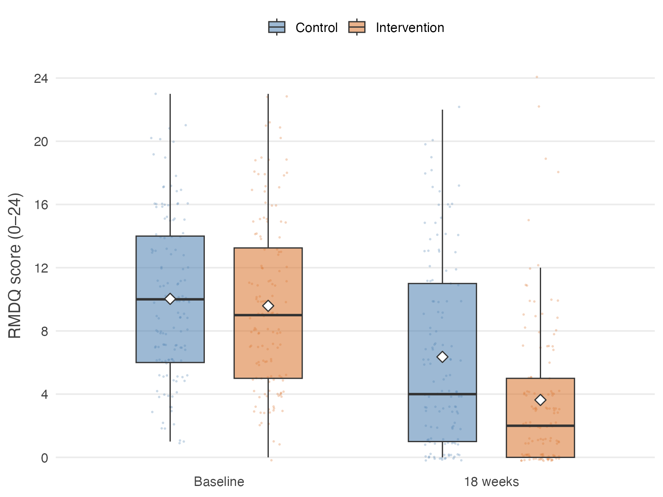
RMDQ in the Australian RESOLVE trial (Bagg et al. 2022) at baseline and 18 weeks, by arm. Diamonds mark the means. Every participant is plotted as a point behind the boxes, scattered horizontally and vertically so that repeated integer scores remain visible.
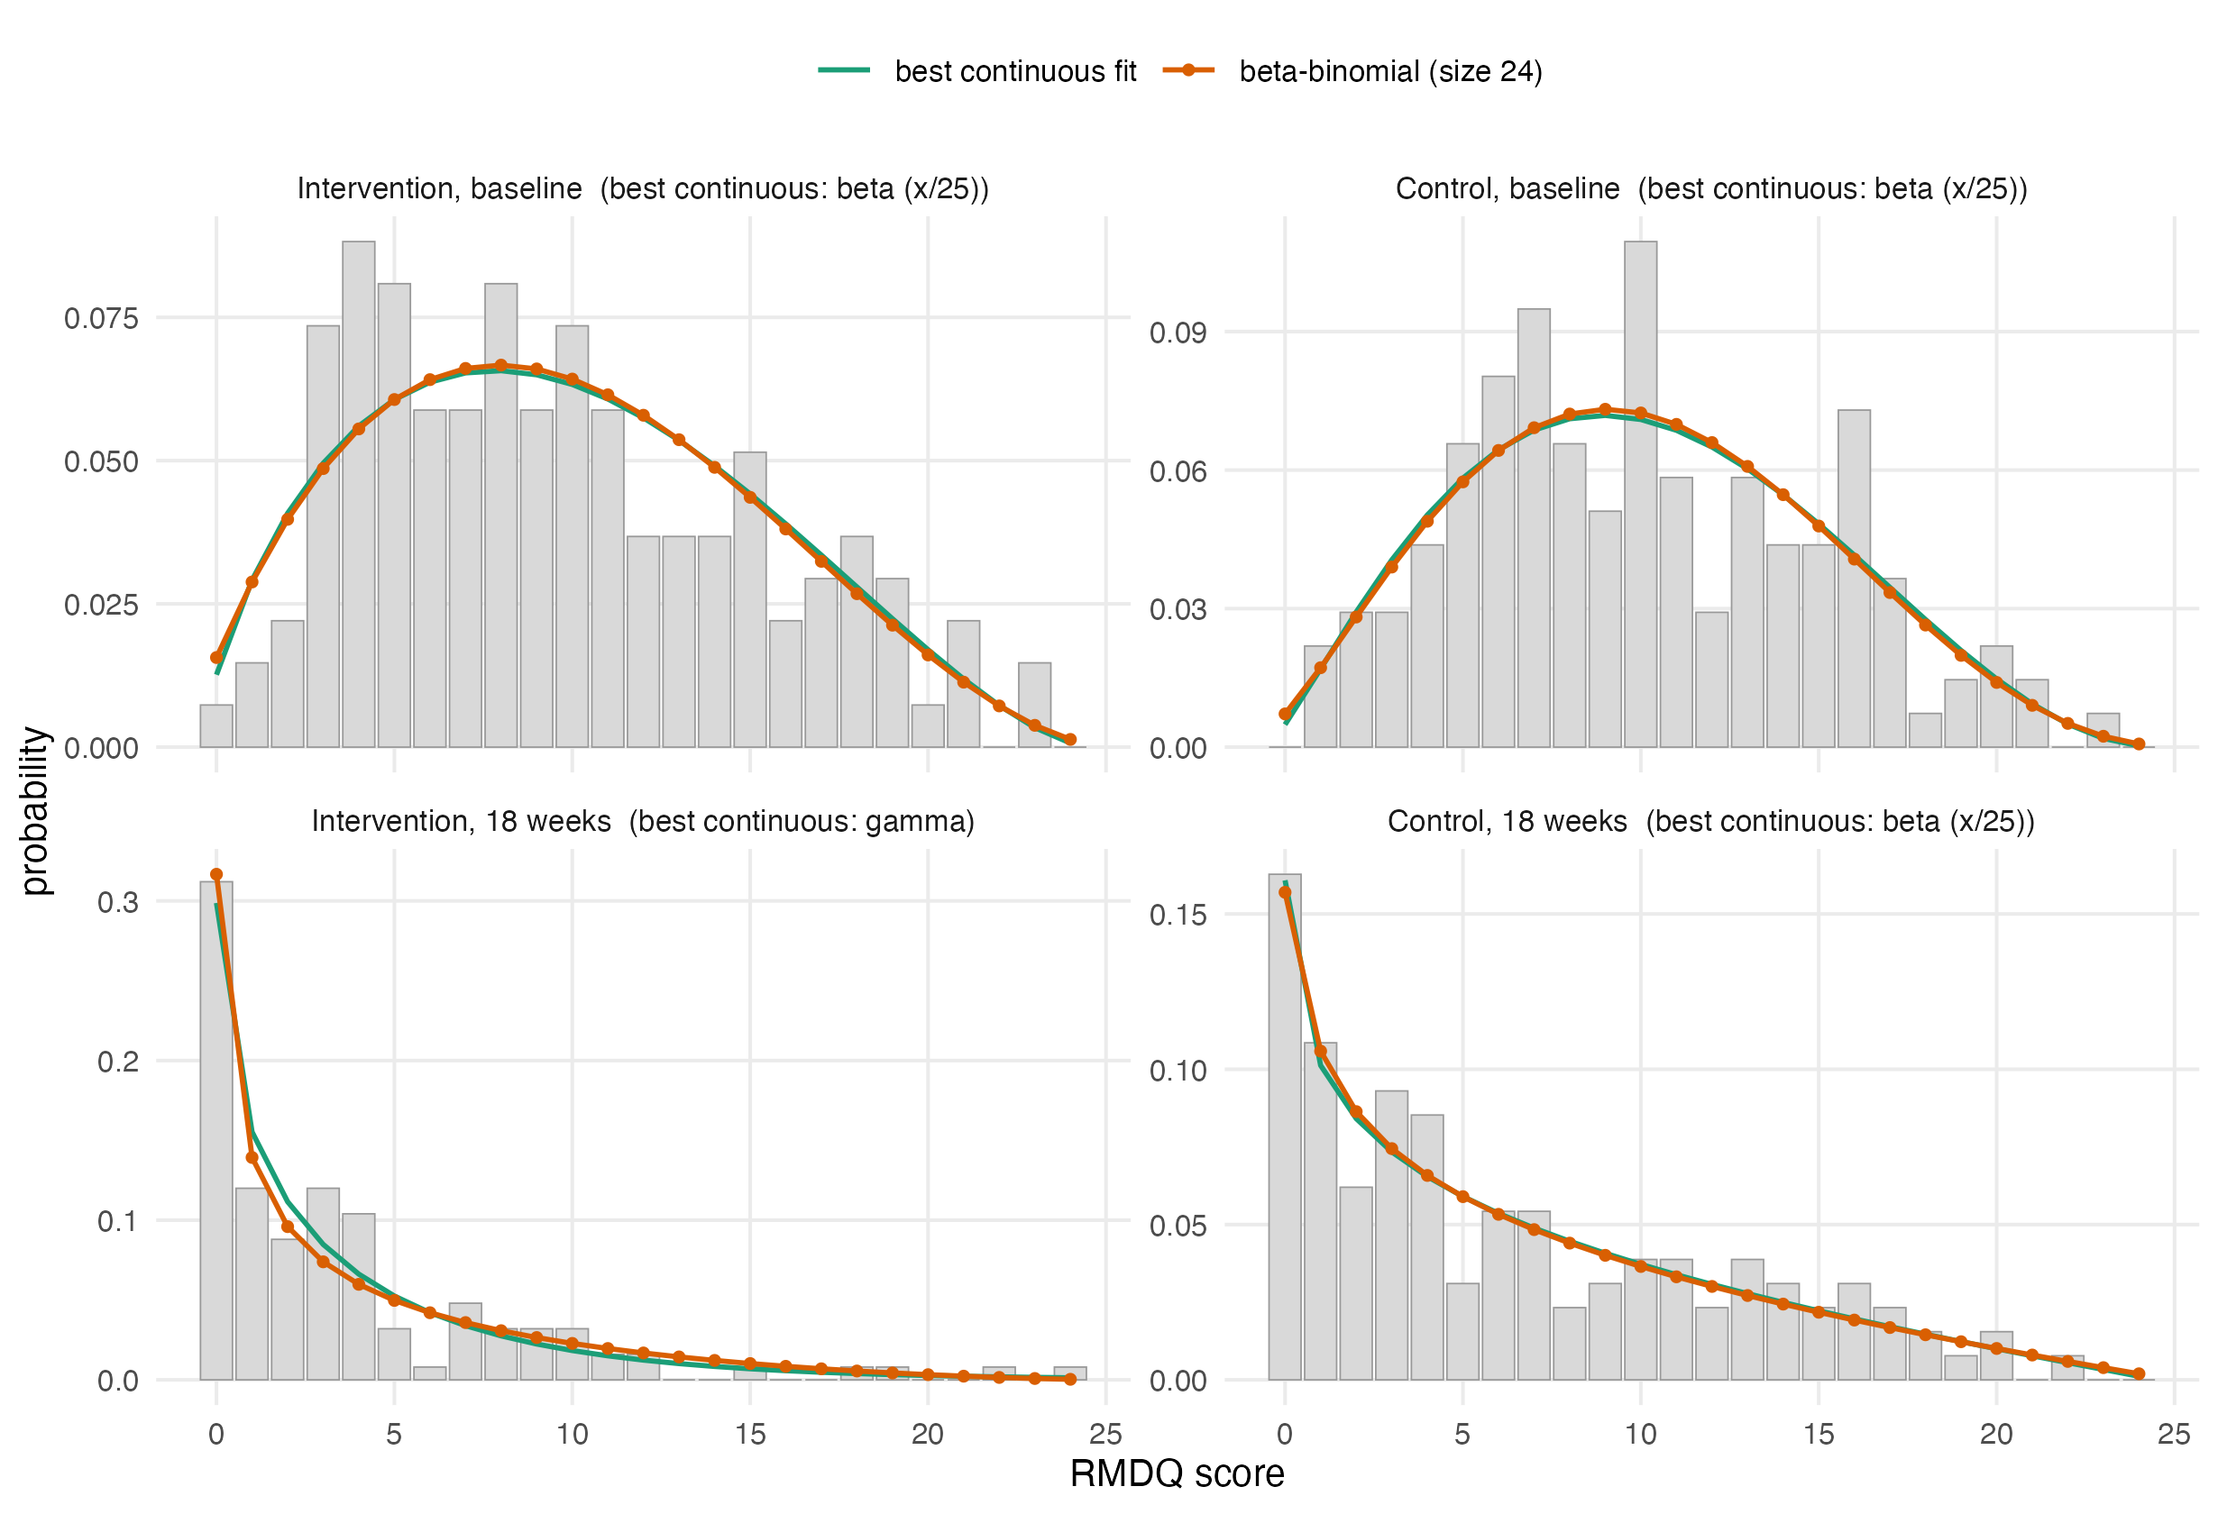
Observed relative frequencies of the RMDQ in the four arm-by-occasion subgroups of the Australian RESOLVE trial, with maximum likelihood fits evaluated on the integer grid so that the families are directly comparable. The beta-binomial with size 24 stays within four AIC points of the best-fitting continuous family in every subgroup. Fitted values (prob, $θ$): intervention 0.40, 4.9 at baseline and 0.16, 3.0 at 18 weeks. Control 0.42, 6.3 at baseline and 0.26, 2.7 at 18 weeks.
With few practices the posterior for the between-practice variance is sensitive to its prior (Spiegelhalter 2001). We will therefore report a sensitivity analysis over the between-practice variance prior. For the treatment effect we will report the full posterior distribution as a density plot under each prior, together with the posterior probabilities that the benefit exceeds 0, 1 and 2 RMDQ points. The Australian data will not be redistributed with this plan.

3.5 Secondary outcomes
Secondary outcomes will be analysed with models of the same structure as (4), with the link function and distribution appropriate to the outcome, always including a random intercept for practice and always using the same small-sample correction. Effects will be reported as point estimates with 95% confidence intervals (Table 7). No formal claim of efficacy will be based on a secondary outcome.
Analysis of secondary outcomes (shell).
Outcome and time point | Intervention | Control | Effect (95% CI)
 | mean (SD) | mean (SD)
Pain intensity (NRS)
/ 26 / 52 weeks | xx (xx) | xx (xx) | xx (xx to xx)
Patient Specific Functional Scale
/ 26 / 52 weeks | xx (xx) | xx (xx) | xx (xx to xx)
Tactile acuity: two-point discrimination, point-to-point
weeks | xx (xx) | xx (xx) | xx (xx to xx)
Lumbar movement control
weeks | xx (xx) | xx (xx) | xx (xx to xx)
Quality of life (EQ-5D-5L)
/ 26 / 52 weeks | xx (xx) | xx (xx) | xx (xx to xx)
Pain knowledge and attitudes (NPQ, Back-PAQ, PSEQ)
/ 26 / 52 weeks | xx (xx) | xx (xx) | xx (xx to xx)
Psychological measures (DASS, TSK)
/ 26 / 52 weeks | xx (xx) | xx (xx) | xx (xx to xx)
Sleep (ISI), body awareness (FreBAQ)
/ 26 / 52 weeks | xx (xx) | xx (xx) | xx (xx to xx)
Work absence (WPAI), medication intake
/ 26 / 52 weeks | xx (xx) | xx (xx) | xx (xx to xx)

3.6 Sensitivity analyses
The following are prespecified and will be reported whether or not they change the conclusion.
- Leave-one-practice-out. The primary model refitted once per practice, each time omitting that practice. With few clusters a single atypical practice can drive the result, and the spread of these estimates shows how much it does.
- Therapist effects. A third level for therapist within practice. This is the more faithful description of the data hierarchy, but variance components at three levels are poorly identified with as few practices as this trial will have. It is prespecified as a sensitivity analysis.
- Unconstrained model. Model (4) with a main effect of treatment added, which frees the baseline means and shows what the constraint contributes.
- Cluster-mean baseline. Model (4) with the practice mean baseline score added as a further fixed effect. The baseline cluster mean captures differences between practices that the individual scores do not, and adjusting for it is recommended for cluster randomised trials (Klar and Darlington 2004; Hooper et al. 2018).
- Practice-by-time interaction. Model (4) with an additional random practice-by-time effect, which allows the correlation between two participants of the same practice to be weaker across occasions than within one occasion. A constrained baseline analysis without this flexibility can overstate precision (Hooper et al. 2016, 2018; Martin et al. 2016), and the time-constant practice intercept of the primary model is the less flexible variant.

3.7 Missing data
The primary analysis uses all participants with a baseline measurement, whether or not the 18-week outcome was recorded, and is valid under a missing-at-random assumption conditional on the observed measurements (Bell and Rabe 2020). We will report the number and proportion of missing outcomes by arm and by practice, then compare the baseline characteristics of participants with and without an 18-week outcome. As a sensitivity analysis we will use multiple imputation by chained equations, with a two-level imputation model that carries a random intercept for the practice, since imputation that ignores the clustering understates the uncertainty of the imputed values and cluster fixed effects overstate it (Andridge 2011). If an entire practice is lost, that will be reported separately and not imputed.

3.8 Non-adherence and contamination
The full distribution of the number of the 12 sessions attended will be reported descriptively by arm. A participant counts as adherent when they attended at least 9 of the 12 sessions (75%), and the proportion of adherent participants will be reported. The mean effect among participants who would adhere to the intervention if allocated to it, the complier average causal effect, will be estimated by instrumental variable regression with allocation as the instrument (Angrist et al. 1996). The estimate will be reported alongside the intention-to-treat effect. Because this analysis is imprecise with few clusters, it is prespecified as exploratory.
The design itself limits contamination: the 50-hour RESOLVE training is unavailable to control therapists, and the German-language RESOLVE materials exist only inside a secured web application accessible to intervention therapists and participants. Treatment fidelity is monitored through documentation of every treatment session. We will nonetheless describe any contamination that comes to light and discuss its likely direction, since it biases the estimated effect towards the null (Hemming et al. 2021).

3.9 Interim analysis
A single Bayesian interim analysis for futility is planned after 100 participants have been recruited. The trial is declared futile if the posterior probability that the between-group difference is smaller than 1 RMDQ point reaches 95%. The analysis uses model (5) with the priors of section 3.4, so the interim and final analyses are consistent. No sample size adjustment follows from the interim result.

4 Reporting
Results will be reported following CONSORT 2025 with the extension for cluster randomised trials (Hopewell et al. 2025; Campbell et al. 2012), including a flow diagram that tracks both practices and participants (Figure 4).
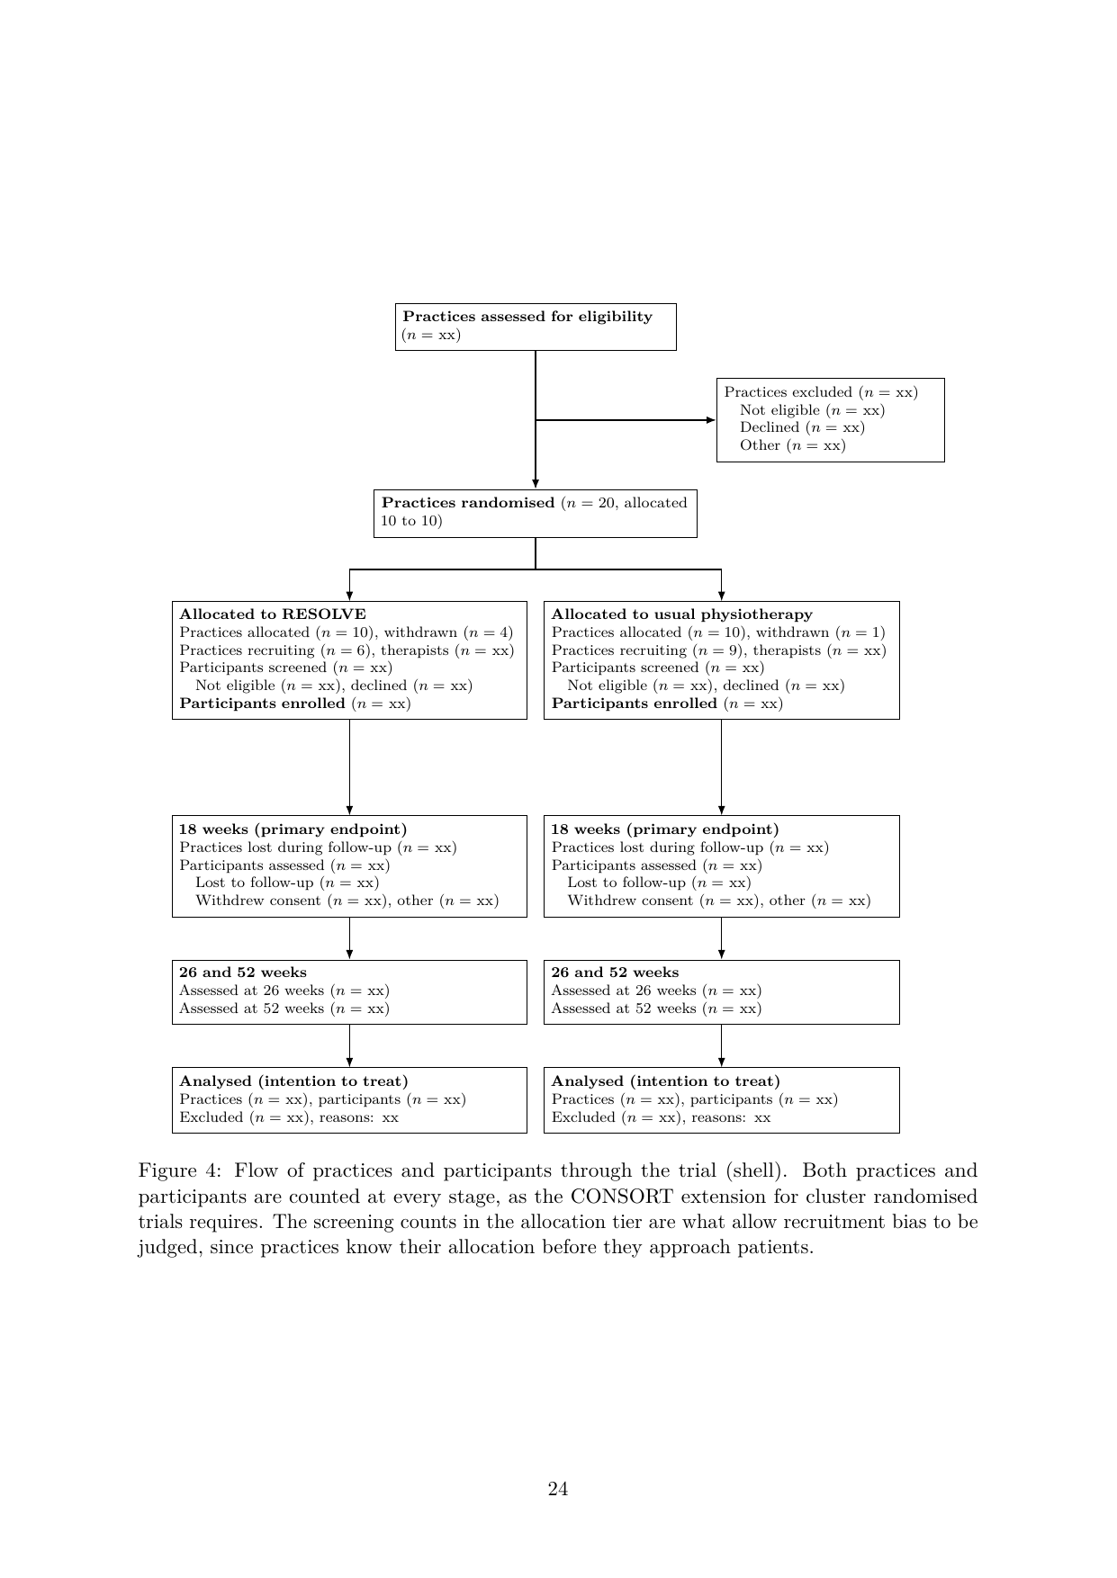
Flow of practices and participants through the trial (shell). Both practices and participants are counted at every stage, as the CONSORT extension for cluster randomised trials requires. The screening counts in the allocation tier are what allow recruitment bias to be judged, since practices know their allocation before they approach patients.
The guideline for the content of statistical analysis plans that this document follows (Gamble et al. 2017) contains no items specific to clustering. An extension for cluster randomised trials is under development but not yet published (Hemming et al. 2025). We have therefore added the cluster-specific items ourselves: the estimand and its weighting, the small-sample correction, the intra-cluster correlation, and the two-level description of the sample.

Declarations
Funding. The RESOLVE Swiss trial is funded by the Swiss National Science Foundation (grant number 220585). The funder has no role in the design of the analysis or the decision to publish this plan.
Conflicts of interest. [open: to be completed by all authors]
Ethics. Ethical approval was granted by the Cantonal Ethics Committee of Zurich as lead committee (BASEC 2025-00784) on 20 January 2026, with conditions whose fulfilment was confirmed on 10 April 2026.
Data and code availability. The code that reproduces the sample size and power calculations reported here accompanies this paper at https://github.com/jdegenfellner/Resolve_Swiss_Statistical_Analysis_Plan, and the version of record will be archived with a DOI on Zenodo [open: make the repository public and mint the Zenodo DOI at submission]. Analysis code for the trial will be published together with the trial results.
We will also publish the participant-level dataset behind the reported results on Zenodo under its own DOI, in an open format and with a codebook that names every variable, its coding and the coding of missing values. Which variables that file contains is a decision about identification risk, and we take it in one direction only: as few variables as re-analysis tolerates, never as many as the data permit. Two features of this trial make the risk larger than in an individually randomised trial. The participating practices are named in the study protocol, which makes a practice identifier an indirect identifier in itself. Some practices contribute few participants, where a single person can stand out inside a cluster.
The published file will therefore carry an arbitrary participant identifier and an arbitrary practice label with no key to the named practices. It will hold the treatment arm, the assessment occasion, the primary outcome, the secondary outcomes of section 2.9.2, and only those baseline variables that a prespecified analysis in this plan actually uses. The practice identifier is kept because the primary model cannot be refitted without it. Everything that is not needed for that purpose stays out. This covers dates, which are replaced by the study day counted from the baseline measurement, free-text entries, practice characteristics such as canton, size or setting, and the demographic detail that no analysis in this plan consumes. Age is released in five-year bands and any category holding very few participants is collapsed. We will assess the re-identification risk of the assembled file before it is deposited, and we will report in the results paper which variables were withheld, so that a reader can see what the published file cannot answer.
Publication follows the data publication procedure of the ZHAW School of Health Sciences: the dataset and its documentation pass an internal review by a person outside the project before deposition, and the deposit is registered in the ZHAW digitalcollection afterwards. [open: legal basis for publishing the participant-level data: the departmental guidance permits it only if the data are published fully anonymously with no key still in existence, or if participants signed a separate consent to publication. The trial keeps a participant identification list at each site for 20 years, so confirm with the sponsor and the ethics committee which of the two routes applies before anything is deposited]
Author contributions. JD: conceptualization, data curation, formal analysis, investigation, methodology, software, validation, visualization, writing – original draft, writing – review & editing. FP, AS, SC, BS: writing – review & editing. TB: funding acquisition, resources, writing – review & editing. All authors read and approved the final manuscript.
Adamczyk, W., A. Sługocka, O. Saulicz, and E. Saulicz. 2016. “The point-to-point test: a new diagnostic tool for measuring lumbar tactile acuity? Inter and intra-examiner reliability study of pain-free subjects.” Manual Therapy 22: 220–26. https://doi.org/10.1016/j.math.2015.12.012.
Adams, Geoffrey, Martin C. Gulliford, Obioha C. Ukoumunne, Sandra Eldridge, Susan Chinn, and Michael J. Campbell. 2004. “Patterns of Intra-Cluster Correlation from Primary Care Research to Inform Study Design and Analysis.” Journal of Clinical Epidemiology 57 (8): 785–94. https://doi.org/10.1016/j.jclinepi.2003.12.013.
Altman, Douglas G. 1985. “Comparability of Randomised Groups.” Journal of the Royal Statistical Society: Series D (The Statistician) 34 (1): 125–36. https://doi.org/10.2307/2987510.
Amrhein, Valentin, Sander Greenland, and Blake McShane. 2019. “Scientists Rise up Against Statistical Significance.” Nature 567 (7748): 305–7. https://doi.org/10.1038/d41586-019-00857-9.
Andridge, Rebecca R. 2011. “Quantifying the Impact of Fixed Effects Modeling of Clusters in Multiple Imputation for Cluster Randomized Trials.” Biometrical Journal 53 (1): 57–74. https://doi.org/10.1002/bimj.201000140.
Angrist, Joshua D., Guido W. Imbens, and Donald B. Rubin. 1996. “Identification of Causal Effects Using Instrumental Variables.” Journal of the American Statistical Association 91 (434): 444–55. https://doi.org/10.1080/01621459.1996.10476902.
Bagg, Matthew K., Benedict M. Wand, Aidan G. Cashin, et al. 2022. “Effect of Graded Sensorimotor Retraining on Pain Intensity in Patients with Chronic Low Back Pain.” JAMA 328 (5): 430–39. https://doi.org/10.1001/jama.2022.9930.
Barth, J., A. Kern, S. Lüthi, and C. M. Witt. 2019. “Assessment of patients’ expectations: development and validation of the Expectation for Treatment Scale (ETS).” BMJ Open 9: e026712. https://doi.org/10.1136/bmjopen-2018-026712.
Bell, Melanie L., and Brooke A. Rabe. 2020. “The Mixed Model for Repeated Measures for Cluster Randomized Trials: A Simulation Study Investigating Bias and Type i Error with Missing Continuous Data.” Trials 21 (1): 148. https://doi.org/10.1186/s13063-020-4114-9.
Bell, Robert M., and Daniel F. McCaffrey. 2002. “Bias Reduction in Standard Errors for Linear Regression with Multi-Stage Samples.” Survey Methodology 28 (2): 169–81.
Ben-Ami, N., G. Chodick, Y. Mirovsky, T. Pincus, and Y. Shapiro. 2017. “Increasing recreational physical activity in patients with chronic low back pain: a pragmatic controlled clinical trial.” Journal of Orthopaedic & Sports Physical Therapy 47 (2): 57–66. https://doi.org/10.2519/jospt.2017.7057.
Billot, Laurent, Andrew Copas, Clemence Leyrat, Andrew Forbes, and Elizabeth L. Turner. 2024. “How Should a Cluster Randomized Trial Be Analyzed?” Journal of Epidemiology and Population Health 72 (1): 202196. https://doi.org/10.1016/j.jeph.2024.202196.
Breukelen, Gerard J P van, and Math J J M Candel. 2018. “How to Design and Analyse Cluster Randomized Trials with a Small Number of Clusters? Comment on Leyrat Et Al.” International Journal of Epidemiology 47 (3): 998–1001. https://doi.org/10.1093/ije/dyy061.
Campbell, M. K., G. Piaggio, D. R. Elbourne, and D. G. Altman. 2012. “CONSORT 2010 Statement: Extension to Cluster Randomised Trials.” BMJ 345: e5661. https://doi.org/10.1136/bmj.e5661.
Campbell, Marion K., Peter M. Fayers, and Jeremy M. Grimshaw. 2005. “Determinants of the Intracluster Correlation Coefficient in Cluster Randomized Trials: The Case of Implementation Research.” Clinical Trials 2 (2): 99–107. https://doi.org/10.1191/1740774505cn071oa.
Catley, M. J., A. Tabor, B. M. Wand, and G. L. Moseley. 2013. “Assessing tactile acuity in rheumatology and musculoskeletal medicine—how reliable are two-point discrimination tests at the neck, hand, back and foot?” Rheumatology 52: 1454–61. https://doi.org/10.1093/rheumatology/ket140.
Chiarotto, Alessandro, Lara J. Maxwell, Caroline B. Terwee, George A. Wells, Peter Tugwell, and Raymond W. Ostelo. 2016. “Roland-Morris Disability Questionnaire and Oswestry Disability Index: Which Has Better Measurement Properties for Measuring Physical Functioning in Nonspecific Low Back Pain? Systematic Review and Meta-Analysis.” Physical Therapy 96 (10): 1620–37. https://doi.org/10.2522/ptj.20150420.
Copas, Andrew J., and Richard Hooper. 2021. “Optimal Design of Cluster Randomized Trials Allowing Unequal Allocation of Clusters and Unequal Cluster Size Between Arms.” Statistics in Medicine 40 (25): 5474–86. https://doi.org/10.1002/sim.9135.
Darlow, B. et al. 2014. “The development and exploratory analysis of the Back Pain Attitudes Questionnaire (Back-PAQ).” BMJ Open 4: e005251. https://doi.org/10.1136/bmjopen-2014-005251.
Dieck, A., C. M. Morin, and J. Backhaus. 2018. “A German version of the Insomnia Severity Index.” Somnologie 22: 27–35. https://doi.org/10.1007/s11818-017-0147-z.
Ehrenbrusthoff, K., C. G. Ryan, C. Grüneberg, B. M. Wand, and D. J. Martin. 2018. “The translation, validity and reliability of the German version of the Fremantle Back Awareness Questionnaire.” PLOS ONE 13: e0205244. https://doi.org/10.1371/journal.pone.0205244.
Eldridge, Sandra M, Deborah Ashby, and Sally Kerry. 2006. “Sample Size for Cluster Randomized Trials: Effect of Coefficient of Variation of Cluster Size and Analysis Method.” International Journal of Epidemiology 35 (5): 1292–300. https://doi.org/10.1093/ije/dyl129.
Eldridge, S., S. Kerry, and D. J Torgerson. 2009. “Bias in Identifying and Recruiting Participants in Cluster Randomised Trials: What Can Be Done?” BMJ 339: b4006. https://doi.org/10.1136/bmj.b4006.
Gamble, Carrol, Ashma Krishan, Deborah Stocken, et al. 2017. “Guidelines for the Content of Statistical Analysis Plans in Clinical Trials.” JAMA 318 (23): 2337–43. https://doi.org/10.1001/jama.2017.18556.
Hawker, G. A., S. Mian, T. Kendzerska, and M. French. 2011. “Measures of adult pain: Visual Analog Scale for Pain (VAS Pain), Numeric Rating Scale for Pain (NRS Pain), McGill Pain Questionnaire (MPQ), Short-Form McGill Pain Questionnaire (SF-MPQ), Chronic Pain Grade Scale (CPGS), Short Form-36 Bodily Pain Scale (SF-36 BPS), and Measure of Intermittent and Constant Osteoarthritis Pain (ICOAP).” Arthritis Care & Research 63: S240–52. https://doi.org/10.1002/acr.20543.
Hayes, Richard J., and Lawrence H. Moulton. 2017. Cluster Randomised Trials. 2nd ed. Chapman; Hall/CRC. https://doi.org/10.4324/9781315370286.
Heldmann, P., T. Schöttker-Königer, and A. Schäfer. 2015. “Cross-cultural adaption and validity of the ‘Patient Specific Functional Scale’.” International Journal of Health Professions 2: 73–82. https://doi.org/10.1515/ijhp-2015-0002.
Hemming, Karla, and Monica Taljaard. 2023. “Key Considerations for Designing, Conducting and Analysing a Cluster Randomized Trial.” International Journal of Epidemiology 52 (5): 1648–58. https://doi.org/10.1093/ije/dyad064.
Hemming, Karla, Monica Taljaard, Mirjam Moerbeek, and Andrew Forbes. 2021. “Contamination: How Much Can an Individually Randomized Trial Tolerate?” Statistics in Medicine 40 (14): 3329–51. https://doi.org/10.1002/sim.8958.
Hemming, Karla, Jacqueline Y. Thompson, Richard L. Hooper, et al. 2025. “Guidelines for the Content of Statistical Analysis Plans in Clinical Trials: Protocol for an Extension to Cluster Randomized Trials.” Trials 26 (1): 72. https://doi.org/10.1186/s13063-025-08756-3.
Hemming, K, S Eldridge, G Forbes, C Weijer, and M Taljaard. 2017. “How to Design Efficient Cluster Randomised Trials.” BMJ 358: j3064. https://doi.org/10.1136/bmj.j3064.
Herdman, M. et al. 2011. “Development and preliminary testing of the new five-level version of EQ-5D (EQ-5D-5L).” Quality of Life Research 20: 1727–36. https://doi.org/10.1007/s11136-011-9903-x.
Hooper, Richard, Andrew Forbes, Karla Hemming, Andrea Takeda, and Lee Beresford. 2018. “Analysis of Cluster Randomised Trials with an Assessment of Outcome at Baseline.” BMJ 360: k1121. https://doi.org/10.1136/bmj.k1121.
Hooper, Richard, Steven Teerenstra, Esther de Hoop, and Sandra Eldridge. 2016. “Sample Size Calculation for Stepped Wedge and Other Longitudinal Cluster Randomised Trials.” Statistics in Medicine 35 (26): 4718–28. https://doi.org/10.1002/sim.7028.
Hopewell, Sally, An-Wen Chan, Gary S Collins, et al. 2025. “Consort 2025 Statement: Updated Guideline for Reporting Randomised Trials.” BMJ 389: e081123. https://doi.org/10.1136/bmj-2024-081123.
Hurley, Deirdre A., Isabelle Jeffares, Amanda M. Hall, et al. 2020. “Feasibility Cluster Randomised Controlled Trial Evaluating a Theory-Driven Group-Based Complex Intervention Versus Usual Physiotherapy to Support Self-Management of Osteoarthritis and Low Back Pain (SOLAS).” Trials 21 (1): 807. https://doi.org/10.1186/s13063-020-04671-x.
Ibrahim, Joseph G., and Ming-Hui Chen. 2000. “Power Prior Distributions for Regression Models.” Statistical Science 15 (1): 46–60.
International Council for Harmonisation. 2019. ICH E9(R1): Addendum on Estimands and Sensitivity Analysis in Clinical Trials to the Guideline on Statistical Principles for Clinical Trials. ICH Harmonised Guideline, final version adopted 20 November 2019.
Ivers, Noah M, Ilana J Halperin, Jan Barnsley, et al. 2012. “Allocation Techniques for Balance at Baseline in Cluster Randomized Trials: A Methodological Review.” Trials 13 (1): 120. https://doi.org/10.1186/1745-6215-13-120.
Kahan, B. C., and T. P. Morris. 2012. “Reporting and Analysis of Trials Using Stratified Randomisation in Leading Medical Journals: Review and Reanalysis.” BMJ 345: e5840. https://doi.org/10.1136/bmj.e5840.
Kahan, Brennan C., Frank Bretz, Andrew Copas, et al. 2026. “CRT-Estimands Framework: Consensus Based Extension of the ICH E9(R1) Addendum for Cluster Randomised Trials.” BMJ 393: e089050. https://doi.org/10.1136/bmj-2025-089050.
Kahan, Brennan C., Gordon Forbes, Yunus Ali, et al. 2016. “Increased Risk of Type i Errors in Cluster Randomised Trials with Small or Medium Numbers of Clusters: A Review, Reanalysis, and Simulation Study.” Trials 17 (1): 438. https://doi.org/10.1186/s13063-016-1571-2.
Kahan, Brennan C, Fan Li, Andrew J Copas, and Michael O Harhay. 2023. “Estimands in Cluster-Randomized Trials: Choosing Analyses That Answer the Right Question.” International Journal of Epidemiology 52 (1): 107–18. https://doi.org/10.1093/ije/dyac131.
Kent, P., T. Haines, P. O’Sullivan, et al. 2023. “Cognitive functional therapy with or without movement sensor biofeedback versus usual care for chronic, disabling low back pain (RESTORE): a randomised, controlled, three-arm, parallel group, phase 3, clinical trial.” The Lancet 401 (10391): 1866–77. https://doi.org/10.1016/S0140-6736(23)00441-5.
Kenward, Michael G., and James H. Roger. 1997. “Small Sample Inference for Fixed Effects from Restricted Maximum Likelihood.” Biometrics 53 (3): 983. https://doi.org/10.2307/2533558.
King, Lauren K., Nicolas S. Bodmer, Pakeezah Saadat, Pavlos Bobos, Gillian A. Hawker, and Bruno R. da Costa. 2023. “Intracluster Correlation Coefficients in Osteoarthritis Cluster Randomized Trials: A Systematic Review.” Osteoarthritis and Cartilage 31 (12): 1548–53. https://doi.org/10.1016/j.joca.2023.09.006.
Klar, Neil, and Gerarda Darlington. 2004. “Methods for Modelling Change in Cluster Randomization Trials.” Statistics in Medicine 23 (15): 2341–57. https://doi.org/10.1002/sim.1858.
Korevaar, Elizabeth, Jessica Kasza, Monica Taljaard, et al. 2021. “Intra-cluster correlations from the CLustered OUtcome Dataset bank to inform the design of longitudinal cluster trials.” Clinical Trials 18 (5): 529–40. https://doi.org/10.1177/17407745211020852.
Lang, Thomas A., and Douglas G. Altman. 2015. “Basic Statistical Reporting for Articles Published in Biomedical Journals: The ‘Statistical Analyses and Methods in the Published Literature’ or the SAMPL Guidelines.” International Journal of Nursing Studies 52 (1): 5–9. https://doi.org/10.1016/j.ijnurstu.2014.09.006.
Leyrat, Clémence, Katy E Morgan, Baptiste Leurent, and Brennan C Kahan. 2018. “Cluster Randomized Trials with a Small Number of Clusters: Which Analyses Should Be Used?” International Journal of Epidemiology 47 (1): 321–31. https://doi.org/10.1093/ije/dyx169.
Liang, Kung-Yee, and Scott L. Zeger. 2000. “Longitudinal Data Analysis of Continuous and Discrete Responses for Pre-Post Designs.” Sankhyā: The Indian Journal of Statistics, Series B 62 (1): 134–48.
Luomajoki, H., J. Kool, E. D. de Bruin, and O. Airaksinen. 2007. “Reliability of movement control tests in the lumbar spine.” BMC Musculoskeletal Disorders 8: 90. https://doi.org/10.1186/1471-2474-8-90.
Luomajoki, H., J. Kool, E. D. de Bruin, and O. Airaksinen. 2008. “Movement control tests of the low back: evaluation of the difference between patients with low back pain and healthy controls.” BMC Musculoskeletal Disorders 9: 170. https://doi.org/10.1186/1471-2474-9-170.
Mangels, M., S. Schwarz, G. Sohr, M. Holme, and W. Rief. 2009. “Der Fragebogen zur Erfassung der schmerzspezifischen Selbstwirksamkeit (FESS).” Diagnostica 55: 84–93. https://doi.org/10.1026/0012-1924.55.2.84.
Martin, James, Alan Girling, Krishnarajah Nirantharakumar, Ronan Ryan, Tom Marshall, and Karla Hemming. 2016. “Intra-Cluster and Inter-Period Correlation Coefficients for Cross-Sectional Cluster Randomised Controlled Trials for Type-2 Diabetes in UK Primary Care.” Trials 17: 402. https://doi.org/10.1186/s13063-016-1532-9.
Moulton, Lawrence H. 2004. “Covariate-Based Constrained Randomization of Group-Randomized Trials.” Clinical Trials 1 (3): 297–305. https://doi.org/10.1191/1740774504cn024oa.
Nilges, P., and C. Essau. 2015. “Die Depressions-Angst-Stress-Skalen: der DASS – ein Screeningverfahren nicht nur für Schmerzpatienten.” Der Schmerz 29: 649–57. https://doi.org/10.1007/s00482-015-0019-z.
R Core Team. 2026. R: A Language and Environment for Statistical Computing. R Foundation for Statistical Computing. https://www.R-project.org/.
Reilly, M. C., A. S. Zbrozek, and E. M. Dukes. 1993. “The validity and reproducibility of a work productivity and activity impairment instrument.” PharmacoEconomics 4: 353–65. https://doi.org/10.2165/00019053-199304050-00006.
Richter, M. et al. 2019. “Die deutsche Version des Neurophysiology of Pain Questionnaire: Übersetzung, transkulturelle Adaptation, Reliabilität und Validität.” Der Schmerz 33: 244–52. https://doi.org/10.1007/s00482-019-0366-2.
Roland, Martin, and Jeremy Fairbank. 2000. “The Roland–Morris Disability Questionnaire and the Oswestry Disability Questionnaire.” Spine 25 (24): 3115–24. https://doi.org/10.1097/00007632-200012150-00006.
Rusu, A. C., N. Kreddig, D. Hallner, J. Hülsebusch, and M. I. Hasenbring. 2014. “Fear of movement/(re)injury in low back pain: confirmatory validation of a German version of the Tampa Scale for Kinesiophobia.” BMC Musculoskeletal Disorders 15: 280. https://doi.org/10.1186/1471-2474-15-280.
Senn, Stephen. 1994. “Testing for Baseline Balance in Clinical Trials.” Statistics in Medicine 13 (17): 1715–26. https://doi.org/10.1002/sim.4780131703.
Spiegelhalter, David J. 2001. “Bayesian Methods for Cluster Randomized Trials with Continuous Responses.” Statistics in Medicine 20 (3): 435–52.
Spiegelhalter, David J., Laurence S. Freedman, and Mahesh K. B. Parmar. 1994. “Bayesian Approaches to Randomized Trials.” Journal of the Royal Statistical Society, Series A 157 (3): 357–416.
Taljaard, Monica, Steven Teerenstra, Noah M Ivers, and Dean A Fergusson. 2016. “Substantial Risks Associated with Few Clusters in Cluster Randomized and Stepped Wedge Designs.” Clinical Trials 13 (4): 459–63. https://doi.org/10.1177/1740774516634316.
Teerenstra, Steven, Sandra Eldridge, Maud Graff, Esther de Hoop, and George F. Borm. 2012. “A Simple Sample Size Formula for Analysis of Covariance in Cluster Randomized Trials.” Statistics in Medicine 31 (20): 2169–78. https://doi.org/10.1002/sim.5352.
Turner-Stokes, L. 2009. “Goal attainment scaling (GAS) in rehabilitation: a practical guide.” Clinical Rehabilitation 23: 362–70. https://doi.org/10.1177/0269215508101742.
UK BEAM Trial Team. 2003. “UK Back Pain Exercise and Manipulation (UK BEAM) Trial – National Randomised Trial of Physical Treatments for Back Pain in Primary Care: Objectives, Design and Interventions.” BMC Health Services Research 3 (1): 16. https://doi.org/10.1186/1472-6963-3-16.
UK BEAM Trial Team. 2004. “United Kingdom Back Pain Exercise and Manipulation (UK BEAM) Randomised Trial: Effectiveness of Physical Treatments for Back Pain in Primary Care.” BMJ 329 (7479): 1377. https://doi.org/10.1136/bmj.38282.669225.AE.
Wälti, Philipp, Jan Kool, and Hannu Luomajoki. 2015. “Short-Term Effect on Pain and Function of Neurophysiological Education and Sensorimotor Retraining Compared to Usual Physiotherapy in Patients with Chronic or Recurrent Non-Specific Low Back Pain, a Pilot Randomized Controlled Trial.” BMC Musculoskeletal Disorders 16 (1): 83. https://doi.org/10.1186/s12891-015-0533-2.
Wand, Benedict M., and Neil E. O’Connell. 2008. “Chronic Non-Specific Low Back Pain – Sub-Groups or a Single Mechanism?” BMC Musculoskeletal Disorders 9: 11. https://doi.org/10.1186/1471-2474-9-11.
Wasserstein, Ronald L., Allen L. Schirm, and Nicole A. Lazar. 2019. “Moving to a World Beyond p $<$ 0.05”.” The American Statistician 73 (sup1): 1–19. https://doi.org/10.1080/00031305.2019.1583913.
Westfall, Peter H., and Andrea L. Arias. 2020. Understanding Regression Analysis: A Conditional Distribution Approach. Chapman & Hall/CRC.
Wirz, Markus, Fabian Pfeiffer, Andrea Stehrenberger, et al. 2026. Pain Science Education and Graded Sensorimotor Relearning Versus Usual Physiotherapy for Chronic Non-Specific Low Back Pain (RESOLVE Swiss): Study Protocol for a Multicentre, Cluster-Randomised Controlled Trial with a Nested Neuroimaging Substudy.

