**PC Repair Surgeon Application**

**WIREFRAME- HOME PAGE**

My mobile application will be called THE PC SURGEON. The application will be used to schedule PC repairs.

I do not want the three buttons to stack on smaller devices so I will create block level buttons that span the full width of a page. I will add the .btn-block to achieve this. (Example buttons are HOME, BOOK APPOINTMENT, and ABOUT US).

All app pages will display the application name in the header and in the footer will have the page name as well as our address and contact information.

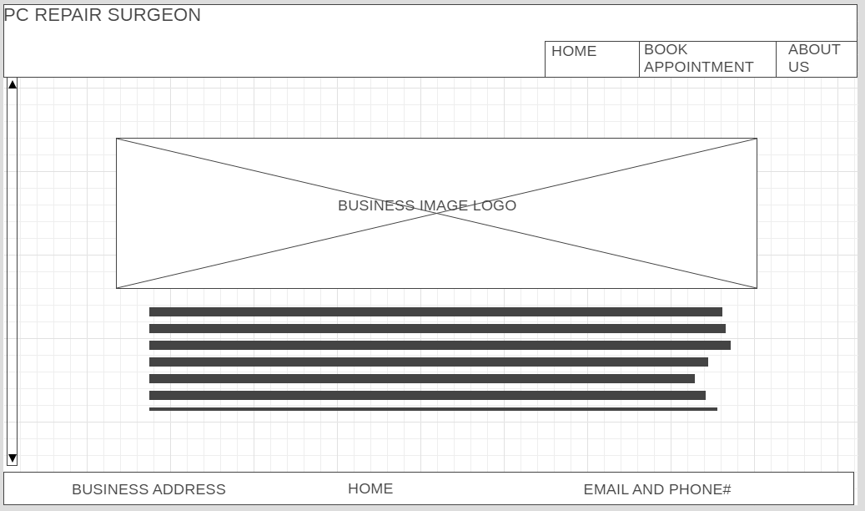

**WIREFRAME PAGE 2- BOOK APPOINTMENTS**

On this page I will be making a calendar thumbnail to allow the system to open a calendar. The drop down list on the right of the calendar thumbnail will display the available appointments.

All app pages will display the application name in the header and in the footer will have the page name as well as our address and contact information.

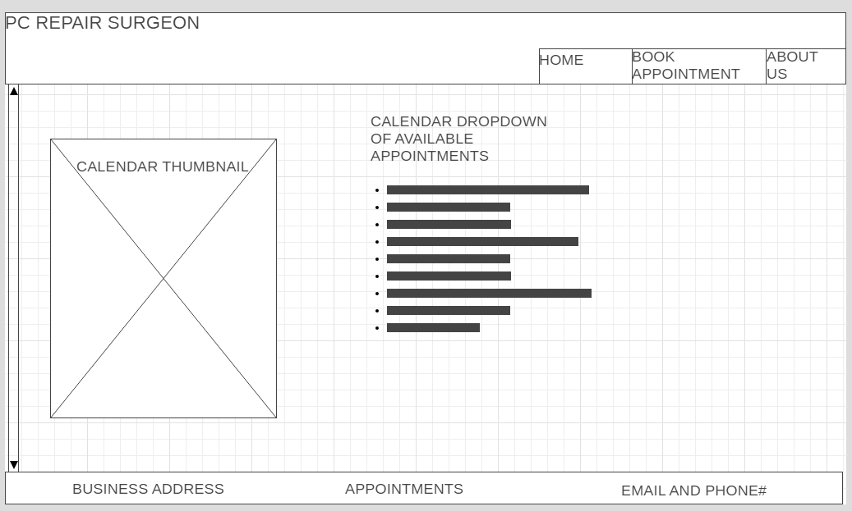

**WIREFRAME PAGE 3 – ABOUT US**

The ABOUT US page will display an IT innovations image and on the right side will be a paragraph that gives information about our application and business endeavors.

All app pages will display the application name in the header and in the footer will have the page name as well as our address and contact information.

