Experiments

Benchmarks and Skill Corpus.
We conduct experiments on SRA-Bench, which comprises six capability-intensive benchmarks: TheoremQA (Chen et al. 2023), LogicBench (Parmar et al. 2024), ToolQA (Zhuang et al. 2023), CHAMP (Mao, Kim, and Zhou 2024), MedCalc-Bench (Khandekar et al. 2024), and BigCodeBench (Zhuo et al. 2025). These datasets cover diverse task settings, including mathematical reasoning, formal logic, tool use, and code generation. Each instance is paired with annotated gold skill(s) and evaluated against a shared external skill corpus, enabling decomposed analysis of retrieval, incorporation, and end-task execution. We split each dataset into train, validation, and test splits with ratios of 70%, 15%, 15%, respectively. To evaluate the learning capabilities of baselines, we further filter and balance splits such that each split has at least one task that share the same required skill.

Evaluation Metrics.
We evaluate the SRA pipeline from both retrieval and end-task perspectives. For skill retrieval, we report Recall@$k$ and nDCG@$k$. We additionally report F1@$k$ to compare filtering capabilities. For end-task performance, each benchmark follows its standard evaluation protocol: rule-based exact match or accuracy for reasoning and QA datasets, and pass@1 based on unit-test execution for BigCodeBench. Averages are measured across task instances.
Table 1: Skill routing performance using Qwen3.5 4B. BM25, Vector, and SkillSight are shown first as native retrieval baselines. Each remaining row is the equal-weight mean across those three retrievers. Columns report nDCG@1 (N@1) and nDCG@10 (N@10) for each benchmark; Average uses each retriever’s task-weighted scores over 748 tasks. Bold and underlined values mark the best and second-best distinct scores in each column.
Method | BigCode Bench |  | CHAMP |  | LogicBench |  | MedCalc- Bench |  | TheoremQA |  | ToolQA |  | Average
 | N@1 | N@10 | N@1 | N@10 | N@1 | N@10 | N@1 | N@10 | N@1 | N@10 | N@1 | N@10 | N@1 | N@10
Retrievers
BM25 | 0.610 | 0.544 | 0.423 | 0.410 | 0.158 | 0.220 | 0.315 | 0.462 | 0.524 | 0.659 | 0.070 | 0.271 | 0.302 | 0.410
Vector | 0.504 | 0.407 | 0.346 | 0.463 | 0.105 | 0.248 | 0.988 | 0.992 | 0.695 | 0.833 | 0.312 | 0.413 | 0.516 | 0.575
SkillSight | 0.724 | 0.616 | 0.308 | 0.429 | 0.167 | 0.406 | 0.830 | 0.903 | 0.733 | 0.852 | 0.102 | 0.390 | 0.471 | 0.609
Routers
LLM Select | 0.480 | 0.510 | 0.385 | 0.458 | 0.266 | 0.394 | 0.745 | 0.834 | 0.683 | 0.819 | 0.437 | 0.547 | 0.519 | 0.616
SkillRouter | 0.366 | 0.299 | 0.449 | 0.476 | 0.269 | 0.416 | 0.974 | 0.981 | 0.816 | 0.860 | 0.600 | 0.711 | 0.619 | 0.671
SkillDAG | 0.612 | 0.600 | 0.359 | 0.453 | 0.143 | 0.378 | 0.709 | 0.785 | 0.651 | 0.781 | 0.161 | 0.421 | 0.429 | 0.576
Skill-Pro | 0.238 | 0.446 | 0.218 | 0.395 | 0.161 | 0.317 | 0.705 | 0.850 | 0.460 | 0.712 | 0.402 | 0.527 | 0.407 | 0.574
${RouterBSI}_{init}$ | 0.466 | 0.417 | 0.346 | 0.435 | 0.184 | 0.341 | 0.830 | 0.877 | 0.559 | 0.726 | 0.290 | 0.453 | 0.462 | 0.561
RouterBSI | 0.832 | 0.707 | 0.551 | 0.556 | 0.336 | 0.449 | 0.915 | 0.933 | 0.686 | 0.808 | 0.631 | 0.712 | 0.687 | 0.728

Selected Models.
We evaluate five models spanning four open-weight checkpoints and one proprietary frontier model: Qwen3.5-4B (Qwen Team 2026a), Qwen3.8-27B (Qwen Team 2026b), Llama-3.3-70B-Instruct (Meta 2024), gpt-oss-120b (OpenAI 2025), and GPT-5.4 (OpenAI 2026).

Baselines
We study retrieval, reranker, and selection baselines. The retrievers include sparse and dense retrievers (Su et al. 2026) and SkillSight, a hybrid retriever. They are trained on training split and frozen on validation and test splits. LLM Select is a static router, and LLM Direct and LLM Oracle are downstream performance baselines representing without skills and with ground-truth skill set, respectively (Su et al. 2026). The non-parametric optimization baselines are SkillDag and Skill-Pro (Mi et al. 2026; Bai et al. 2026). ${RouterBSI}_{init}$ and RouterBSI refer to the cold-start and final iteration performance. ${RouterBSI}_{strict}$ selects skills only when their predicate evaluates to true. ${RouterBSI}_{topk}$ are the top k skills using the sum of their predicate label and the retrieval score.

Implementation Details.
The retrievers use either pretrained embedding models or lexical matching, so they do not require training. Candidate skills are retrieved from the shared external skill corpus in response to the input query. The reranking and selection baselines are conditioned on the top 50 retrieved skills and use an optimization method to improve performance. SkillSight is the default retriever for reranking and selection baselines. The non-parametric baselines, including ours, do not output a continuous score like rerankers, so we rank them by the sum of their binary label and the retrieval score, where 1 is the label for selected skills and 0 otherwise. We use a temperature of 1 for proposing candidate predicates and 0 for evaluating predicates and downstream performance. RouterBSI is optimized over 10 iterations. Qwen3.5-4B is the default model used in our experiments.
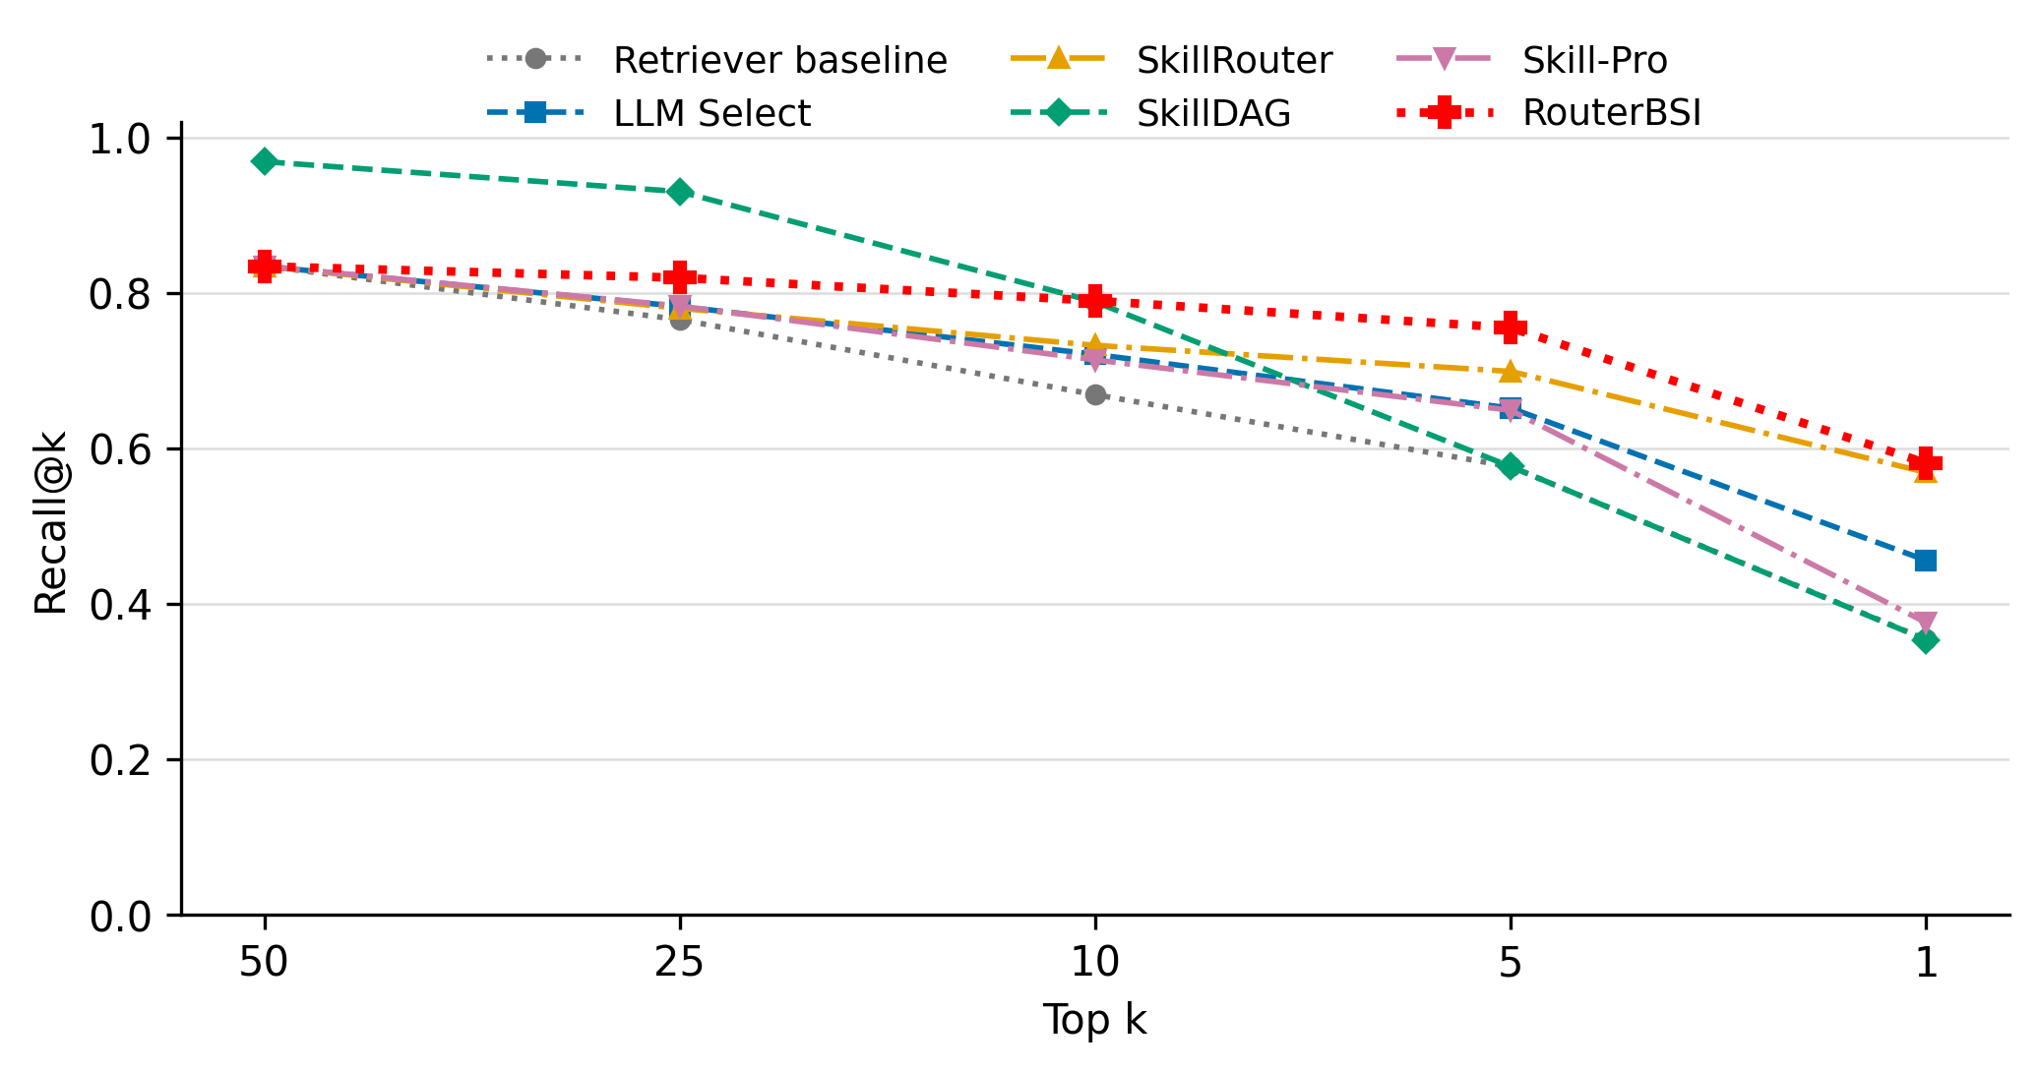
Figure 3: Required-skill recall comparison as the number of selected skills decreases. Lines show task-weighted test Recall@k averaged equally across BM25, Vector, and SkillSight. The retriever baseline averages the three native retrievers.
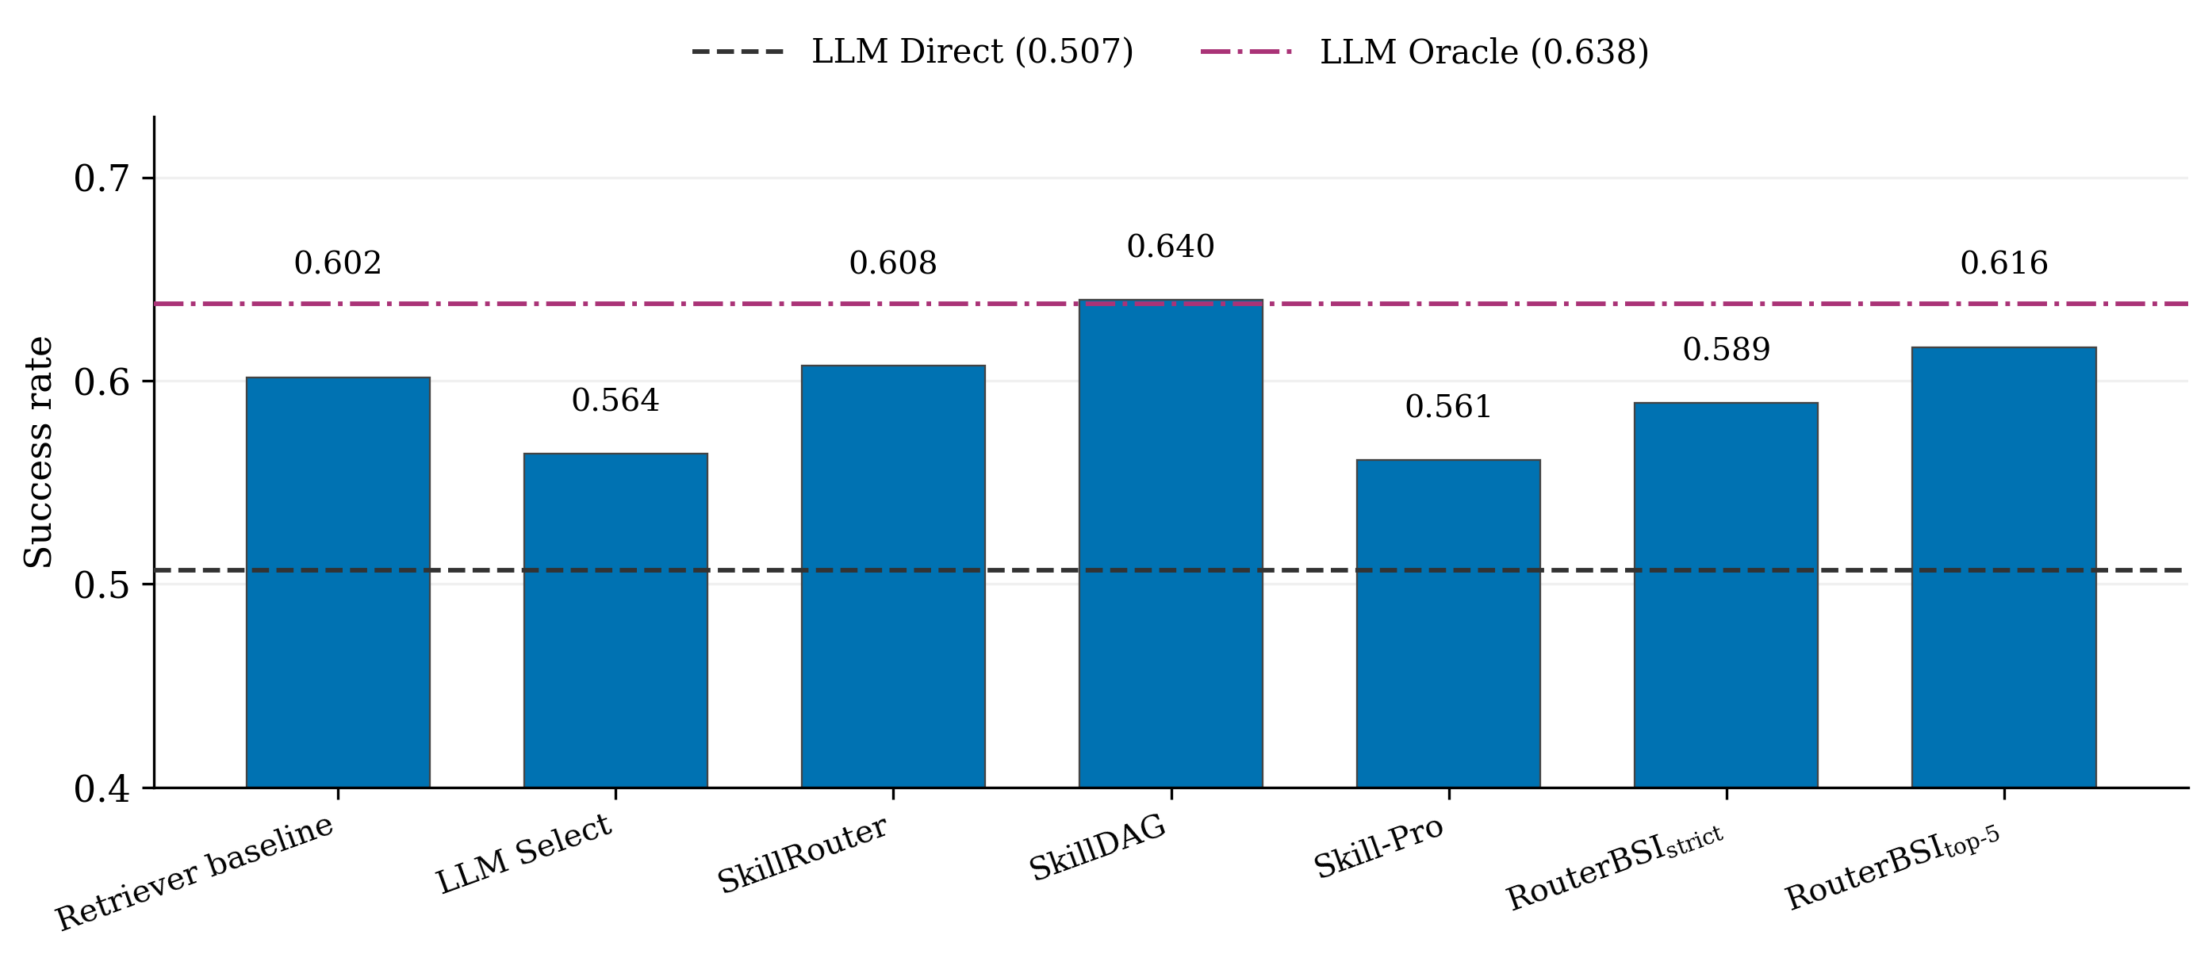
Figure 4: Downstream performance comparison using Qwen3.5 4B. Bars show task-weighted success rates averaged equally across BM25 and SkillSight. Horizontal lines show the LLM Direct and LLM Oracle references.
Bai, Tong, Zhenglin Wan, Pengfei Zhou, Xingrui Yu, Yang You, and Ivor W. Tsang. 2026. “SkillDAG: Self-Evolving Typed Skill Graphs for LLM Skill Selection at Scale.” https://arxiv.org/abs/2606.03056.
Chen, Wenhu, Ming Yin, Max Ku, Pan Lu, Yixin Wan, Xueguang Ma, Jianyu Xu, Xinyi Wang, and Tony Xia. 2023. “TheoremQA: A Theorem-Driven Question Answering Dataset.” In Proceedings of the 2023 Conference on Empirical Methods in Natural Language Processing, 7889–7901. Singapore: Association for Computational Linguistics. https://doi.org/10.18653/v1/2023.emnlp-main.489.
Khandekar, Nikhil, Qiao Jin, Guangzhi Xiong, Soren Dunn, Serina S Applebaum, Zain Anwar, Maame Sarfo-Gyamfi, et al. 2024. “MedCalc-Bench: Evaluating Large Language Models for Medical Calculations.” In Advances in Neural Information Processing Systems, 37:84730–45. Curran Associates, Inc. https://doi.org/10.52202/079017-2690.
Mao, Yujun, Yoon Kim, and Yilun Zhou. 2024. “CHAMP: A Competition-Level Dataset for Fine-Grained Analyses of LLMs’ Mathematical Reasoning Capabilities.” In Findings of the Association for Computational Linguistics: ACL 2024, 13256–74. Bangkok, Thailand: Association for Computational Linguistics. https://doi.org/10.18653/v1/2024.findings-acl.785.
Meta. 2024. “Llama 3.3 Model Card.” https://github.com/meta-llama/llama-models/blob/main/models/llama3\_3/MODEL\_CARD.md.
Mi, Qirui, Zhijian Ma, Mengyue Yang, Haoxuan Li, Yisen Wang, Haifeng Zhang, and Jun Wang. 2026. “Skill-Pro: Learning Reusable Skills from Experience via Non-Parametric PPO for LLM Agents.” In Proceedings of the 43rd International Conference on Machine Learning, 306:88574–95. Proceedings of Machine Learning Research. PMLR. https://proceedings.mlr.press/v306/mi26d.html.
OpenAI. 2025. “gpt-oss-120b & gpt-oss-20b Model Card.” https://arxiv.org/abs/2508.10925.
———. 2026. “Introducing GPT-5.4.” https://openai.com/index/introducing-gpt-5-4/.
Parmar, Mihir, Nisarg Patel, Neeraj Varshney, Mutsumi Nakamura, Man Luo, Santosh Mashetty, Arindam Mitra, and Chitta Baral. 2024. “LogicBench: Towards Systematic Evaluation of Logical Reasoning Ability of Large Language Models.” In Proceedings of the 62nd Annual Meeting of the Association for Computational Linguistics (Volume 1: Long Papers), 13679–707. Bangkok, Thailand: Association for Computational Linguistics. https://doi.org/10.18653/v1/2024.acl-long.739.
Qwen Team. 2026a. “Qwen3.5: Towards Native Multimodal Agents.” https://qwen.ai/blog?id=qwen3.5.
———. 2026b. “Qwen3.8-Max: A New Bar for Coding and Cowork.” https://qwen.ai/blog?id=qwen3.8.
Su, Weihang, Jianming Long, Qingyao Ai, Qiaozhi He, Yichen Tang, Changyue Wang, Yiteng Tu, Yingbo Wang, and Yiqun Liu. 2026. “Skill Retrieval Augmentation for Agentic AI.” https://arxiv.org/abs/2604.24594.
Zhuang, Yuchen, Yue Yu, Kuan Wang, Haotian Sun, and Chao Zhang. 2023. “ToolQA: A Dataset for LLM Question Answering with External Tools.” In Advances in Neural Information Processing Systems, 36:50117–43. Curran Associates, Inc. https://doi.org/10.52202/075280-2180.
Zhuo, Terry Yue, Minh Chien Vu, Jenny Chim, Han Hu, Wenhao Yu, Ratnadira Widyasari, Imam Nur Bani Yusuf, et al. 2025. “BigCodeBench: Benchmarking Code Generation with Diverse Function Calls and Complex Instructions.” In International Conference on Learning Representations, 2025:66602–56. https://proceedings.iclr.cc/paper\_files/paper/2025/file/a6a90bcc2aa470c3871b2d39a67d26e8-Paper-Conference.pdf.

