Introduction
Large language model (LLM) agents increasingly rely on reusable skills to extend their capabilities beyond knowledge encoded in model parameters. These skills package procedural knowledge that can be reused across recurring classes of tasks. As skill libraries grow, however, explicitly exposing every available skill in the context becomes increasingly impractical. Recent work therefore shifts toward Skill Retrieval Augmentation (SRA), where skills must be retrieved and loaded from a large-scale skill corpora (Su et al. 2026) (Figure 1).
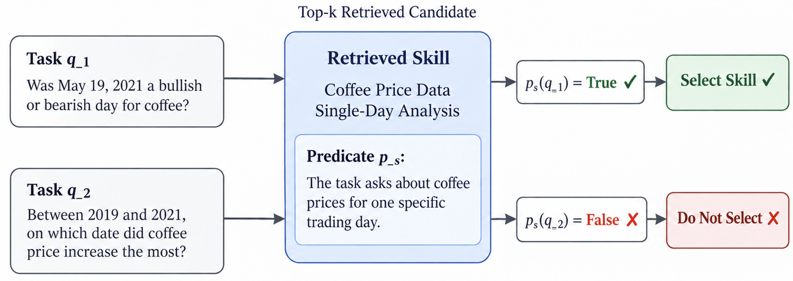
Figure 1: Skill routing with a task applicability predicate.
In SRA, retrieval based on semantic relevance alone is not enough. Skills must be invoked based on their downstream utility for completing a task to reliably augment the agent’s capabilities. Current agents can struggle to distinguish useful skills from irrelevant candidates even when the correct skill has been successfully retrieved (Su et al. 2026). We refer to skill routing as the process of determining which retrieved candidate skills are applicable to a task and should therefore enter the agents active context for completing a task. Reliable routing must distinguish applicability from semantic relatedness: a skill can be topically similar to a task without satisfying the requirements under which its procedure should be invoked. This distinction becomes increasingly important as broader candidate sets introduce irrelevant procedures that can distract the model or interfere with downstream reasoning.
Existing routing approaches address this problem through similarity scores, learned utility functions, direct model-based selection, and explicit activation conditions. Learned retrievers and rerankers can improve discrimination among candidates but encode routing criteria implicitly in model parameters and require additional optimization data and compute. In contrast, non-parametric approaches keep the underlying model fixed while modifying external state that influences future decisions. For example, Skill-Pro evolves natural-language skills that include explicit activation conditions, while SkillDAG persistently updates typed relationships among skills from interaction experience (Mi et al. 2026; Bai et al. 2026). Yet persistent external updates introduce a different reliability problem: an edit motivated by the current failure can improve one decision while degrading behavior on previously handled or unseen tasks. As interaction histories grow, retaining all prior examples for checking each update also makes continual adaptation increasingly expensive. This creates a need for a routing mechanism whose applicability criteria are explicit and editable, but whose updates are constrained by prior experience and independently checked for generalization. These problems of controlling regressions while bounding used experience serve as the motivation for our approach.
We introduce RouterBSI, a recursive self-improving framework for reliable skill routing based on explicit task applicability predicates. Each skill is associated with a natural-language predicate specifying the type of tasks for which the skill is applicable. RouterBSI first retrieves the top-$k$ candidate skills, then evaluates their predicates and selects a skill only when its predicate evaluates to true given the task. To learn from failed skill invocations, RouterBSI uses Minimum Bayes Risk (MBR) to select a candidate update that minimizes the error on a bounded replay of seen tasks. To prevent overfitting on seen tasks, we discard updates that regress performance on a held-out validation set. RouterBSI improves its cold-start top-k recall of required skills by an average of 22.3% across tasks from TheoremQA, LogicBench, ToolQA, MedCalc-Bench, CHAMP, BigCodeBench sharing a 26k skill corpus. Its top-5 recall is 79.8%, which is 13.8% to 22.3% higher than baselines.
Our contributions are:
- We propose RouterBSI, a non-parametric skill-routing framework that evaluates explicit applicability predicates over retrieved candidates, making routing criteria interpretable and directly editable without updating the underlying language model.
- We develop a recursive self-improvement procedure that refines predicates from routing failures, selects updates through minimum Bayes risk over a bounded replay of relevant and irrelevant tasks, and rejects updates that increase held-out validation error.
- We evaluate RouterBSI on six SRA-Bench datasets with a shared 26K-skill corpus, achieving the highest aggregate nDCG@10 and Hit@1 among evaluated methods while ablations establish the contributions of replay and validation.
Bai, Tong, Zhenglin Wan, Pengfei Zhou, Xingrui Yu, Yang You, and Ivor W. Tsang. 2026. “SkillDAG: Self-Evolving Typed Skill Graphs for LLM Skill Selection at Scale.” https://arxiv.org/abs/2606.03056.
Mi, Qirui, Zhijian Ma, Mengyue Yang, Haoxuan Li, Yisen Wang, Haifeng Zhang, and Jun Wang. 2026. “Skill-Pro: Learning Reusable Skills from Experience via Non-Parametric PPO for LLM Agents.” In Proceedings of the 43rd International Conference on Machine Learning, 306:88574–95. Proceedings of Machine Learning Research. PMLR. https://proceedings.mlr.press/v306/mi26d.html.
Su, Weihang, Jianming Long, Qingyao Ai, Qiaozhi He, Yichen Tang, Changyue Wang, Yiteng Tu, Yingbo Wang, and Yiqun Liu. 2026. “Skill Retrieval Augmentation for Agentic AI.” https://arxiv.org/abs/2604.24594.

