Get data files in order. Have a central data wrangling file where I do all calculations and bring everything together and then go outward from there. Completel mess and differences starting to show up in my analysis.

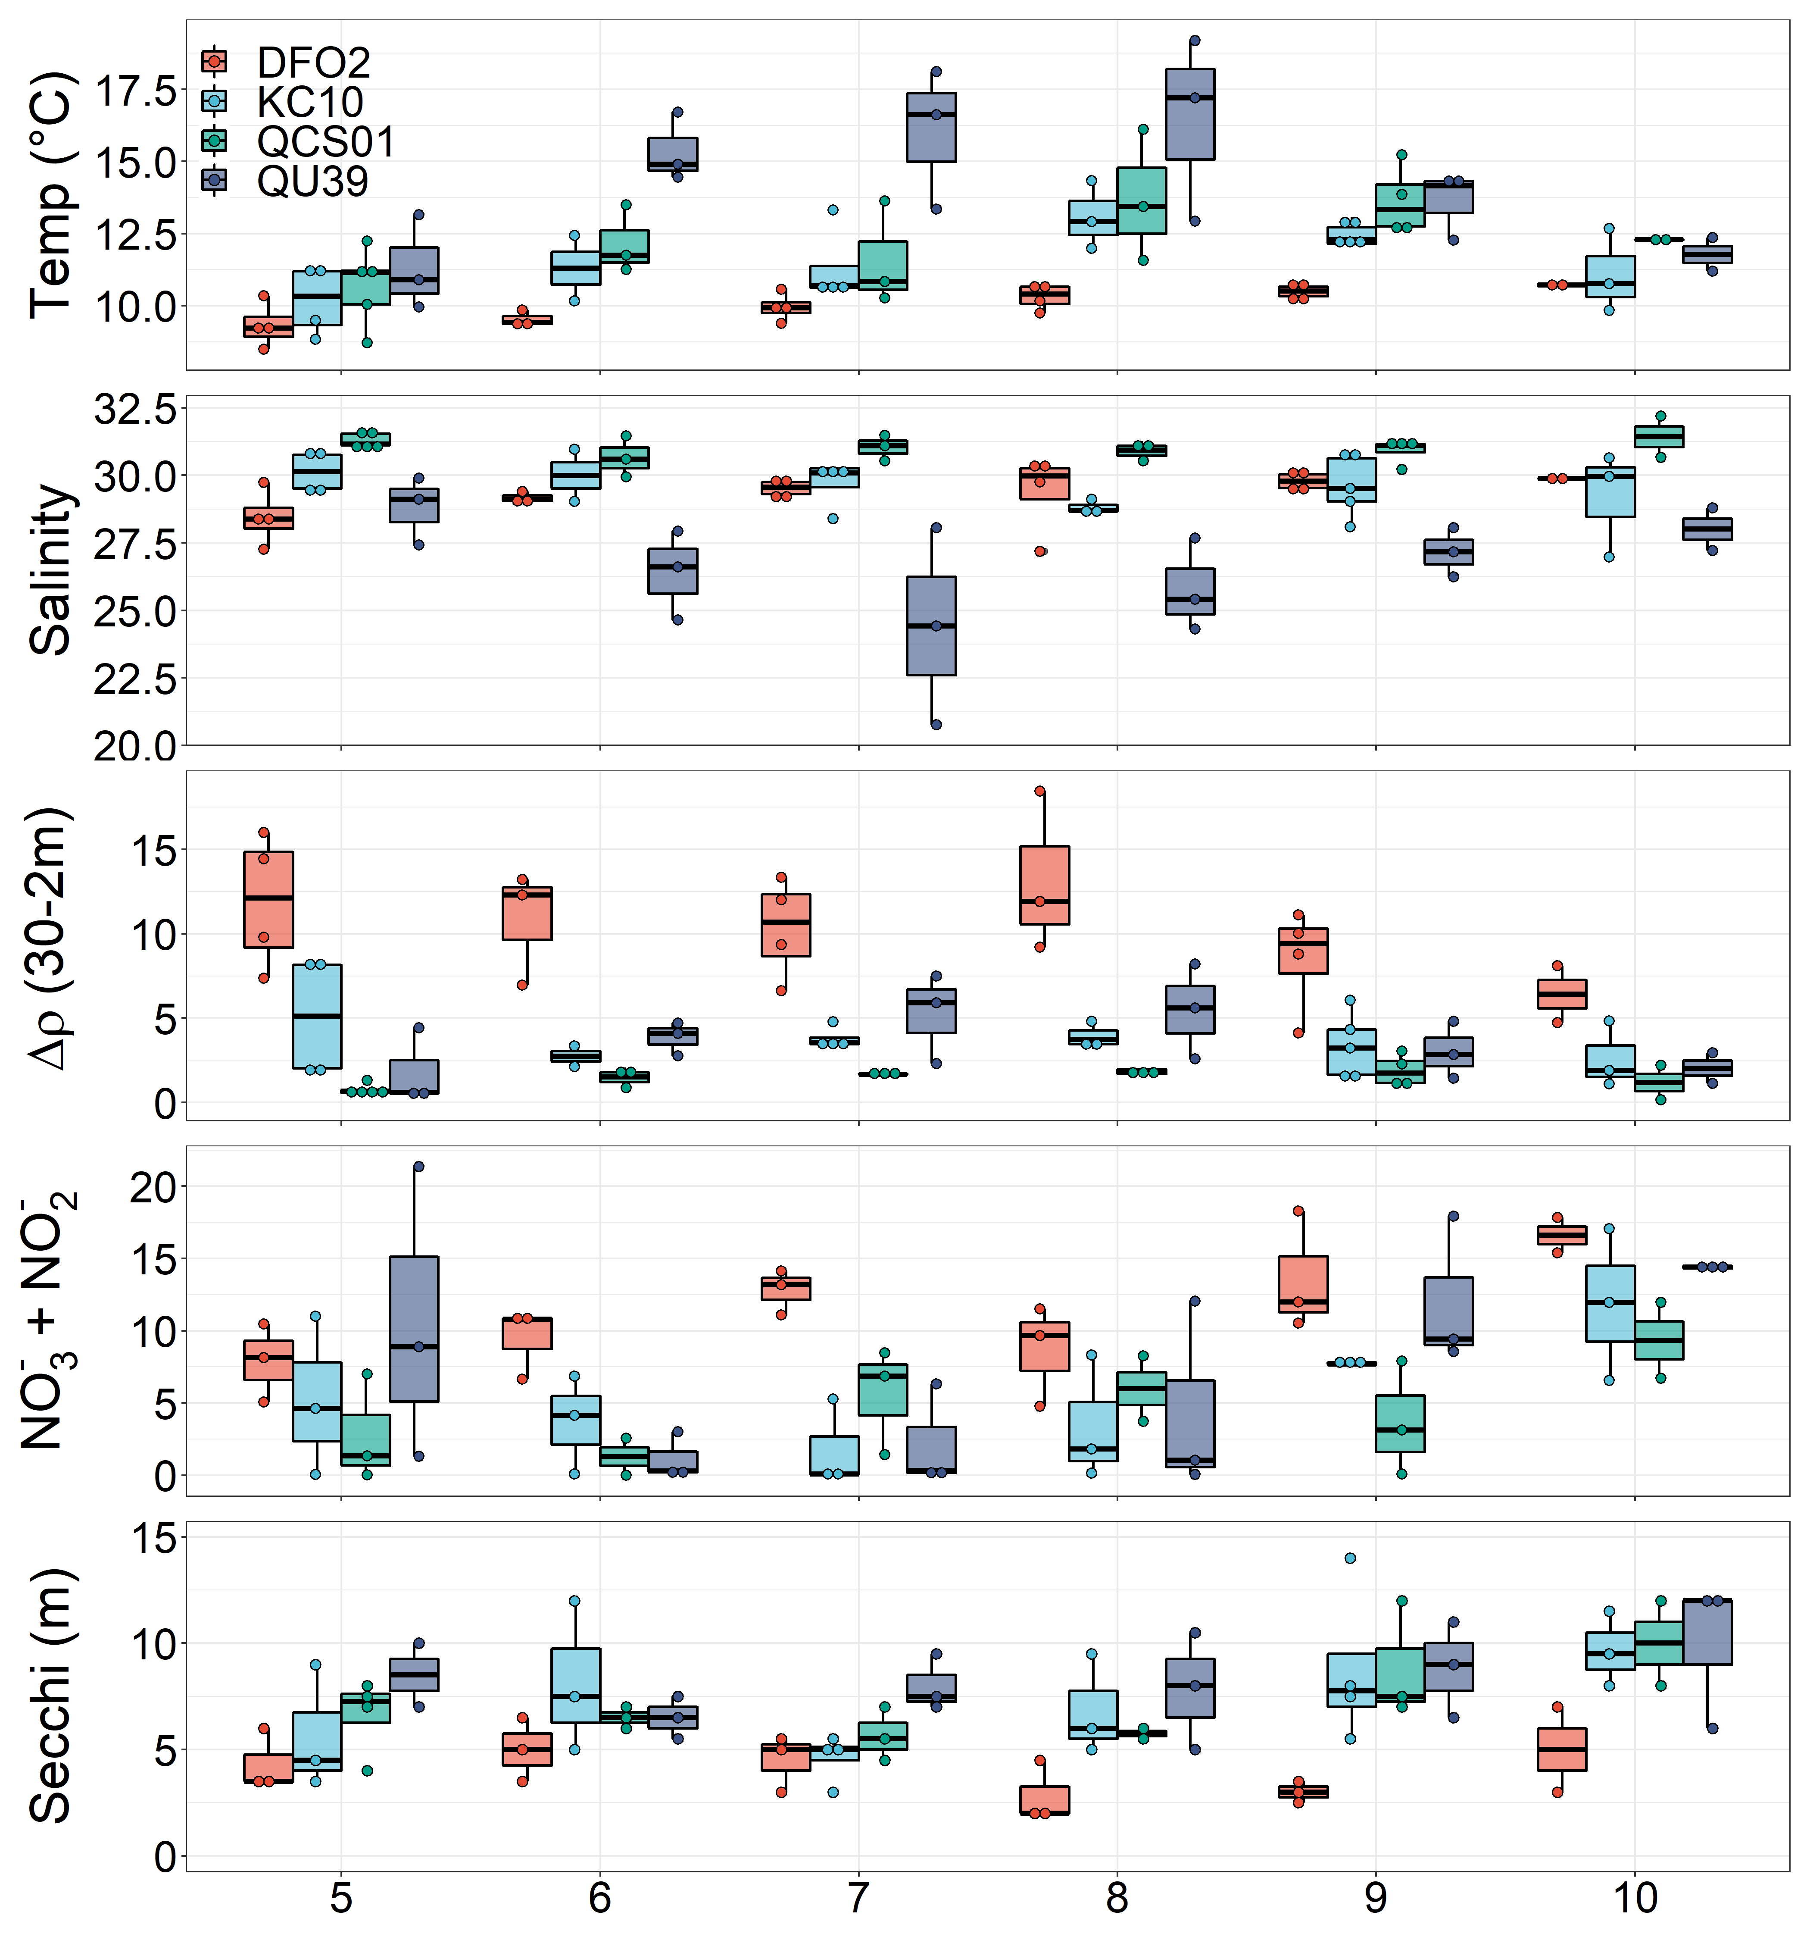

Issues – lots of times with 4+ points, despite three years of data.

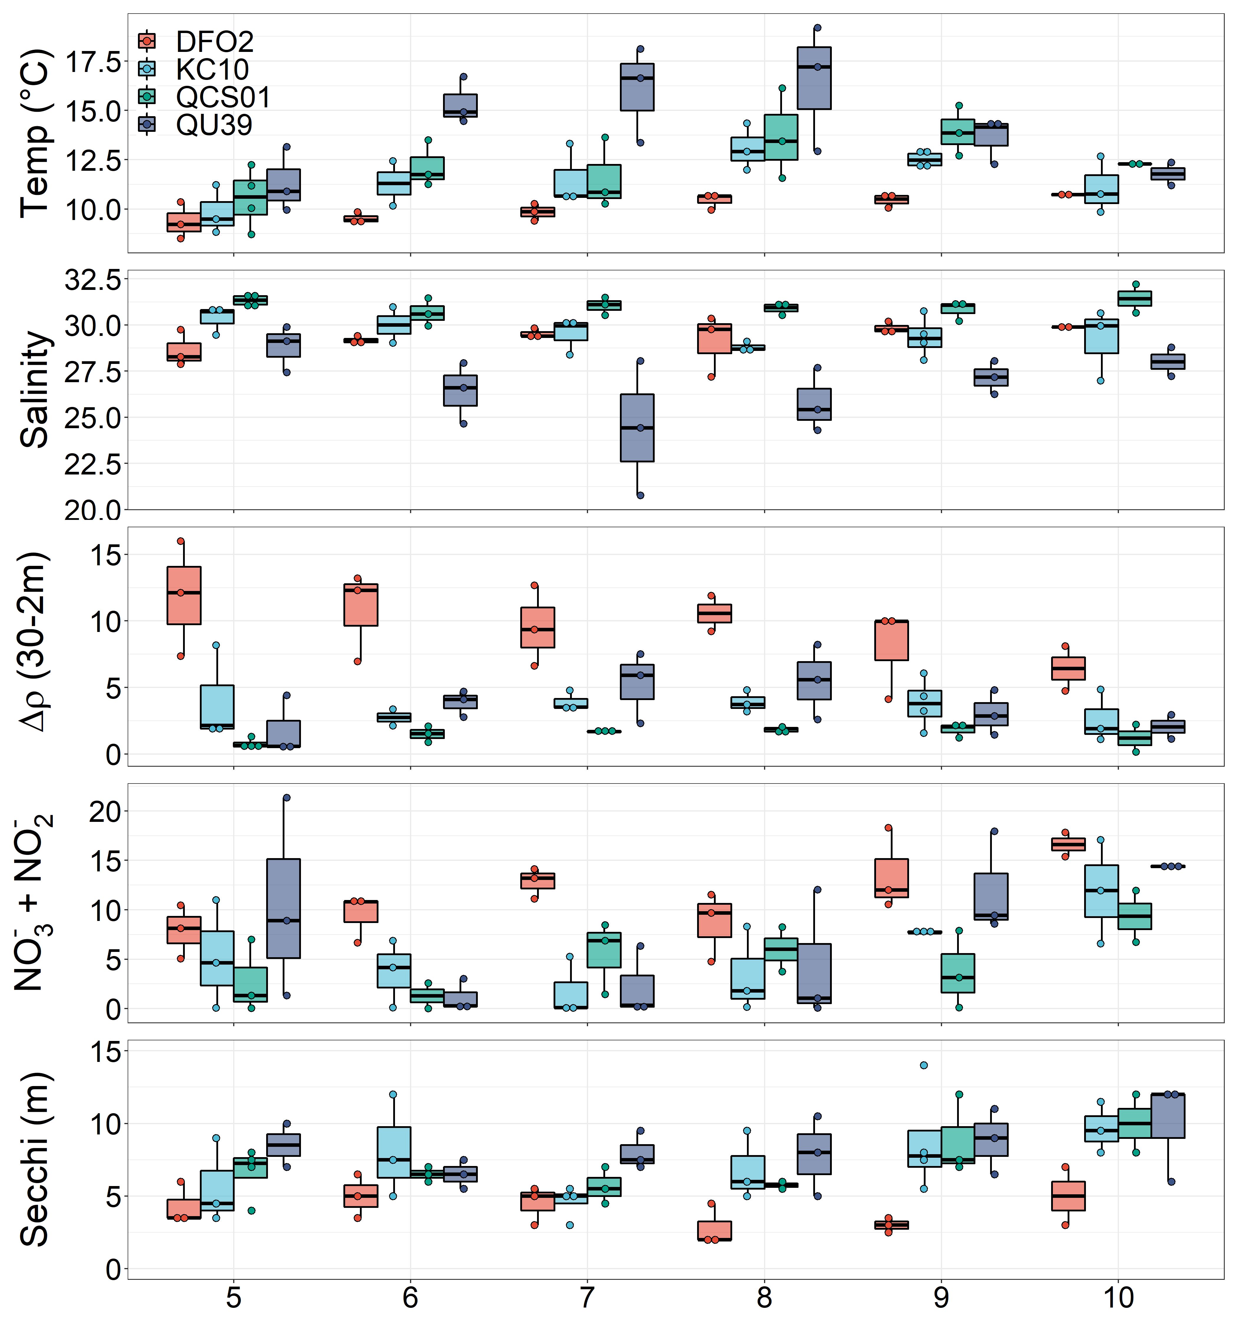

Physical description

Physically, there was wide variability between years and stations. In general, at Calvert Island, The KC10 (Fitz Hugh Channel) and QCS01 (Shelf) showed similar seasonality in 5 m depth temperature with

Since we don’t have HPLC for all years, do I use abundance or Chl for a general descriptor of Phytoplankton?

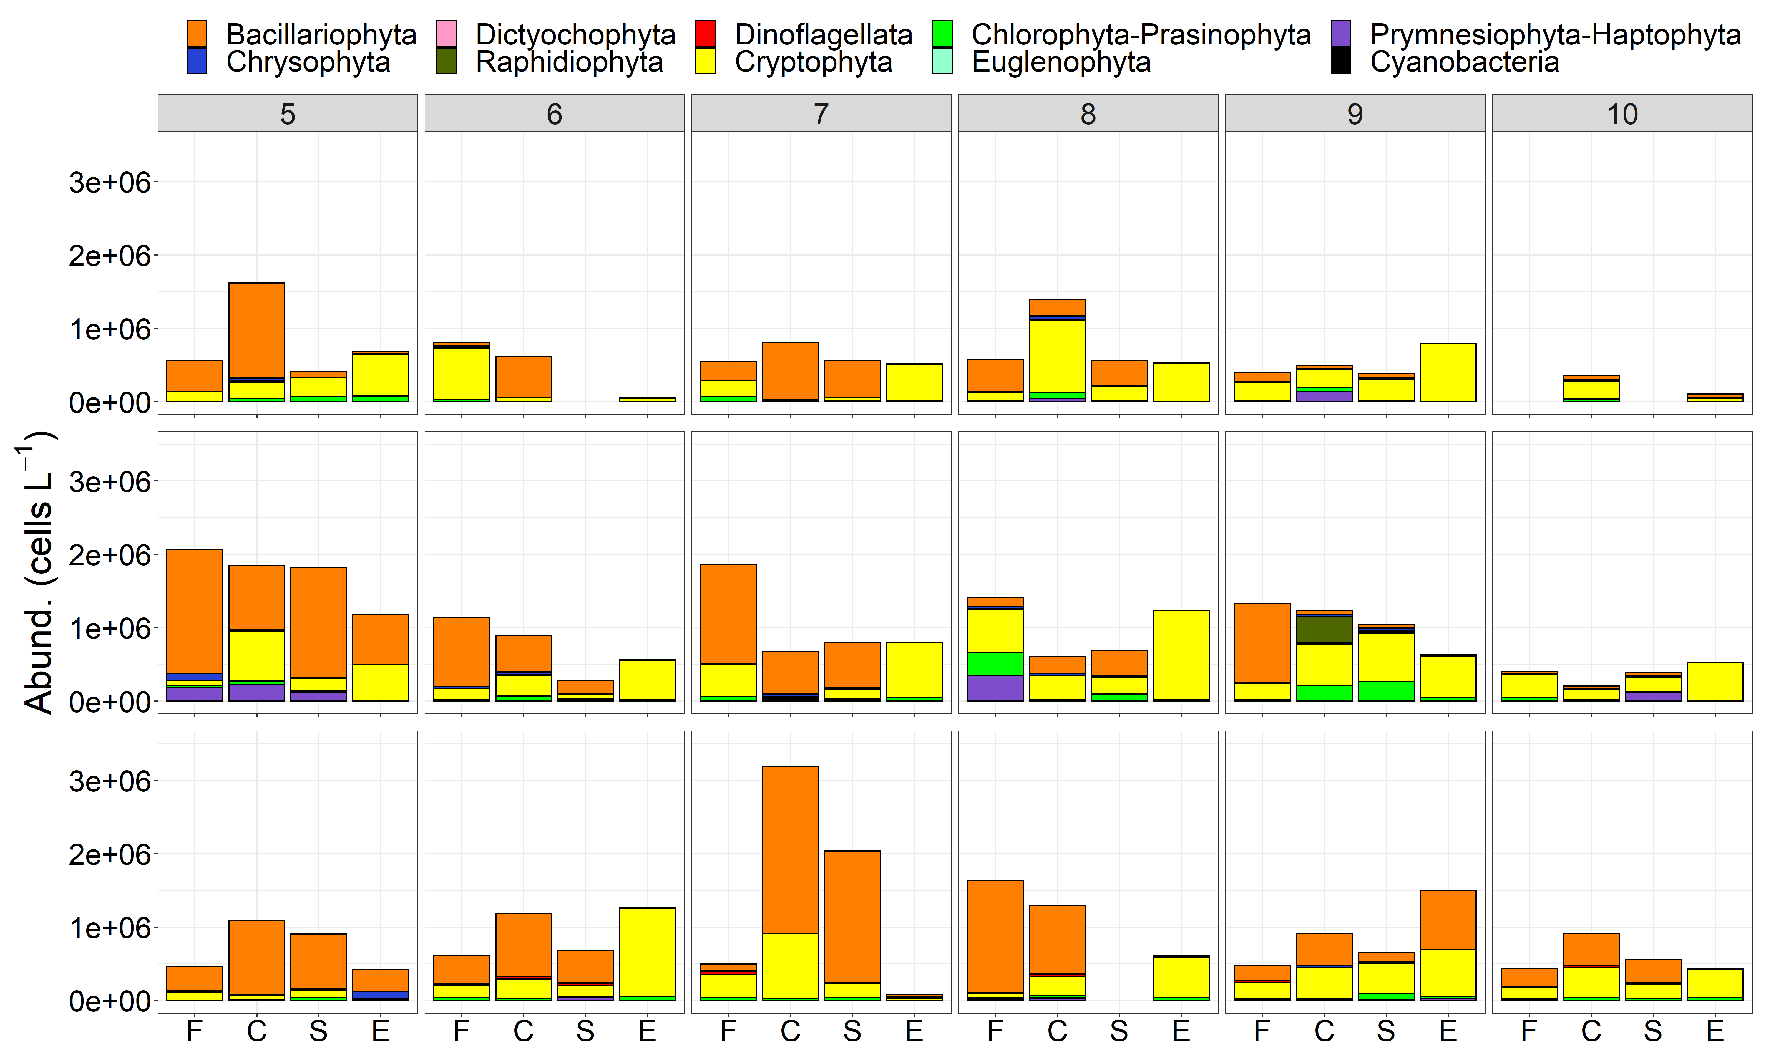

I really need to redo my chemtax analysis here. This is provisional. There is just not a lot of consistency here to describe. Seems sort of all over the place. Maybe a clustering method would better describe?