This report summarizes quality control issues we saw with the chlorophyll dataset form 2014 to present and the corrective actions we took to improve data quality.

Issue 1 - Calibration Variability
Prior to 2018, we saw variability in benchtop chlorophyll calibrations, particularly for instrument #1154: At this time, a fluorometer was operated on Calvert (#0982) and Quadra (#1154). Both instruments were calibrated on site by different teams and using different standards with both instruments showing different trends. Notably for instrument #1154, the observed calibration variability did not follow expected trends for instrument drift and likely represented analytical error. For instance, this instrument showed strongly linear calibrations (r2 > 0.999), but with erratically varying slopes. As the linear fit was strong for these calibrations, variability in slope may represent uncalibrated pipettes consistently adding error to standard concentrations. Another factor, observed on both instruments was low and variable acid ratios (fm): The acid ratio is the ratio of the pre-acidified (pure chlorophyll) to post-acidified (completely degraded chlorophyll) chlorophyll reading and should be consistently high for a pure chlorophyll standard. Both calibration slopes and fm values are instrument specific and cannot be directly compared between instruments.
The estimates below attempt to bound how much error this may have introduced into field concentrations. They rely on several assumptions and cannot be validated. They are meant to give a rough sense of magnitude, not a correction.

What we observed
- The two instruments behaved differently:
  - #1154 (operated on Quadra) showed erratic, inconsistent variability in both calibration slope and acid ratio (fm) prior to 2018.
  - #0982 drifted predictably at a relatively consistent $\sim$1.5% increase in slope with each calibration. This predictability is what made it usable as a reference for modelling #1154 (see below).
- Two distinct acid ratio (fm) observations:
  - Within our own calibrations: fm variability between calibrations.
  - Relative to DFO: fm values were (and remain) systematically below those done during DFO-IOS cross calibrations.

What is generally expected
- Calibration slopes are expected to drift slightly over time (generally increase).
- fm is expected to stay consistent. It indicates the purity of the chlorophyll standard with lower values suggesting degradation.
- Possible causes:
  - Inconsistent slopes: improper measurement, differences in degradation of the chlorophyll standard, temperature difference between calibrations.
  - Low and variable fm: potential degradation of our chlorophyll standards, potentially driven by temperature or light exposure.
DFO-IOS cross-calibration (2018)
Two tests were performed:
- The Calvert instrument (#0982) was brought to Quadra and cross calibrated, using the same standards, with the Quadra instrument (Figure 2, 2018-04-17).
  - The Calvert instrument (#0982) showed a considerably lower slope than those derived from prior calibrations done at Calvert
  - The Quadra instrument (#1154) showed a considerably lower slope than the prior calibration done at Quadra.

- On 2018-05-04, we took both instruments to DFO-IOS to cross-calibrate against their Turner 10AU instruments. At the time, their analytical methods were considerably tighter than ours. We used their standards to calibrate our instruments and considered the results a baseline for comparison. The outcomes were:
  - Both instruments showed increased fm compared to calibrations done at Hakai
  - #0982 slope was in-line with prior Calvert Island calibrations
  - #1154 slope was mid-range of prior Quadra Island calibrations

Estimating the potential error
We tried to estimate the error potentially introduced by the slope and fm differences (figure 1):
- Back-calculated #1154's slope from the DFO value, applying the ~1.5% per-calibration drift observed on #0982.
- Used the DFO fm for both #0982 and #1154.
- Recalculated field concentrations with these values and compared them to the original field concentrations.

Error Estimations
- #0982 — potential error introduced from fm variability was relatively marginal (< 5%).
- #1154 — potential error was larger, reflecting the combined slope and fm effects (approximately −11.55% to 5.57%).
It is not possible to assess how accurate these calculations are. They depend on assumptions of instrument stability and a linear backward slope drift carried over from #0982, and are intended only to give a rough idea of the magnitude of error potentially present in the pre-2018 records

Actions taken
- Started performing annual cross-calibrations at DFO-IOS
  - Done in 2018 and 2019;
  - Ended with COVID
- Moved to a single instrument model, with all samples run on Quadra, to:
  - reduce potential cross-comparability issues between instruments;
  - have all samples run in a controlled lab setting within a dark room;
  - maintain an operational and a reserve instrument in case of malfunction.
- Post-COVID (2022), adapted DFO-IOS methods and improved analytical controls for Quadra-based calibrations.
  - Switched from Turner pre-made chlorophyll standards to Sigma-Aldrich HPLC-grade chlorophyll standards:
    - pre-made standards may degrade during transport;
    - Sigma-Aldrich standards are made on site, with concentrations determined directly prior to calibration, reducing the chance of degradation.
    - allowed for calibrations across the instrument sensitivity range (0-300 mg m⁻³)
  - Improved analytical precision more broadly:
    - purchased better equipment (e.g. Class A glassware, gas-tight syringes);
    - improved controls on light exposure.
- Improved tracking of solid standards both between calibrations and analysis runs
  - Worksheet set up flagging when reading > $±$ 5% of calibration value

Assessment
- The 2018 and 2019 DFO-IOS cross-calibrations showed good consistency and expected trends (Figure 2)
- The 2022 Hakai calibration using the improved methods and controls was only possible for #1154 (#0982 malfunctioned)
  - Both the slope and fm decreased relative to the 2019 DFO-IOS calibration, but the change was small and remained within a tighter band than the pre-2018 variability (i.e. the improved methods reduced, but did not eliminate, the offset).
  - The reason for the residual decrease could not be determined as we were exceptionally careful.
- As a follow-up, new optical modules were purchased for both instruments to address the #0982 malfunction and give both instruments a fresh baseline.
  - Unfortunately, this changed the calibrations so the below trends could no longer be tracked.

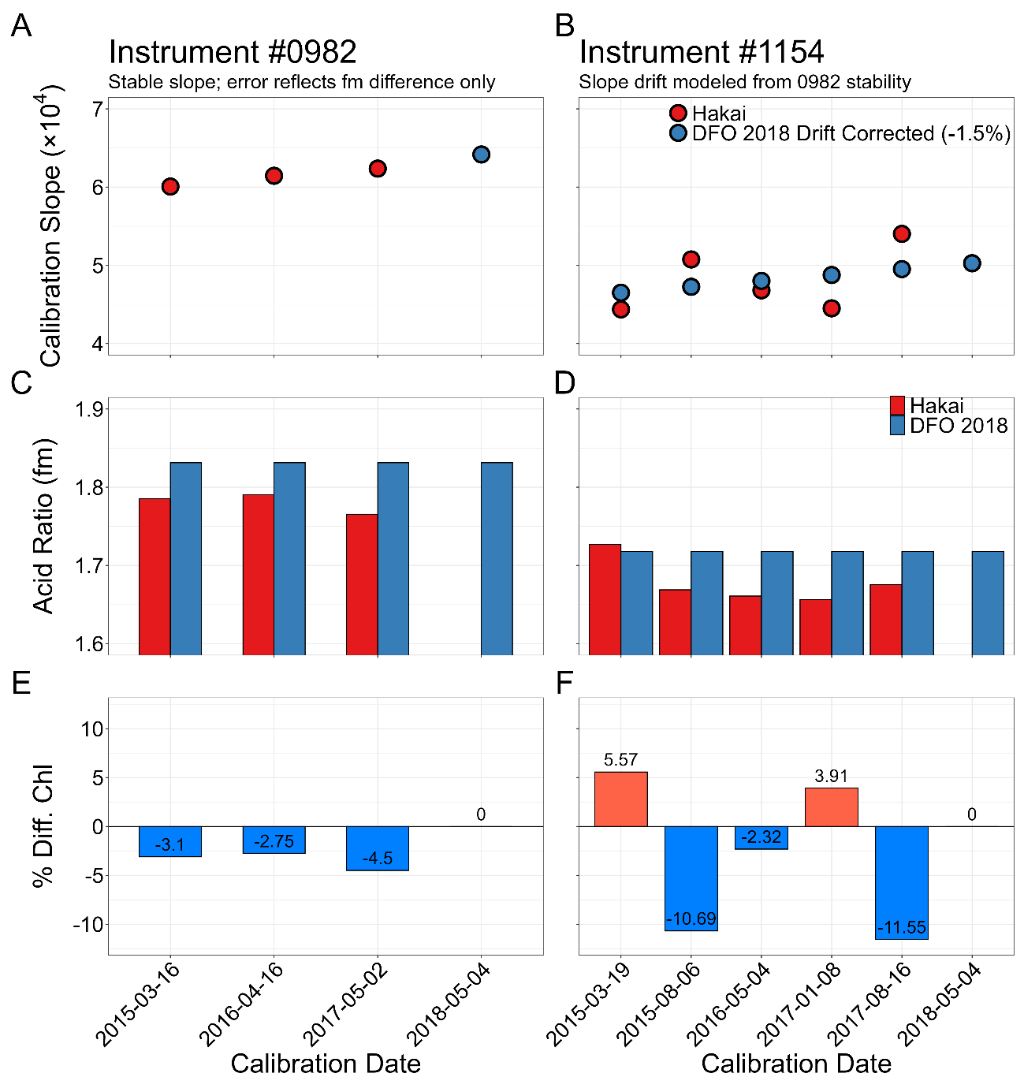
Figure 1 Estimated effect of pre-2018 calibration variability on field chlorophyll concentrations for benchtop Turner Trilogy fluorometers #0982 (left, A/C/E) and #1154 (right, B/D/F), by calibration date. (A, B) Calibration slope (×10⁴) where Red points are the original Hakai calibration slopes and blue points show the DFO 2018 benchmark. For #0982 the stable slope means no correction was applied, whereas for #1154 the blue points are the DFO 2018 slope adjusted for a modelled backward drift of 1.5% per calibration, derived from the predictable drift of #0982. (C, D) Mean acid ratio (fm) for each calibration: original Hakai values (red) against the DFO 2018 benchmark fm (blue). (E, F) Percent difference in field chlorophyll when concentrations are recalculated using the back-corrected slope and DFO fm, relative to the original concentrations.

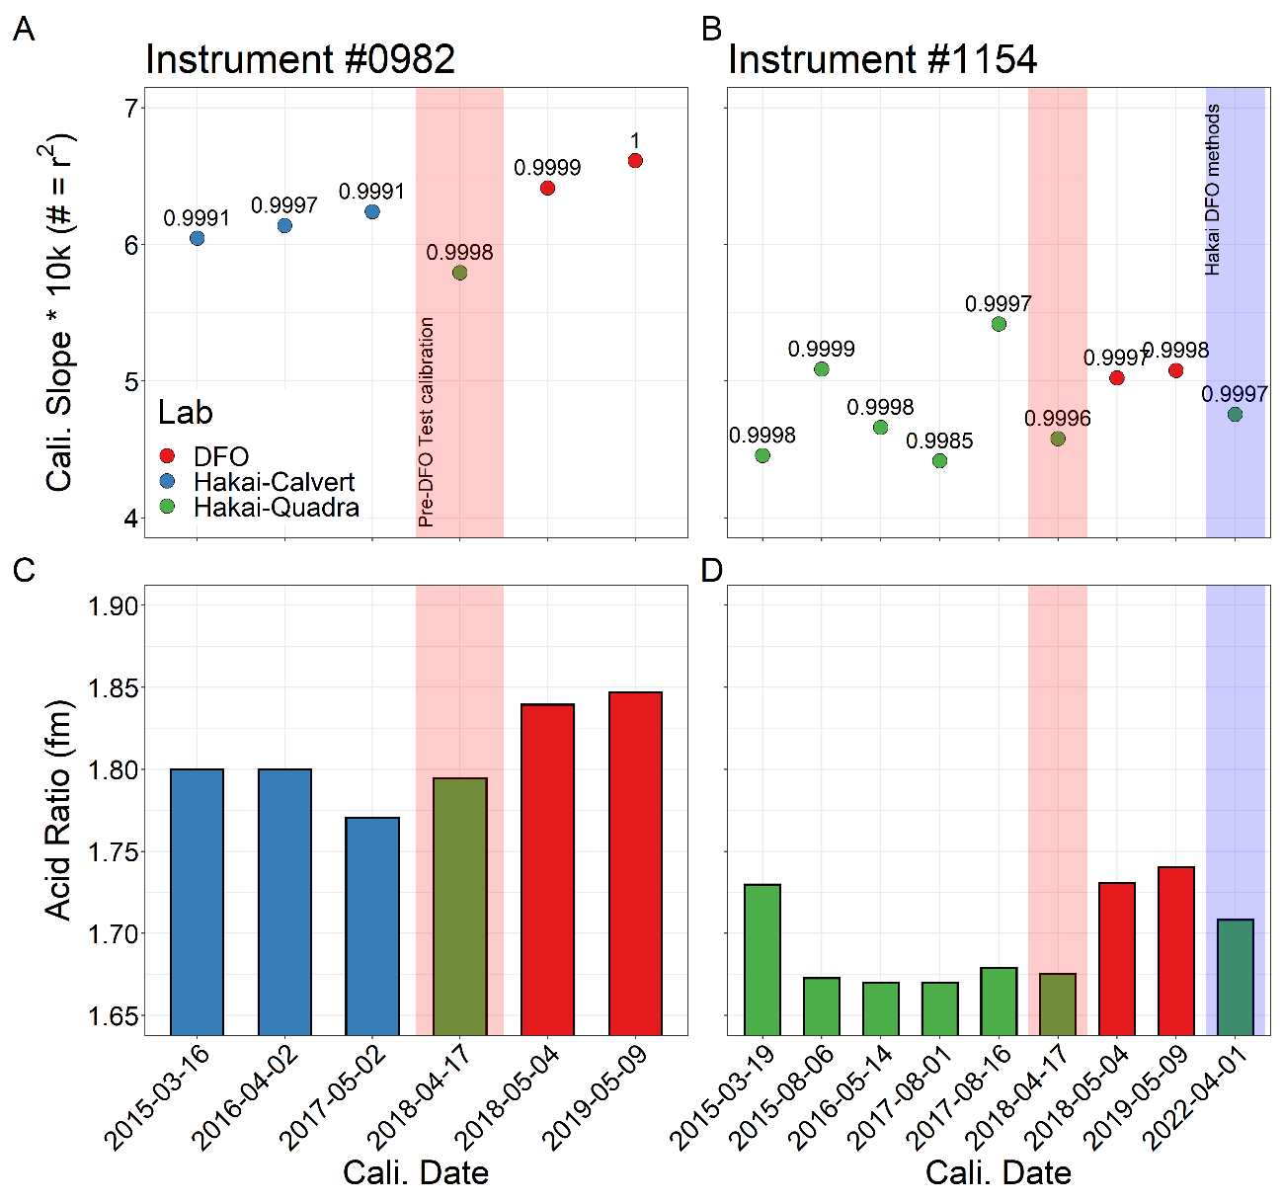
Figure 2

Issue 2 - Samples above instrument sensitivity range not diluted
The sensitivity range of the turner Trilogy benchtop chlorophyll fluorometer is 0-300 mg m⁻³. It was thought that this range covered the range of concentrations we see in the field, so samples were never diluted. However, this is the range for un-concentrated samples and the field samples are concentrated. For concentrated samples, this range represents roughly 0 – 10 mg m⁻³. Therefore, many of the pre-2018 bloom samples were run above the instrument range and have been flagged as above detection level (ADL) on the portal.

Samples run over the instrument sensitivity range are expected to have a quenching effect with artificially diminished fluorescence outputs. This is because both the emitted light and fluorescent output cannot travel through the highly concentrated sample back to the sensor. I could not find any literature characterizing how strong this effect is or how much error it may introduce.

Comparisons with HPLC

Using QU39 samples, fluorometric chlorophyll (Chl) concentrations were compared against concurrently collected HPLC-TChla concentrations. Samples were split into three groups: in-range samples, post 2018 diluted in-range high-biomass samples (HPLC TChla > 5 µg/L), and pre-2018 undiluted samples run above the instrument detection level (the ADL grouping). The high-biomass in-range group served as a control compared to the ADL grouping.

Samples run above the sensitivity range were expected to show suppressed Chl relative to HPLC-TChla due to quenching, but this was not observed. The ADL samples did not bend toward lower Chl at high TChla as quenching would predict; if anything, they sat above the 1:1 line. Examining the Chl/TChla ratio by group: the general in-range group centered on 1.0 (good agreement), the in-range high-biomass group sat modestly above 1.0, and the ADL group sat higher still. The fact that high-biomass in-range samples also read high relative to HPLC suggests a positive bias associated with high biomass likely representing the influence of accessory pigments on the less specific fluorometric determination of Chl that is independent of the detection range. The ADL group showed a further elevation above this high-biomass baseline, along with greater scatter, which may reflect residual effects of running over-range and/or the limited number and narrow concentration range of ADL samples.

Critically, the over-range samples were biased high rather than low, the opposite of what quenching would produce, so the original concern of artificially diminished fluorescence is not supported. These samples appear usable, but they carry greater uncertainty and remain flagged as ADL on the portal; they should not be treated as quantitatively equivalent to in-range samples.

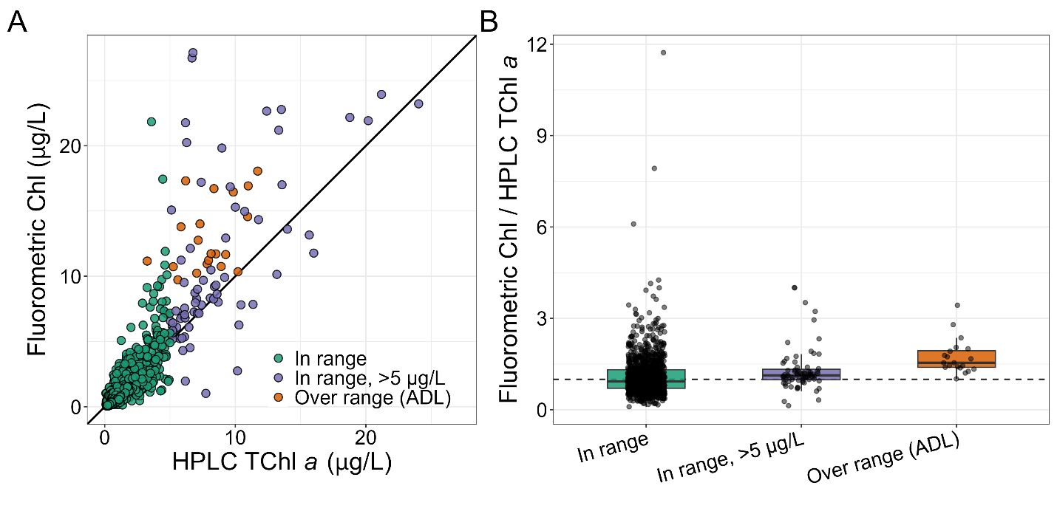
Figure 3 - Comparison of fluorometric chlorophyll (Chl) against concurrently collected HPLC total chlorophyll a (TChl a) for QU39 samples. Samples are grouped as in-range, in-range high-biomass (HPLC TChl a > 5 µg/L), and above the instrument sensitivity range (ADL). (A) Fluorometric Chl versus HPLC TChl a; the solid line is the 1:1 relationship. (B) Ratio of fluorometric Chl to HPLC TChl a by group (boxplots; points are individual samples); the dashed line marks a ratio of 1.0 (agreement). Values above 1.0 indicate fluorometric Chl exceeds HPLC TChl a.
Actions taken

From 2019-01-01 onward, all above-detection-level (ADL) samples were diluted to fall within the instrument's range.

Issue 3 - Acid contamination of Calvert samples

Summary
A subset of chlorophyll samples analyzed at the Calvert Island research station between 2015 and 2017 (predominantly 2016) were affected by acid contamination. Affected samples returned anomalously low chlorophyll and high phaeopigment concentrations, driven by low acid ratios (fm). The contamination was confined to specific analysis days on which nearly all samples were affected, indicating an analysis-session source. Protocols were subsequently introduced to prevent and detect the problem, and no further analysis day wide contamination has been observed since.

Background
The acid ratio (fm) is a diagnostic of sample quality and the degree of chlorophyll degradation. In normal analysis, a reading is taken before and after acidifying the sample; the before-acid reading reflects total chlorophyll fluorescence and the after-acid reading the fully-degraded (phaeopigment) state. The difference between these readings allows calculation of the chlorophyll and phaeopigment concentrations of the sample. Low fm (high phaeopigment concentrations) does occur naturally consistently in deep samples (>100 m) and periodically during senescent surface-assemblage conditions. Low fm is therefore not in itself evidence of contamination.
Acid contamination acidifies the sample before the before-acid reading is taken, suppressing that reading relative to the after-acid value. This drives fm toward 1 and produces artificially low chlorophyll and high phaeopigment (degradation product) concentrations. Low fm across an entire analysis day, where samples from different collection days and biological conditions are run together, is highly suggestive of contamination.
The contamination problem was originally noticed as abnormally low growing season values in the chlorophyll concentration time-series. These samples were then compared to CTD fluorescence measurements confirming that they were abnormally low. Tracing these anomalous samples back to their analysis dates revealed that they clustered on specific analysis days, on which nearly all samples showed low fm. This pointed to an analysis-session source rather than a property of the individual samples.
Identifying contaminated analysis days
Each analysis day was classified by the proportion of its samples with fm < 1.2. Days on which ≥ 80% of samples fell below this threshold were flagged as being potentially contaminated. All filter types and depths were included in the analysis, but smaller filter sizes from size-fractionated samples (< 3μm) tend to show greater proportions of naturally low fm and nearly all samples from > 100m depth show low fm.
Over the entire time-series, most analysis days showed no or relatively few low-fm samples (<20%, Figure 4A). Relatively few analysis days showed >80% of samples with low-fm, but the majority of these were from 2016. While there was overlap due to naturally low-fm and also, higher fm samples within contamination days, the median fm of the contaminated days was notably lower when compared to more characteristic analysis days (Figure 4B). Generally, deep samples were interspersed across analysis days, but there was a single analysis day in 2024 that was comprised entirely of deep samples and showed a high proportion of low fm samples.
Corroboration with HPLC
Simultaneously collected HPLC-TChla samples were available for comparison with a subset of the bulk (bulk GF/F, not size fractionated) fluorometric chlorophyll samples that were run both within and outside of suspected contamination days (Figure 5). The HPLC-TChla samples do not have an acidification step in the analysis and are free from the suspected contamination making them an independent control to compare against.
Available comparison samples with fm < 1.2 generally showed considerably lower fluorometric chlorophyll than HPLC-TChla with fm >1.2; although some low fm samples fell within the expected relationship (Figure 5A). All of the low fm outlier samples were analyzed on days with high proportions of low fm samples (Figure 5B) and were nearly exclusively from 2016, prior to the implementation of methods to eliminate acid contamination.

Likely cause
The source of contamination could not be definitively identified, but two mechanisms are plausible:
- Acetone used for chlorophyll extraction prior to analysis may have become contaminated with acid.
- At the time, analysis cuvettes were washed and re-used between samples. Trace acid remaining in a cuvette could have contaminated subsequent samples in the same run. This seems the more likely cause: some affected days included samples with normal fm interspersed among the low ones, which fits intermittent cuvette carryover better than uniformly contaminated acetone (which would be expected to affect every sample in the run).
Either mechanism would act at the analysis-session level, consistent with the whole-day pattern observed.

Actions taken and current status
Protocols were introduced to both eliminate the contamination at source and to identify it during analysis:
- Better controls on extraction acetone
- Single-use glass cuvettes for analysis (as per DFO-IOS protocols) eliminating the washing step
- Real time per sample fm checks and alerts during analysis
Following these protocols and the consolidation to a single instrument at the Quadra Island field station, no further analysis-day level contamination has been observed.
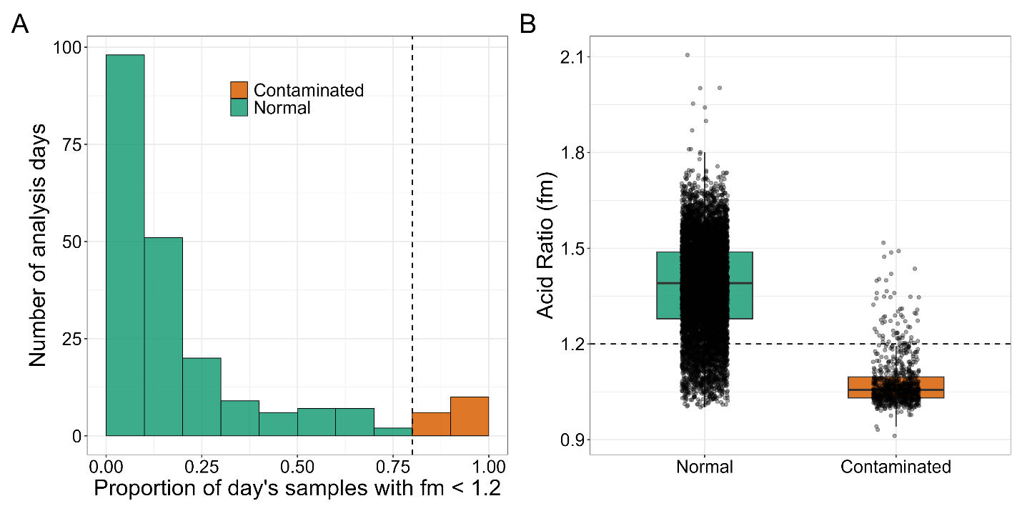
Figure 4
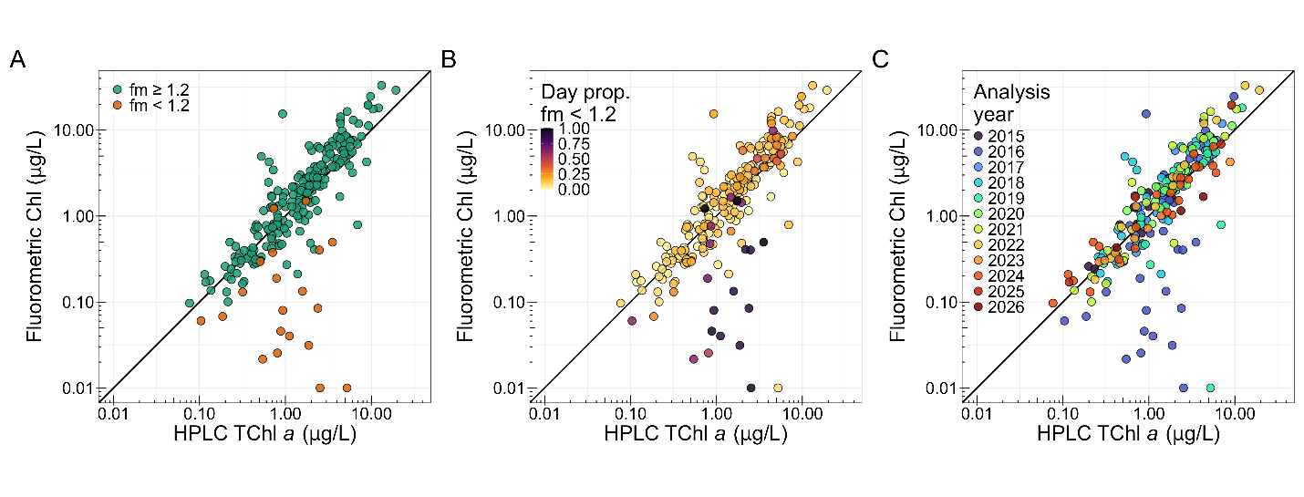
Figure 5

