Summary
This document reviews three historical data-quality issues affecting the Hakai benchtop fluorometric chlorophyll record, documented here for future users. Brief summaries are provided below and more in-depth analysis provided in the following sections.
Issue 1 — Calibration variability. Prior to 2018, calibrations of the two fluorometers (#0982 at Calvert, #1154 at Quadra) showed variability that did not follow expected instrument-drift patterns, most notably erratic slopes on #1154 and low, variable acid ratios (fm) on both instruments. This variability likely reflecting standard-preparation error and standard degradation rather than true instrument response. Cross-calibrations at DFO-IOS (2018–2019) provided a baseline, and the potential error introduced into pre-2018 field concentrations was estimated (<5% for #0982, approximately −12% to +6% for #1154). Subsequent method improvements and consolidation to a single Quadra instrument reduced the variability.
Issue 2 — Samples above the instrument sensitivity range. Because the fluorometer's stated range applies to un-concentrated samples, many pre-2018 bloom samples were unknowingly run above the effective range and are flagged as above detection level (ADL). These samples were expected to show artificially suppressed chlorophyll concentrations due to quenching, but comparison with concurrent HPLC showed the opposite: A slight high concentration bias was observed. The ADL samples are therefore usable but carry greater uncertainty. Dilution of high-biomass samples was introduced from 2019 onward.
Issue 3 — Acid contamination of Calvert samples. A subset of samples analyzed at Calvert between 2015 and 2017 (predominantly 2016) were affected by acid contamination, producing artificially low chlorophyll and low fm. The problem was session-level, clustering on specific analysis days, and was independently corroborated by HPLC. Protocol changes and the move to a single Quadra instrument resolved the issue, with no further session-level contamination observed since.

Issue 1 — Calibration variability

Summary
Prior to 2018, benchtop chlorophyll calibrations showed variability that did not follow expected instrument-drift trends, particularly for instrument #1154. At this time a fluorometer was operated at each of two stations, #0982 at Calvert and #1154 at Quadra, and each was calibrated on-site by different teams using different standards. Instrument #1154 showed strongly linear but erratically varying calibration slopes, while both instruments showed low and variable acid ratios (fm) relative to later DFO-IOS cross-calibrations. Because calibration slopes and fm are instrument-specific, the variability could not be resolved by direct comparison between instruments. The analysis below attempts to bound the resulting error in field concentrations; although, it relies on unvalidated assumptions and is intended only to indicate the approximate magnitude of error, not to correct it.

Background
Two calibration parameters are relevant. The calibration slope relates instrument raw fluorescence units to chlorophyll concentration and is expected to drift slightly over time (generally increasing) but otherwise be stable. The acid ratio (fm) is the ratio of the pre-acidified (intact chlorophyll) to post-acidified (fully degraded) reading, and should be consistently high for a pure chlorophyll standard; lower values indicate a degraded standard. Both parameters are instrument-specific and cannot be compared directly between instruments.
Some variability is expected as slopes drift, and fm can vary with standard condition so variability alone is not evidence of error. What was notable for #1154 was that the slope varied erratically, not in the gradual manner expected of instrument drift, despite strongly linear individual calibrations (r² > 0.999). Because the linear fit was strong, the varying slope more likely reflects a consistent analytical error in standard preparation (e.g. uncalibrated pipettes adding error to standard concentrations) than a genuine instrument response. Low and variable fm on both instruments, meanwhile, is consistent with degradation of the chlorophyll standards, potentially driven by temperature or light exposure.

What we observed
The two instruments behaved differently:
- #1154 (Quadra) showed erratic, inconsistent variability in both slope and fm prior to 2018.
- #0982 (Calvert) drifted predictably, at a relatively consistent ~1.5% increase in slope per calibration. This predictability is what made it usable as a reference for modelling #1154 (see below).
The fm variability had two distinct aspects: variability between our own calibrations, and fm values that sat systematically below those obtained during the DFO-IOS cross-calibrations (a gap that persisted in later years, though our values improved).

DFO-IOS cross-calibration (2018)
Two tests were performed:
- The Calvert instrument (#0982) was brought to Quadra and cross-calibrated against #1154 using the same standards (Figure 2, 2018-04-17). Both instruments showed considerably lower slopes than their respective prior on-site calibrations.
- On 2018-05-04, both instruments were taken to DFO-IOS and cross-calibrated against their Turner 10AU instruments, using DFO standards, with DFO's (considerably tighter) methods taken as a baseline. Both instruments showed increased fm relative to Hakai calibrations; #0982's slope was in line with prior Calvert calibrations, and #1154's slope fell mid-range of prior Quadra calibrations.

Estimating the potential error
To bound the error the pre-2018 variability may have introduced into field concentrations (Figure 1):
- #1154's slope was back-calculated from the DFO value, applying the ~1.5% per-calibration drift observed on the stable #0982.
- The DFO fm was applied to both instruments.
- Field concentrations were recalculated with these values and compared to the original concentrations.
Estimated error:
- #0982 — error from fm variability alone was marginal (< 5%).
- #1154 — larger error, reflecting combined slope and fm effects (approximately −11.55% to +5.57%).
These estimates cannot be validated. They depend on assumptions of instrument stability and a linear backward slope drift carried over from #0982, and are intended only to indicate the approximate magnitude of error potentially present in the pre-2018 record.

Likely cause
The variability appears to have arisen from analytical rather than instrument sources:
- Erratic #1154 slopes: most consistent with standard-preparation error (e.g. uncalibrated pipettes) adding error to standard concentrations, given the strong linearity of individual calibrations.
- Low, variable fm on both instruments: consistent with degradation of the chlorophyll standards, potentially from temperature or light exposure during storage or handling.

Actions taken and current status
Several changes were introduced:
- Began annual cross-calibrations at DFO-IOS (2018 and 2019; discontinued with COVID).
- Moved to a single-instrument model with all samples run at Quadra to:
  - reduce cross-comparability issues;
  - run all samples in a controlled dark-room lab setting, and;
  - maintain an operational plus reserve instrument.
- Post-COVID (2022), adopted DFO-IOS methods and improved analytical controls for Quadra calibrations, including:
  - switching from Turner pre-made standards (which may degrade in transport) to Sigma-Aldrich HPLC-grade standards made on site with concentrations determined immediately before calibration;
  - calibrating across the full instrument sensitivity range (0–300 mg m⁻³);
  - improved equipment (Class A glassware, gas-tight syringes) and controls on light exposure;
  - improved tracking of solid standards between calibrations and analysis runs, with worksheet flagging when a reading falls > ±5% of the calibration value.
Assessment of the outcome: the 2018 and 2019 DFO-IOS cross-calibrations showed good consistency and expected trends (Figure 2). A 2022 Quadra calibration under the improved methods was possible only for #1154 (#0982 had malfunctioned); its slope and fm decreased slightly relative to 2019 but remained within a tighter band than the pre-2018 variability. The improved methods reduced, but did not fully eliminate, the offset, for reasons that could not be determined despite careful analysis. New optical modules were subsequently installed on both instruments to address the #0982 malfunction and establish a fresh baseline. This changed the calibration values, so the pre-existing trends could no longer be tracked forward.

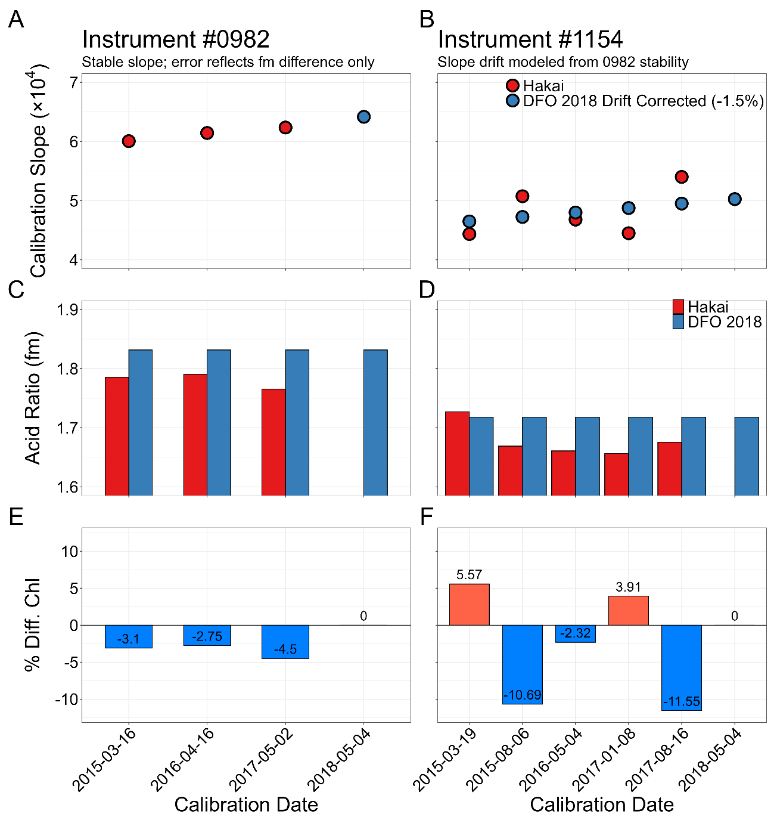
Figure 1 - Estimated effect of pre-2018 calibration variability on field chlorophyll concentrations for benchtop Turner Trilogy fluorometers #0982 (left, A/C/E) and #1154 (right, B/D/F), by calibration date. (A, B) Calibration slope (×10⁴) where Red points are the original Hakai calibration slopes and blue points show the DFO 2018 benchmark. For #0982 the stable slope means no correction was applied, whereas for #1154 the blue points are the DFO 2018 slope adjusted for a modelled backward drift of 1.5% per calibration, derived from the predictable drift of #0982. (C, D) Mean acid ratio (fm) for each calibration: original Hakai values (red) against the DFO 2018 benchmark fm (blue). (E, F) Percent difference in field chlorophyll when concentrations are recalculated using the back-corrected slope and DFO fm, relative to the original concentrations.

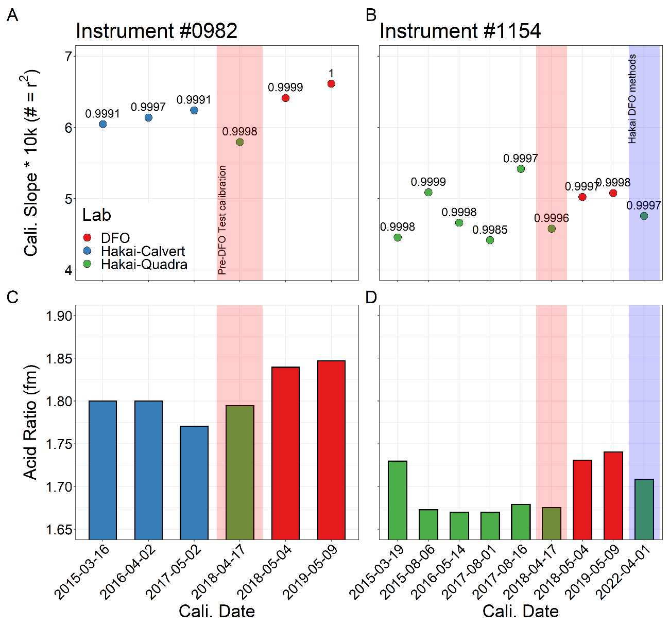
Figure 2 - Calibration slope and acid ratio (fm) by calibration date for benchtop fluorometers #0982 (left, A/C) and #1154 (right, B/D), coloured by calibrating lab: Hakai-Calvert (blue), Hakai-Quadra (green), and DFO-IOS (red). (A, B) Calibration slope (× 10⁴); the number above each point is the regression r². (C, D) Mean acid ratio (fm) for each calibration. The pink band marks the 2018-04-17 pre-DFO cross-calibration, in which #0982 was brought to Quadra and both instruments were calibrated against the same standards (shown in olive, where the Calvert and Quadra colours overlap). The blue band (D) marks the 2022-04-01 Quadra calibration performed under the improved DFO-derived Hakai methods. Note that #0982 was historically operated at Calvert and #1154 at Quadra, so their pre-2018 calibrations (blue vs green) were performed by different teams; slope and fm are instrument-specific and are not directly comparable between the two instruments.

Issue 2 — Samples above instrument sensitivity range not diluted

Summary
Many pre-2018 bloom samples were run above the fluorometer's effective sensitivity range and are flagged as above detection level (ADL) on the portal. This occurred because the instrument's stated range applies to un-concentrated samples, whereas field samples are concentrated during extraction. Over-range samples were expected to show artificially suppressed chlorophyll (Chl) due to quenching, but comparison against concurrent HPLC total chlorophyll a (TChl a) does not support this. If anything, the ADL samples read slightly high, not low. The samples therefore appear usable but carry greater uncertainty, and remain flagged as ADL.

Background
The Turner Trilogy benchtop chlorophyll fluorometer has a stated sensitivity range of 0–300 mg m⁻³. This range was assumed to cover the concentrations seen in the field, so samples were not diluted. However, the stated range applies to un-concentrated samples, and field samples are concentrated during extraction; for concentrated samples the effective range corresponds to roughly 0–10 mg m⁻³ of ambient chlorophyll. As a result, many pre-2018 bloom samples were run above the instrument range and are flagged as above detection level (ADL) on the portal.
Samples run over the sensitivity range are expected to show a quenching effect, with artificially diminished fluorescence, because both the excitation and emitted light are attenuated travelling through the highly concentrated sample back to the sensor. No literature was found characterizing the strength of this effect or the magnitude of error it might introduce, so the effect was assessed empirically against HPLC.

Comparison with HPLC
Using QU39 samples, fluorometric Chl was compared against concurrently collected HPLC TChl a (Figure 3). Samples were split into three groups:
- in-range samples;
- in-range high-biomass samples (post-2018 diluted samples with HPLC TChl a > 5 µg/L); and
- ADL samples (pre-2018 undiluted samples run above the detection level).
The high-biomass in-range group served as a control: it isolates any bias associated with high biomass from any bias associated specifically with running over-range, so that the two can be distinguished.
Over-range (ADL) samples were expected to show suppressed Chl relative to HPLC due to quenching, but this was not observed. The ADL samples did not bend toward lower Chl at high TChl a as quenching would predict. Rather, they sat above the 1:1 line. Examining the Chl/TChl a ratio by group (Figure 3B): the in-range group centered on 1.0, the in-range high-biomass group sat modestly above 1.0, and the ADL group showed the highest value.

Interpretation
The high-biomass in-range samples also reading high relative to HPLC indicates a positive bias associated with high biomass. This effect was likely due to the influence of accessory pigments on the less specific fluorometric determination of Chl that is independent of the detection range. The ADL group showed a further elevation above this high-biomass baseline, together with greater scatter, which may reflect residual effects of running over-range and/or the limited number and narrow concentration range of the ADL samples.
Critically, the over-range samples were biased high rather than low, which was the opposite of what quenching would produce. Therefore, the original concern of artificially diminished fluorescence is not supported. These samples appear usable, but they carry greater uncertainty and remain flagged as ADL on the portal; they should not be treated as quantitatively equivalent to in-range samples.

Actions taken and current status
From 2019-01-01 onward, all above-detection-level (ADL) samples were diluted to fall within the instrument's range prior to analysis. Pre-2018 ADL samples remain flagged on the portal and are usable with the caveats above.

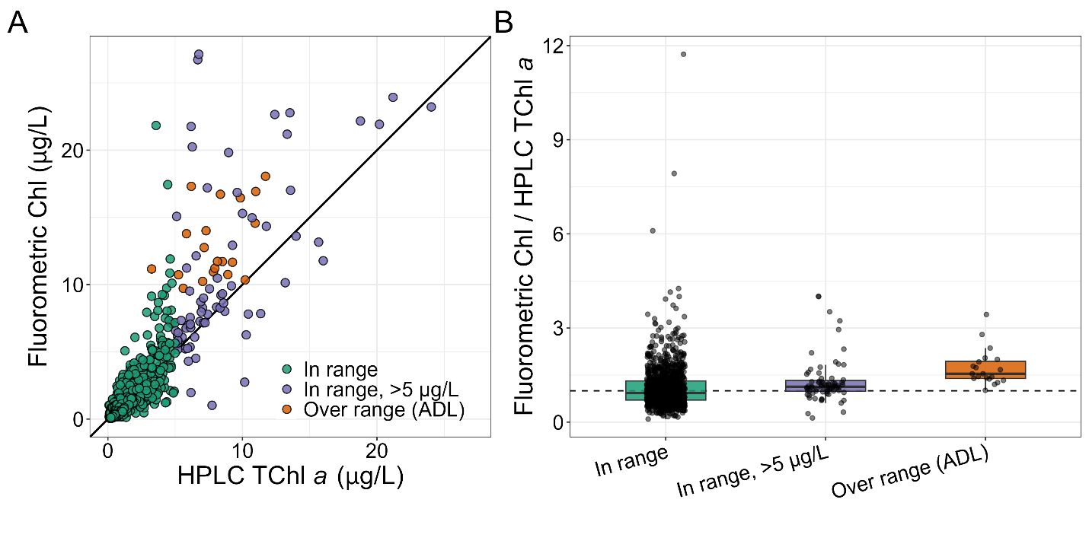
Figure 3 - Comparison of fluorometric chlorophyll (Chl) against concurrently collected HPLC total chlorophyll a (TChl a) for QU39 samples. Samples are grouped as in-range, in-range high-biomass (HPLC TChl a > 5 µg/L), and above the instrument sensitivity range (ADL). (A) Fluorometric Chl versus HPLC TChl a; the solid line is the 1:1 relationship. (B) Ratio of fluorometric Chl to HPLC TChl a by group (boxplots; points are individual samples); the dashed line marks a ratio of 1.0 (agreement). Values above 1.0 indicate fluorometric Chl exceeds HPLC TChl a.

Issue 3 - Acid contamination of Calvert samples

Summary
A subset of chlorophyll samples analyzed at the Calvert Island research station between 2015 and 2017 (predominantly 2016) were affected by acid contamination. Affected samples returned anomalously low chlorophyll and high phaeopigment concentrations, driven by low acid ratios (fm). The contamination was confined to specific analysis days on which nearly all samples were affected, indicating an analysis-session source. Protocols were subsequently introduced to prevent and detect the problem, and no further analysis day wide contamination has been observed since.

Background
The acid ratio (fm) is a diagnostic of sample quality and the degree of chlorophyll degradation. In normal analysis, a reading is taken before and after acidifying the sample; the before-acid reading reflects total chlorophyll fluorescence and the after-acid reading the fully-degraded (phaeopigment) state. The difference between these readings allows calculation of the chlorophyll and phaeopigment concentrations of the sample. Low fm (high phaeopigment concentrations) does occur naturally consistently in deep samples (>100 m) and periodically during senescent surface-assemblage conditions. Low fm is therefore not in itself evidence of contamination.
Acid contamination acidifies the sample before the before-acid reading is taken, suppressing that reading relative to the after-acid value. This drives fm toward 1 and produces artificially low chlorophyll and high phaeopigment (degradation product) concentrations. Low fm across an entire analysis day, where samples from different collection days and biological conditions are run together, is highly suggestive of contamination.
The contamination problem was originally noticed as abnormally low growing season values in the chlorophyll concentration time-series. These samples were then compared to CTD fluorescence measurements confirming that they were abnormally low. Tracing these anomalous samples back to their analysis dates revealed that they clustered on specific analysis days, on which nearly all samples showed low fm. This pointed to an analysis-session source rather than a property of the individual samples.
Identifying contaminated analysis days
Each analysis day was classified by the proportion of its samples with fm < 1.2. Days on which ≥ 80% of samples fell below this threshold were flagged as being potentially contaminated. All filter types and depths were included in the analysis, but smaller filter sizes from size-fractionated samples (< 3μm) tend to show greater proportions of naturally low fm and nearly all samples from > 100m depth show low fm.
Over the entire time-series, most analysis days showed no or relatively few low-fm samples (<20%, Figure 4A). Relatively few analysis days showed >80% of samples with low-fm, but the majority of these were from 2016. While there was overlap due to naturally low-fm and also, higher fm samples within contamination days, the median fm of the contaminated days was notably lower when compared to more characteristic analysis days (Figure 4B). Generally, deep samples were interspersed across analysis days, but there was a single analysis day in 2024 that was comprised entirely of deep samples and showed a high proportion of low fm samples.
Corroboration with HPLC
Simultaneously collected HPLC-TChla samples were available for comparison with a subset of the bulk (bulk GF/F, not size fractionated) fluorometric chlorophyll samples that were run both within and outside of suspected contamination days (Figure 5). The HPLC-TChla samples do not have an acidification step in the analysis and are free from the suspected contamination making them an independent control to compare against.
Available comparison samples with fm < 1.2 generally showed considerably lower fluorometric chlorophyll than HPLC-TChla with fm >1.2; although some low fm samples fell within the expected relationship (Figure 5A). All of the low fm outlier samples were analyzed on days with high proportions of low fm samples (Figure 5B) and were nearly exclusively from 2016, prior to the implementation of methods to eliminate acid contamination.

Likely cause
The source of contamination could not be definitively identified, but two mechanisms are plausible:
- Acetone used for chlorophyll extraction prior to analysis may have become contaminated with acid.
- At the time, analysis cuvettes were washed and re-used between samples. Trace acid remaining in a cuvette could have contaminated subsequent samples in the same run. This seems the more likely cause: some affected days included samples with normal fm interspersed among the low ones, which fits intermittent cuvette carryover better than uniformly contaminated acetone (which would be expected to affect every sample in the run).
Either mechanism would act at the analysis-session level, consistent with the whole-day pattern observed.

Actions taken and current status
Protocols were introduced to both eliminate the contamination at source and to identify it during analysis:
- Better controls on extraction acetone
- Single-use glass cuvettes for analysis (as per DFO-IOS protocols) eliminating the washing step
- Real time per sample fm checks and alerts during analysis
Following these protocols and the consolidation to a single instrument at the Quadra Island field station, no further analysis-day level contamination has been observed.
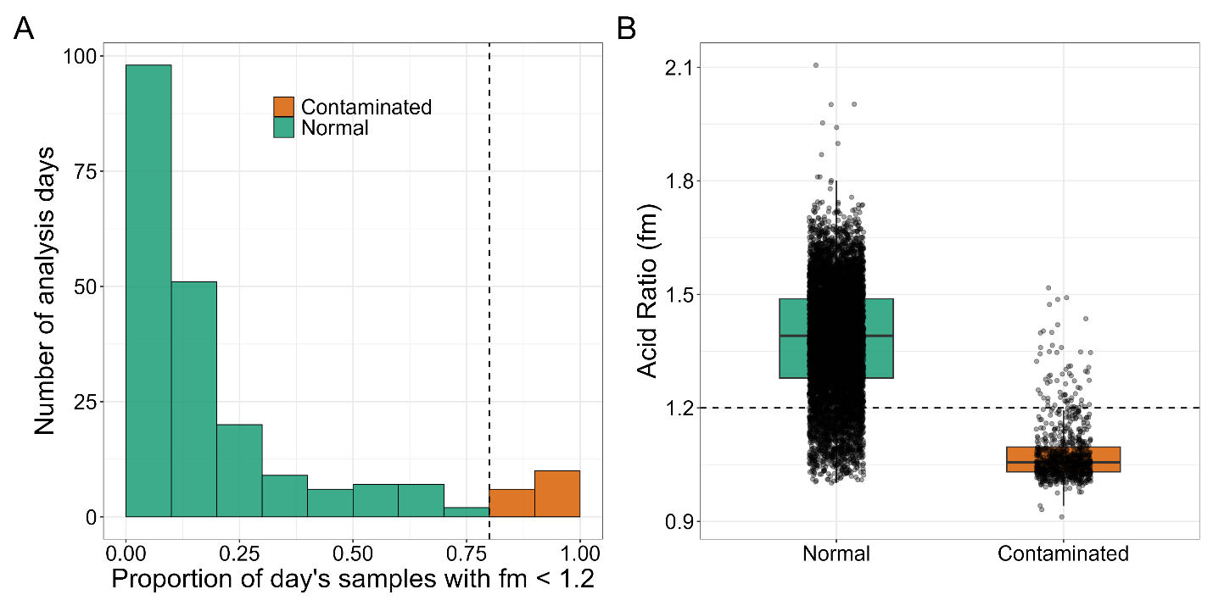
Figure 4 - Identification of acid-contaminated analysis days at the Calvert station, based on the acid ratio (fm). (A) Distribution of the per-day proportion of samples with fm < 1.2 across all analysis days; each day is coloured by its classification, with days having ≥ 80% of samples below the threshold (dashed line) flagged as contaminated (orange) and all others normal (green). (B) Acid ratio (fm) of individual samples by day type (boxplots; points are individual samples); the dashed line marks fm = 1.2. Samples on contaminated days had markedly lower fm than those on normal days. The overlap that does occur reflects naturally low-fm samples on normal days and higher-fm samples interspersed within contaminated days.
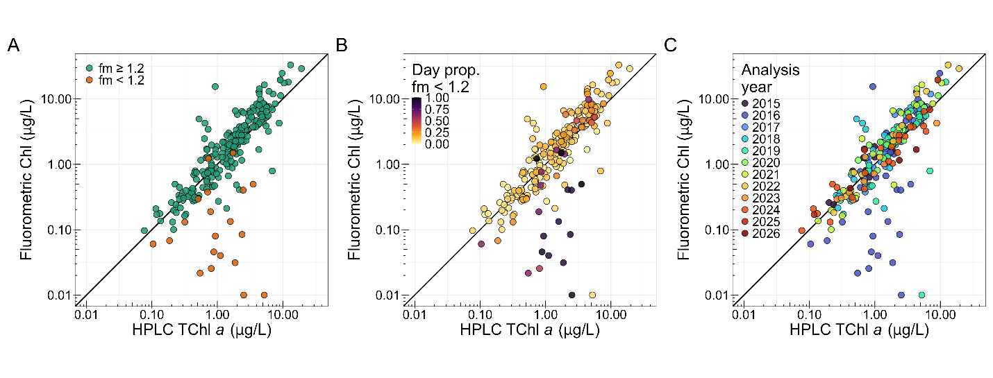
Figure 5 - HPLC corroboration of acid contamination at the Calvert station using a subset of samples where both measurements were collected simultaneously. Fluorometric chlorophyll (Chl) plotted against concurrently collected HPLC total chlorophyll a (TChl a) for matched bulk chlorophyll samples, on log–log axes with the 1:1 line shown. The same matched pairs are shown in all three panels, coloured by: (A) sample-level acid ratio, fm < 1.2 (orange) versus fm ≥ 1.2 (green); (B) the proportion of that sample's analysis day with fm < 1.2; and (C) analysis year.

