GEM AquaFluor Testing

1. **Introduction**
2. **Methods**
3. **Results**
   1. **Chla calibration with analytical standards**

Calibrations using analytical Chla standards showed strong linearity over the manufacturer specified instrument measurement range (0 – 300 μg L-1, figure #). Percent error between the defined standard concentration and calibration calculated instrument concentration showed the highest error at the lowest concentration (-6.88 %) and low error for all other concentrations (< 2.30%. (Table #). Technical triplicates run at each standard concentration during the manual calibration showed low variability generally increasing with concentration ( $±$ 0.04 – 0.41 μg L-1). High concentration standards run as samples outside of the 5-point auto-calibration following the expected linear response of the instrument showing < 2% error when compared to the standard concentration.

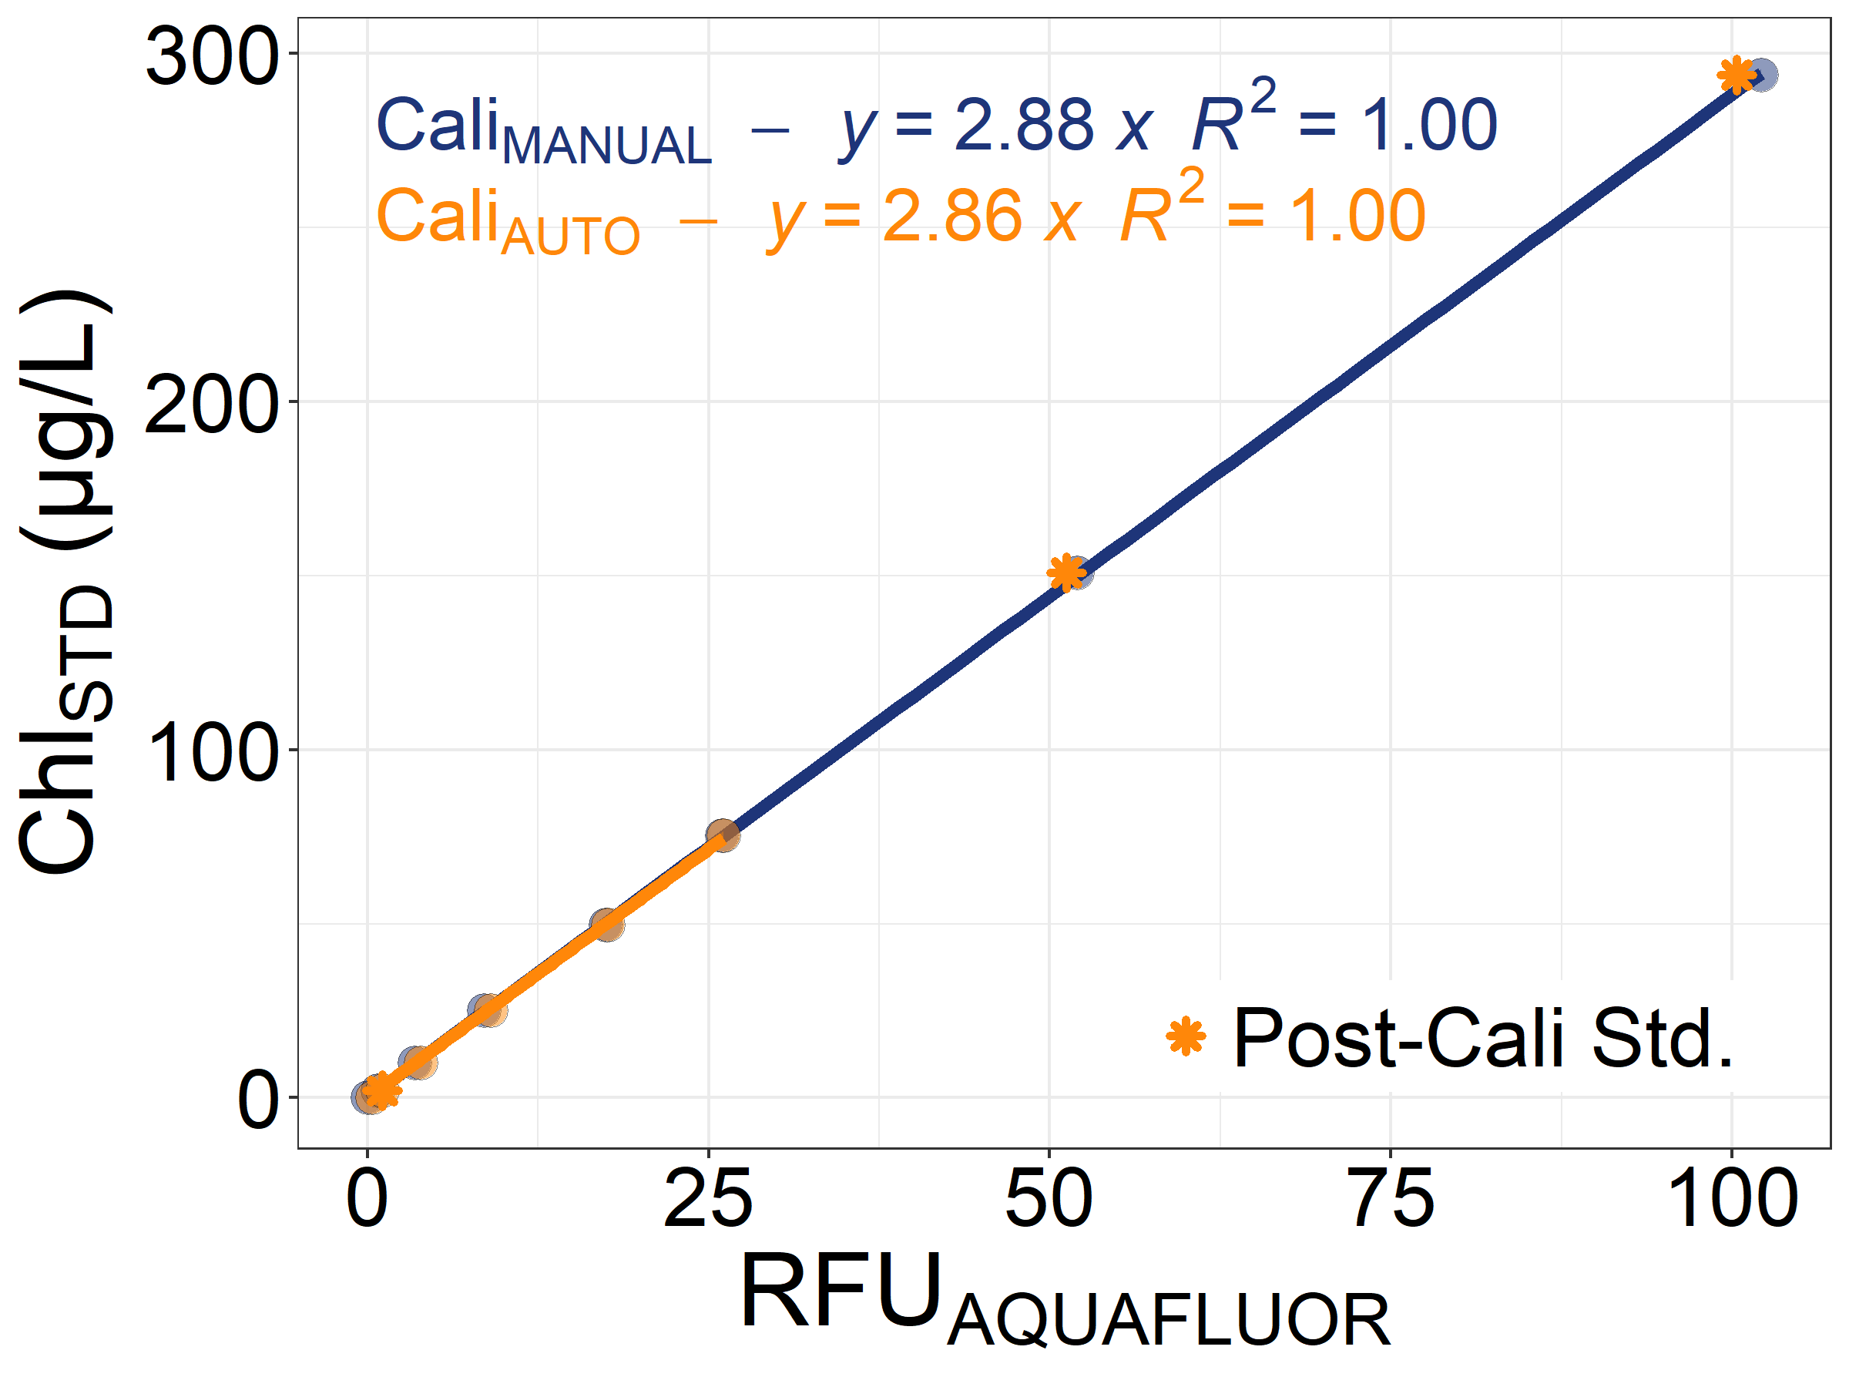

Figure 1 – Scatterplot of AquaFluor instrument relative fluorescence units (RFU) versus analytical Chla standard concentrations (μg L-1). The blue points and line represent that calibration done with standards run manually as samples whereas the orange points and lines represent the instrument automatic calibration allowing for only a 5-point calibration. The orange stars represent standards run following the auto-calibration with the concentrations automatically calculated by the instrument.

Table 1 – AquaFluor calibration standard concentrations, technical replicates averages and standard deviations and percent error of Aquafluor calculated Chla concentrations when compared to the standard concentration. Standards run as samples after performing the auto calibration are specified under the type column.

|  |  |  |  |  |
| --- | --- | --- | --- | --- |
| **Standard (μg/L)** | **Triplicate Avg.**  **Chla (μg L-1)** | **Std.Dev.**  **Chla (μg L-1)** | **% Error** | **Type** |
| 0 | 0 | 0 | 0 | Blank subtracted |
| 2.01 | 2.16 | 0.04 | -6.88 | Manual Calibration |
| 10.04 | 9.96 | 0.01 | 0.77 | Manual Calibration |
| 25.09 | 24.53 | 0.01 | 2.30 | Manual Calibration |
| 49.62 | 50.26 | 0.07 | -1.28 | Manual Calibration |
| 75.42 | 74.76 | 0.06 | 0.88 | Manual Calibration |
| 150.84 | 149.80 | 0.22 | 0.70 | Manual Calibration |
| 293.74 | 294.23 | 0.41 | -0.17 | Manual Calibration |
| **2.01** | **2.10** | **0.02** | **-4.06** | **Run as sample using Auto Cali.** |
| **150.84** | **148.00** | **0.16** | **1.92** | **Run as sample using Auto Cali.** |
| **293.74** | **290.97** | **0.54** | **0.95** | **Run as sample using Auto Cali.** |
|  |  |  |  |  |
|  |  |  |  |  |

* 1. **Turbidity calibrations with NTU standards**

Calibrations performed on the AquaFluor turbidity channel using the Turner brand NTU turbidity standards were highly linear (Figure #). The use of an additional 1000 NTU standard (manufacturer ###) resulted in a poor calibration (not shown). When the 1000 NTU standard was run as a sample on the AquaFluor calibrated using the Turner standards, the resulting NTU was considerably higher than expected based on the linear trend extrapolated to 1000 NTU. Calibrations performed using glass cuvettes resulted in slightly higher slopes than those performed using plastic cuvettes.

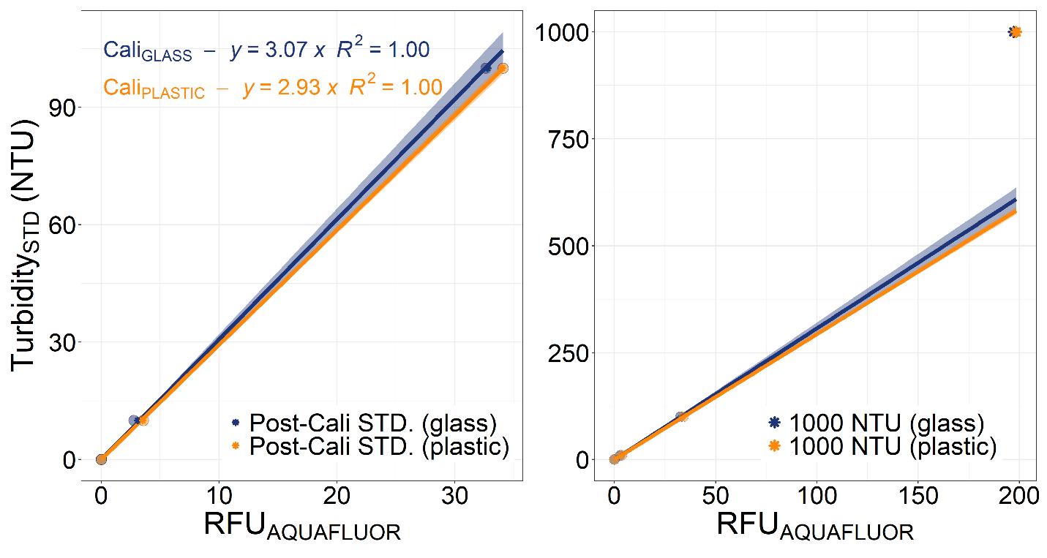

* 1. **Field Chla observations**
  2. **Field sample comparisons with extracted Chla**

Comparisons of *in vivo* Chla concentrations from the AquaFluor instrument versus simultaneously collected *in vitro* extracted Chla concentrations run on the Hakai Institute Trilogy instrument are shown in Figure 2. The Aquafluor instrument concentrations showed strong linear correlations with concentrations derived using the Trilogy instrument regardless Aquafluor calibration standard type. When the AquaFluor instrument was calibrated using analytical Chla standards (auto-calibration in section 3.1), it showed a moderate overestimation of those derived via the Trilogy (slope = 1.39). In turn, the rhodamine calibrated AquaFluor Chla concentrations highly overestimated concentrations from the Trilogy instrument (slope = 8.71).

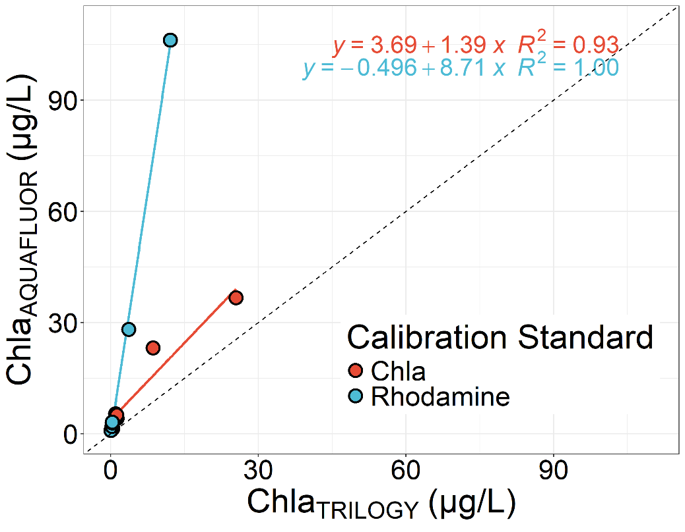

Figure 2 – scatterplot of in vitro extracted Chla concentrations from the Hakai Institute Trilogy fluorometer versus those derived on simultaneous collected samples run on the AquaFluor instrument. The red dots, regression line and statistics represent when the Aquafluor was calibrated using analytical Chla standards and the blue represents when the AquaFluor was calibrated using Rhodamine.