Phytoclass Trial log

1. Min_chem_100_noc1c2 (ran on July 22rd, 2025)
   * I meant to do 100% difference from my CHEMTAX manuscript values, but actually did CHEMTAX ratio/0.5 (min) and CR*2 (max).
     + Think did to ensure min ratios did not = 0.
   * Deleted chlc1c2 as was causing confusion and large misclassifications.
   * Created my best comparison yet with high R2 for each group   
     (> 0.91) and slight phytoclass underestimates of:
     + Cyanobacteria
     + Dinoflagellates
     + Green Algae
   * Pro
     + Can nearly replicate CHEMTAX with easier method to run
   * Con
     + Defeats the purpose of Phytoclass - meant to not rely on specific input ratios with convergence on optimized ratios from wide min_max range.
     + Optimized ratios meant to provide better results.
   * Trials
     + Iteratively introduce literature min and max for group to see how it changes.
   * Todo
     + Export converged ratios and analysis stats for comparison to CHEMTAX output ratios.
     + Try to set min_max based on my field data rather than lit?
     + Should I try to get Phytoclass to exactly replicate CHEMTAX?
     + Run on clusters and see how changes.

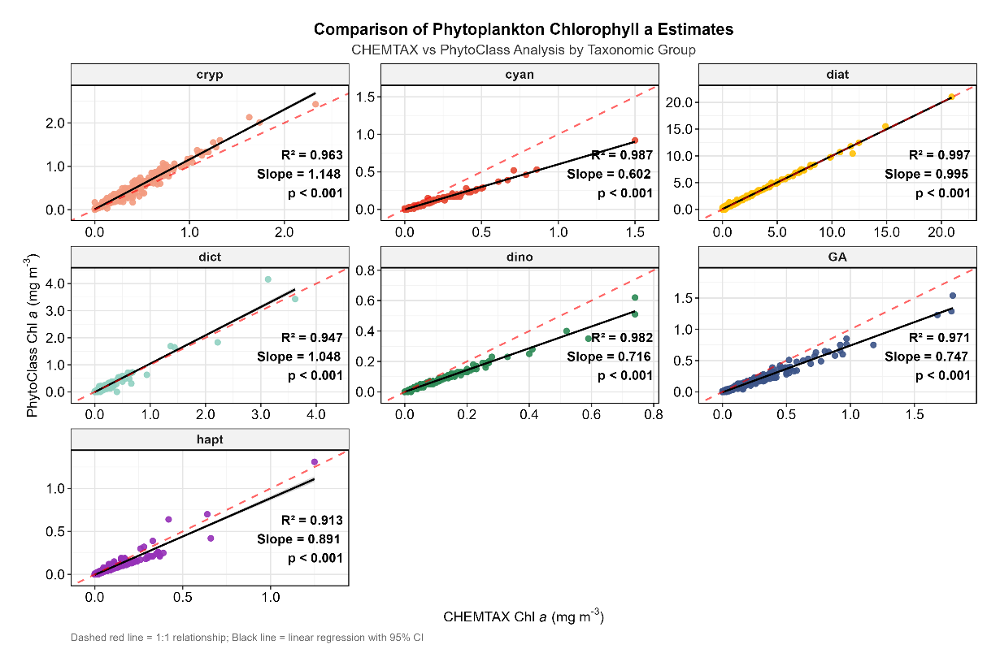

1. Min_chem_100_noc1c2_pras_lit (ran on July 23rd, 2025)
   * Took the prasinophytes-3 literature min and max values.