Jonathon Delemos
Professor Sabzevary
CSC134
11/30/2024

Homework 10 Joins
1 | Give a listing of all the ssns,first names and the class descriptions of  all the classes the students are taking. If there are no class _descriptions  display 'No description is available yet'. (USE NVL)
 | 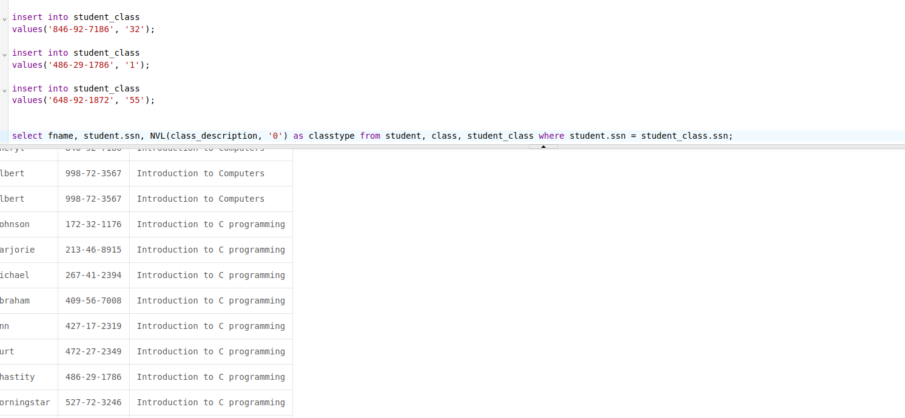
2 | Give a listing of only the lname and the class_code for  students who are taking 'Introduction to C programming'. (Inner join)
 | 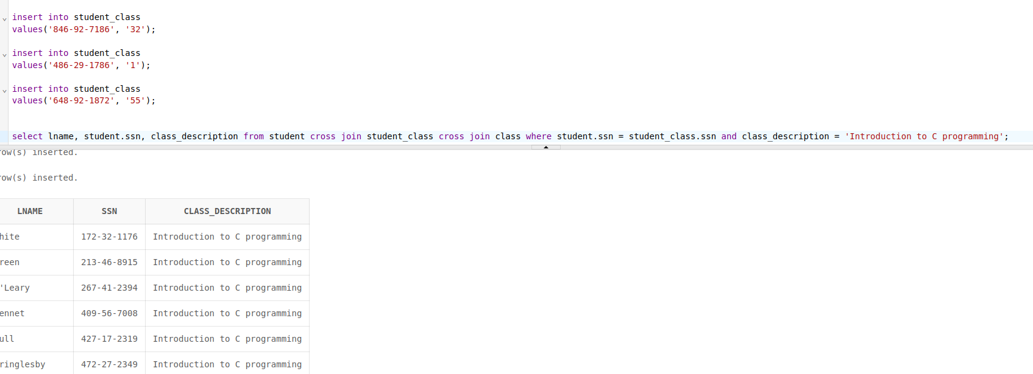
3 | Give a lising of all the class_descriptions and the number of  students enrolled in each class for all students who are older  than the average age where the total number of students for the class  is more than 1 student. Order by the number of students. If there  is no class description replace it with 'Other Classes'  (Note: Take it in steps. First do all those who are older than the average age, then do the group by, then add the having clause and then the order and then combine everything together)
 | 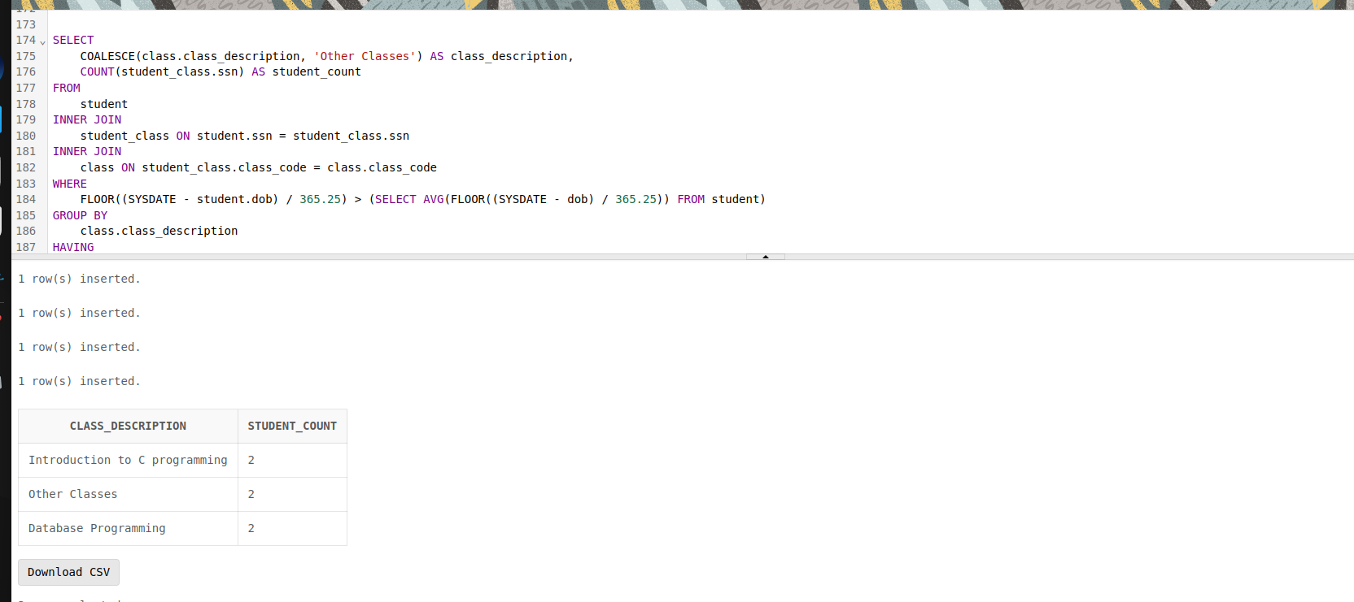
4 | Give a listing of all the classes for which no students are  enrolled in (use in or not in clause) (subquery)
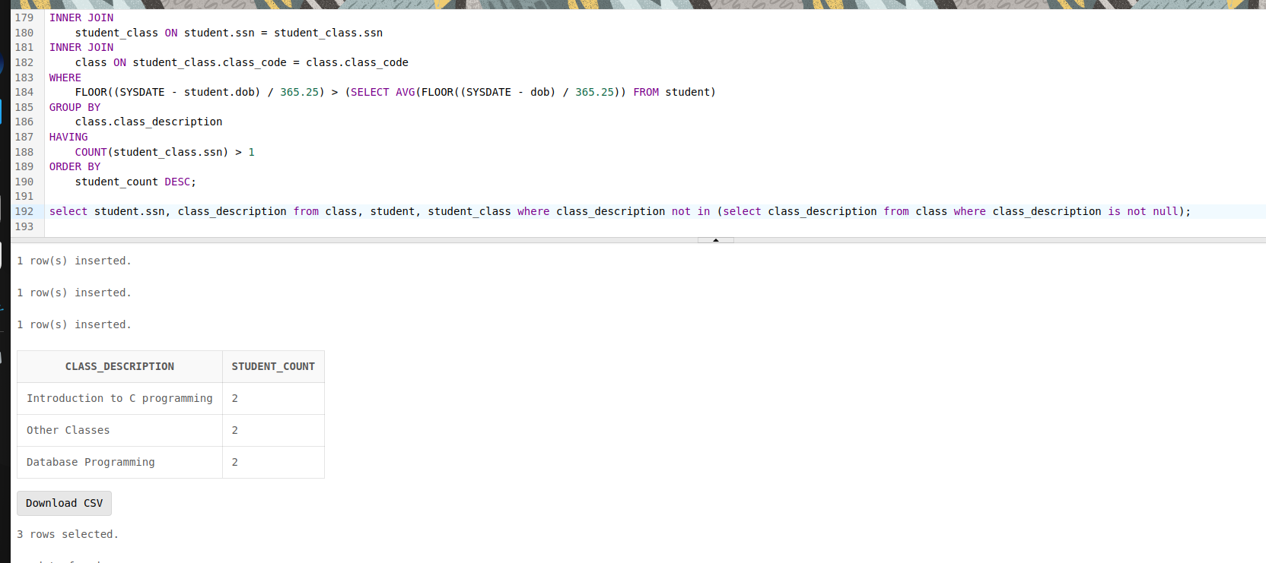
Basic subquery where we find information that is NOT within the subquery, therefore eliminating that query from our product.
5 | Give a listing of all the students who are not enrolled in any  classes (Note: Use Exists or not Exists)
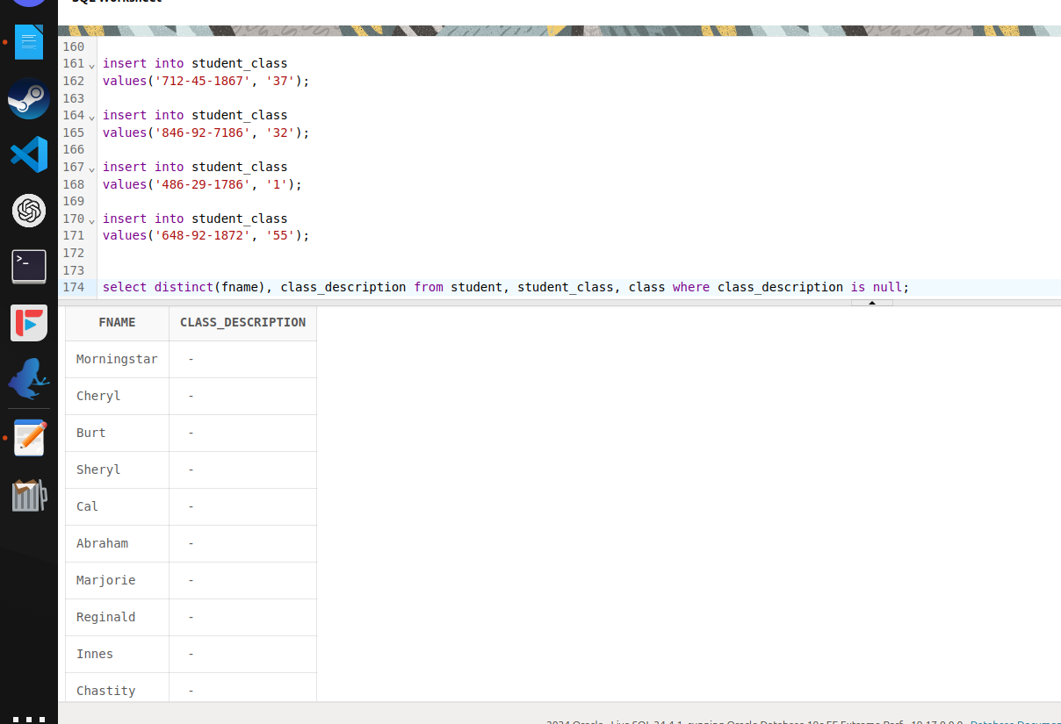
The basic thought process is cross join then limit by distinct to get single variables and restrict to ‘’ empty class descriptions.
6 | create a new table that contains the list of all the students  and class_descriptions. Include In this table the list of all  students who are not enrolled in any classes (display no classes). If there are no class descriptions then display ‘no description’  (Use combination of inner join, union and minus)  (Note: minus will deal with the students who are not enrolled in any classes)
 | 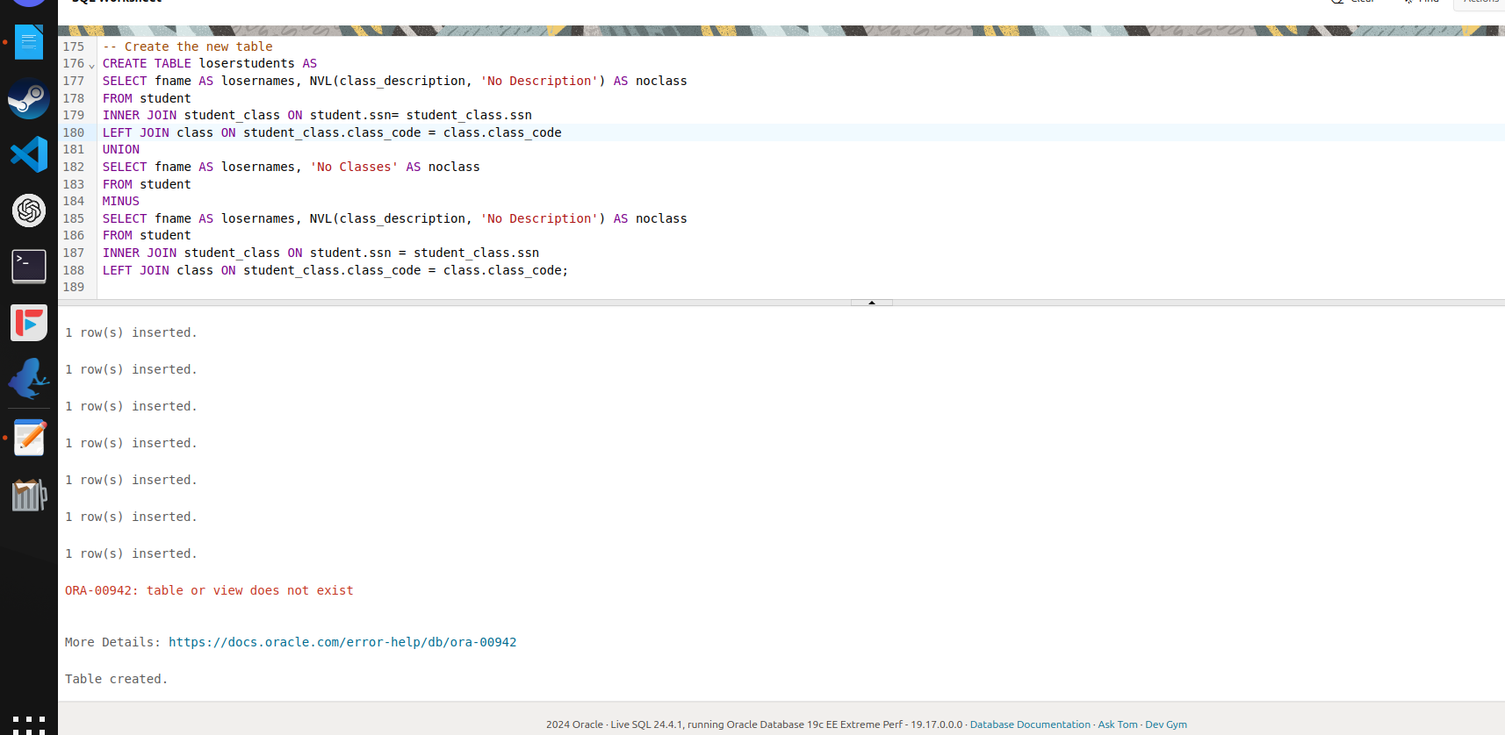
7 | repeat question 6 using a combination of inner join, union and not exists  (Note: Not exists will deal with the students who are not enrolled in any classes)
 | 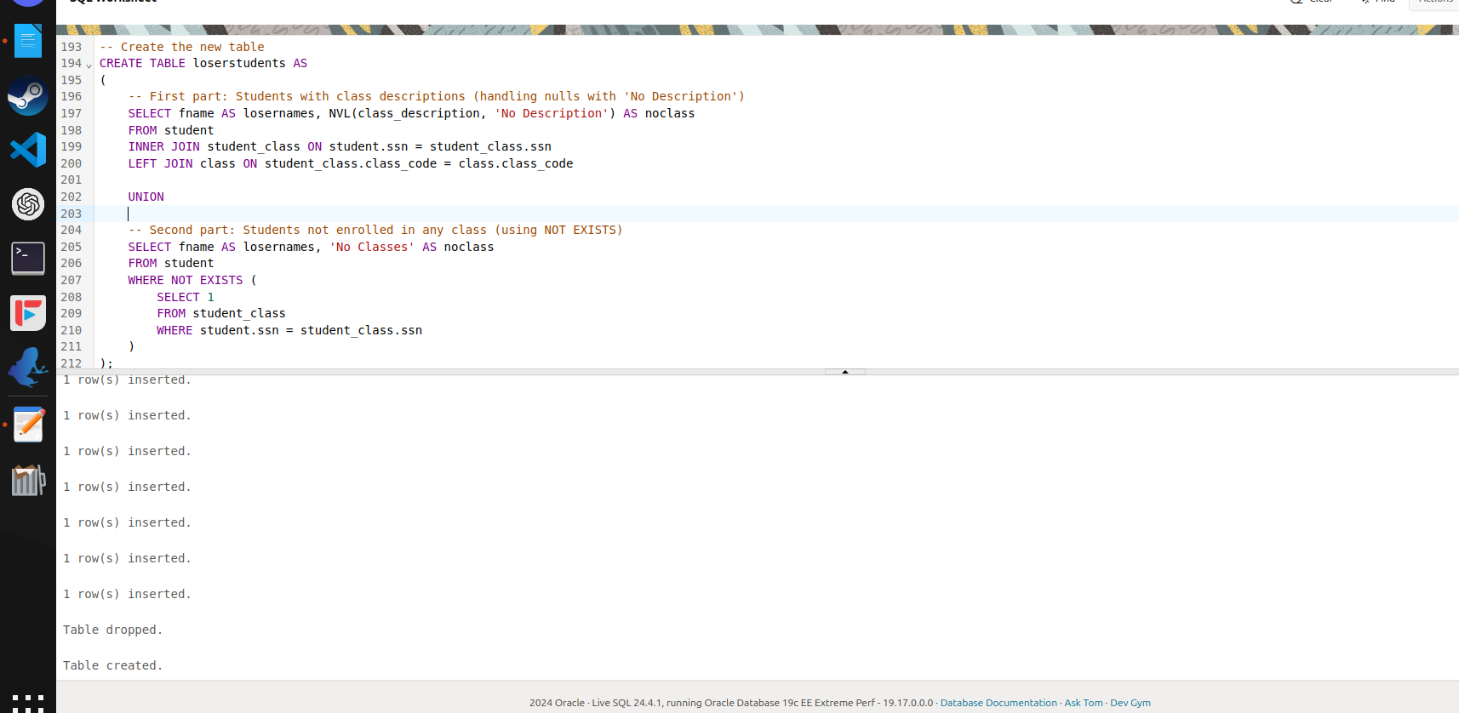
8 | create a view. We want to find out which courses are being taken by the different students for all those whose age is greater than the average age. Give a listing of the course descriptions and student names (Inner join)
 | 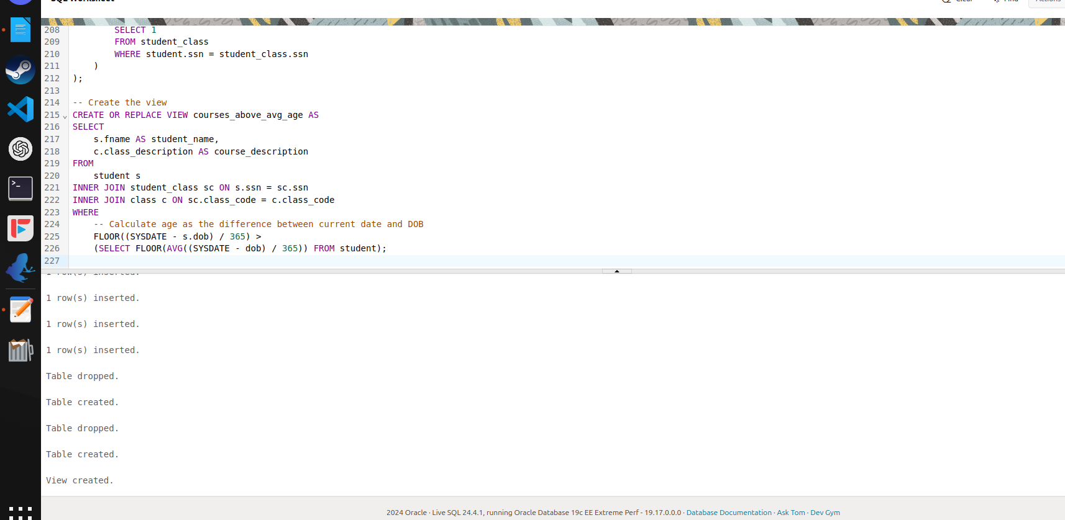
9 | We want to find out the courses that each student is not enrolled in.  Give a listing of the course descriptions, and the students (lname) who are not taking that specific course  (Use a cartesian product and union it with a minus)
 | 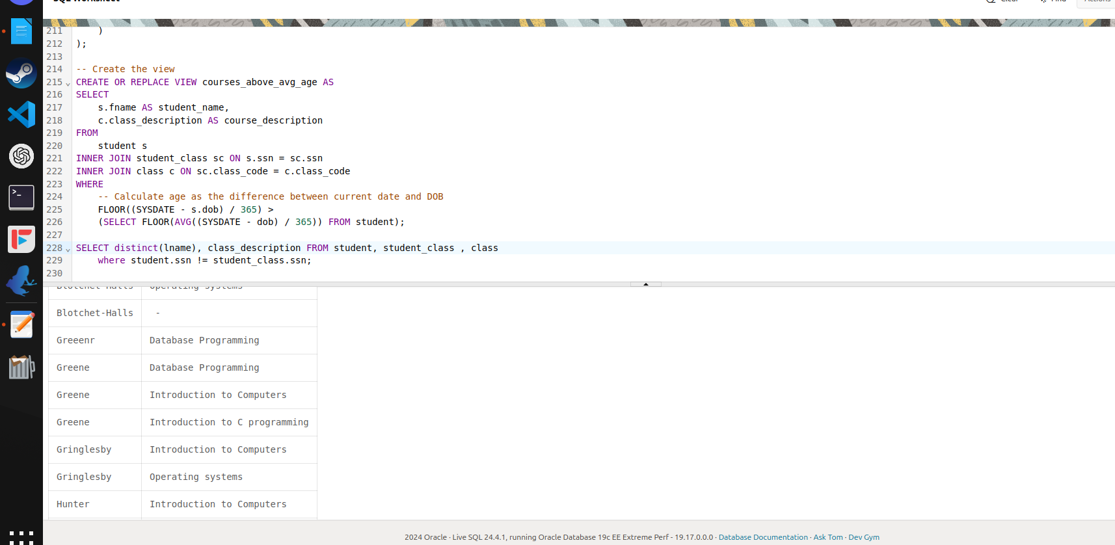
10 | Use the system catalog tables to display the results to find out the  following:(Note show me the SQL syntax along with your results) Only a single SQL statement for each question.
 | a) Primary key name and the columns that make up the primary key for student table
 | 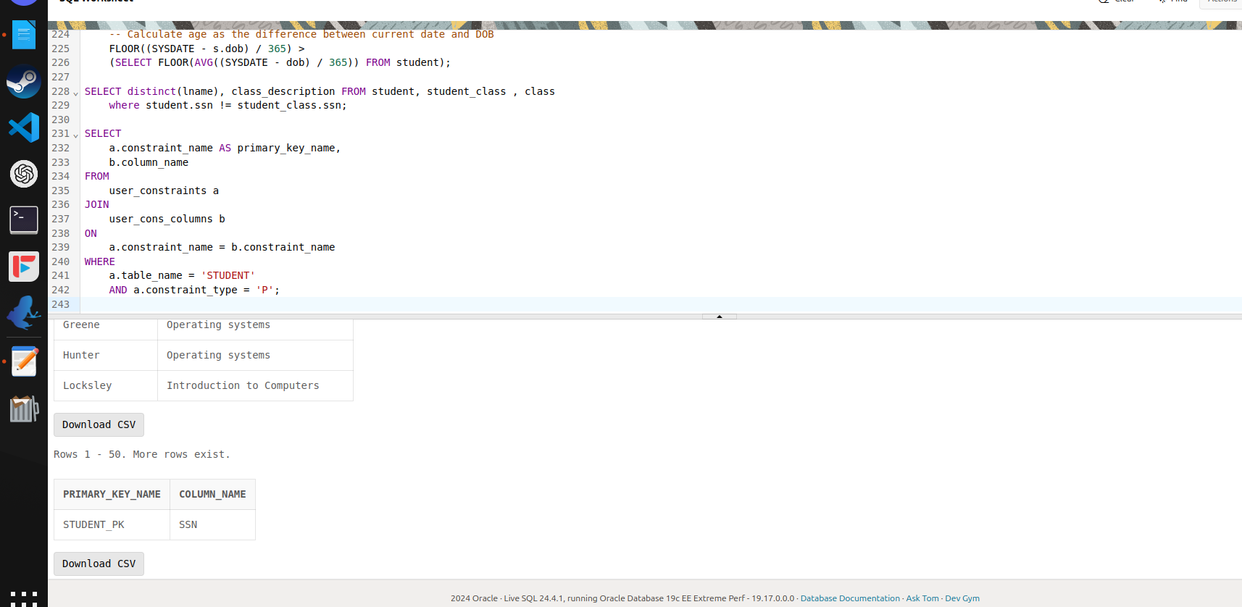
 | b) Unique key name and the columns that make up the unique key for the student table
 | 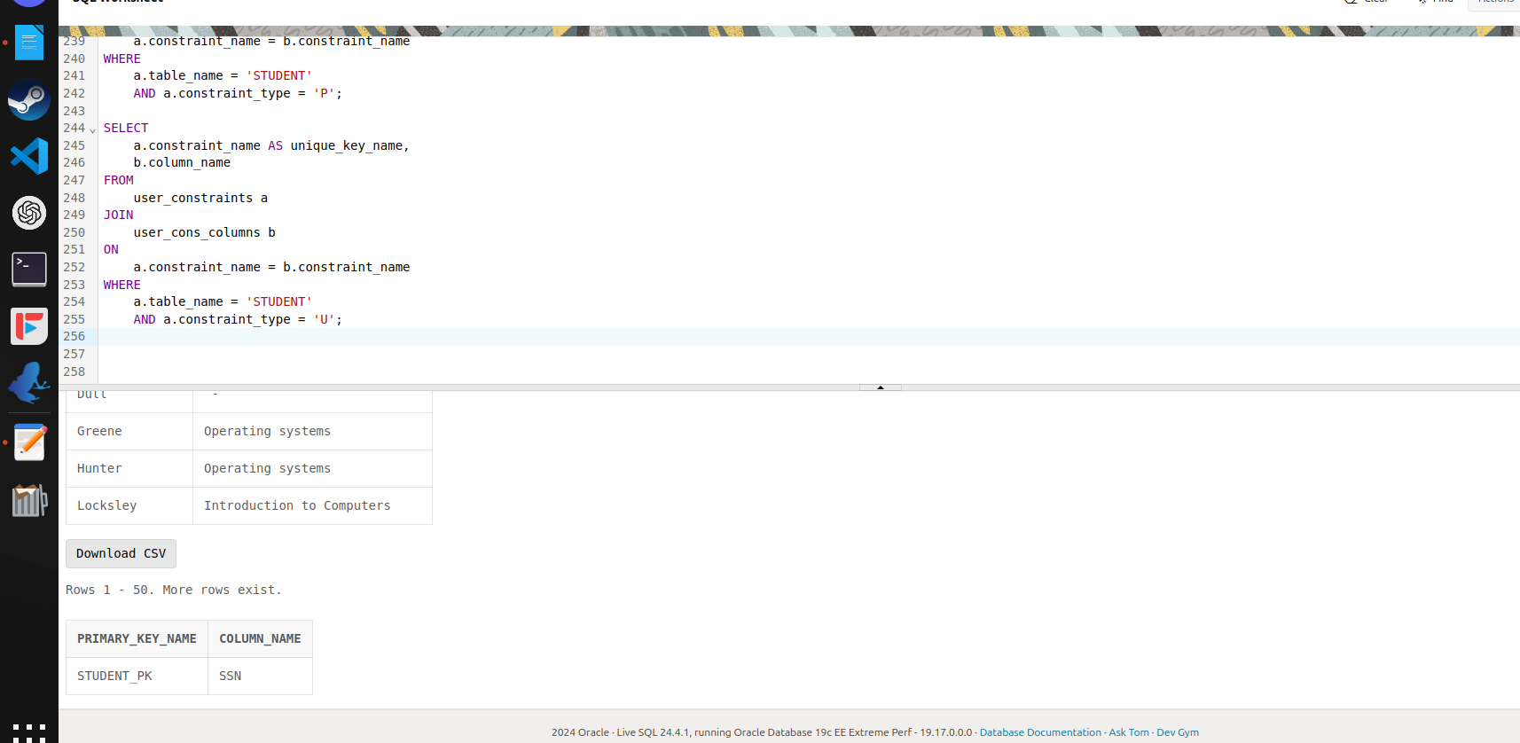
c) Foreign key name, the columns that make up the foreign key
and the columns it references in the parent table for student_class table
 | 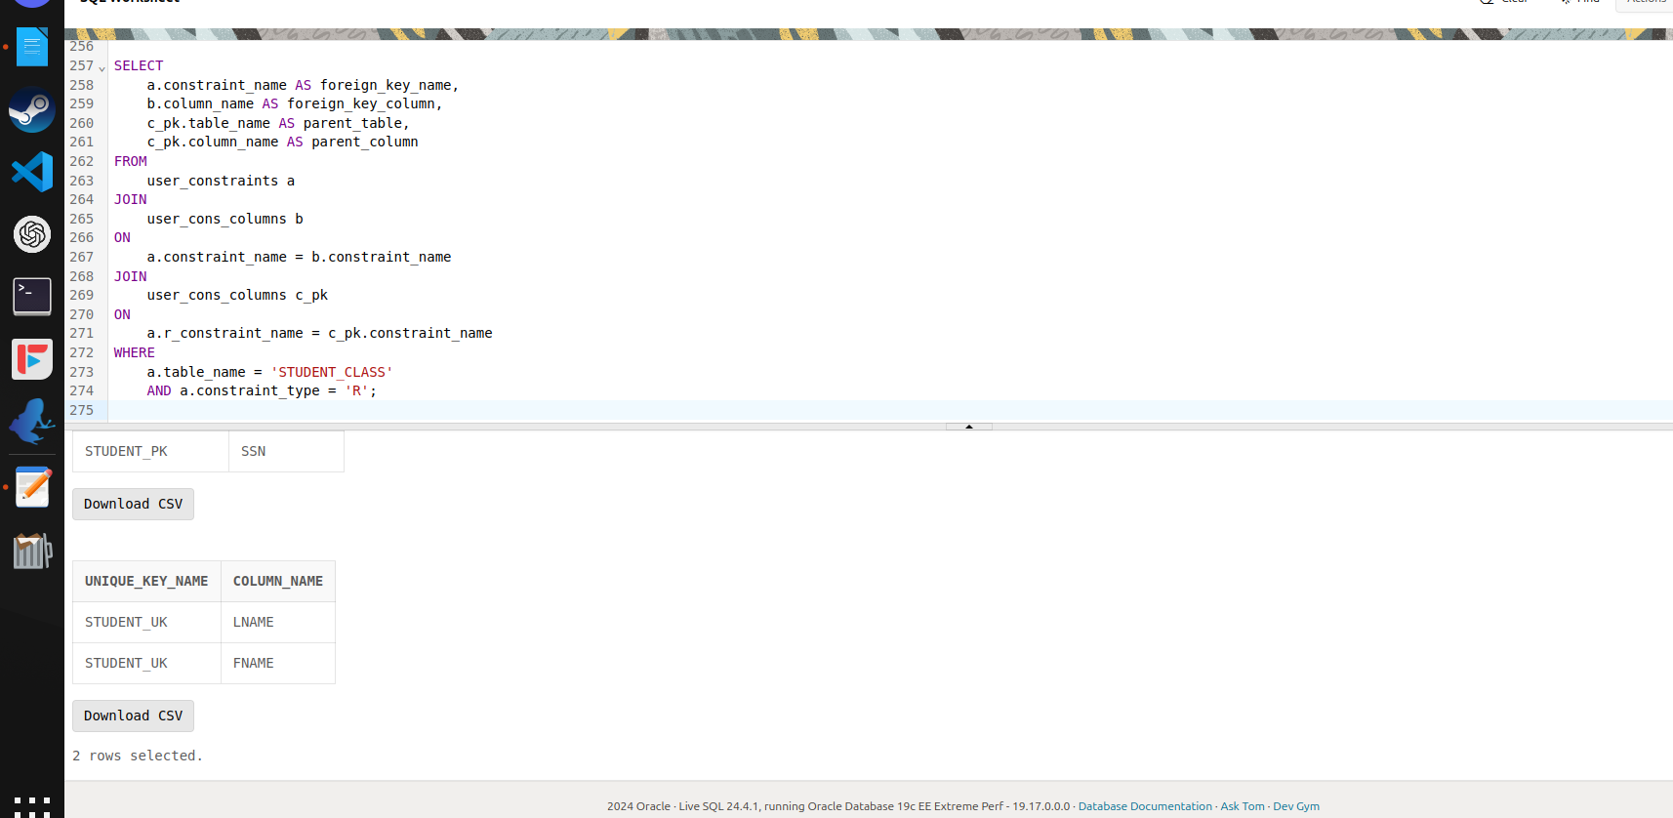
 | d) Name of all the check constraints and their conditions for the student table
 | 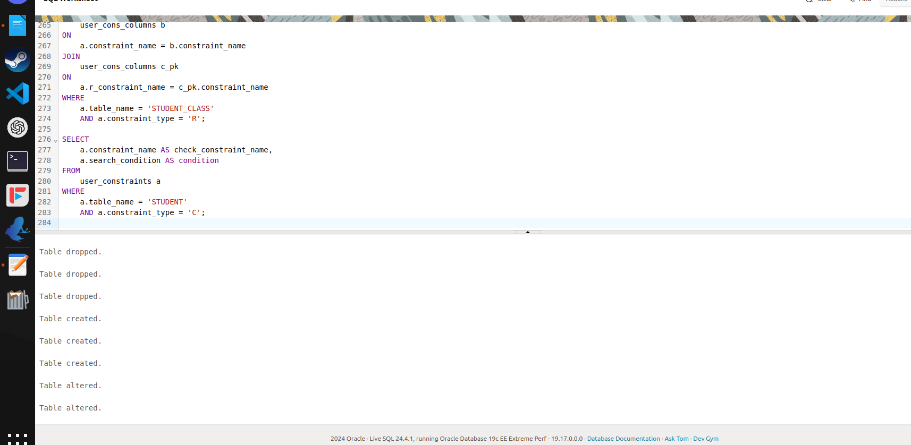

drop table student_class;
drop table student;
drop table class;

create table student
(
ssn char(11) not null,
lname varchar(40) not null,
fname varchar(20) not null,
phone char(12),
address varchar(40),
city varchar(20),
state char(2),
zip char(5),
dob date,
salary number
);

create table class
(
class_code varchar2(10),
class_description varchar2(30)
);

create table student_class
(
ssn char(11) not null,
class_code varchar2(10) not null
);

alter table student add constraint student_pk primary key (ssn);
alter table student_class add constraint stu_cla_pk primary key(ssn,class_code);
alter table class add constraint clss_pk primary key(class_code);
alter table student_class add constraint st_fk foreign key (ssn) references student;
alter table student add constraint student_uk unique(lname,fname);
create index clss_desc_indx on class (class_description);

insert into student
values('409-56-7008', 'Bennet', 'Abraham',
'', '6223 Bateman St.', 'Berkeley', 'CA', '94705','26-feb-1988',10000);

insert into student
values ('213-46-8915', 'Green', 'Marjorie',
'', '309 63rd St. #411', 'Oakland', 'CA', '94618','25-feb-1989',20000 );

insert into student
values('238-95-7766', 'Gren', 'Cheryl',
'415 548-7723', '589 Darwin Ln.', 'Berkeley', 'CA', '94705',null,45000);

insert into student
values('998-72-3567', 'Greeenr', 'Albert',
'801 826-0752', '67 Seventh Av.', 'Salt Lake City', 'UT', '84152','24-feb-1992',15000);

insert into student
values('427-17-2319', 'Dull', 'Ann',
'415 836-7128', '3410 Blonde St.', 'Palo Alto', 'CA', '94301','23-feb-1993',30000);

insert into student
values('672-71-3249', 'Yokomoto', 'Akiko',
'415 935-4228', '3 Silver Ct.', 'Walnut Creek', 'CA', '94595','22-feb-1994',35000);

insert into student
values('267-41-2394', 'O''Leary', 'Michael',
'409-56-7008', '22 Cleveland Av. #14', 'San Jose', 'CA', '95128','12-feb-1995',32000);

insert into student
values('472-27-2349', 'Gringlesby', 'Burt',
'707 938-6445', 'PO Box 792', 'Covelo', 'NY', '95428','12-feb-1996',34000);

insert into student
values('527-72-3246', 'Greene', 'Morningstar',
'615 297-2723', '22 Graybar House Rd.', 'Nashville', 'TN', '37215','11-feb-1995',25000);

insert into student
values('999-00-0000', 'Al', 'Cal',
'615 297-2723', '22 Graybar House Rd.', 'Nashville', 'TN', '37215','06-feb-1998',22000);

insert into student
values('172-32-1176', 'White', 'Johnson',
'408 496-7223', '10932 Bigge Rd.', 'Menlo Park', 'ma', '94025','05-feb-1999',23000);

insert into student
values('712-45-1867', 'del Castillo', 'Innes',
'615 996-8275', '2286 Cram Pl. #86', 'Ann Arbor', 'MI', '48105','04-feb-1982',23500);

insert into student
values('846-92-7186', 'Hunter', 'Sheryl',
'415 836-7128', '3410 Blonde St.', 'Palo Alto', 'CA', '94301','03-feb-1979',18000);

insert into student
values('486-29-1786', 'Locksley', 'Chastity',
'415 585-4620', '18 Broadway Av.', 'San Francisco', 'CA', '94130','02-feb-1978',15500);

insert into student
values('648-92-1872', 'Blotchet-Halls', 'Reginald',
'503 745-6402', '55 Hillsdale Bl.', 'Corvallis', 'OR', '97330','01-feb-1977',43000);

insert into class
values('37','Database Programming');

insert into class
values('3','Introduction to Computers');

insert into class
values('32','Introduction to C programming');

insert into class
values('34','Intro to principles');

insert into class
values('14A','Operating systems');

insert into class
values('1','');

insert into class
values('55','');

insert into student_class
values('409-56-7008', '37');

insert into student_class
values ('213-46-8915', '32');

insert into student_class
values('998-72-3567', '3');

insert into student_class
values('998-72-3567', '55');

insert into student_class
values('427-17-2319', '34');

insert into student_class
values('672-71-3249', '3');

insert into student_class
values('267-41-2394', '34');

insert into student_class
values('472-27-2349', '32');

insert into student_class
values('527-72-3246', '1');

insert into student_class
values('172-32-1176', '37');

insert into student_class
values('712-45-1867', '37');

insert into student_class
values('846-92-7186', '32');

insert into student_class
values('486-29-1786', '1');

insert into student_class
values('648-92-1872', '55');
-- Drop the table if it exists
DROP TABLE loserstudents;

-- Create the new table
CREATE TABLE loserstudents AS
SELECT fname AS losernames, NVL(class_description, 'No Description') AS noclass
FROM student
INNER JOIN student_class ON student.ssn= student_class.ssn
LEFT JOIN class ON student_class.class_code = class.class_code
UNION
SELECT fname AS losernames, 'No Classes' AS noclass
FROM student
MINUS
SELECT fname AS losernames, NVL(class_description, 'No Description') AS noclass
FROM student
INNER JOIN student_class ON student.ssn = student_class.ssn
LEFT JOIN class ON student_class.class_code = class.class_code;

-- Drop the table if it exists
DROP TABLE loserstudents;

-- Create the new table
CREATE TABLE loserstudents AS
(
-- First part: Students with class descriptions (handling nulls with 'No Description')
SELECT fname AS losernames, NVL(class_description, 'No Description') AS noclass
FROM student
INNER JOIN student_class ON student.ssn = student_class.ssn
LEFT JOIN class ON student_class.class_code = class.class_code

UNION

-- Second part: Students not enrolled in any class (using NOT EXISTS)
SELECT fname AS losernames, 'No Classes' AS noclass
FROM student
WHERE NOT EXISTS (
SELECT 1
FROM student_class
WHERE student.ssn = student_class.ssn
)
);

-- Create the view
CREATE OR REPLACE VIEW courses_above_avg_age AS
SELECT
s.fname AS student_name,
c.class_description AS course_description
FROM
student s
INNER JOIN student_class sc ON s.ssn = sc.ssn
INNER JOIN class c ON sc.class_code = c.class_code
WHERE
-- Calculate age as the difference between current date and DOB
FLOOR((SYSDATE - s.dob) / 365) >
(SELECT FLOOR(AVG((SYSDATE - dob) / 365)) FROM student);

SELECT distinct(lname), class_description FROM student, student_class , class
where student.ssn != student_class.ssn;

SELECT
a.constraint_name AS primary_key_name,
b.column_name
FROM
user_constraints a
JOIN
user_cons_columns b
ON
a.constraint_name = b.constraint_name
WHERE
a.table_name = 'STUDENT'
AND a.constraint_type = 'P';

SELECT
a.constraint_name AS unique_key_name,
b.column_name
FROM
user_constraints a
JOIN
user_cons_columns b
ON
a.constraint_name = b.constraint_name
WHERE
a.table_name = 'STUDENT'
AND a.constraint_type = 'U';

SELECT
a.constraint_name AS foreign_key_name,
b.column_name AS foreign_key_column,
c_pk.table_name AS parent_table,
c_pk.column_name AS parent_column
FROM
user_constraints a
JOIN
user_cons_columns b
ON
a.constraint_name = b.constraint_name
JOIN
user_cons_columns c_pk
ON
a.r_constraint_name = c_pk.constraint_name
WHERE
a.table_name = 'STUDENT_CLASS'
AND a.constraint_type = 'R';

SELECT
a.constraint_name AS check_constraint_name,
a.search_condition AS condition
FROM
user_constraints a
WHERE
a.table_name = 'STUDENT'
AND a.constraint_type = 'C';

