Relational Algebra

TABLE CREATE:
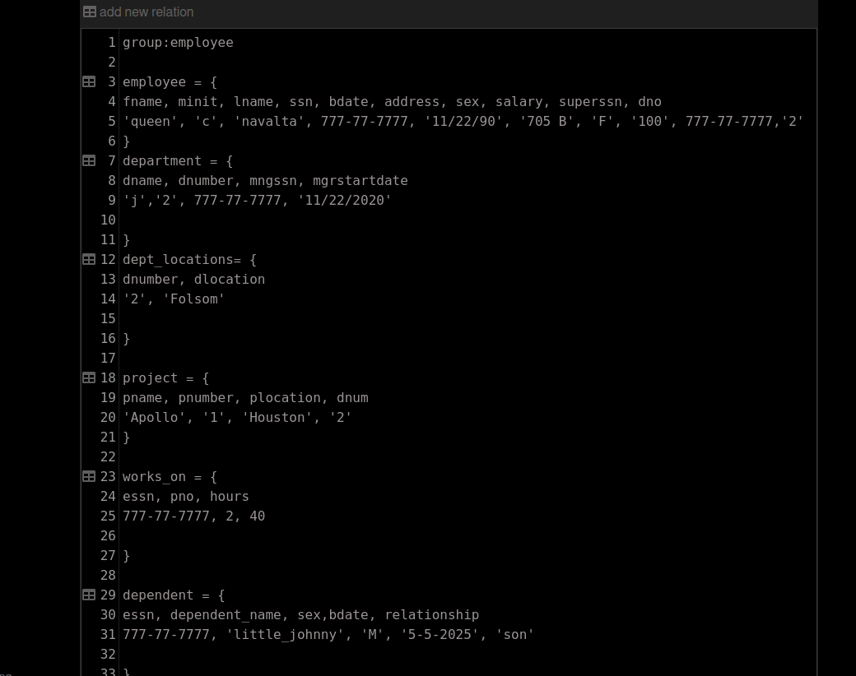

You can use the Relational Algebra Calculator to test your code
https://dbis-uibk.github.io/relax/calc.htm

(1) Retrieve the names (fname,lname) of employees who work more than 10 hours per week on the 'ASTU' project. (“ASTU” is project name.)

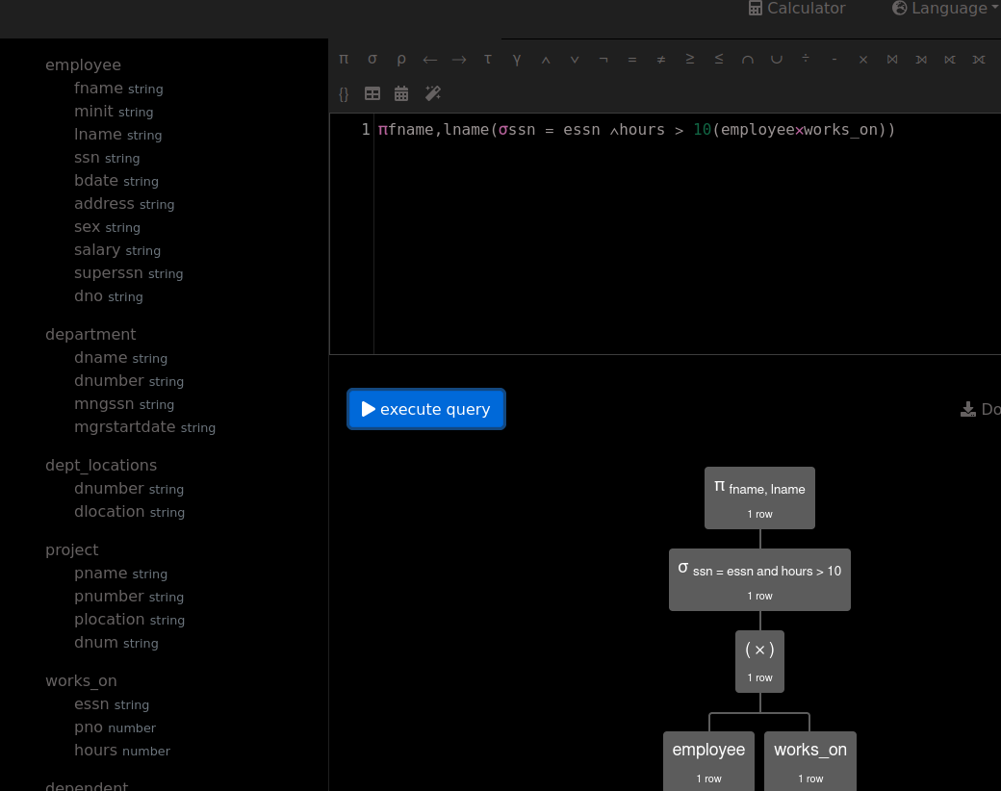
(2) Retrieve the names (fname, lname) of all employees who work on at least one project.

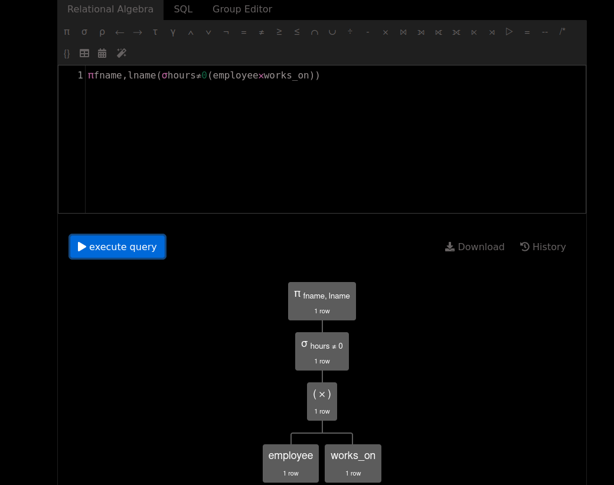
(3) Retrieve the locations of “CPE” department. (“CPE” is department name).

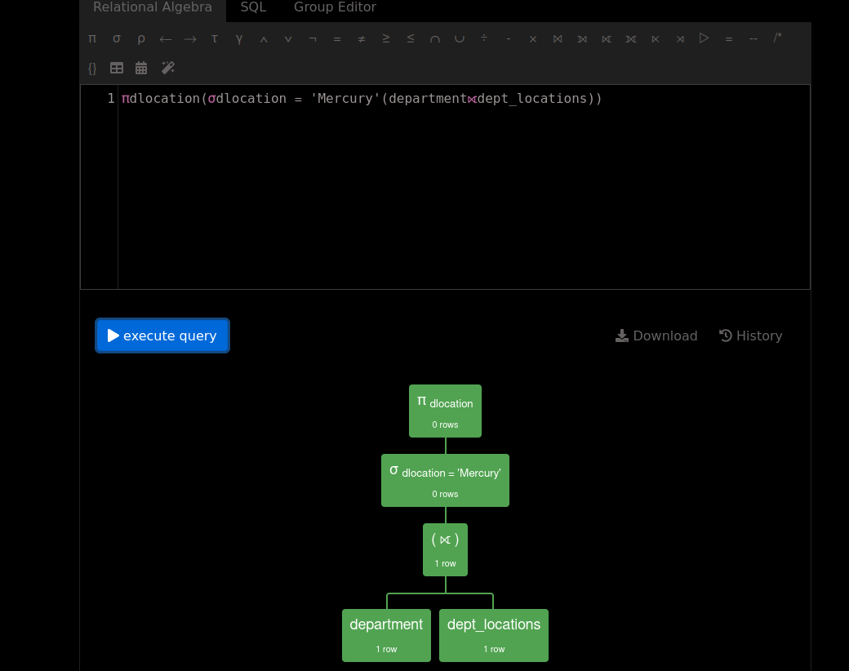
(4) Find the name (fname,lname) of the direct supervisor of “Mary Smith”. (“Mary Smith” is an employee).

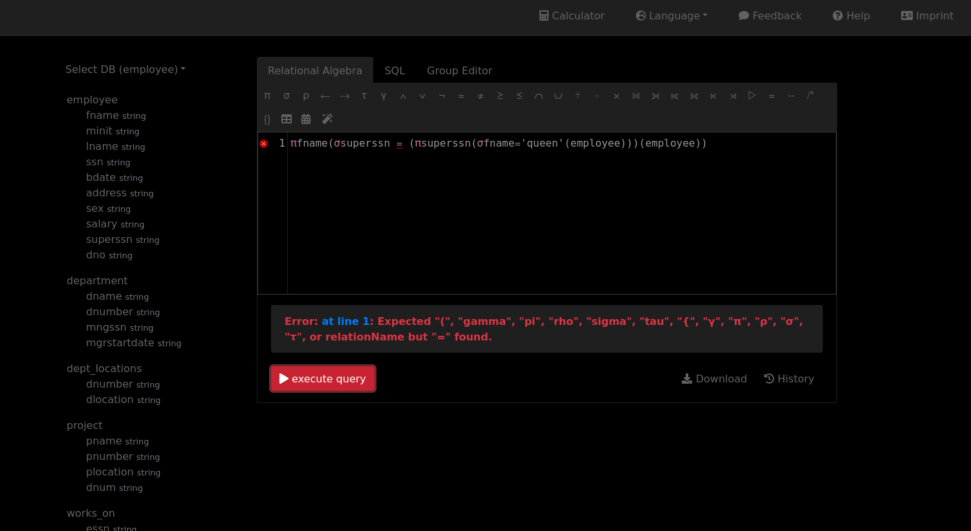
This program isn’t recognizing a subquery, but the concept should work. Declaring variables was also not functional for whatever reason, could be a site issue.
This will print Marys boss, as well as the boss of everyone is also supervised by Mary, but I suppose it doesn’t matter.
5) Draw the query tree for question #4

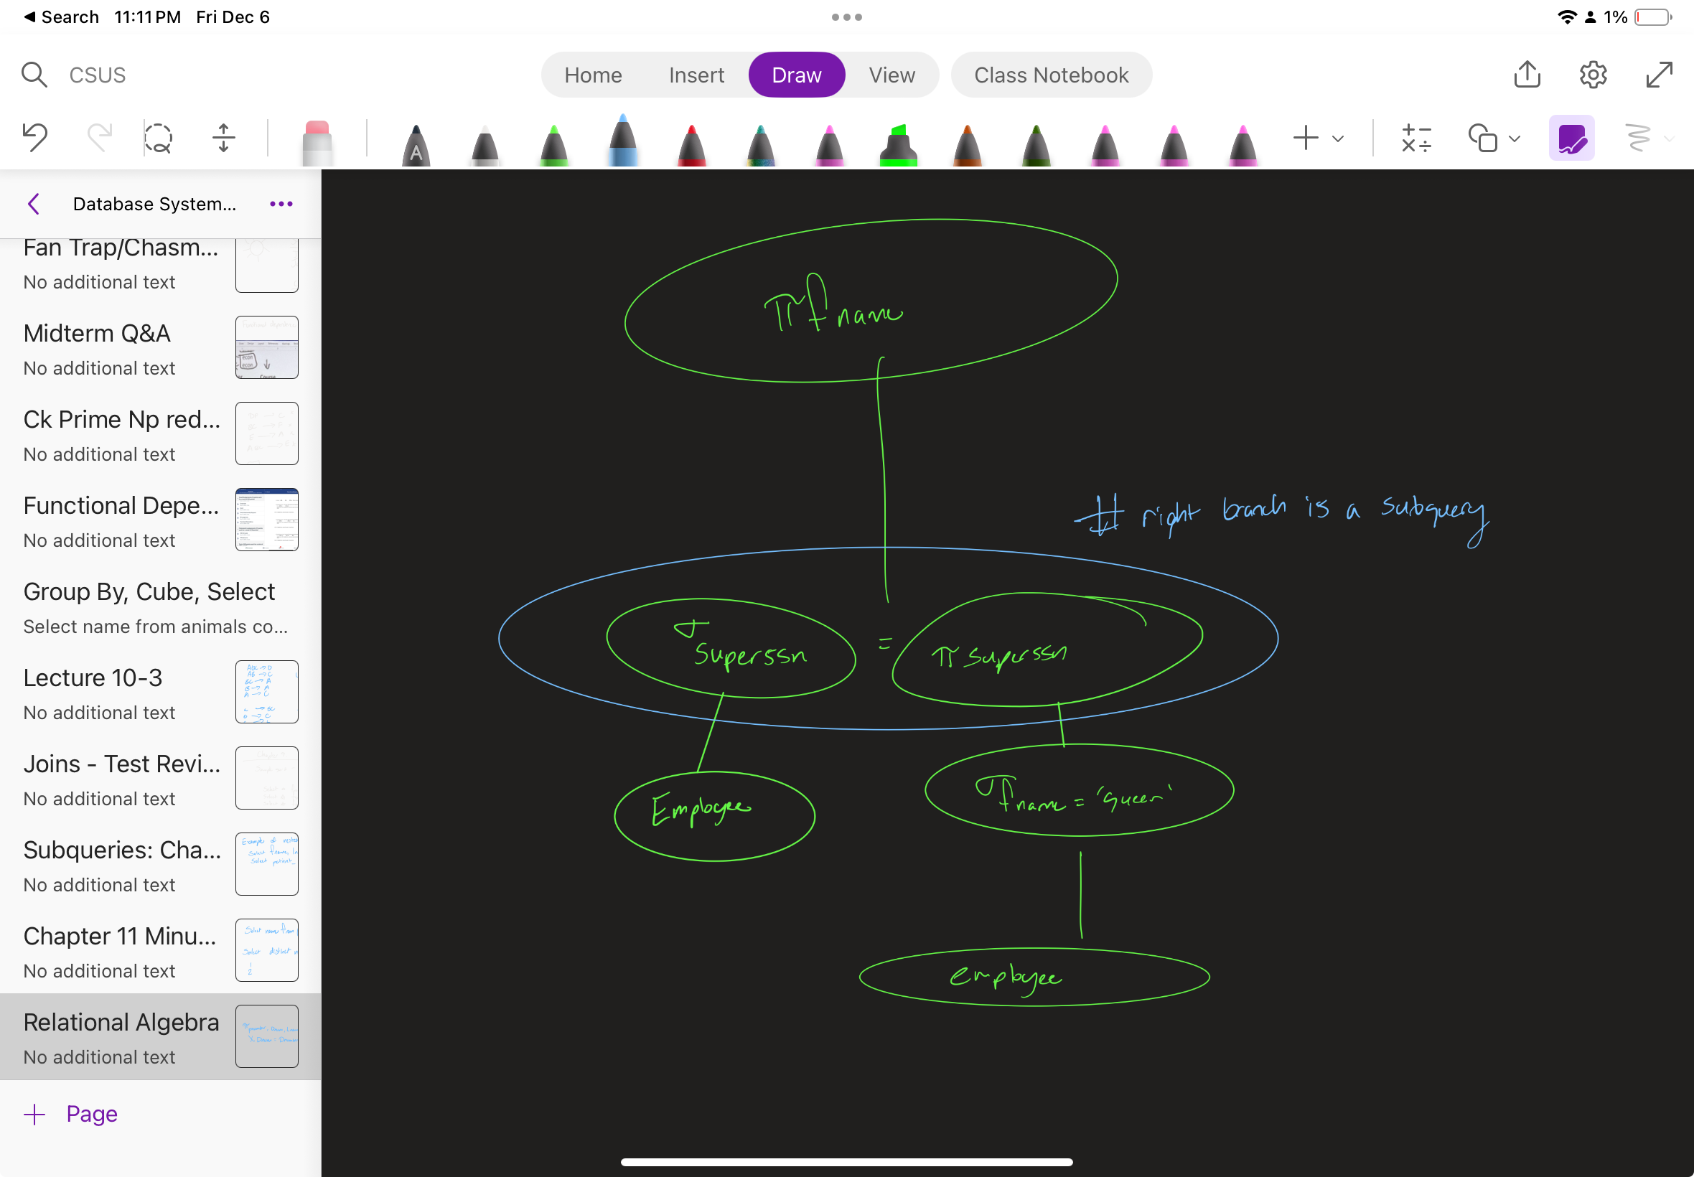

Here is some sample code code that shows how to create relations with data that can be used in the relational algebra editor. Change the data and code to fit your database

group: disease

patient = {
ssn, fname, age

1, 'a', 30
3, 'b', 22
4, 'c', 33
5, 'd', 44
6, 'e', 25
}

patientdisease = {
ssn, id

1, 11
2, 22
1, 12
}

disease= {
id, descr

11, 'malaria'
22, 'flu'
33, 'cold'
}

