3 Jon Delemos

HW #3
CSc 137, Harvey
Adder/Mux (12 pts)

- Design a Single cell -1 bit Carry propagate (Ripple Carry Adder) full adder. (6 pts)
  - Generate the truth table

A | B | CIN(CARRY) | SUM | CARRY
0 | 0 | 0 | 0 | 0
0 | 0 | 1 | 1 | 0
0 | 1 | 0 | 1 | 0
0 | 1 | 1 | 0 | 1
1 | 0 | 0 | 1 | 0
1 | 0 | 1 | 0 | 1
1 | 1 | 0 | 0 | 1
1 | 1 | 1 | 1 | 1

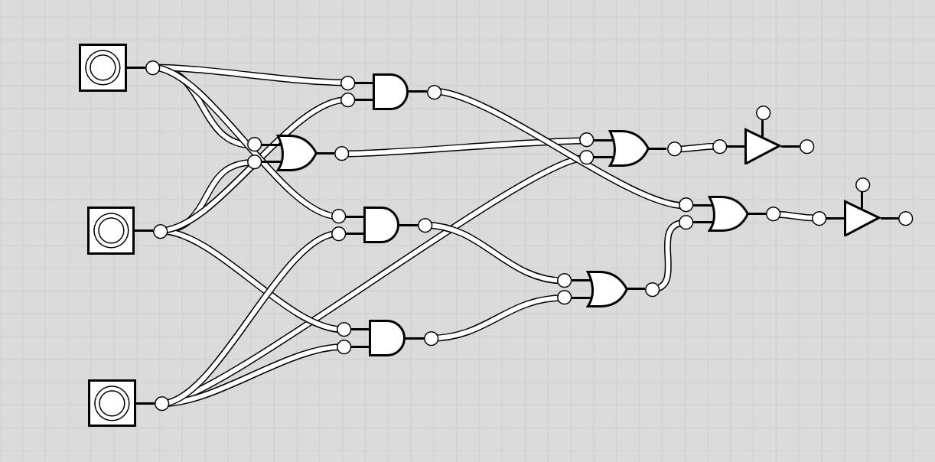

  - Using K-map, determine the logical expression for Carry out (C-out) and Sum (S)

Sum

B/C 00 01 11 10
A in 0 | 00 | 1 | 0 | 1
1 | 1 | 0 | 1 | 0

Cout

B/C 00 01 11 10
A in 0 | 00 | 0 | 1 | 0
1 | 0 | 1 | 1 | 1

SOP = A + B+ C
Cout = Ab + BC + AC

  - Based on the logical expression, create the schematic diagram for full adder

- Design a 1 bit, 2 to 1 multiplexer (Mux). Outputs Y when S = 0; X when S = 1. (6 pts)
  - Generate the truth table
  - Using K-map, determine the logical expression for output
  - Based on the logical expression, create the schematic diagram for Mux

S | X | Y | OUTPUT
0 | 0 | 0 | 0
0 | 0 | 1 | 1
0 | 1 | 0 | 0
0 | 1 | 1 | 1
1 | 0 | 0 | 0
1 | 0 | 1 | 0
1 | 1 | 0 | 1
1 | 1 | 1 | 1

MUX

XY 00 01 11 10
S in 0 | 00 | 1 | 1 | 0
1 | 0 | 0 | 1 | 1

INVERSE SY OR SX:

