1.2.

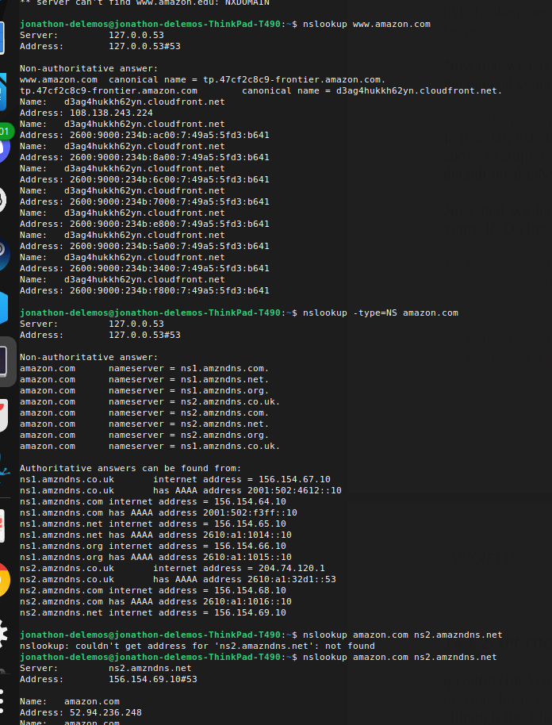

3.

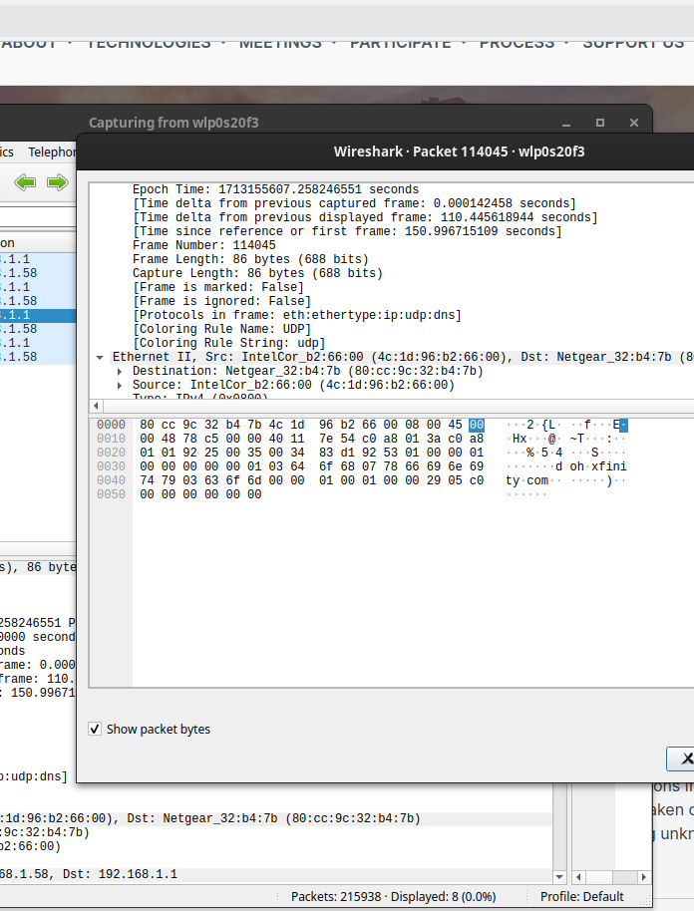

4.

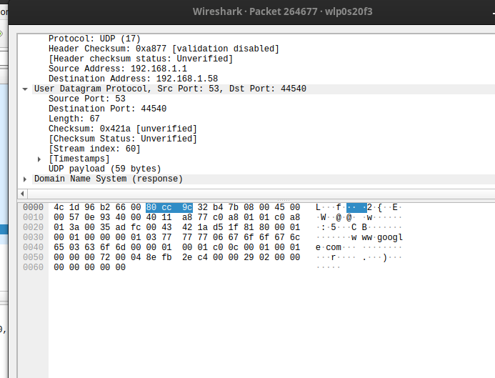

5.
Ubuntu is reporting this destination no matter what I do.

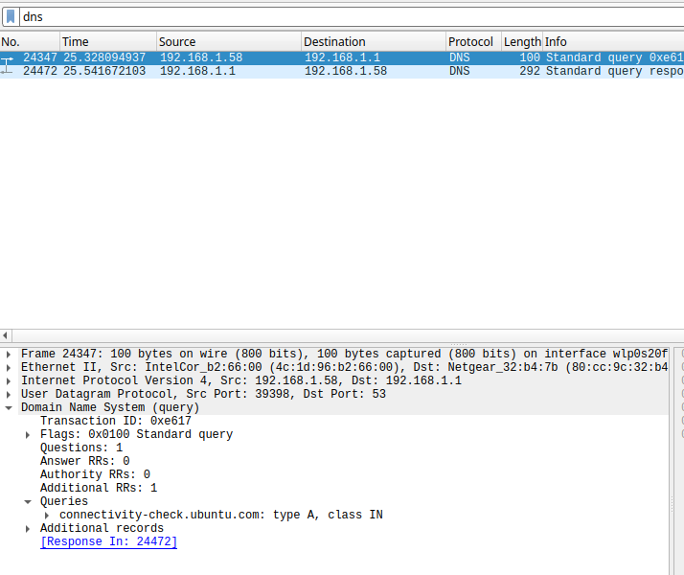

6.7 I think it says some information about my system, although the DNS filter was seeminlgy not operational.

8. The query is reporting a Type A.

9.

15. yes.
16. The message did not contain any answers.
17. The mit servers are use5.akam.net

internet address = 2.16.40.64
use5.akam.net has AAAA address 2600:1403:a::40
ns1-37.akam.net internet address = 193.108.91.37
ns1-37.akam.net has AAAA address 2600:1401:2::25
asia1.akam.net internet address = 95.100.175.64
eur5.akam.net internet address = 23.74.25.64
asia2.akam.net internet address = 95.101.36.64
usw2.akam.net internet address = 184.26.161.64
use2.akam.net internet address = 96.7.49.64

