Jonathon DeLemos
19.2.2024
Instructor: Badruddoja,Syed
CSC138
STUDENT ID: 213441385
SECTION 4
Course ID: 110586
Class Number: 32640
SSN:###-##-####

HOMEWORK 1
I have each question above the answer I provide. Spaces have been added for formatting purposes.

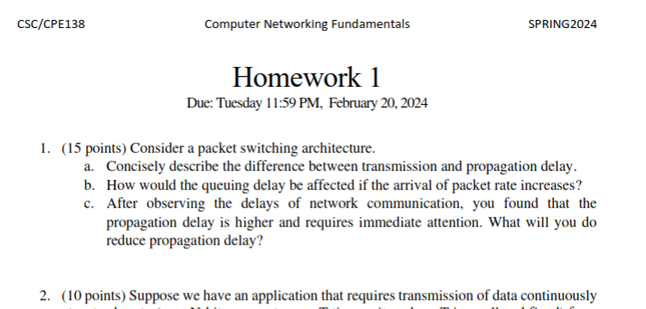

Homework #1
Answers
1. Packet Switching
1a. Transmission is the delay of being passed through the gate to the propagation lane which is the highway that the packet travels to reach it’s destination.
1b. The arrival of packet rate increase would increase the length of the queue. If you wanted to trap a certain message, I’d imagine you could overwhelm the queue upon arrival of target message, then quickly sift through the queue to find what you want. Sort of like clog pipe just as object gets dropped in it, then worm (up) through it to find the temporarily blocked message. Once the message is found, unblock the pipe, allow it to pass the gate and propagate.
1c. Short answer: shorten the distance between the objects, but if the object needs to travel that distance, then we must work toward improving the logic behind it’s transmission.

NUMBER 2

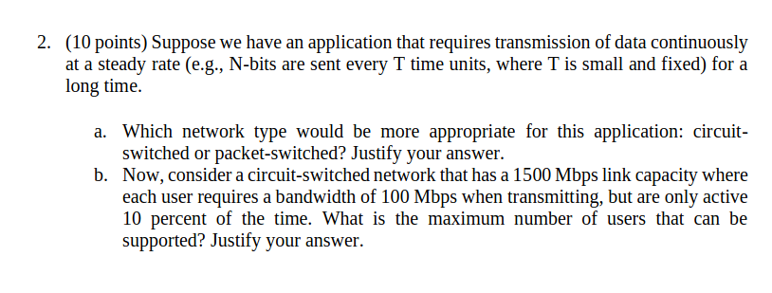
2a. For a application that REQUIRES a constant transmission, like a vital healthcare system, we would likely want a circuit based system, because it would maintain constant connection without dropping packets. This would limit the number of users on the network but that’s irrelevant if we have a dedicated system for a singular vital individual.

2b.

NUMBER 3
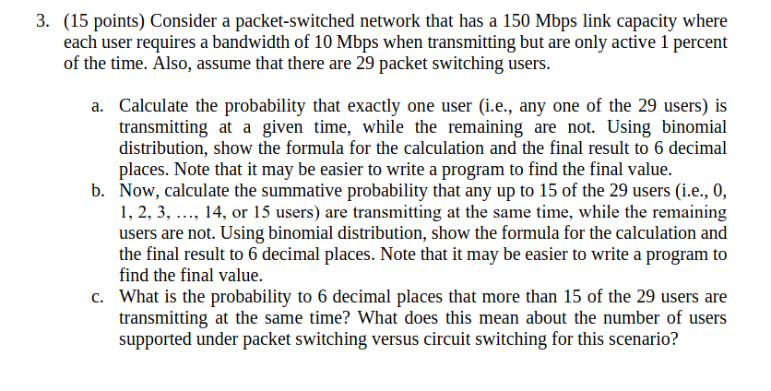
3a. Okay, so we want to find the likelihood of a single user transmitting at any given time.

3b. Now we calculate the summative chance 15 users might be transmitting at the same time.
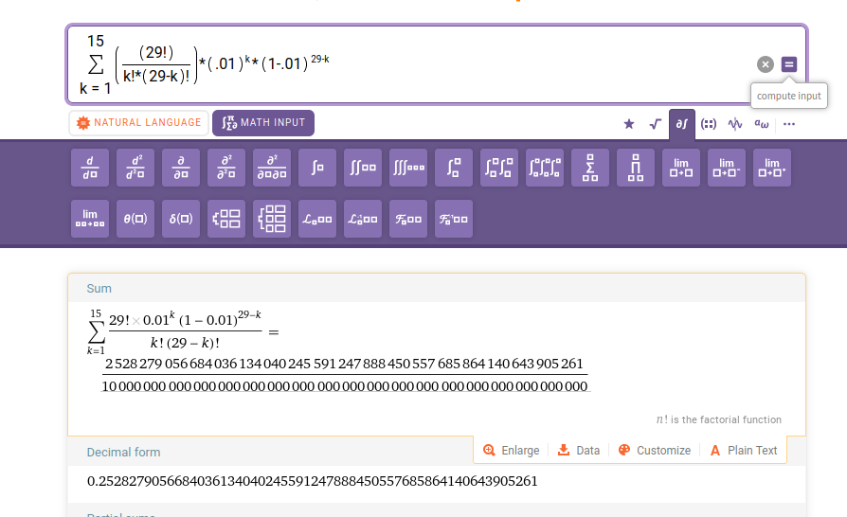
Where p = .01 Round to six places:
.252828% probability Final answer

3c. greater than fifteen encompasses 14 summed possibilities, so it’s going to be a larger number. The remaining possibilities are 15-29, or 1-.25828 =
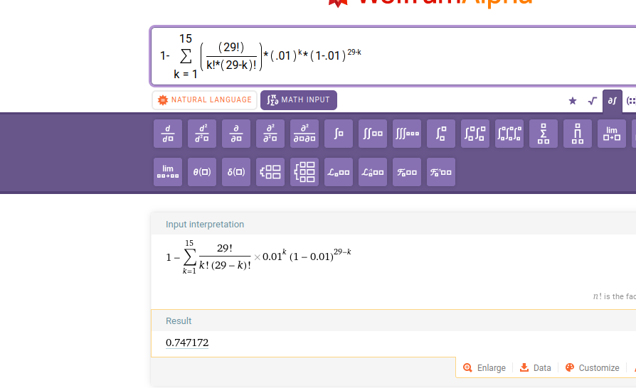
Final Answer: .747172% probability

NUMBER 4
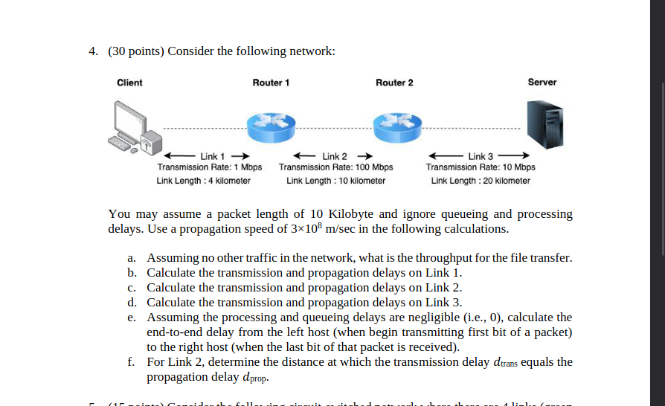

4a. Here, we discover the throughput is defined by the slowest transmission rate, Link1, which is 1mbps.
4b.

4c. We are going to do the exact same thing, so I will reuse the formula.

4d. We are going to do the exact same thing, so I will reuse the formula.

4e. End to end is simply adding the numbers together, so we get approximately 0.101203333, rounded, all because of the slow rate that exists within link1.
4f. For this, we set up a proportional equation and discover the answer is 30,000 km.

NUMBER 5
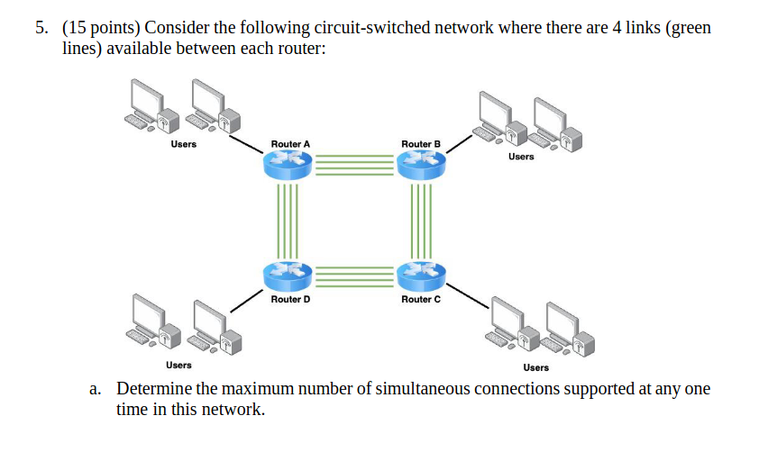
5a. Maximum number of simultaneous connections supported in the network:
Each router has 4 links available. If we assume each link can support one simultaneous connection, then the maximum number of simultaneous connections in the network is 4 (since there are 4 links per router and there are 4 routers in total).

5b. Maximum number of simultaneous connections from router A to router C:
Router A has 4 links available. Router C also has 4 links available. Therefore, the maximum number of simultaneous connections from router A to router C is determined by the router with fewer available links, which is 4.

5c. Simultaneous connections for scenario with 4 users at router A and 4 users at router B:
Router A has 4 links available. Router B also has 4 links available. Router C has 4 links available. Router D also has 4 links available. However, since each router has only 4 links, it's not possible to make 8 simultaneous connections in this network. The maximum number of simultaneous connections that can be made is limited by the number of links available at each router, which is 4.

NUMBER 6
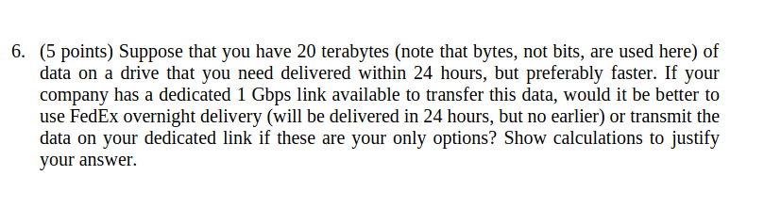

There are 3600 * 24 seconds in a day, therefore I’d use the dedicated link.

NUMBER 7

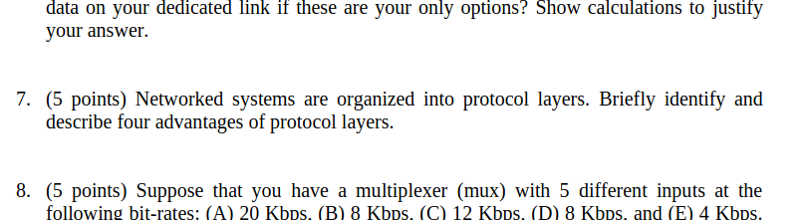

Here are four protocol layer approaches and their advantages:

From our lectures
Internet application: File transfer protocol, SMTP, HTTP, Rfc
Transport: Transfer control protocol, UDP, data safety, guarantees reliable transport
Network: IP, routing protocols, port designation, priority, allows packets to be interconected.
Physical: ethernet, fiber, wifi, bluetooth etc.
In a broad sense:
Protocol layers allow for the separation of different functions and services into distinct layers, making it easier to understand, maintain, and update the system. Each layer can be developed and modified independently without affecting other layers.

NUMBER 8

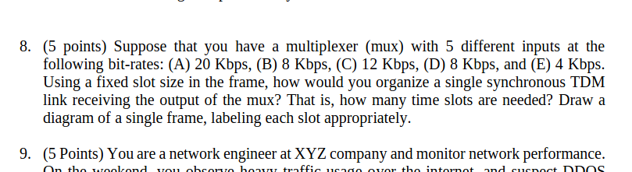

20 | 8 | 12 | 8 | 4

To organize a single synchronous TDM link receiving the output of the mux with 5 different inputs at the specified bit-rates, we need to allocate time slots in the frame for each input based on its bit-rate. Since the total capacity of the TDM link should accommodate the highest bit-rate input, we need to calculate the total capacity and then divide it into time slots. Total capacity of the TDM link = Sum of bit-rates of all inputs = 20 Kbps + 8 Kbps + 12 Kbps + 8 Kbps + 4 Kbps = 52 Kbps If we use a fixed slot size in the frame, the number of time slots needed would be determined by the frame duration required to transmit all inputs. For example, if we use a frame duration of 1 second: Number of time slots = Total capacity / Frame duration = 52 Kbps / 1 second = 52 slots Therefore, we would need 52 time slots in the frame.

NUMBER 9

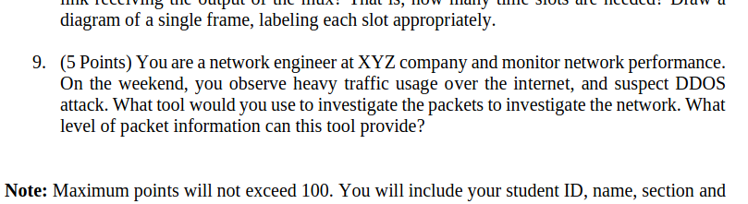
9a. Drawing from our lab, we could use wireshark. Although there are other programs available that would or could accomplish the same thing. You can capture loads of data like source and destination locationBurp might be able to do it as well.

