Computer Network Fundamentals 2-6 Topics

Internet Structure
Packet Loss, Delay, and throughput
Protocol layers
Network security
Internet History

Internet Structure: Network of networks
End systems connect to Internet via access ISPs (Internet service provider)
Residential, company and university ISPs
Access ISPs in turn must be interconnected
So that any two hosts can send packets to each other

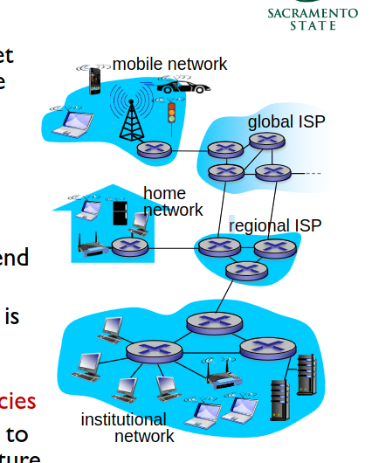

Connecting each access ISP to each other doesn’t scale O(N^2)

Next Solution:
Global ISP (Internet service provider) – For example, we have AT&T as the service provider for taiwan.
This is incredibly dangerous because if there were to be a security flaw within the global ISP, the banks would be compromised.

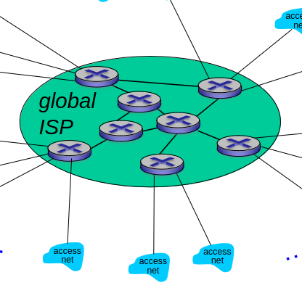
Modern Internet Structure:
Network of Networks
But if one global ISP is viable business, there will be competitors which must be interconnected.
Here is an image.
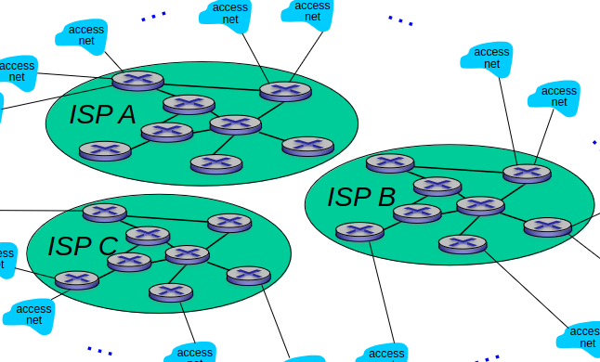
IXP = Internet Exchange Points
Content delivery networks, and ISP are interconnected. Therefore xFininty and AT&T must be connected.
If we connect to the IXP, then we can connect to multiple service providers! That means we are capable of accessing AT&T and xFinity which results in a much smaller bottleneck.
Bigger businesses form their own IXPs.
What is the function of the IXP?

NEXT: REGIONAL NETWORKS

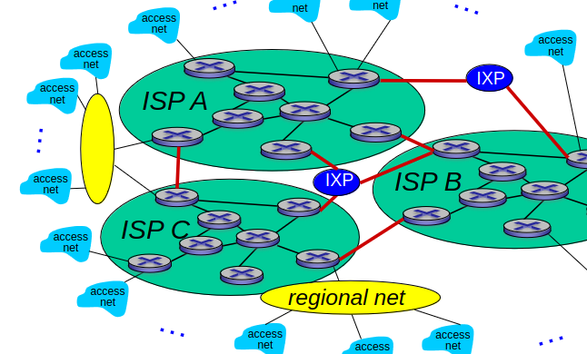
Connecting to a regional net is less expensive and resource intensive than connect to regional ISP’s
This is what creates the regional net.
We want to maintain the accessibility across the state.
What about locations where there are no IXP’s?
The result is these areas do not have great access to the internet or high resolution videos.

MODERN NETWORK

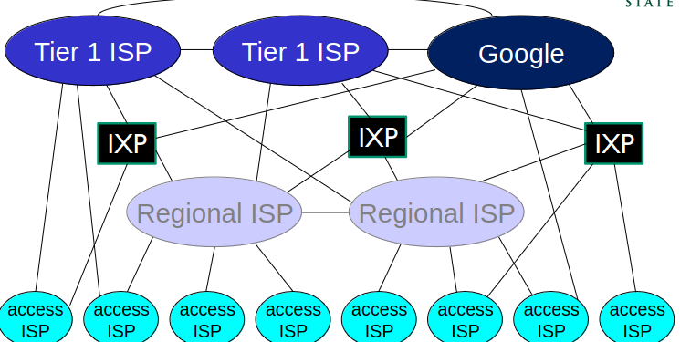
The system is distributed because the access ISP’s cannot connect to each other.
Tier 1 commerical ISP (Level 3, Sprint, AT&T, NTT)
Content provider network (e.g., Google): private network that connects its data to internet.
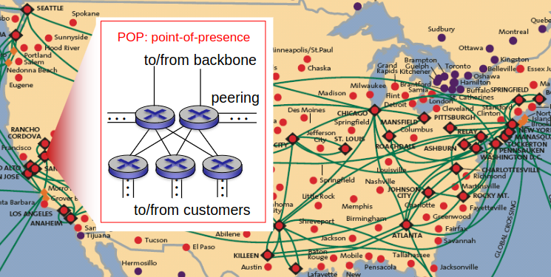
Tier one ISP are giant and lay the backbone of the internet

Tier 1:
AT&T, Sprint, Verizon, NTT, Level3, Qwest
Full-Mesh
Settlement-Free
Peering Interconnections

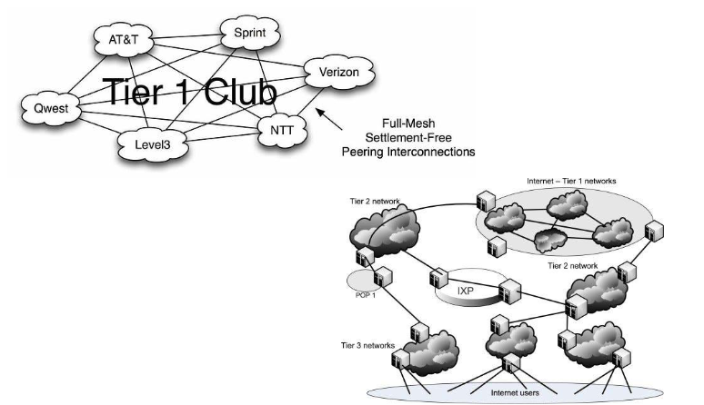
IXPS are connecting multiple access points to each other.
What is Network Performance?
Why is it important?

How does loss and delay occur?
Packets queue in router buffers
packet arrive rate to link (temporarily) exceeds output link capacity
packets will lag to due to bottleneck in router packet queuing delay.
The processing delay is the routers ability to process the packets it is receiving, or hardware limitations.
If there are one million packets, then there is a delay to enter the link.

