Lab 2: Exploring the HTTP Protocol

Due: 27th February, 2024

Lab adapted from Computer Networking: A Top-Down Approach, Kurose Ross, 8th edition.

Student name: ____Jonathon Delemos_______________ Section:_________4________ Student ID: _______213441385___________
Note: You will continue your lab in virtual machine that you already installed in Lab 1.

Task 1: The Basic HTTP GET/response interaction (36 Points)

- Start up your web browser.
- Start up the Wireshark packet sniffer, as described in the Introductory lab (but don’t yet begin packet capture). Enter “http” (just the letters, not the quotation marks) in the display-filter-specification window, so that only captured HTTP messages will be displayed later in the packet-listing window. (We’re only interested in the HTTP protocol here, and don’t want to see the clutter of all captured packets).
- Wait a bit more than one minute (we’ll see why shortly), and then begin Wireshark packet capture.
- Enter the following to your browser http://gaia.cs.umass.edu/wireshark-labs/HTTP-wireshark-file1.html. Your browser should display a very simple, one-line HTML file.
- Stop Wireshark packet capture.

Your Wireshark window should look similar to the window shown in Figure 1. If you are seeing too many http packets, then scroll to the packet under “Info” column with message “ GET /wireshark-labs….” as shown in the below figure.

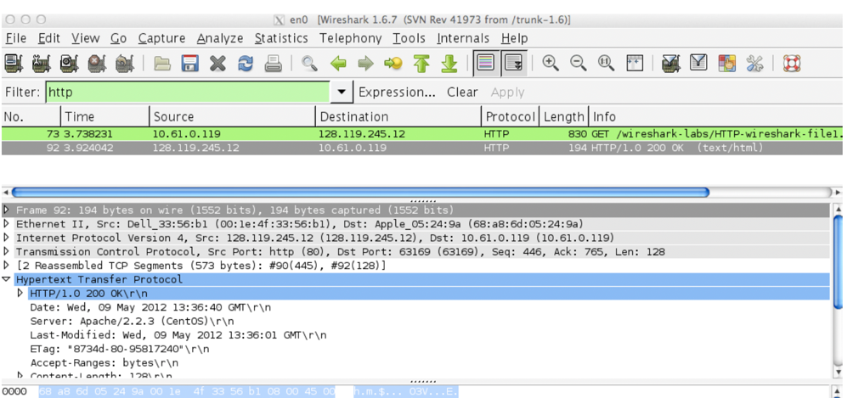

Figure 1: HTTP Packet capture example

The example in Figure 1 shows in the packet-listing window that two HTTP messages were captured: the GET message (from your browser to the gaia.cs.umass.edu web server) and the response message from the server to your browser. Your answer may vary, however, you need to focus on “GET” request and response. The packet-contents window shows details of the selected message (in this case the HTTP OK message, which is highlighted in the packet-listing window). Recall that since the HTTP message. was carried inside a TCP segment, which was carried inside an IP datagram, which was carried within an Ethernet frame, Wireshark displays the Frame, Ethernet, IP, and TCP packet information as well. You will investigate the HTTP protocol from highlighted red box similar to figure 2, as shown below.

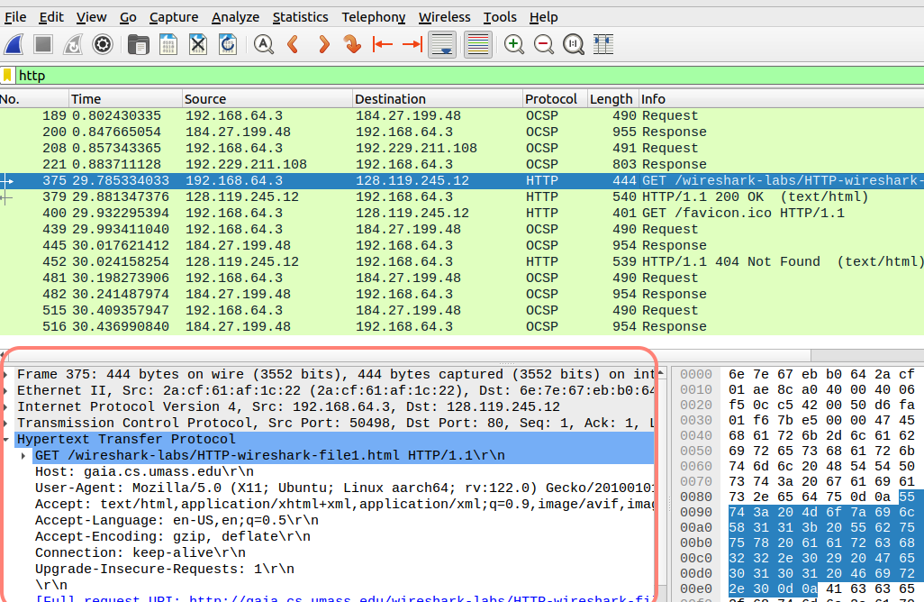
Figure 2: Example Image of HTTP information highlighted in red.

By looking at the information in the HTTP GET and response messages in your machine, answer the following questions. When answering the following questions, you should print out the GET and response messages (see the introductory Wireshark lab for an explanation of how to do this) and indicate where in the message you’ve found the information that answers the following questions. Additionally, you may need to look at other protocol layers to find out other answers on Ip address and port information. When you hand in your assignment, annotate the output so that it’s clear where in the output you’re getting the information for your answer (e.g., for our classes, we ask that students markup paper copies with a pen, or annotate electronic copies with text in a colored font).

Question 1 : Is your browser running HTTP version 1.0 or 1.1? What version of HTTP is the server running? (Attach screenshot)
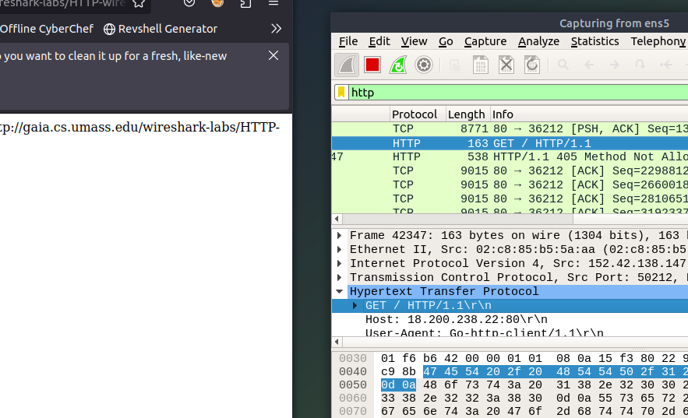
1.1

Question 2 : What languages (if any) does your browser indicate that it can accept to the server? (Attach screenshot)

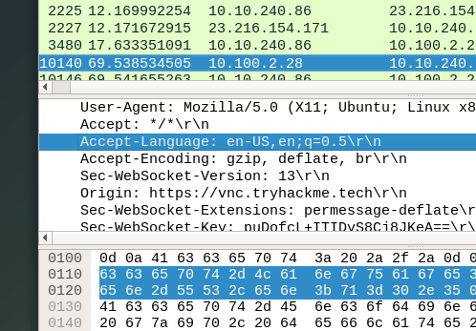

Question 3: What is the IP address of your computer? What is the IP address of the gaia.cs.umass.edu server? (Attach screenshot)

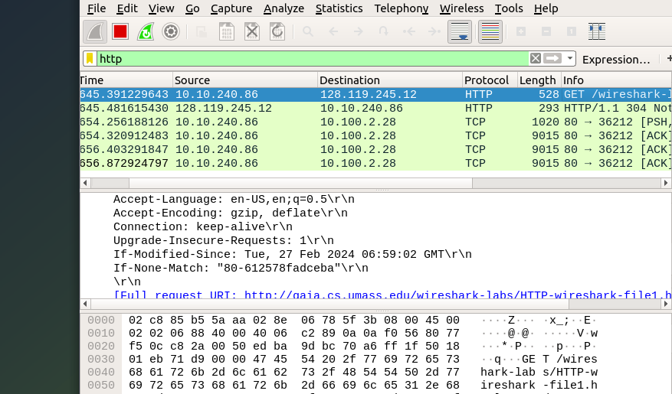

Question 4: What is the status code returned from the server to your browser? (Attach screenshot)
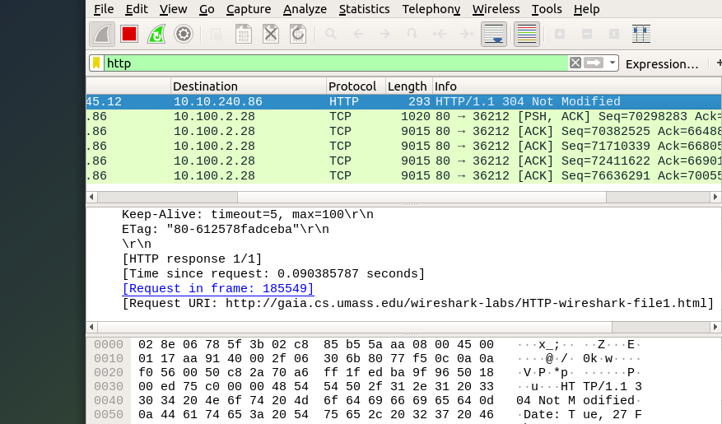

Question 5: When was the HTML file that you are retrieving last modified at the server? (Attach screenshot)

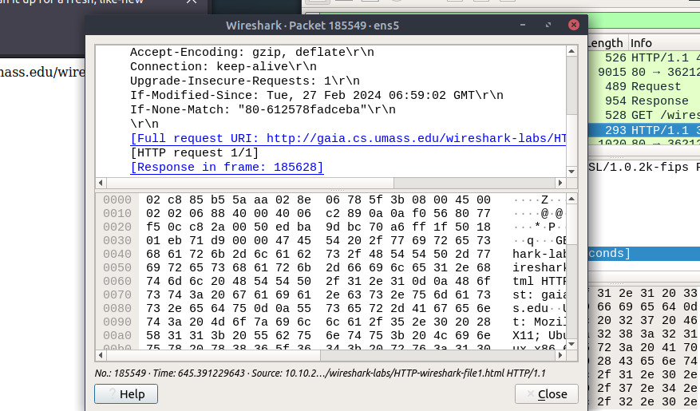

Question 6: How many bytes of content are being returned to your browser? (Attach screenshot)

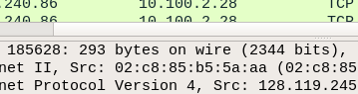

In your answer to question 5 above, you might have been surprised to find that the document you just retrieved was last modified within a minute before you downloaded the document. That’s because (for this particular file), the gaia.cs.umass.edu server is setting the file’s last-modified time to be the current time and is doing so once per minute. Thus, if you wait a minute between accesses, the file will appear to have been recently modified, and hence your browser will download a “new” copy of the document.

Task 2: The HTTP CONDITIONAL GET/response interaction (24 Points)

Recall from Section 2.2.5 of the text, that most web browsers perform object caching and thus perform a conditional GET when retrieving an HTTP object. Before performing the steps below, ensure your browser’s cache is empty. (To do this, under Firefox, select Tools->History->Clear Recent History and check the Cache box; these actions will remove cached files from your browser’s cache.) Now do the following:
- Start up your web browser, and make sure your browser’s cache is cleared, as discussed above.
- Start up the Wireshark packet sniffer
- Enter the following URL into your browser http://gaia.cs.umass.edu/wireshark-labs/HTTP-wireshark-file2.html . Your browser should display a very simple five-line HTML file.
- Quickly enter the same URL into your browser again (or simply select the refresh
- button on your browser)
- Stop Wireshark packet capture, and enter “http” in the display-filter-specification window, so that only captured HTTP messages will be displayed later in the packet-listing window.

Based on the outputs, answer the following questions:

Question 7: Inspect the contents of the first HTTP GET request from your browser to the server. Do you see an “IF-MODIFIED-SINCE” line in the HTTP GET? (Attach screenshot)

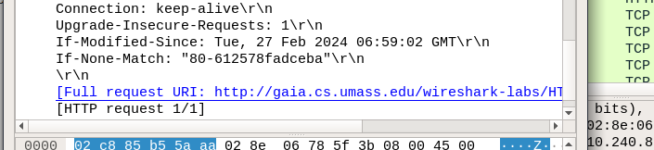
Question 8: Inspect the contents of the server response. Did the server explicitly return the contents of the file? How can you tell? (Attach screenshot)

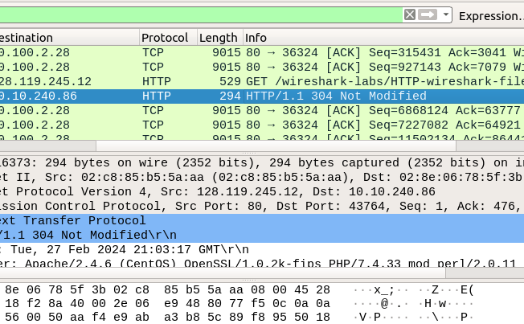

Question 9: Now inspect the contents of the second HTTP GET request from your browser to the server. Do you see an “IF-MODIFIED-SINCE:” line in the HTTP GET? If so, what information follows the “IF-MODIFIED-SINCE:” header? (Attach screenshot)

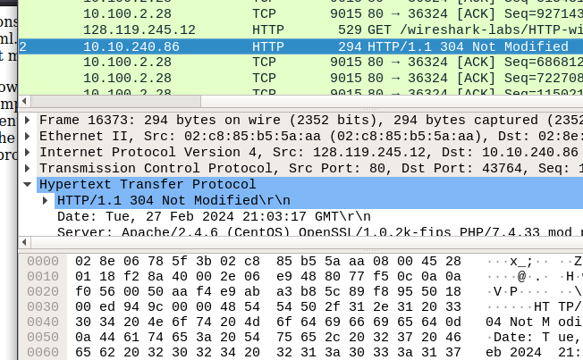
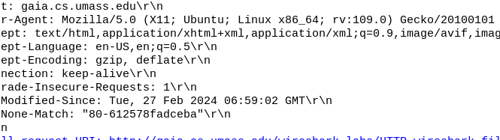

Question 10: What is the HTTP status code and phrase returned from the server in response to this second HTTP GET? Did the server explicitly return the contents of the file? Explain. (Attach screenshot)

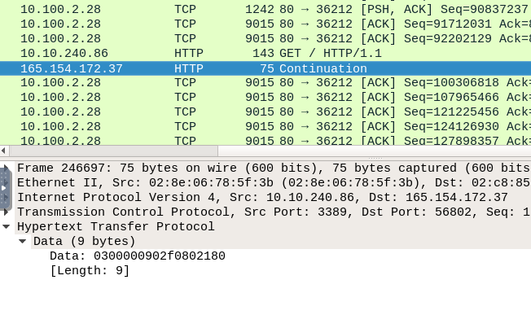

Task 3: Retrieving Long Documents (20 Points)

In our examples thus far, the documents retrieved have been simple and short HTML files. Let’s next see what happens when we download a long HTML file. Do the following:

- Start up your web browser, and make sure your browser’s cache is cleared, as discussed above.
- Start up the Wireshark packet sniffer
- Enter the following URL into your browser http://gaia.cs.umass.edu/wireshark-labs/HTTP-wireshark-file3.html. Your browser should display the rather lengthy US Bill of Rights.
- Stop Wireshark packet capture, and enter “http” in the display-filter-specification window, so that only captured HTTP messages will be displayed.

In the packet-listing window, you should see your HTTP GET message, followed by a multiple-packet TCP response to your HTTP GET request. This multiple-packet response deserves a bit of explanation. Recall from Section 2.2 of the textbook (see Figure 2.9 in the text) that the HTTP response message consists of a status line, followed by header lines, followed by a blank line, followed by the entity body. In the case of our HTTP GET, the entity body in the response is the entire requested HTML file. In our case here, the HTML file is rather long, and at 4500 bytes is too large to fit in one TCP packet. The single HTTP response message is thus broken into several pieces by TCP, with each piece being contained within a separate TCP segment (see Figure 1.24 in the text). In recent versions of Wireshark, Wireshark indicates each TCP segment as a separate packet, and the fact that the single HTTP response was fragmented across multiple TCP packets is indicated by the “TCP segment of a reassembled PDU” in the Info column of the Wireshark display. Earlier versions of Wireshark used the “Continuation” phrase to indicate that the entire content of an HTTP message was broken across multiple TCP segments. We stress here that there is no “Continuation” message in HTTP!

Answer the following questions based on your output:
Question 11: How many HTTP GET request messages did your browser send? Which packet number in the trace contains the GET message for the Bill or Rights? (Attach screenshot)

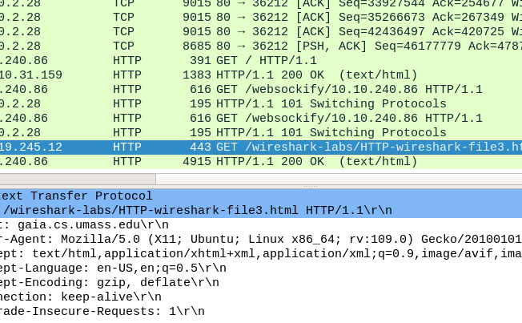

Question 12: Which packet number in the trace contains the status code and phrase associated with the response to the HTTP GET request? (Attach screenshot)http://gaia.cs.umass.edu/wireshark-labs/HTTP-wireshark-file3.html

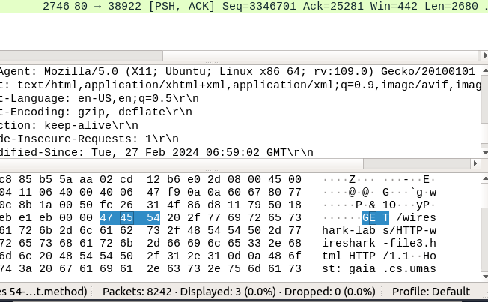

Question 13: What is the status code in the response? (Attach screenshot)

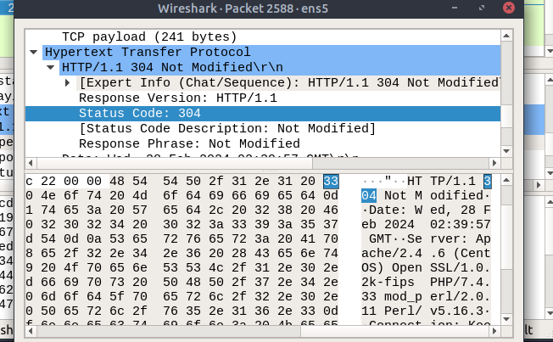

Question 14: How many data-containing TCP segments were needed to carry the single HTTP response and the text of the Bill of Rights? (Attach screenshot) (Hint: you should remove http filter and look at the tcp packets sourced from server to the client. Also, look at the ACK fields and TCp segments.)
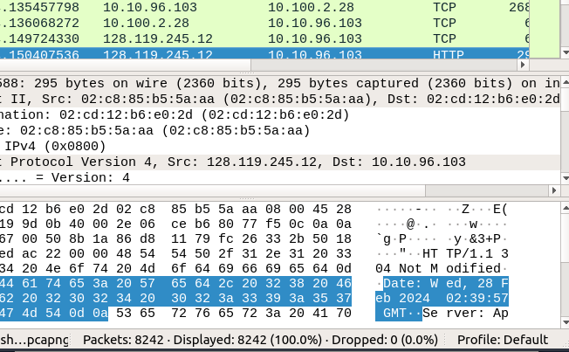

Task 4: HTML Documents with Embedded Objects (10 Points)
Now that we’ve seen how Wireshark displays the captured packet traffic for large HTML files, we can look at what happens when your browser downloads a file with embedded objects, i.e., a file that includes other objects (in the example below, image files) that are stored on another server(s). Do the following:

- Start up your web browser, and make sure your browser’s cache is cleared, as discussed above.
- Start up the Wireshark packet sniffer
- Enter the following URL into your browser http://gaia.cs.umass.edu/wireshark-labs/HTTP-wireshark-file4.html. Your browser should display a short HTML file with two images. These two images are referenced in the base HTML file. That is, the images themselves are not contained in the HTML; instead the URLs for the images are contained in the downloaded HTML file. As discussed in the textbook, your browser will have to retrieve these logos from the indicated web sites. The publisher’s logo is retrieved from the gaia.cs.umass.edu web site. The image of the book cover is stored at the caite.cs.umass.edu server.

- Stop Wireshark packet capture, and enter “http” in the display-filter-specification window, so that only captured HTTP messages will be displayed.

Answer the following questions based on your output:
Question 15: How many HTTP GET request messages did your browser send? To which Internet addresses were these GET requests sent? (Attach screenshot)

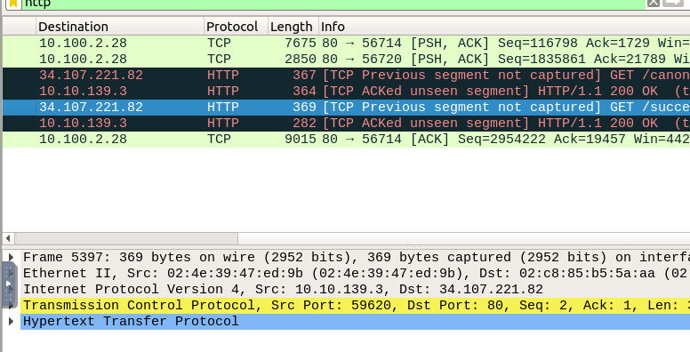

Question 16: Can you tell whether your browser downloaded the two images serially, or whether they were downloaded from the two web sites in parallel? Explain.

It would appear as though these images were downloaded in parallel.
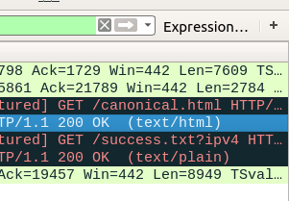

Here, we can see two get messages with one displaying HTML gets and one satisfying the text.

Task 5: HTTP Authentication (10 Points)
Finally, let’s try visiting a web site that is password-protected and examine the sequence of HTTP message exchanged for such a site. The URL http://gaia.cs.umass.edu/wireshark-labs/protected_pages/HTTP-wireshark-file5.html is password protected. The username is “wireshark-students” (without the quotes), and the password is “network” (again, without the quotes). So let’s access this “secure” password-protected site. Do the following:

Make sure your browser’s cache is cleared, as discussed above, and close down your browser. Then, start up your browser

- Start up the Wireshark packet sniffer
- Enter the following URL into your browser http://gaia.cs.umass.edu/wireshark-labs/protected_pages/HTTP-wiresharkfile5.html. Type the requested user name and password into the pop up box and hit enter (You will observe that the requested URL is not found).
- Stop Wireshark packet capture, and enter “http” in the display-filter-specification window, so that only captured HTTP messages will be displayed later in the packet-listing window.

Now let’s examine the Wireshark output. You might want to first read up on HTTP authentication by reviewing the easy-to-read material on “HTTP Access Authentication Framework” at http://frontier.userland.com/stories/storyReader$2159

Answer the following questions:
Question 17: What is the server’s response (status code and phrase) in response to the initial HTTP GET message from your browser? (Attach screenshot). Explain your observations and findings.

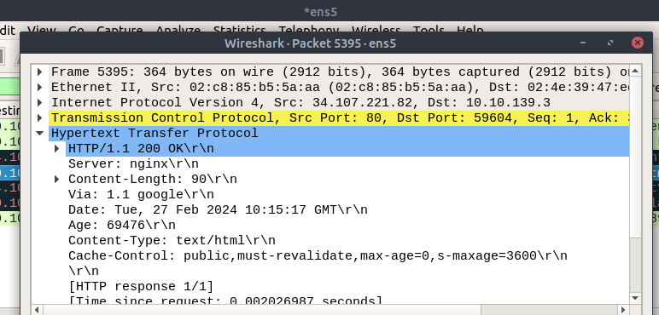

200 ok, This is because the server has accepted the request and will respond with the data requested being transmitted back.

Question 18: When your browser’s sends the HTTP GET message for the second time, what
new field is included in the HTTP GET message? (Attach screenshot). Can you find your credentials in the second GET “Request”. Explain your observation and findings.

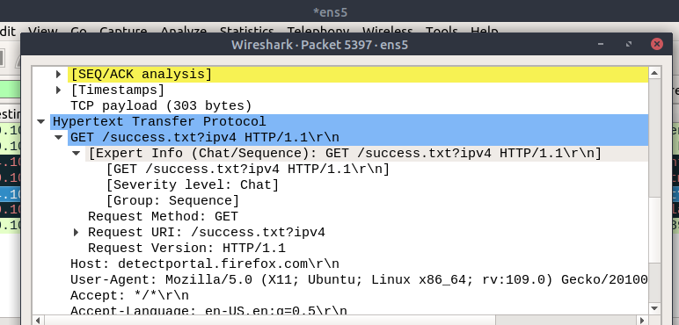

It appears as though these TCP has generated a second layer of information in the form of “Expert Info” which probably is just a bloated term for extended data required to facilitate the connection. Very uncertain about this.

Submission Guideline: Submit a PDF version of your answers on Canvas.

