Jonathon Delemos
CSC139
Dr. Ghassan Shobaki
Assignment 2
Software Testing Document: Multithreading and Synchronization

The purpose of this assignment was to analyze thread creation and synchronization. This multi-threaded program is designed such that user determines the size of an array, the number of threads, and the placement of a zero. The objective with these parameters and the program is to test the amount of time it takes to find the product of the threads. An additional goal is to examine the performance of each approach to multi-threading: parent waits for all children, parent keeps checking on children, and parent waits on a semaphore. Based on the number of threads, we should see different results. Listed down below is a screenshot of the results we gathered.

1. Array size = 100M, T=2, index for zero =50M+1
2. Array size = 100M, T=4, index for zero =75M+1
3. Array size = 100M, T=8, index for zero =88M
4. Array size = 100M, T=2, index for zero =-1 (no zero)
5. Array size = 100M, T=4, index for zero =-1 (no zero)
6. Array size = 100M, T=8, index for zero =-1 (no zero)

RESULTS:
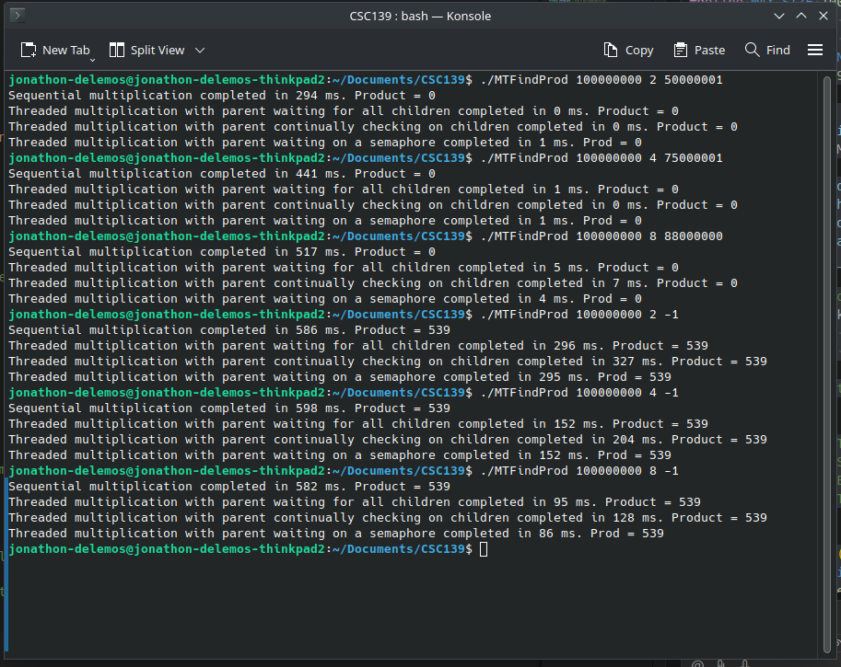

Analysis

1. Test Case #1: 100M 2 5000001

In this case, we have determined the creation of two threads and placed a zero at 50,000,001. For the sequential case, it was determined that the amount of time to find the zero was 294ms. Some test cases reported taking zero seconds. We are confident that some of these results are in fact less than one ms by the additional tests that were conducted.

2. Test Case #2: 100M 4 75000001
In this case, we have determined the creation of four threads and placed a zero at 75,000,001. For the sequential case, it was determined that the amount of time to find the zero was 441ms. Some test cases reported taking zero seconds. We are confident that some of these results are in fact less than one ms by the additional tests that were conducted.

3. Test Case #3: 100M 8 88000001
In this case, we have determined the creation of eight threads and placed a zero at 88,000,001. For the sequential case, it was determined that the amount of time to find the zero was 517 ms. Some test cases reported around 10ms. We are confident that these results are due to early thread cancellation as the zero was placed near the middle of the array.

4. Test Case #4: 100M 2 -1
In this case, we have determined the creation of two threads and no zero is inserted (indexForZero = -1). For the sequential case, it was determined that the amount of time to compute the product was 586ms. The product of the array elements modulo NUM_LIMIT is 539.

5 Test Case #4: 100M 4 -1
In this case, we have determined the creation of four threads and no zero is inserted (indexForZero = -1). For the sequential case, it was determined that the amount of time to compute the product was 598 ms. The product of the array elements modulo NUM_LIMIT is 539.

6. Test Case #5: 100M 8 -1
In this case, we have determined the creation of four threads and no zero is inserted (indexForZero = -1). For the sequential case, it was determined that the amount of time to compute the product was 582 ms. The product of the array elements modulo NUM_LIMIT is 539.

Hardware

These tests were conducted on an Intel I7 with eight cores. The machine is running Ubuntu 22.04 with a KDE-Plasma environment. There is 23.2 GiB of available ram and houses Mesa Intel UHD 620 graphics card. Model number of the physical laptop is 20L70026US. System version ThinkPad T480S.

