

**Experiment**

**2**

1D Motion

|  |
| --- |
|  |

**Introduction**

The quantitative investigation of motion for real-life situations is always complicated by external influences such as friction and the necessity of making measurements (interacting with the system). Ideal theoretical models, which are so useful for discussion purposes, generally cannot be duplicated in the laboratory. In this laboratory exercise, you will look at an example of one-dimensional accelerated motion down an inclined plane. You will soon realize that a careful consideration of external influences along with good experimental technique is essential to the outcome of an experiment. It is highly recommended that you fully understand the procedure before attempting it, and that you always pay close attention to detail.

**Objectives**

**Experimental**

* + - 1. To graphically describe the motion of an accelerated object in one dimension.
      2. To calculate the acceleration due to gravity from measured quantities.
      3. To understand error analysis.
      4. To understand the difference between systematic, random, and personal errors.

**Learning**

To practice making measurements and working with significant figures.

To review and practice the techniques of graphing

To reinforce your understanding of one-dimensional kinematics

#### Theory



Before beginning, be sure that you understand the basic concepts of position, displacement, velocity and acceleration in one dimension, and how they relate to each other. You should also review freefall, and how the displacement mathematically depends on the acceleration due to gravity (refer to derivation in your textbook).

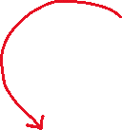

1. Define the terms displacement, position, velocity, and acceleration using complete sentences.

2. Prove that the average velocity in a time interval from t1 to t2=t1+t is equal to the instantaneous velocity in the middle of the time interval between t1 and t2 {*e.g.* (t1+ t2)/2} for an object moving at constant acceleration.

3. Starting with the expressions for average acceleration (refer to your textbook), average velocity at constant acceleration; algebraically (NO CALCULUS) derive the equation for one-dimensional motion that relates displacement to the constant acceleration and time.

**Δx** = _____________________________________



## Procedure



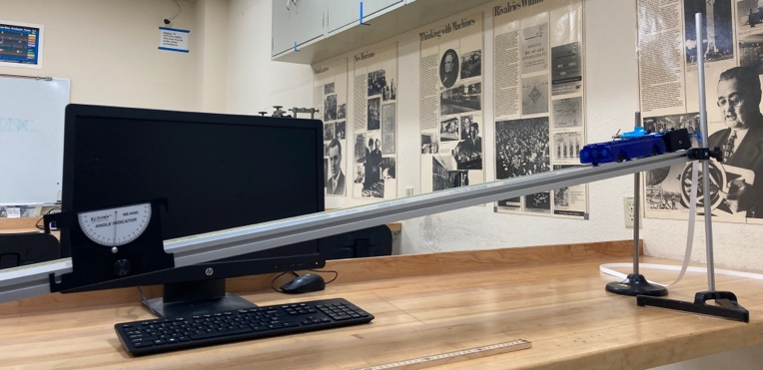



Fig 1: Photo of experimental set-up.

1. Locate the experimental setup and check to see that it is set up correctly.
2. Measure and record the angle the incline makes with the horizontal.
3. Cut a piece of paper tape as long as the distance between the timer and the end of the incline.
4. Attach the paper tape to the cart.
5. Thread the other end of the paper tape through the tape timer with the cart at the top of the incline.
6. Set the Timer to 40Hz and turn it on.
7. Release the cart being careful to allow the tape to thread smoothly through the timer.
8. Tape the paper tape to a table and measure the position of the dots. Don’t use the first dot because the mass may not have begun to move when the dot was made. Record the data in Table 1.

Note: Only one strip of tape is needed for each group. The tape is costly and inconvenient to purchase, so please do not waste it.



**Data & Analysis:**



x0 x1 x2 x3 x4 x5

. . . . . .



Fig 2: schematic of data tape with location marks



Using the above representation of your data tape as a reference and the formulas below, the concepts you proved in Theory section, complete Table 1 and Table 2. Notice that column entries are staggered. This is to make it easier to see which two values to the left of an entry were used to calculate that entry. For example, Δx1 was calculated from x1 and x0. Also notice that the values of both vavg and a are average values for their respective intervals.



Displacement: Δx1 = x1 - x0 , Δx2 = x2 - x1 , etc.

Average Velocity: vavg1 = Δx1 /Δt , vavg2 = Δx2 /Δt , etc.

Change in Velocity: Δv1 = v2 - v1 , etc.

Acceleration: a1 = Δv1 /Δt , a2 = Δv2 /Δt , etc.

Instantaneous V V1=Vavg1 at t1 +t/2, V2=Vavg2 at t2 +t/2 (Table 2)



# θ = _______



# Table 1: Position & Time Data



|  |  |  |  |
| --- | --- | --- | --- |
| **t (s)** | **x (cm)** | **Δx (cm)** | **Vavg (cm/s)** |
|  |  |  |  |
|  |  |
|  |  |
|  |  |
|  |  |
|  |  |
|  |  |
|  |  |
|  |  |
|  |  |
|  |  |
|  |  |
|  |  |
|  |  |
|  |  |
|  |  |
|  |  |
|  |  |
|  |  |
|  |  |
|  |  |
|  |  |
|  |  |
|  |  |
|  |  |
|  |  |
|  |  |
|  |  |
|  |  |
|  |  |
|  |  |
|  |  |
|  |  |
|  |  |

# Table 2: Velocity & Time Data

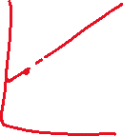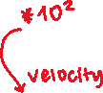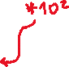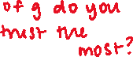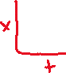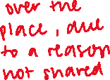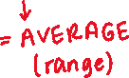

|  |  |  |  |
| --- | --- | --- | --- |
| **t (s)** | **V (cm/s)** | **ΔV (cm/s)** | **a(cm/s2)** |
|  |  |  |  |
|  |  |
|  |  |
|  |  |
|  |  |
|  |  |
|  |  |
|  |  |
|  |  |
|  |  |
|  |  |
|  |  |
|  |  |
|  |  |
|  |  |
|  |  |
|  |  |
|  |  |
|  |  |
|  |  |
|  |  |
|  |  |
|  |  |
|  |  |
|  |  |
|  |  |
|  |  |
|  |  |
|  |  |
|  |  |
|  |  |
|  |  |
|  |  |
|  |  |

**Graphical Presentation of Data:** You are to construct the following two graphs that are to be attached to this report (Remember to follow the “Rules of Graphing”):

1. Position vs. Time

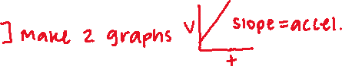

1. Instantaneous Velocity vs. Time



1. Perform a “fit” to your data for the position vs time graph and determine the object’s acceleration along with the uncertainty in its value, and the object’s initial velocity along with the uncertainty in its value. Record these values in Table 3. You should only keep one significant figure for the uncertainty. **How many significant figures should you report for your value of the acceleration and the initial velocity?** *Paste your graph below.*



1. “Fit” your data in the instantaneous velocity vs time graph and determine the acceleration along with the uncertainty in its value, and initial velocity from the fit parameters. Record these values in Table 3. You should only keep one significant figure for the uncertainty. **How many significant figures should you report for your value of the acceleration and the initial velocity?** *Paste your graph below.*

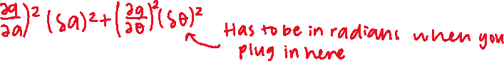

1. From the acceleration data in Table 2, calculate the average acceleration, its standard deviation (s), and the precision of the mean. Record these values in Table 3.



1. Free body analysis of the set up predicts that the acceleration is related to gravitational acceleration by:

,

Where, g is the acceleration due to gravity and θ, is the angle the incline makes with the horizontal.



## Results



Report the extracted values of g (one from each graph) in the table below and calculate the percentage of the error (gRocklin = 9.8006 m/s2). Show your work for the percent error calculation below.

**Table 3: Results for Initial Velocity and Acceleration**

|  |  |  |  |  |  |
| --- | --- | --- | --- | --- | --- |
|  | **Initial Velocity (m/s)** | **Uncertainty (m/s)** | **a (m/s2)** | **Uncertainty**  **(m/s2)** | **% error with g** |
| Quadratic Fit (x vs. t plot) |  |  |  |  |  |
| Linear Fit  (v vs. t plot) |  |  |  |  |  |
| Average from Table 2 |  |  |  |  |  |

### Conclusion

* + - 1. Does the velocity vs. time graph, indicate that the acceleration of the falling mass is constant? Explain?
      2. Why is your measured initial velocity not equal to zero?
      3. State which of the values in the third column in Table 3 is most reliable. Explain.
      4. Use error propagation to determine the uncertainty in your calculation of g for each case. Do the values agree with each other, and do they agree with the accepted value?
      5. What is the purpose of comparing the value of a measured physical quantity to a value we trust?
      6. List and explain the random and systematic errors in your experiment. How can you determine the dominant source of error (random or systematic) in your experiment?

