**Experiment**

**4**

# Centripetal Force

|  |
| --- |
|  |

**Introduction:** The application of Newton's 2nd law to uniform circular motion is a logical extension of the physics developed so far. The result is an important equation that explains circular motion and is therefore essential to problems involving this very common behavior. In this laboratory exercise, you will verify the validity of this equation and thus become more familiar with uniform circular motion.

**Theory:**

1.Derive an equation for centripetal acceleration starting with a particle moving with constant speed in a circle of radius r. In the space provided utilize vector calculus to derive this expression in detail. Be sure to include a detailed diagram in your derivation.

$$\vec{a_{c}}=\frac{-v^{2}}{r}\left(cosθ\hat{ i}+sinθ \hat{j}\right)$$

**Visual Diagram Derived Equation**

*Given we can find velocity from $\frac{2πr}{T}$, where T Is the time period, we can find centripetal acceleration from*

$$\frac{{\left(v_{t}\right)}^{2}}{r}$$

*Substituting:*

$$\frac{{\left(\frac{2πr}{T}\right)}^{2}}{r}$$

*We know all of those values and can calculate for centripetal acceleration quite easily.*

*Applying vector notation to the formula to find vertical $sinθj ̂$ and horizontal location $cosθi ̂$ we find*

$$\overline{a_{c}}=\frac{-{\left(\frac{2πr}{T}\right)}^{2}}{R}*cos\hat{θi}+sinθj ̂$$

Tension

$$net force$$

$$M_{bob}*g$$



Spring force

$${FA}_{c}=\frac{mV_{t}^{2}}{r}$$

**Vertical Diagram**

Net Force

$M_{bob}$

Radius

2. Derive the expression for the magnitude of the centripetal force as a function of the period of motion and the radius of the orbit for a particle undergoing uniform circular motion given the mass m is known.

$$F= \frac{mv^{2}}{r}$$

$$v= \frac{2πr}{T}$$

Substituting v into the expression for centripetal force

$$F= \frac{m{\left(\frac{2πr}{T}\right)}^{2}}{r}$$

Simplifying

$$F= \frac{4π^{2}mr}{T^{2}}$$

**Apparatus:** As usual, the following equipment will be awaiting you in the lab. Be sure to check its condition carefully before beginning and report any problems. Also, be sure to leave the equipment as you would like to have found it ("Do unto others... ").

1. Beck Centripetal Force Unit.
2. Stop watch.
3. Centimeter caliper and meter stick equipped with slide on caliper jaws.
4. Mass hanger with a set of standard masses.
5. Masking tape and scissors.

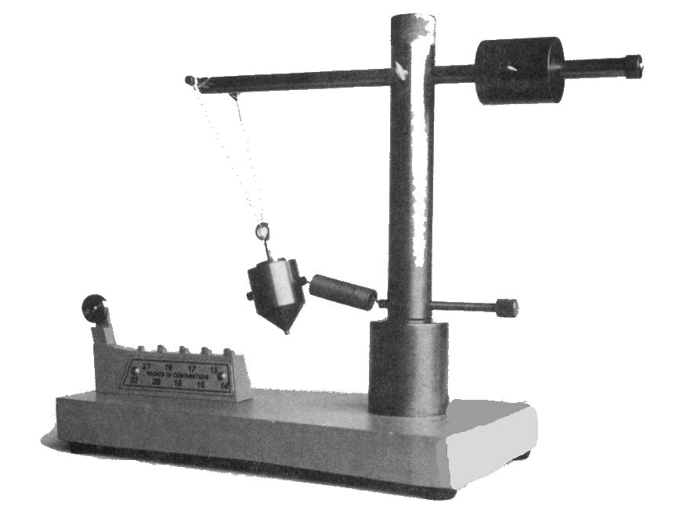

**Procedure:**

1. The position of the bifilar (two-threaded) pendulum bob is critical to your success. The first requirement is that when hanging vertically (spring removed), the tip of the bob be positioned directly over the indicated tooth (radially outward) of the position indicator. The second requirement is that the spring be horizontal so that the spring force acts only along the radius of the circular path. There must not be any spring force component acting vertically. Examine the apparatus carefully and make any necessary adjustments.
2. To make it easier to position the bob while being rotated, fasten a fold of masking tape over the indicated tooth of the position indicator in such a way that when rotated, the tip of the bob just hits the tape. The portion of the tape extending above the tooth should be cut to the thickness of the tooth, and thus be an extension of it. When rotated to the correct radius then, you should hear the bob's tip hitting the tape with a constant frequency. This is a better way to monitor the bob's position than by visual inspection.

**Procedure**, continued:

3. Rotate the bob as indicated above, and practice maintaining its position for an extended period (20 or so revolutions). Now, using the stopwatch, time five trials of 20 revolutions and enter the data below.

1. Connect the mass hanger to the bob via the Atwood machine and the special hook that comes with the Beck unit and load the hanger with mass until the bob is positioned over the indicated tooth. Measure the total hanging mass (MH) used on the centigram balance and record below. To obtain more than one value, each member of your lab group should measure the hanging mass independently.
2. Measure and record the mass of the bob (Mbob).
3. Now measure and record the diameter of the shaft, the distance from the shaft to the middle of the indicated tooth, the width of the tape and the width of the “bob” using the calipers and the meter stick with caliper jaws.

**Data and Results:**

**Table 1: Measured & Derived Spinning Data**

|  |  |  |  |  |
| --- | --- | --- | --- | --- |
| Trial # | Time (s)  (20 Rev) | Time (s)  (1 Rev) | Fc  (N) | % Diff. |
| 1 | 10.57 | 0.528 | 7.9 | -1.0 |
| 2 | 10.45 | 0.522 | 8.1 | -3.3 |
| 3 | 10.96 | 0.548 | 7.3 | 6.2 |
| 4 | 10.91 | 0.545 | 7.4 | 5.3 |
| 5 | 10.84 | 0.542 | 7.5 | 4.0 |
| Mean |  | 0.537 | 7.6 |  |
| δ (uncertainty) |  | 0.005 | 0.1 |  |

|  |  |
| --- | --- |
| **Person #** | **Hanging Mass (kg)** |
| 1 | 0.80012 |
| 2 | 0.85002 |
| 3 | 0.80021 |
| Mean | 0.81678 |

**Miscellaneous Data**:

Mbob = 0.35708 kg

Shaft Diameter = 0.02851 m

Distance, Shaft to indicated Tooth = 0.1291 m

Tape width = ______.005604 cm_

Bob tip “width” = ___.0048 cm_

**Table 2: Hanging Mass**

**Analysis: (Show All Calculations)**

1. Calculate the radius of motion from the measured distances. From the measured tape and bob width, calculate the uncertainty in the radius for the bob’s path. (Show Calculations)

r = _ 0.162 M_____________

**δr** = 0.005_M____________

Radius and Uncertainty

$$R= .1339+ .02851=.162m$$

$δR=\frac{.0048+.005604}{2}$ =.005m

Example:

$$R_{m}=\frac{Dis_{bobwidth}}{2}+\frac{Dis_{tape}}{2}+Distance_{Shaft}$$

$$R_{m}= -\frac{Dis_{bobwidth}}{2}-\frac{Dis_{tape}}{2}+Distance_{Shaft}$$

Performed Calculations:

$R_{m_{i}}=\frac{.0048}{2}+\frac{.005604}{2} + .1624=$ 0.1676 m

$$R_{m_{a}}= -\frac{.0048}{2}-\frac{.005604}{2} + .1624= 0.1571 m$$

1. Calculate the net force acting on the pendulum bob (Fc) using the expression from part 2 of the Theory section. Enter the value for each trial in the table. Calculate the average and uncertainty δFc and report in the table.

Uncertainty Calculations

3. From the average value of the hanging mass MH, calculate the force the spring exerts on the bob when it is directly over the indicated tooth.

Fg = ___8.004

$$-kx+m_{h}*g=0$$



$$-k*1.62+ .802*9.8=0$$



$$δF_{g}=\sqrt{ {\left(\frac{∂F_{g}}{∂m}\right)}^{2}{\left(δm\right)}^{2}+{\left(\frac{∂F_{g}}{∂g}\right)}^{2}{\left(δg\right)}^{2} } \\ =\sqrt{{.9.8}^{2} {\left(.0001\right)}^{2}+{\left(.81678\right)}^{2} {\left(.0001\right)}^{2} }$$



$$F_{g}=8.004±.0001$$

___________

1. Calculate the % difference between the Fc and Fg for each trial and enter the value in the table.

Work Shown:

$$\frac{First Value-Second Value }{(First Value + Second Value)/2} × 100\%$$

$$\frac{8.0044-8.088}{(\frac{8.0044+8.088}{2})}*100\%=1\%$$

1. Propagate the error in Fc to calculate the theoretical error. Show your work.

**δ Fc = ____.4__________**

Work Shown

$$δF_{c}=\sqrt{\begin{aligned} {\left(\frac{∂F_{c}}{∂m}\right)}^{2}{\left(δm\right)}^{2}+{\left(\frac{∂F_{c}}{∂T}\right)}^{2}{\left(δT\right)}^{2}+{\left(\frac{∂F_{c}}{∂r}\right)}^{2}{\left(δr\right)}^{2} \\ \end{aligned}}$$

$δF_{c}=\sqrt{\begin{aligned} {\left(\frac{4π^{2}r}{T^{2}}\right)}^{2}{\left(δm\right)}^{2}+{\left(\frac{-8π^{2}mr}{T^{3}}\right)}^{2}{\left(δT\right)}^{2}+{\left(\frac{4π^{2}m}{T^{2}}\right)}^{2}{\left(δr\right)}^{2} \\ \end{aligned}}$

$δF_{c}=\sqrt{\begin{aligned} {\left(\frac{4π^{2}r}{T^{2}}\right)}^{2}{\left(δm\right)}^{2}+{\left(\frac{-8π^{2}mr}{T^{3}}\right)}^{2}{\left(.005\right)}^{2}+{\left(\frac{4π^{2}m}{T^{2}}\right)}^{2}{\left(δ.005\right)}^{2} \\ \end{aligned}}$

$$δF_{c}= 0.393845$$

**Conclusions and Error Analysis**: Write a formal conclusion being sure to touch on each of the following items.

1. List the sources of experimental error specifying systematic or random.
   1. The sources of systematic error exist in the form of the consistency of the user spinning the device, the spring maintaining constant strength throughout the experiment, and the tension in the string not being accounted for.
   2. Random errors occur in the form of human reaction time. Reaction time varies for every individual and varies within each measured event. Reaction time for event one by person A may be different than reaction time of person A in event two.
2. Comparing the values of Fc and Fg, is the overall error random or systematic?
   1. The values of $F_{c} and F_{g}$ are $7.6± .1 and 8.004± .0001$. These values have been calculated to reflect the uncertainty of the average value for each of these forces. Due to the fact these values do not coexist the errors are random. They do not conflict with each other. If the values were to interfere at any point in time the errors would be systematic.
3. Report the average period with its uncertainty (T ± δT).

Using the time values, we calculated the average period by summing these values and dividing the total number of data points calculated for.

|  |
| --- |
| * 1. 0.5285 |
| * 1. 0.5225 |
| * 1. 0.548 |
| * 1. 0.5455 |
| * 1. 0.542 |

Mean = 0.537

To find uncertainty, we used an excel formula which will be listed here.

=(STDEV.S(C2:C6)/SQRT(5)), and reported the value to be

Uncertainty = 0.005

1. Report the radius with its uncertainty (r ± δr).

To report the radius, we measured multiple segments of the apparatus using vernier calipers and a ruler. Adding these components together we were able to determine a value for the radius of the system. Repeating this process multiple times allowed us to calculate for uncertainty by dividing the components. We found the radius values to be:

|  |
| --- |
| 0.16241 |
| 0.16231 |
| 0.16341 |
| 0.16221 |
| 0.16181 |

To find the uncertainty, we calculated for the width of the bob tip and the width of the tape and divided the two values by two.

$δR=\frac{.0048+.005604}{2}$ =.005m

1. Compare the theoretical uncertainty calculated in step 5 above with the uncertainty calculated from the standard deviation of the average for Fc in Analysis step 2. Should they be the same? Explain.

Theoretically they should not be the same. We are not accounting for everything that exists within the system. Air resistance and string tension are not accounted for. We are not factoring in deficiencies in the system.