FRCA Election App — User Guide for Consistory

A step-by-step guide for running office-bearer elections using the Election App.

Overview
The FRCA Election App lets brothers vote on their phones over a local WiFi network during congregational elections for elders and deacons. It runs on a single laptop — no internet required.
Key features: - Digital voting on phones via unique one-time codes (auto-generated) - Paper ballots accepted alongside digital voting (chairman counts and enters totals afterwards) - Postal vote support (Round 1 only) - Live tally on a projector display, with Article 6a/6b threshold ticks - Multi-round elections with chairman-driven candidate carry-forward - Voter audit log of every code attempt (accepted, rejected, used twice) - Election minutes DOCX, with full round-by-round narration - Compliant with the FRCA Rules for the Election of Office Bearers

Before Election Day

1. First-time setup
When you first open the admin panel a setup wizard guides you through:
- Congregation name — shown on every page and PDF
- Short name — used in PDF filenames
- WiFi network name (SSID) and password — printed on every code slip so voters know which network to join
- Voting Base URL — encoded in the QR code on every slip; for most congregations the default http://church.vote is right
- Admin password — change from the default; at least 6 characters
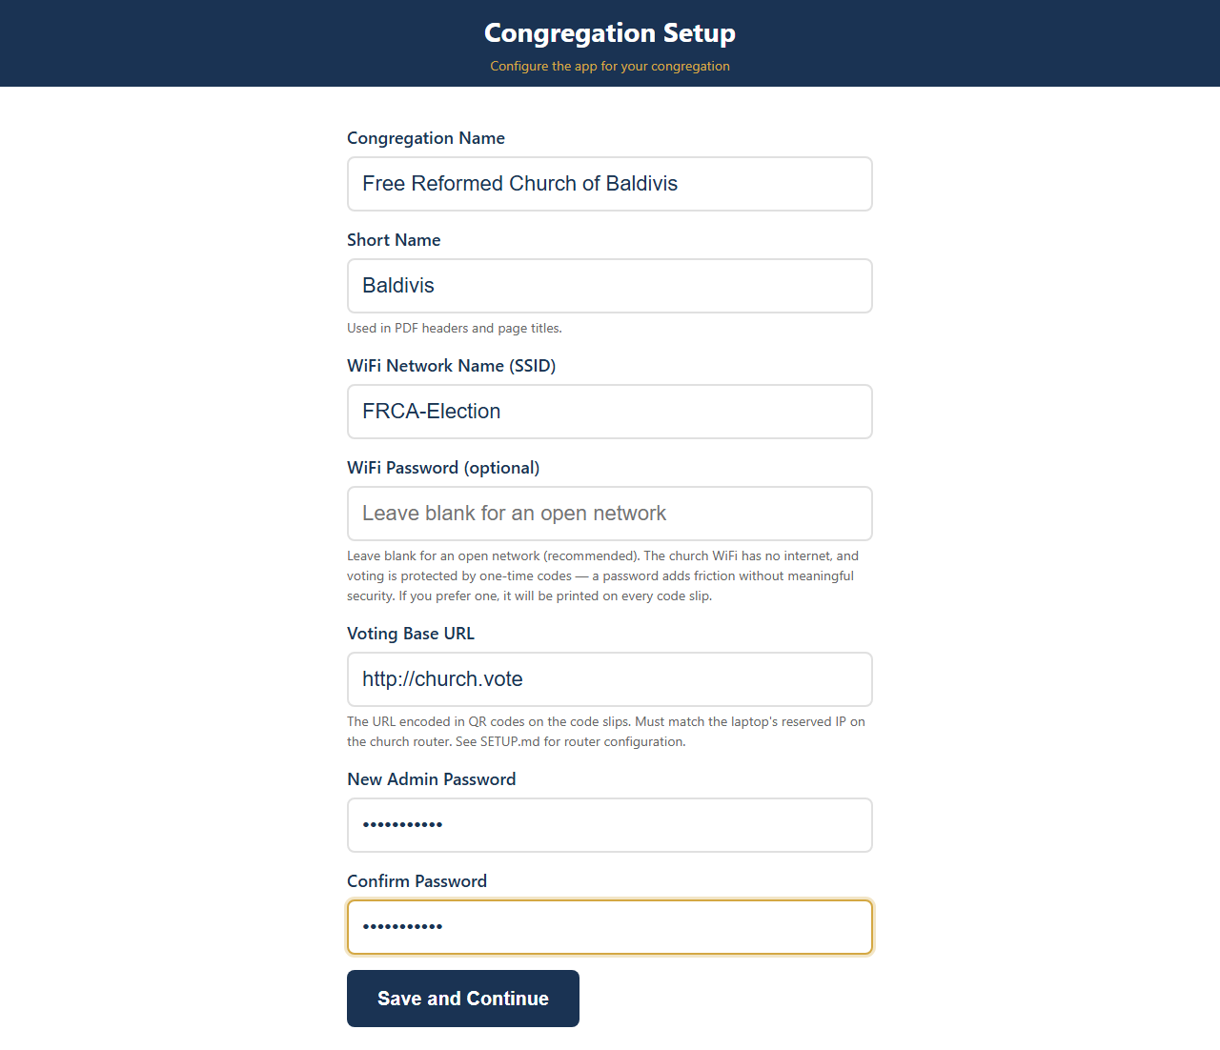
Setup Wizard
Tip: The Settings page can be re-opened from the dashboard at any time. Existing values are pre-filled, and the password fields can be left blank to keep the existing password.

2. Maintain the member list
The dashboard reads top-to-bottom as a three-step flow. Step 2, Attendance Lists, opens the member directory.
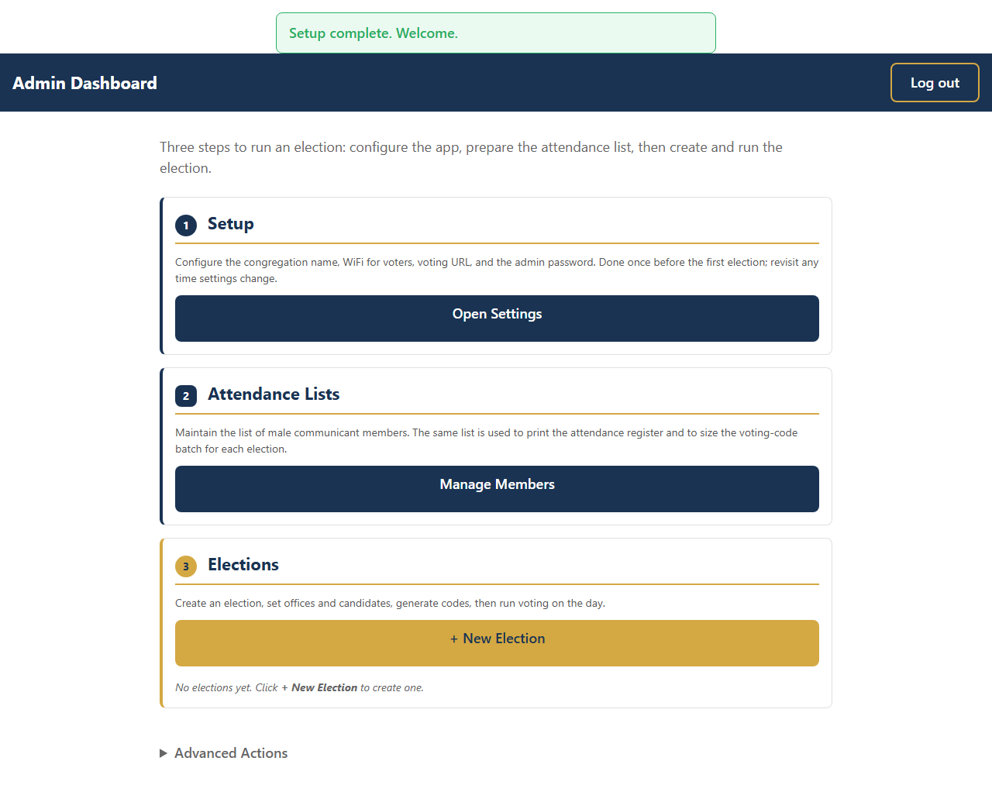
Dashboard — empty
You can import a CSV (e.g. exported from Church Social) of male communicant members. The same list is used to print the attendance register and to size the voting-code batch for each election.

3. Create an election
Step 3 on the dashboard, Elections, has a + New Election button.
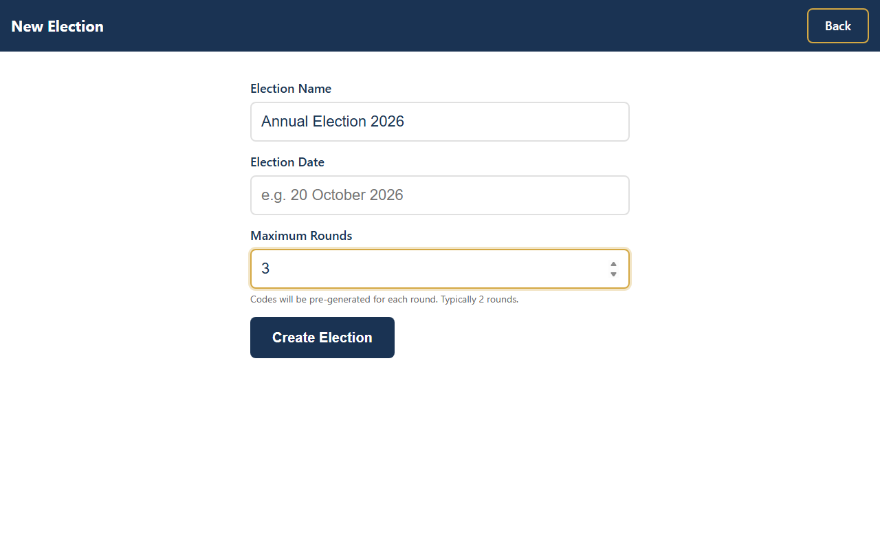
Create Election
- Election name — e.g. “Annual Election 2026”
- Maximum rounds — a hint only; no longer a hard cap (Article 7 determines when the election concludes)
- Election date — for the minutes header

4. Add offices and candidates
Click Offices & Candidates on the new election to add each office (Elder, Deacon) with:
- Number of vacancies
- Candidates — type each name; press Enter to commit it as a tag
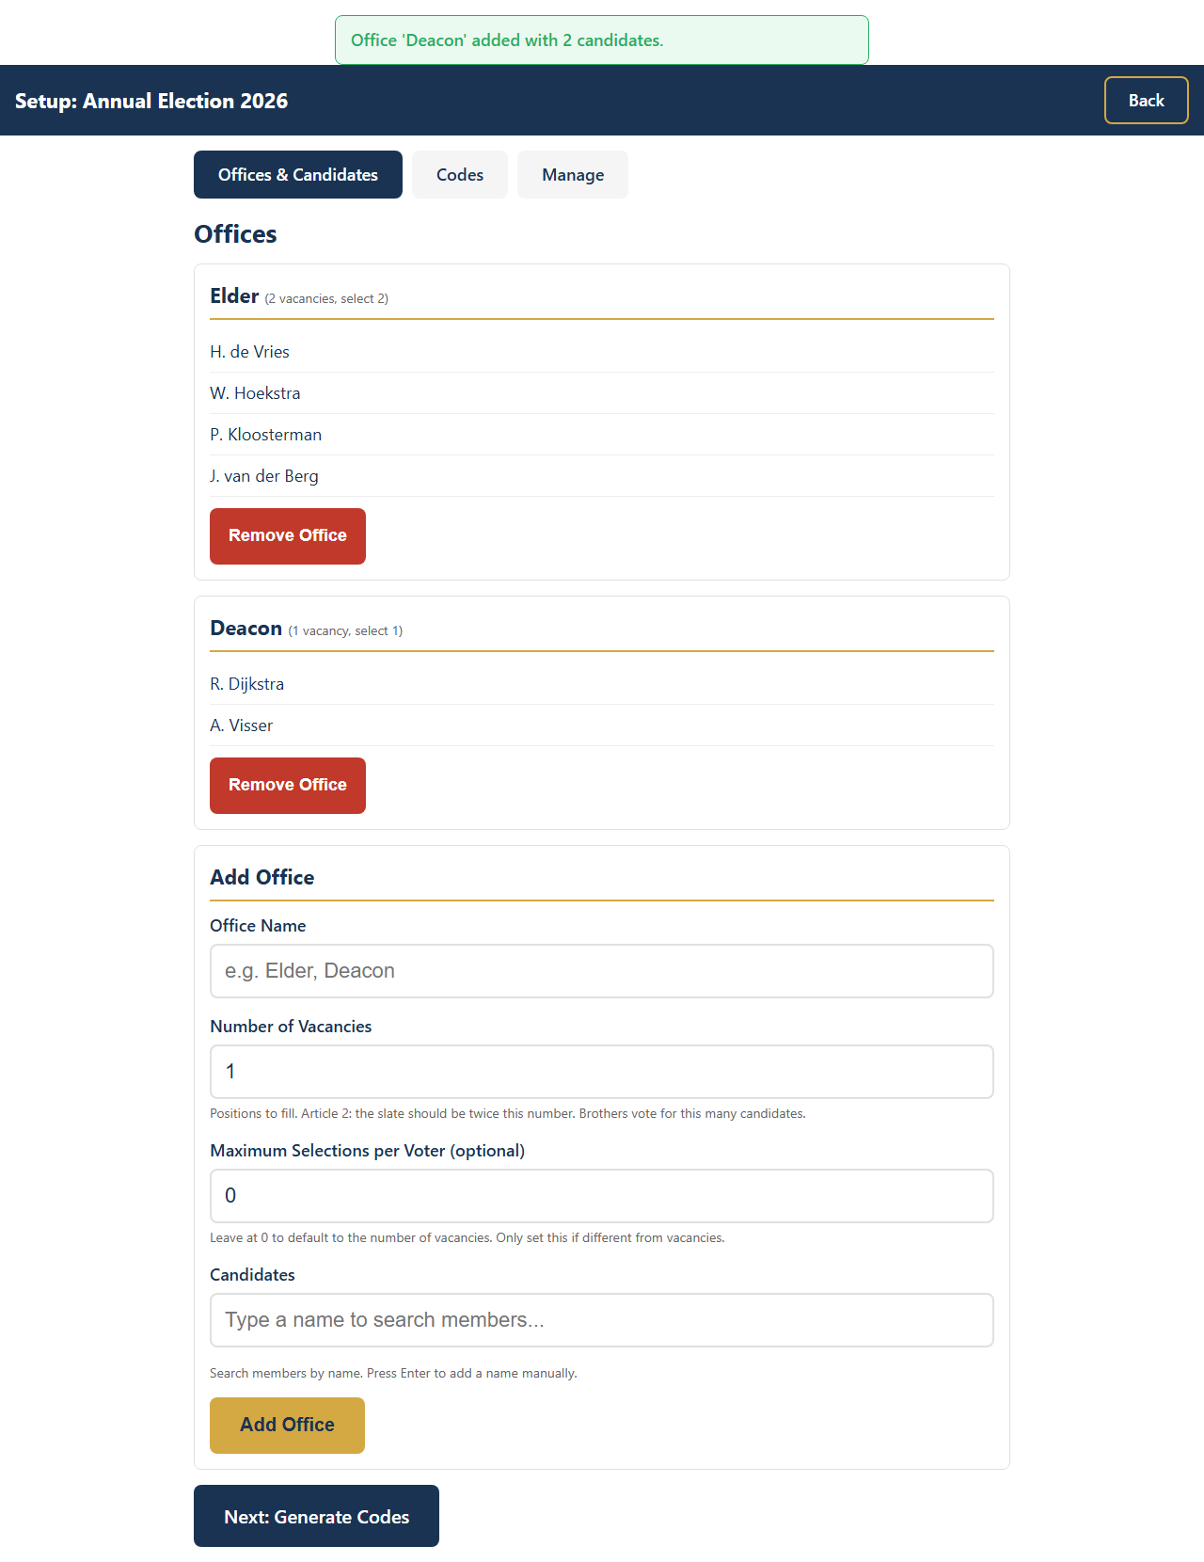
Offices & Candidates
Article 2 compliance: the app warns if the slate is not exactly twice the number of vacancies. You can proceed under Article 13 with explicit confirmation.

5. Voting codes are generated automatically
Click Codes in the election nav. The app auto-generates enough codes for every member across the maximum number of rounds, plus spares. No manual generation step is needed.
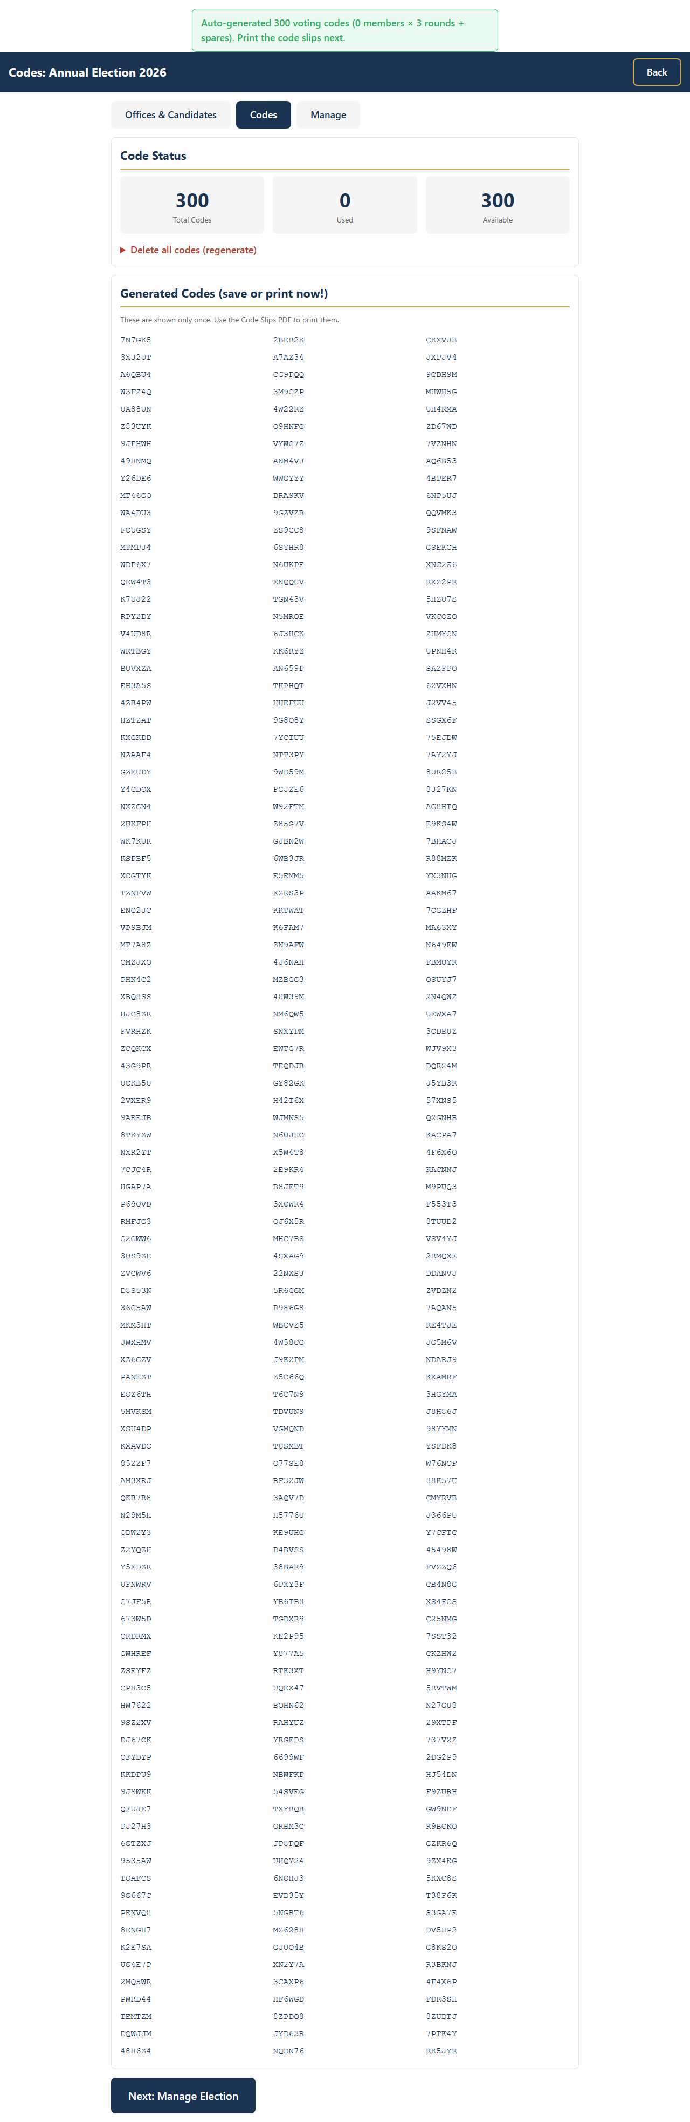
Codes
Important: The codes shown immediately after generation are the only time the plaintext is visible. Print the slips before leaving the page.
The codes page guards against accidental regeneration after voting starts: the Delete All Codes action requires typing the election name and re-entering the admin password. If you re-print, the already-printed slips become invalid — protect printed slips like ballots.

6. Print the materials
On the Manage tab, Step 1 — Before the meeting has the print-ahead pack:
- Printer Pack ZIP (recommended) — contains everything in one bundle
- Attendance Register PDF
- Voting Codes link (back to the codes page above)
- More formats disclosure for individual PDFs (counter sheet, dual-sided ballots, paper ballot, dual-ballot handout, code slips)

7. Enter postal votes (if any)
Still in Step 1, Postal votes has buttons to Enter Postal Votes (Round 1) and a Postal Tally Helper. Postal votes count only in Round 1. They are added to the Round 1 totals before thresholds are calculated.

Election Day

8. Sign the attendance register
As brothers arrive, have them sign the printed attendance register. The total is needed for the Article 6b threshold (participants × 2/5).

9. Open the meeting
In the Manage tab, Step 2 — Opening the meeting is now the active card. It contains:
- The projector display stepper (Welcome → Election Rules → Voting)
- An Open Display link to launch the projector view in a new tab
- An Attendance input — enter the Brothers Present count from the register and click Save. (The paper-ballot count is entered later in Step 4 once the ballots are physically collected.)
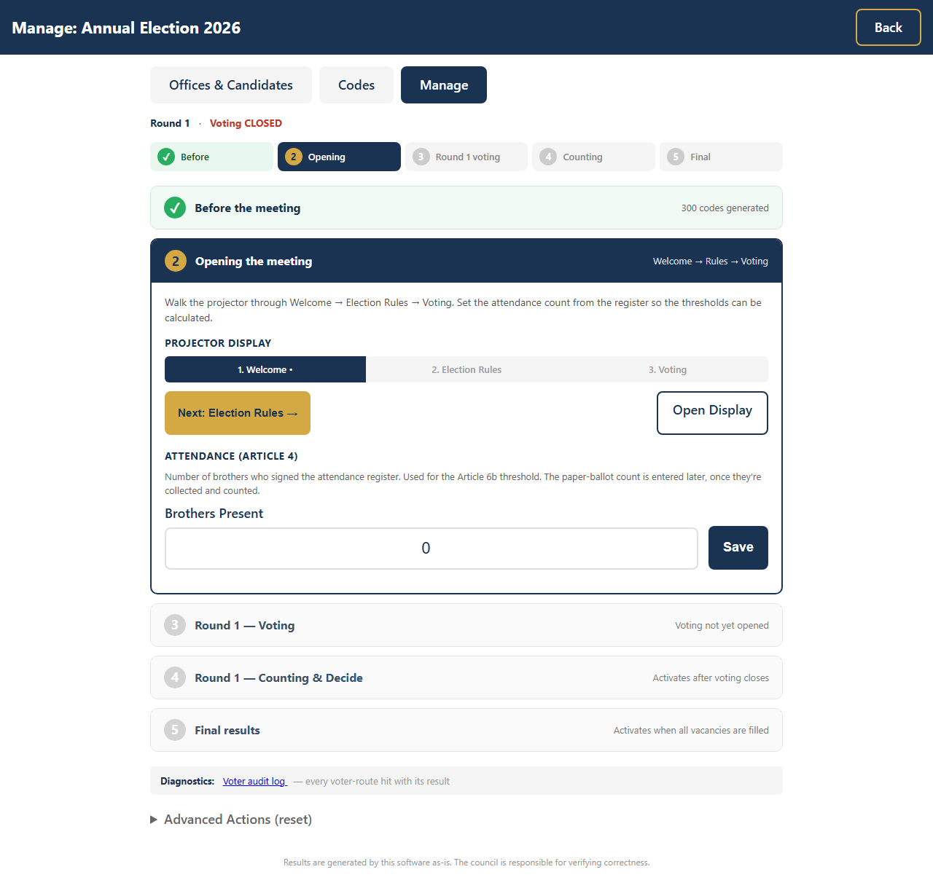
Manage — before voting
Walk the projector through the phases:
- Welcome — congregation header (default on first load)
- Next: Election Rules → — projector now shows the slate and Articles 4, 6, and 12 for the secretary to read aloud
- Next: Open Voting → — opens voting and switches the projector to the live ballot view

10. Hand out codes (or paper ballots)
At the door, hand each brother either a code slip or a paper ballot. Keep both stacks separate. Brothers who voted digitally must not also hand in a paper ballot.

11. How brothers vote
A brother connects to the church WiFi, then opens the voting URL printed on the slip (or scans the QR code).
Step 1: Enter the 6-character code (or arrive via QR).
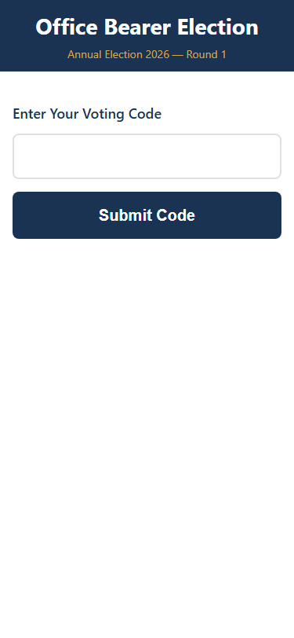
Enter code
Step 2: Tick candidates for each office, up to the allowed number.
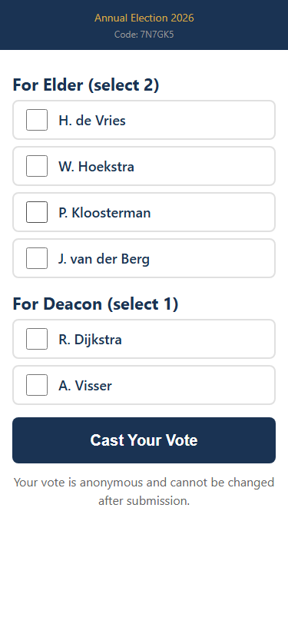
Ballot
Step 3: Tap Cast Your Vote. The code is burned immediately and cannot be reused. The vote is recorded anonymously — no link from code to vote exists in the database.
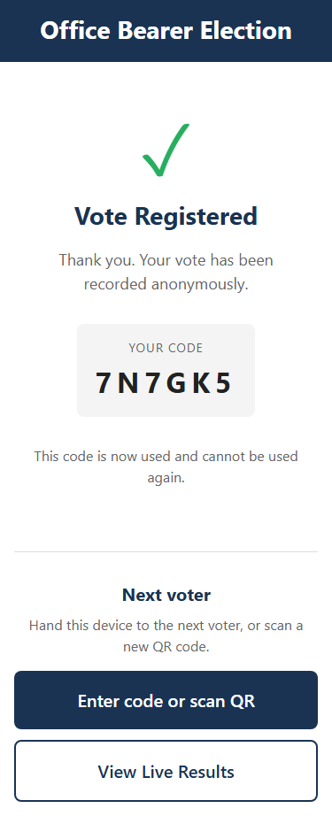
Confirmation
The confirmation page displays the burned code and a clear “Next voter” button so a phone can be passed along without confusion.
Partial ballots: under-voting is allowed but the app warns first. The brother must confirm before the partial ballot is cast.

12. Monitor progress
Step 3 of the Manage page becomes active while voting is open. It shows:
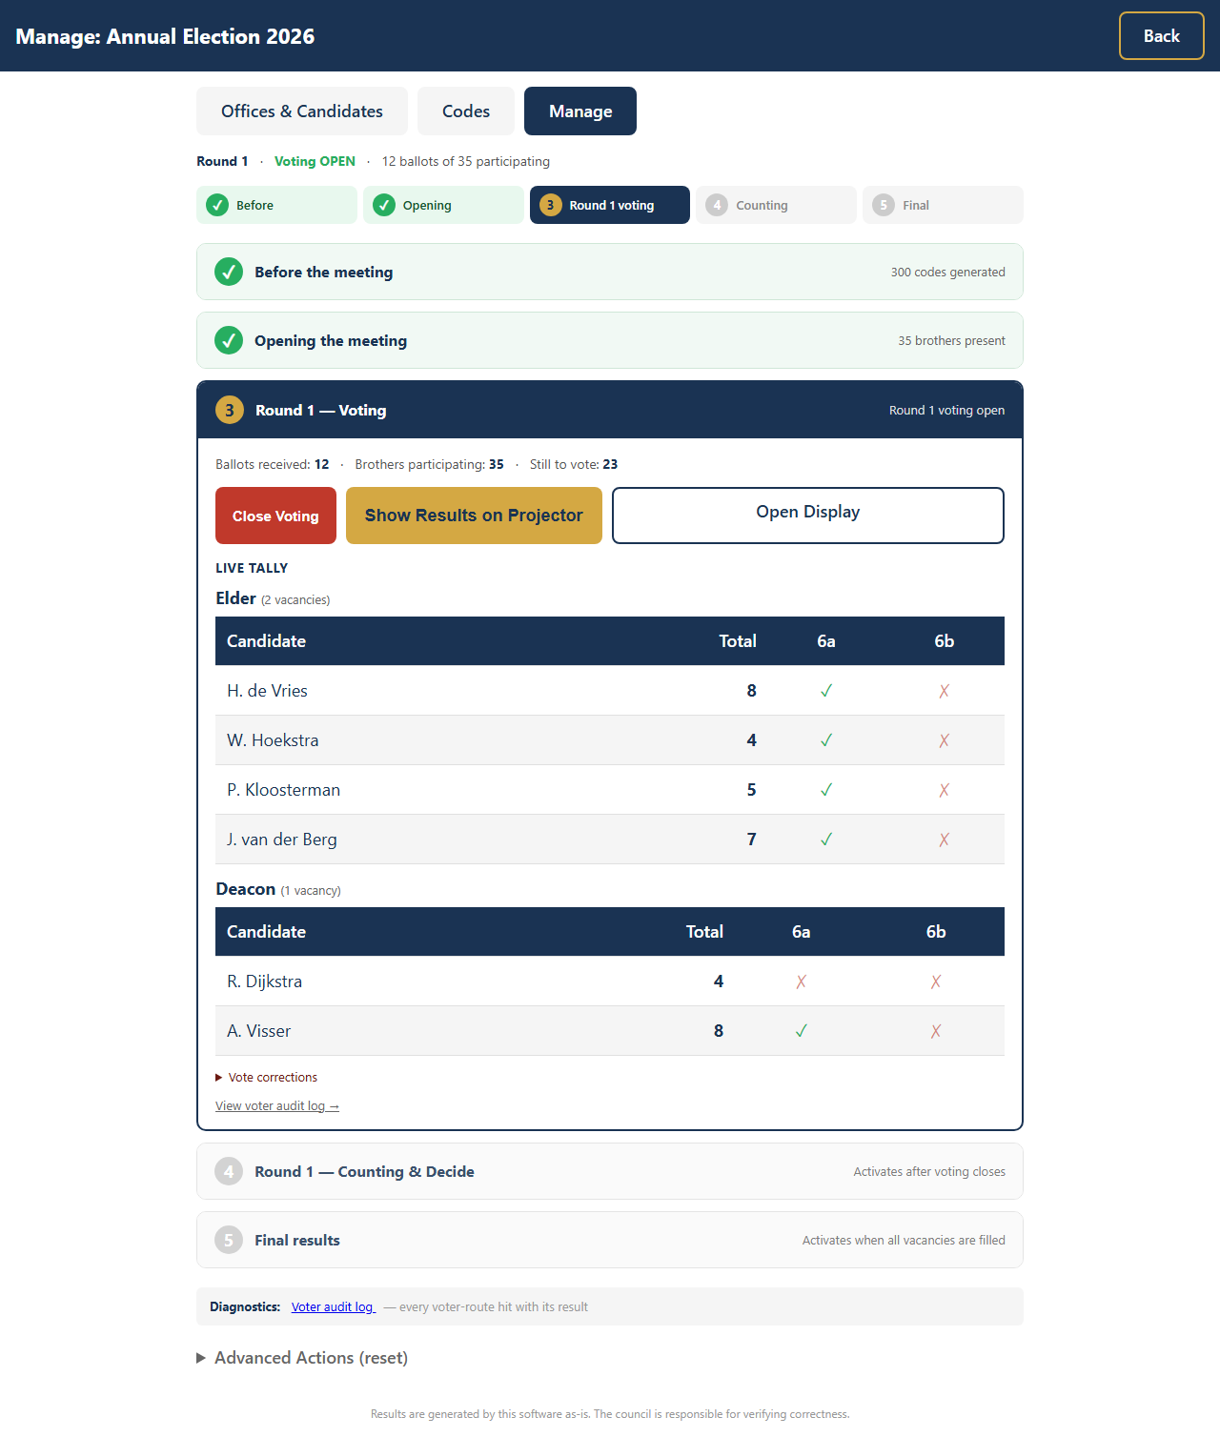
Live tally
- Big counters: ballots received, brothers participating, still to vote
- A live per-office tally with green ✓ or red ✗ marks against Articles 6a and 6b for each candidate
- Hide / Show Results on Projector — by default the audience does not see live counts during voting
- A red Ballot anomaly banner if more ballots come in than there are participants (e.g. someone voted online and also handed in paper)
- Vote corrections disclosure — roll back the most recent digital submission if needed (the code stays burned)
The projector display shows a progress bar and Article 6 thresholds.
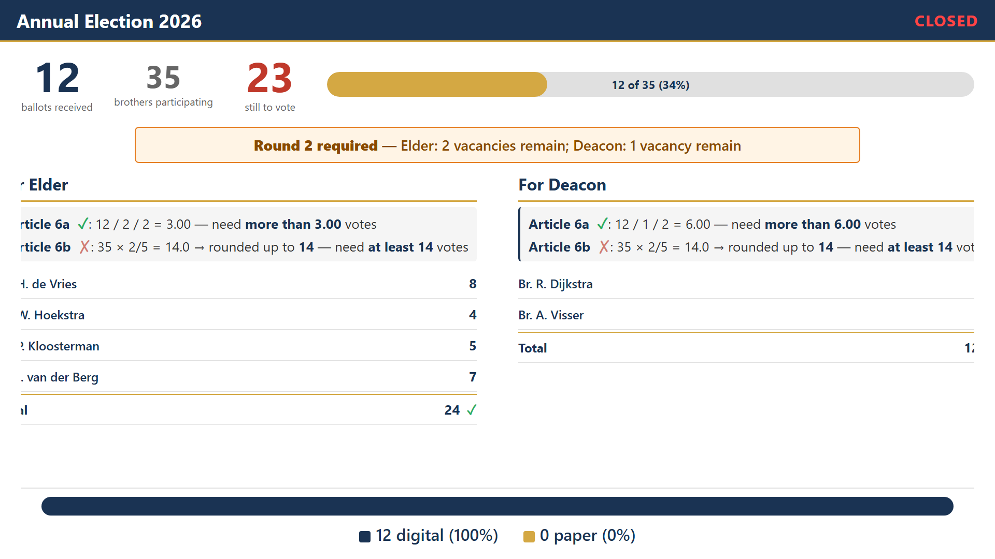
Projector

13. Close voting
Click Close Voting in Step 3. Step 4 — Counting & Decide — now becomes the active card.
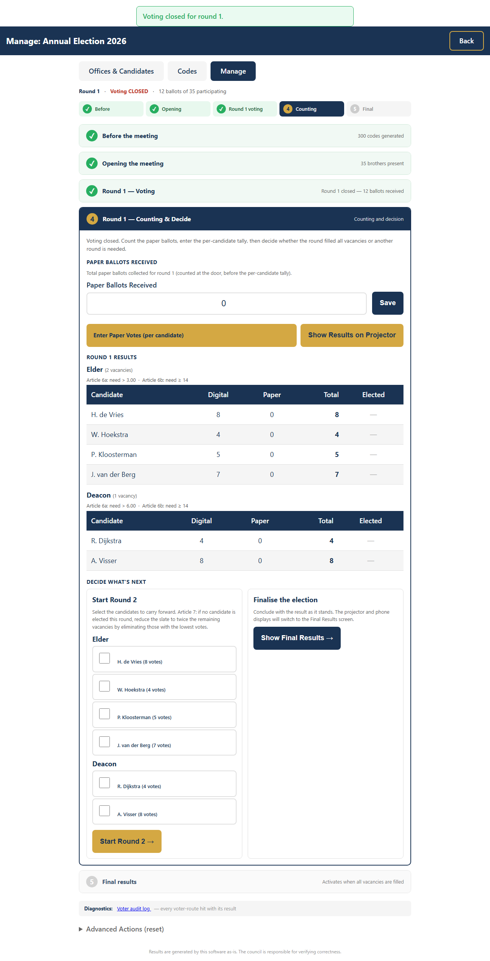
Counting & decide

After Voting Closes

14. Enter the paper-ballot count
Have at least two brothers count the paper ballots together. In Step 4, enter the Paper Ballots Received total and click Save. (Per- candidate paper tallies are entered separately in the next step.)

15. Enter per-candidate paper votes
Click Enter Paper Votes (per candidate) in Step 4. Enter the count for each candidate from the counter sheet and save.

16. Show results on the projector
Click Show Results on Projector to reveal the per-candidate totals to the congregation.
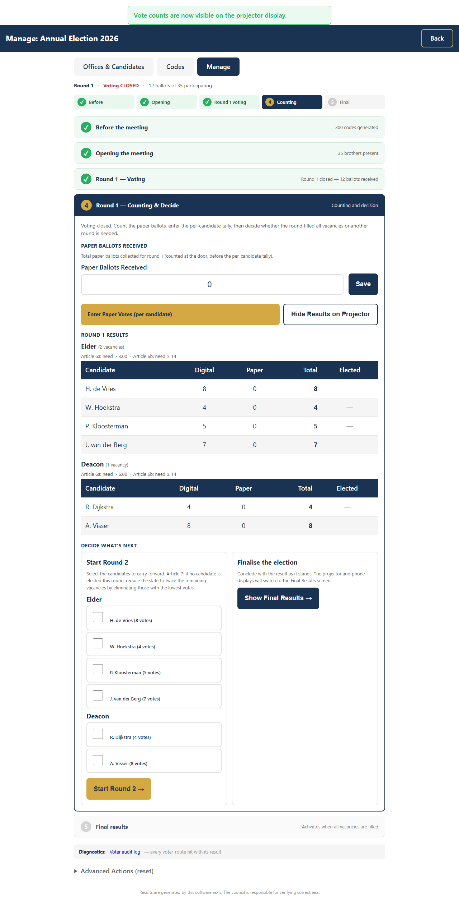
Results showing
For each candidate the projector now shows:
- Total votes (digital + paper + postal-this-round)
- Article 6a tick (more than valid_votes ÷ vacancies ÷ 2)
- Article 6b tick (at least ⌈participants × 2/5⌉)
- A green ELECTED badge for candidates who meet both thresholds and are within the top-N by vote count (where N = office vacancies)

17. Decide what’s next
Step 4’s decision panel offers two choices:
- Start Round N+1 — pick the carry-forward candidates with the checkboxes (already-elected ones are auto-disabled). Click Start Round N+1. The app reduces the office’s remaining vacancies by the number elected this round.
- Show Final Results — if every vacancy has been filled (or the council decides to stop), this switches the projector and phone views to the Final Results page.
If you advance to a new round, return to Step 2 of the Manage page and walk the projector through Welcome → Rules → Voting again. The same code batch is reused — no re-printing needed.

18. Final results
Step 5 — Final results — is active when every vacancy is filled, or when you press Show Final Results explicitly. It contains:
- Elected brothers per office (alphabetical by surname)
- A Show Final Results on Projector button
- A Download Election Minutes (DOCX) button — round-by-round narrative ready for the secretary to fill in (placeholders for chairman name, scripture reference, etc.)
The projector and /displayphone views automatically switch to a clean Final Results screen showing the elected brothers.

Diagnostics: Voter Audit Log
The Manage page footer has a Diagnostics strip with a link to the Voter audit log. This shows every voter-route hit with a colour-coded result pill (accepted, rejected_invalid, rejected_used, vote_submitted, etc.), along with the timestamp, IP, user-agent, and the plaintext code.
A red banner at the top of the log calls out any code that produced more than one acceptance — useful if a code somehow gets used twice.

Troubleshooting Quick Reference
Problem | Solution
Brother’s phone won’t load the page | Check WiFi; try a different browser; use the QR scan
“Invalid code” error | Verify the 6 characters (case-insensitive). If still failing, hand over a paper ballot
Code shows as “already used” but the brother insists they haven’t voted | Check the Voter audit log for that code — usually two scans of the same QR slip
Anomaly banner shows on the projector | Use Vote corrections → Roll back last digital vote in Step 3 to remove an extra submission
WiFi drops out | Restart the WiFi router; cast votes are already saved
App crashes | Restart the app; all data is preserved in the database
Major failure | Switch to paper ballots immediately
Standing rule: If in doubt, fall back to paper ballots. The app is a convenience tool — paper voting is always the backup.

Key Principles
- Anonymity is guaranteed — there is no link between a voting code and a vote in the database
- Paper is always the fallback — digital and paper votes are counted together
- All data stays local — nothing leaves the church WiFi network
- The database is auditable — the consistory can inspect it directly, and the Voter Audit Log shows every interaction
- Compliance built in — Articles 2, 6, 7, and 11 are enforced by the app

